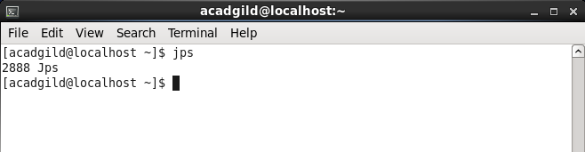

**Starting namenode:**

**Command: ./hadoop-daemon.sh start namenode**

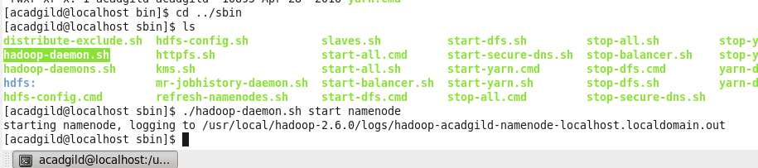

**Starting datanode:**

**Command: ./hadoop-daemon.sh start datanode**

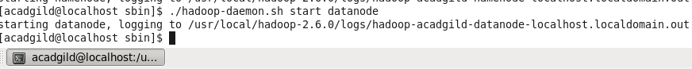

**Starting resourcemanager:**

**Command: ./yarn-daemon.sh start resourcemanager**



**Starting nodemanager:**

**Command: ./yarn-daemon.sh start resourcemanager**



**Type the command jps to check the health of the daemons, if all the daemons will be running then cluster is ready.**

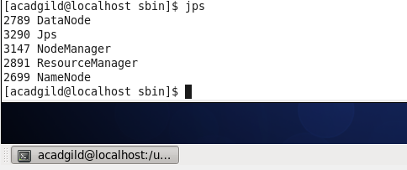

**11.Starting Spark daemons Master,Workers**

Move into the sbin folder of spark installed directory(Here spark is installed in /usr/local/spark/ directory.)

**Starting Master:**

**Command: ./ start-master.sh**

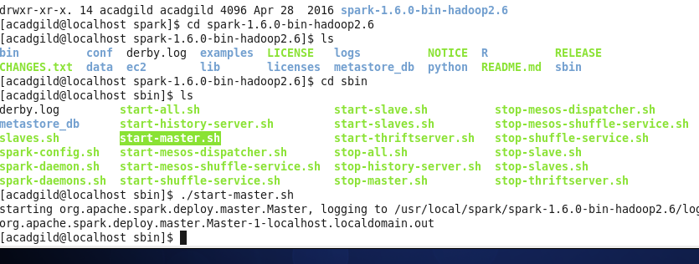

**Starting Slaves:**

**Command: ./start-slaves.sh**

