1. Concat

Employee_Details = LOAD '/user/acadgild/hadoop/pig_data/Employee_Details.txt' USING PigStorage(',') as (id:int, name:chararray, age:int, city:chararray);

Employee_Details_concat = foreach Employee_Details Generate CONCAT (name,'-',city);

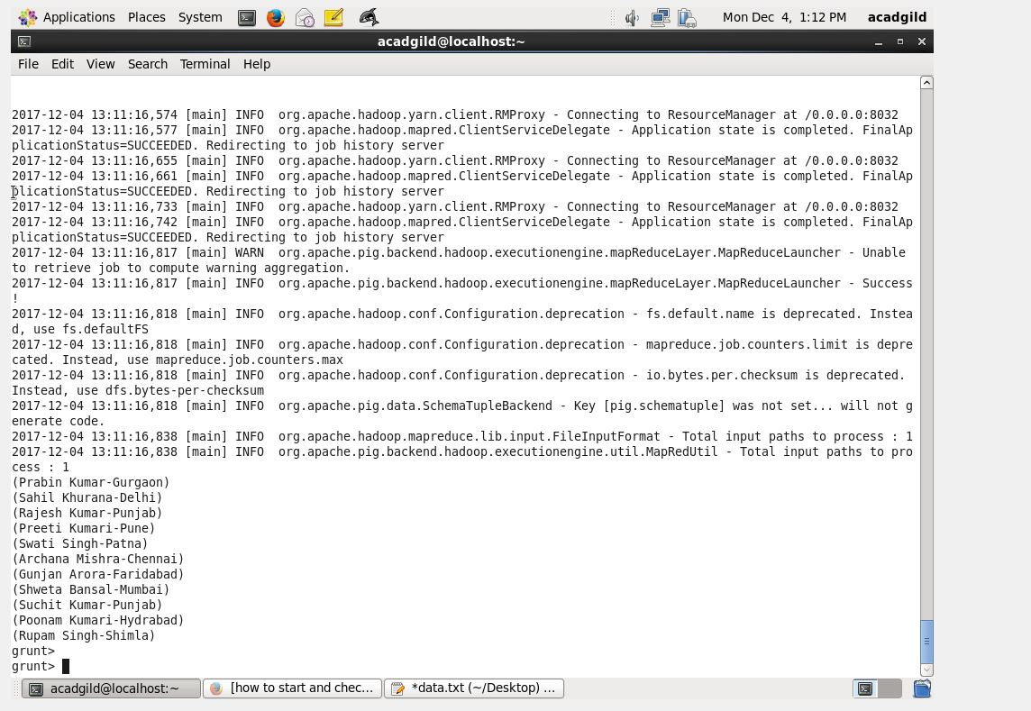

2.Tokenize

Employee_Details = LOAD '/user/acadgild/hadoop/pig_data/Employee_Details.txt' USING PigStorage(',')

as (id:int, name:chararray, age:int, city:chararray);

Employee_Details_tokenize = foreach Employee_Details Generate TOKENIZE(name);

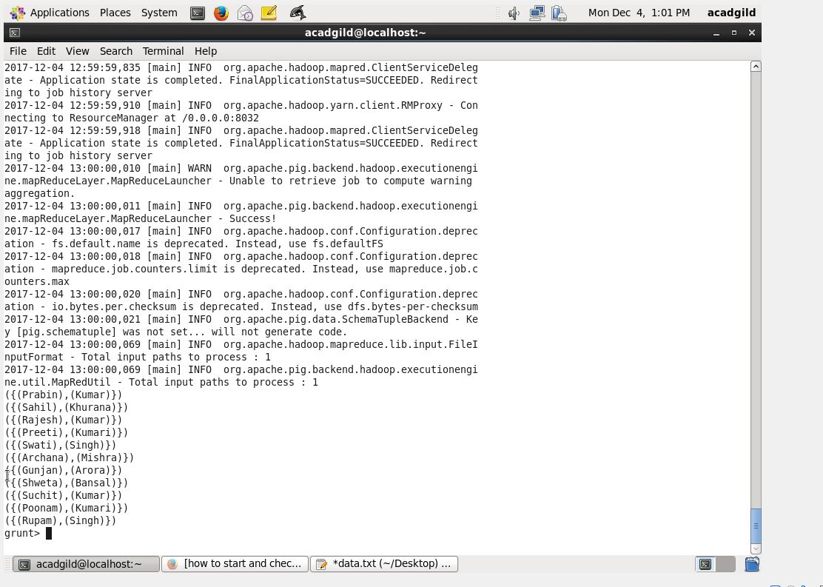

3. MIN

Employee_Details_group = group Employee_Details ALL;

Employee_age_min = foreach Employee_Details_group Generate (Employee_Details.name, Employee_Details.age), MIN(Employee_Details.age);

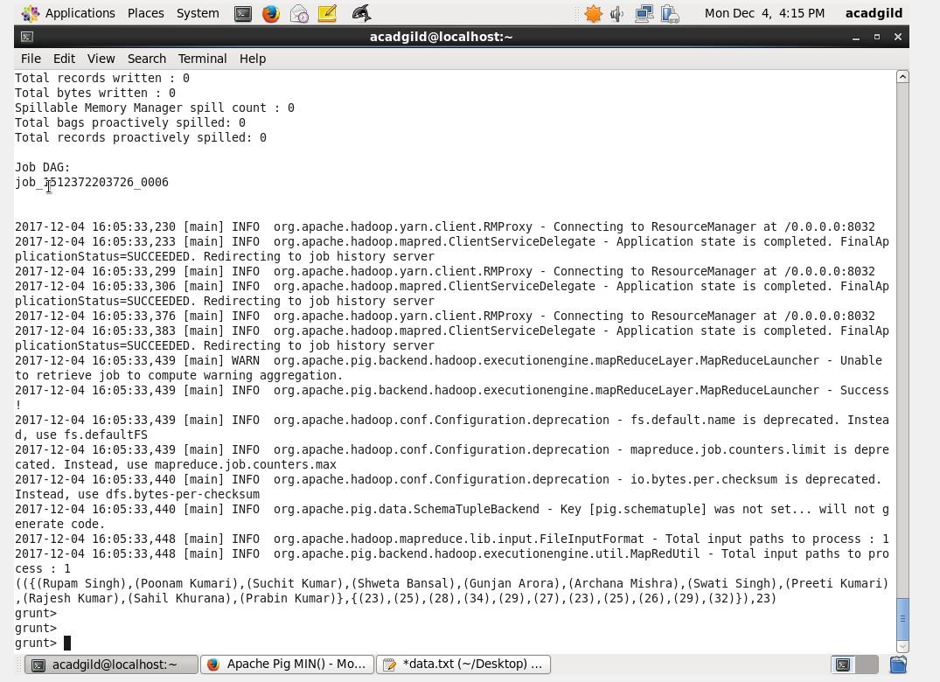

4. MAX

Employee_Details_group = group Employee_Details ALL;

Employee_age_max = foreach Employee_Details_Limit_group Generate (Employee_Details.name, Employee_Details.age), MAX(Employee_Details.age);

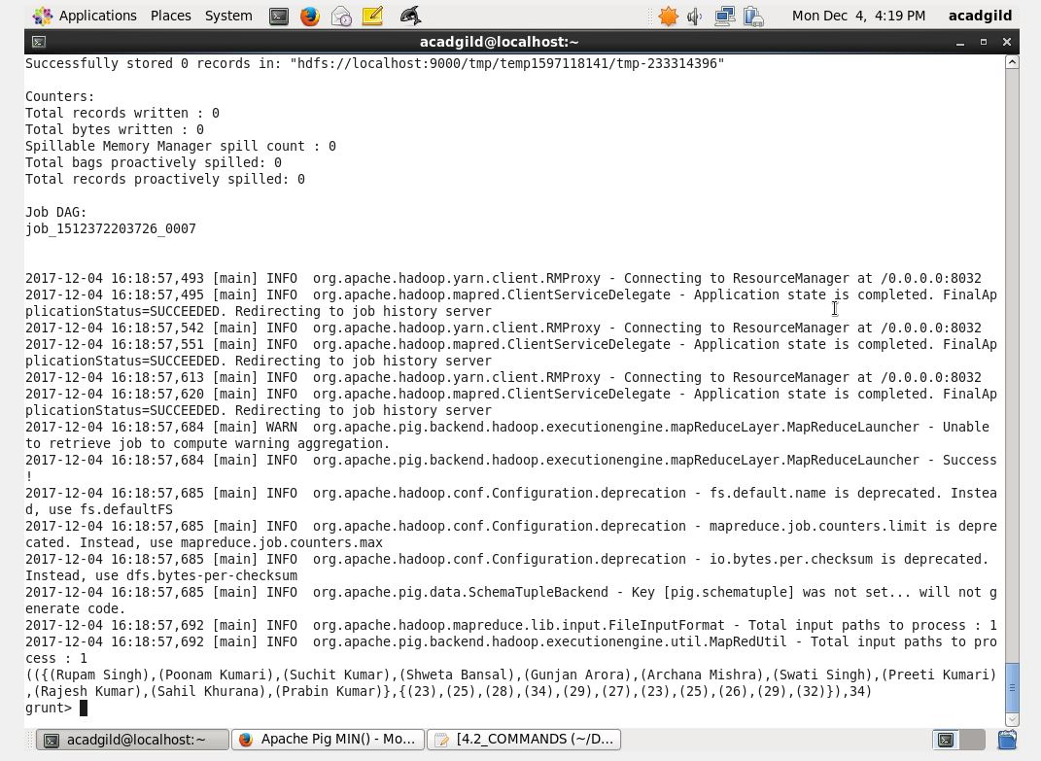

5.SUM

Employee_Details_group = group Employee_Details ALL;

Employee_age_sums = foreach Employee_Details_group Generate (Employee_Details.city),SUM(Employee_Details.age);

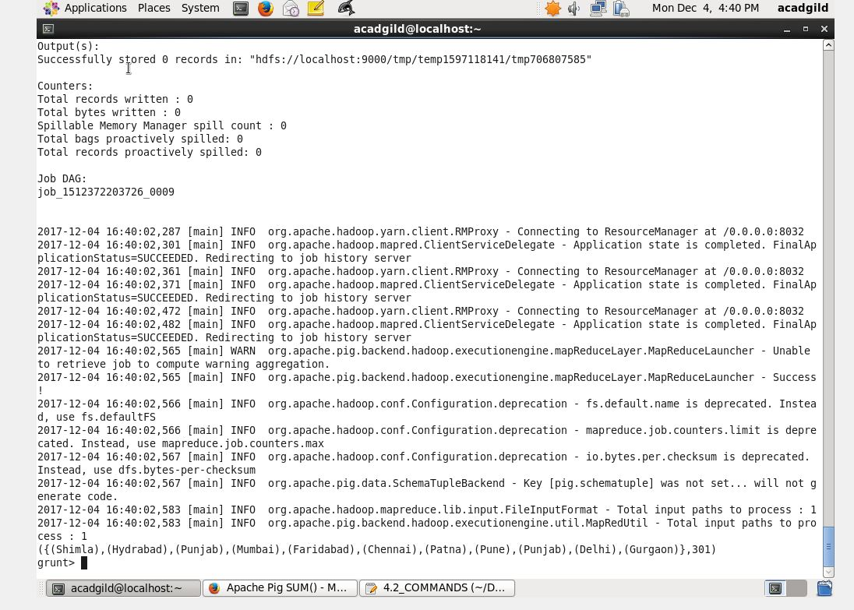

6. LIMIT

Employee_Details_Limit= LIMIT Employee_Details 5;

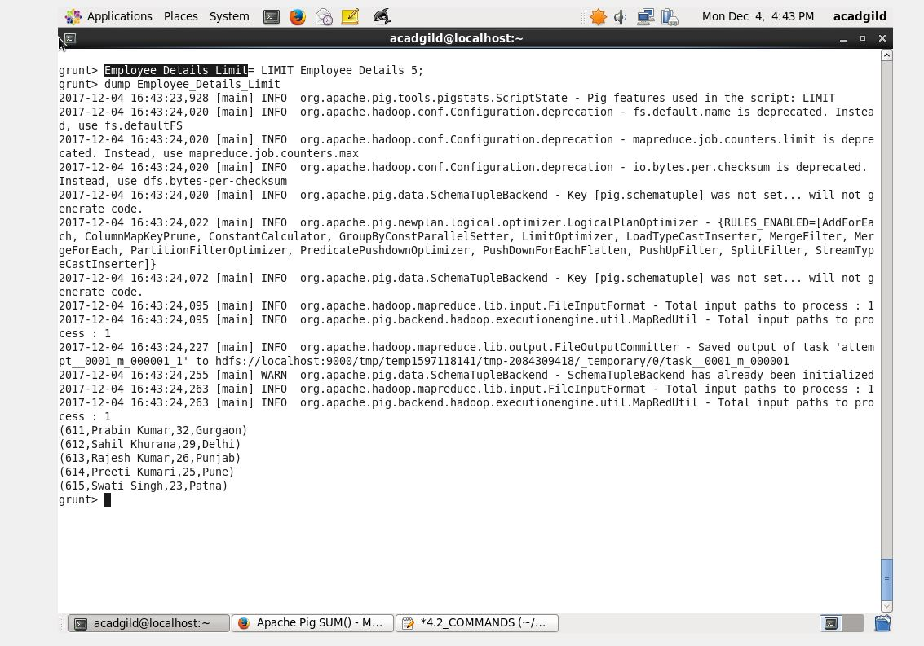

7. STORE

STORE Employee_Details_Limit INTO ' /pig_Output/ ' USING PigStorage (',');

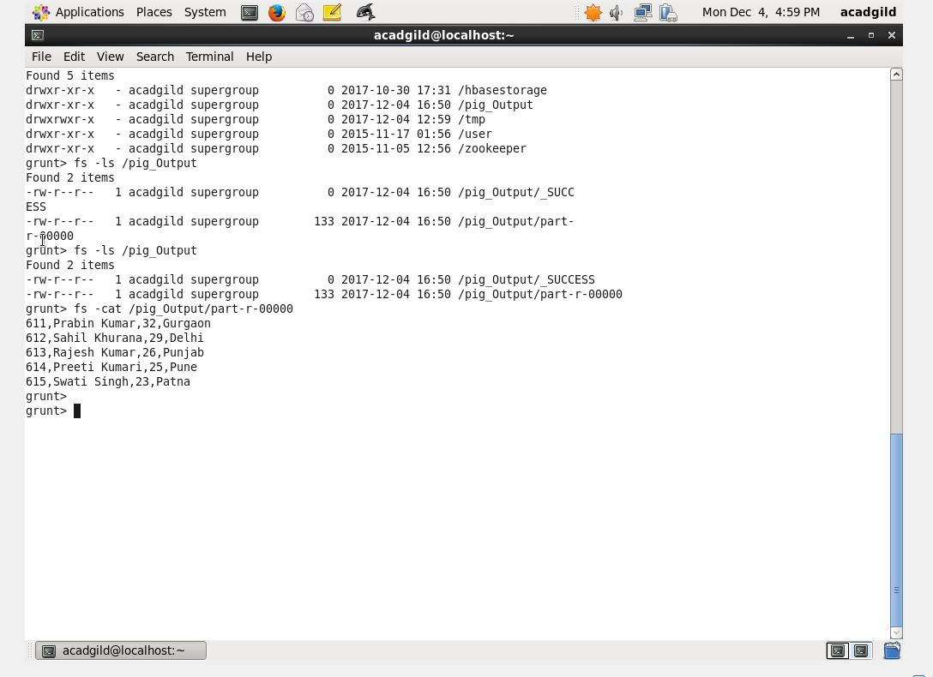

8.DISTINCT

Employee_Details_DISTINCT= DISTINCT Employee_Details;

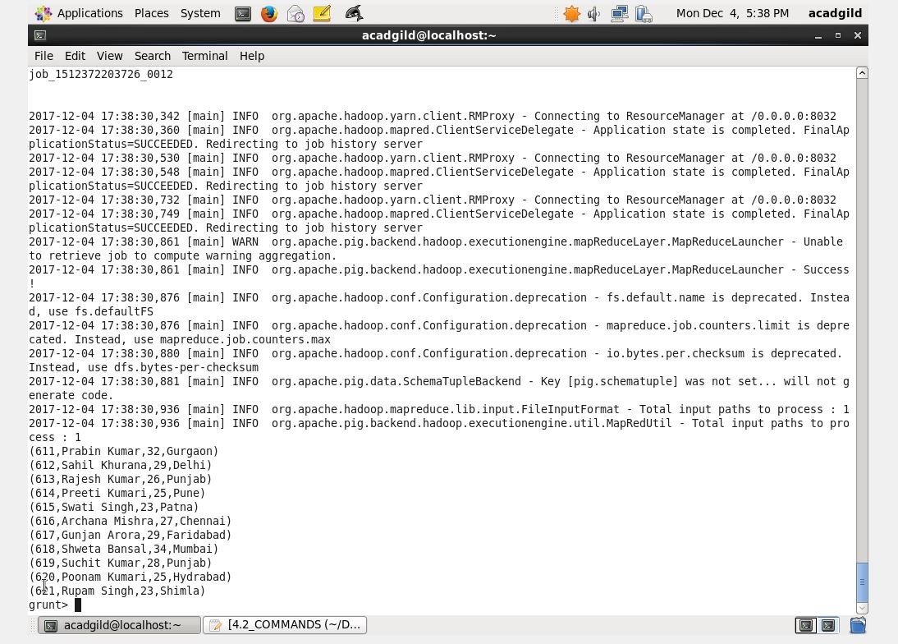

9. FLATTEN

Employee_Details_group = group Employee_Details ALL;

Employee_Details_FLATTEN_DATA= foreach Employee_Details_group Generate FLATTEN($1);

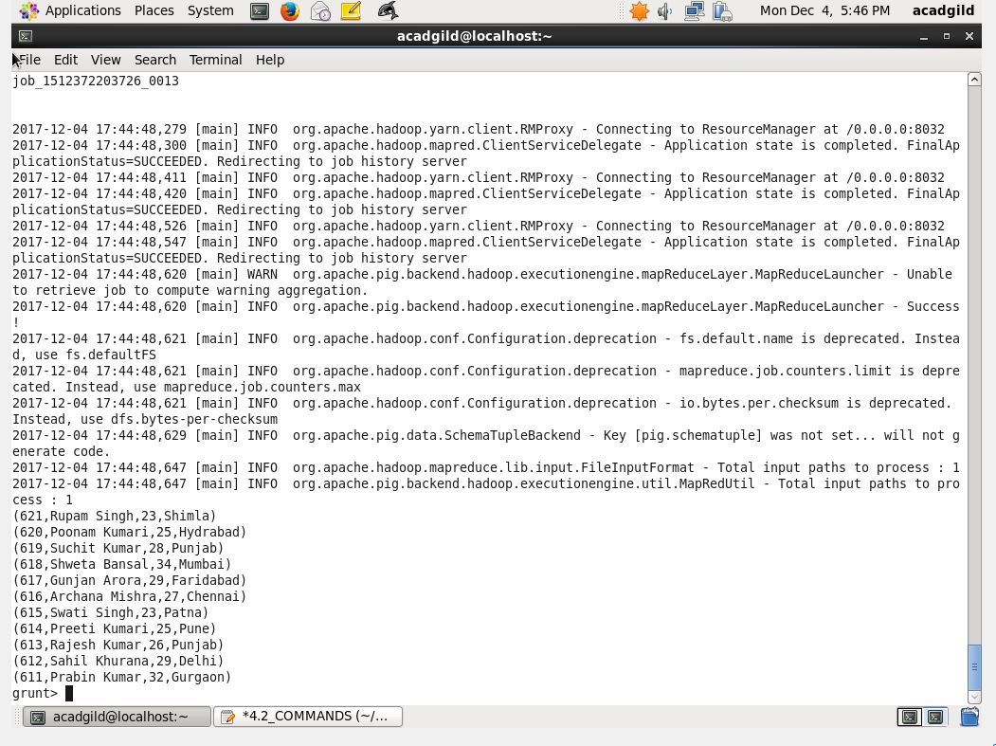

10. IsEmpty

empsales = LOAD '/user/acadgild/hadoop/pig_data/empsales.txt' USING PigStorage(',')

as (sno:int, name:chararray, age:int, salary:int, dept:chararray);

empbonus = LOAD '/user/acadgild/hadoop/pig_data/empbonus.txt' USING PigStorage(',')

as (sno:int, name:chararray, age:int, salary:int, dept:chararray);

cogroup_empdata = COGROUP empsales by age, empbonus by age;

dump cogroup_empdata;

isempty_empdata = filter cogroup_empdata by IsEmpty(empsales);

dump isempty_empdata;

