1. welcome_message = LOAD '/user/acadgild/hadoop/word-count.txt' USING PigStorage as (line:chararray);

dump welcome_message;

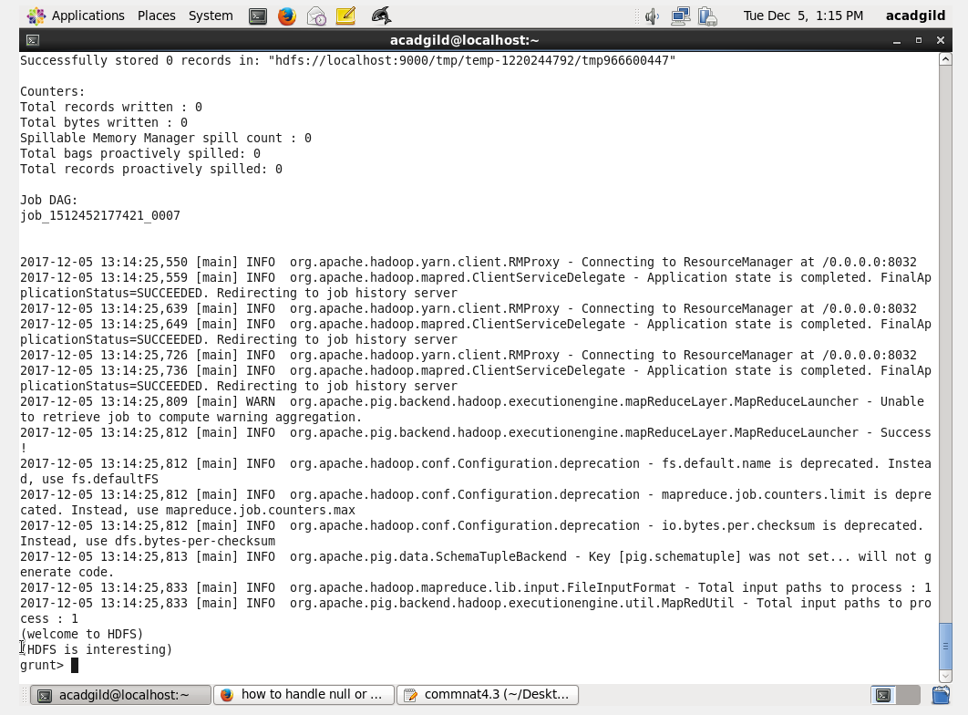

1. tokenize_words = foreach welcome_message GENERATE FLATTEN(TOKENIZE(line,' ')) as word;

dump tokenize_words;

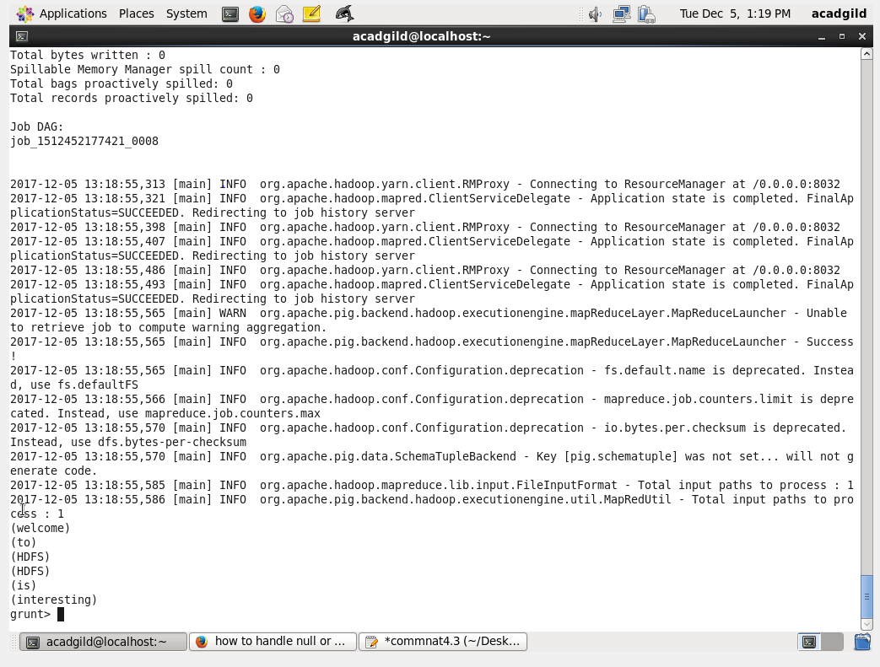

3. words_group= GROUP tokenize_words by word;

dump words_group;

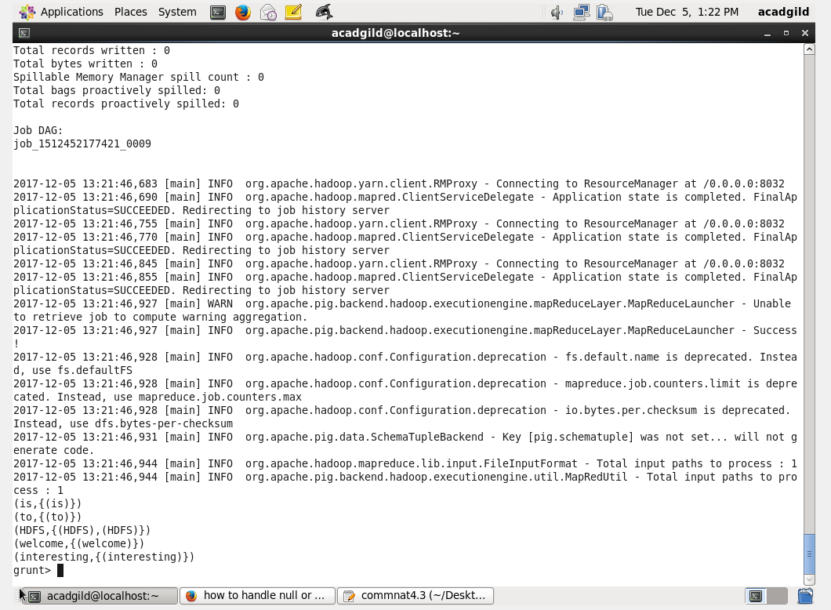

1. words_count= foreach words_group GENERATE group, COUNT(tokenize_words);

dump words_count;

