1. **Top 5 employees (employee id and employee name) with highest rating. (In case two**

**employees have same rating, employee with name coming first in dictionary should get**

**preference)**

**Solutions:**

emp_data= LOAD '/user/acadgild/hadoop/pig_data/assignment_input_data_5.1/employee_details.txt' USING PigStorage(',') AS(empId:int,empName:chararray,Salary:int,rating:int);

A =FOREACH emp_data GENERATE (int)$0 as employee_id,(chararray)$1 as employee_name,(int)$3 as rating;

B= ORDER A BY rating DESC;

C= LIMIT B 5;

D= ORDER C BY employee_name;

dump D;

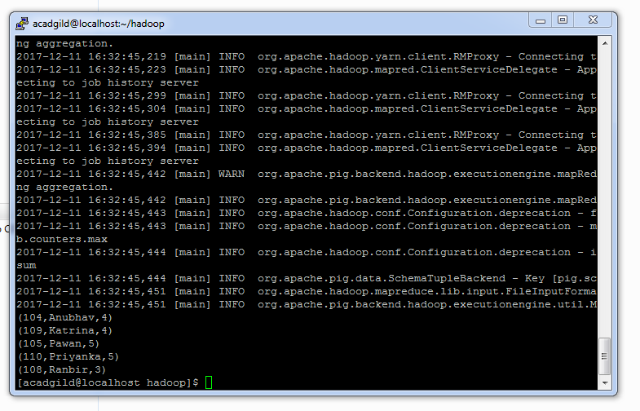

1. **Top 3 employees (employee id and employee name) with highest salary, whose employee id is an odd number. (In case two employees have same salary, employee with name coming first in dictionary should get preference)**

**Solutions:**

emp_data= LOAD '/user/acadgild/hadoop/pig_data/assignment_input_data_5.1/employee_details.txt' USING PigStorage(',') AS(empId:int,empName:chararray,Salary:int,rating:int);

A =FOREACH emp_data GENERATE (int)$0 as employee_id,(chararray)$1 as employee_name,(int)$2 as salary, (int)$0%2 as oddeven;

B= ORDER A BY salary DESC;

C= FILTER B BY oddeven==1;

D= LIMIT C 3;

E= ORDER D BY employee_name;

dump E;

