**Ques 1: Find the list of players that have been selected in the qualifying round (DEFENCE>55).**

**fs -copyFromLocal /home/acadgild/Desktop/assignments_work/Data_from_acadgild/5.3/Pokemon.csv/ /user/acadgild/pokemon/**

**Load_Data = LOAD '/user/acadgild/pokemon/Pokemon.csv' USING PigStorage(',') AS(Sno:int,Name:chararray,Type1:chararray,Type2:chararray,Total:int,HP:int,Attack:int,Defense:int,Sp. Atk:int,Sp. Def:int,Speed:int);**

**selected_list = FILTER Load_Data BY Defense>55;**

**dump selected_list;**

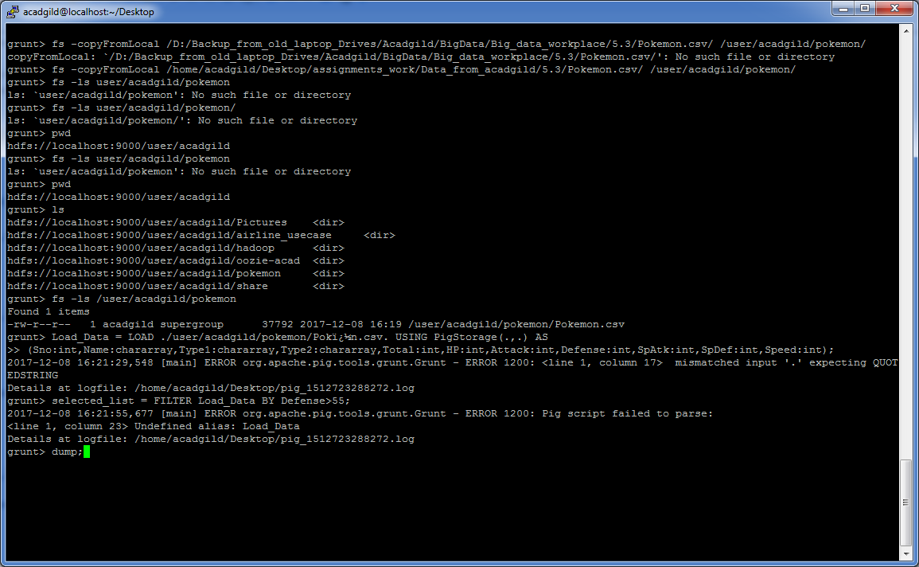

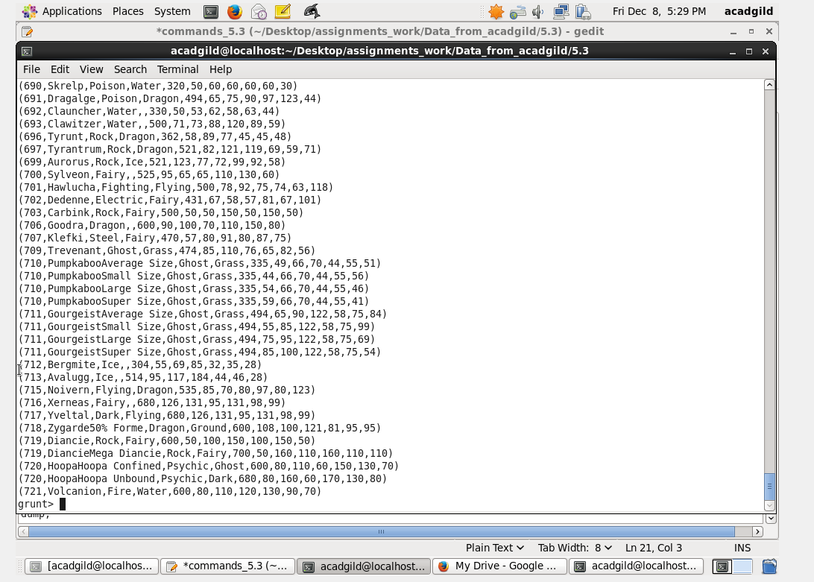

**Ques 2: State the number of players taking part in the competition after getting selected in the qualifying round.**

gourp_selcted_list = Group selected_list All;

count_selcted_list = foreach gourp_selcted_list GENERATE COUNT(selected_list);

dump count_selcted_list;

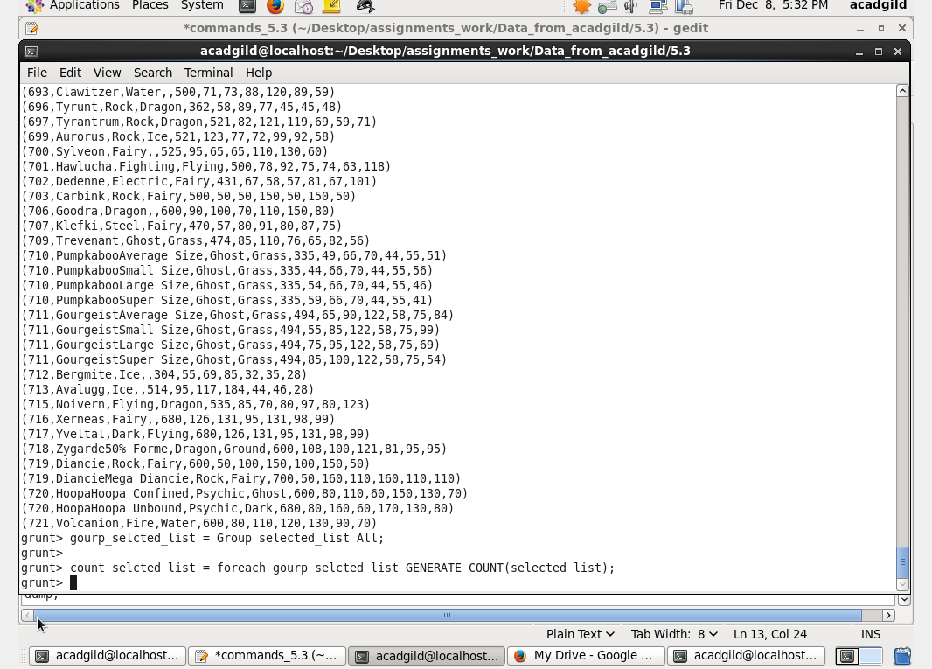

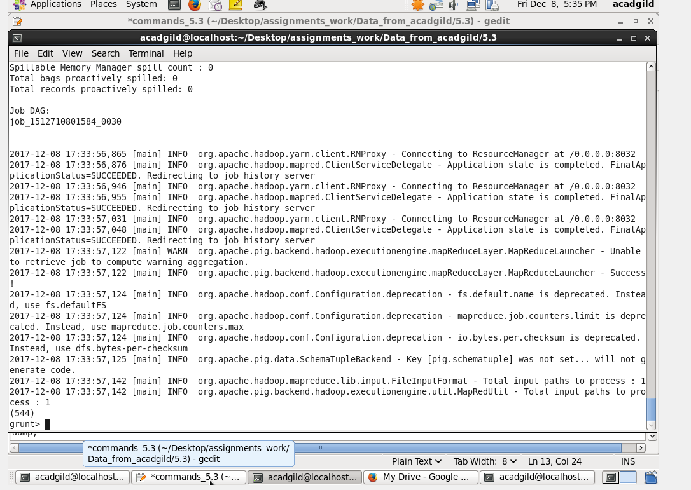

**Ques 3**: **Using random() generate random numbers for each Pokémon on the selected list.**

random_include1 = foreach selected_list GENERATE RANDOM(),Name,Type1,Type2,Total,HP,Attack,Defense,SpAtk,SpDef,Speed**;**

dumprandom_include1**;**

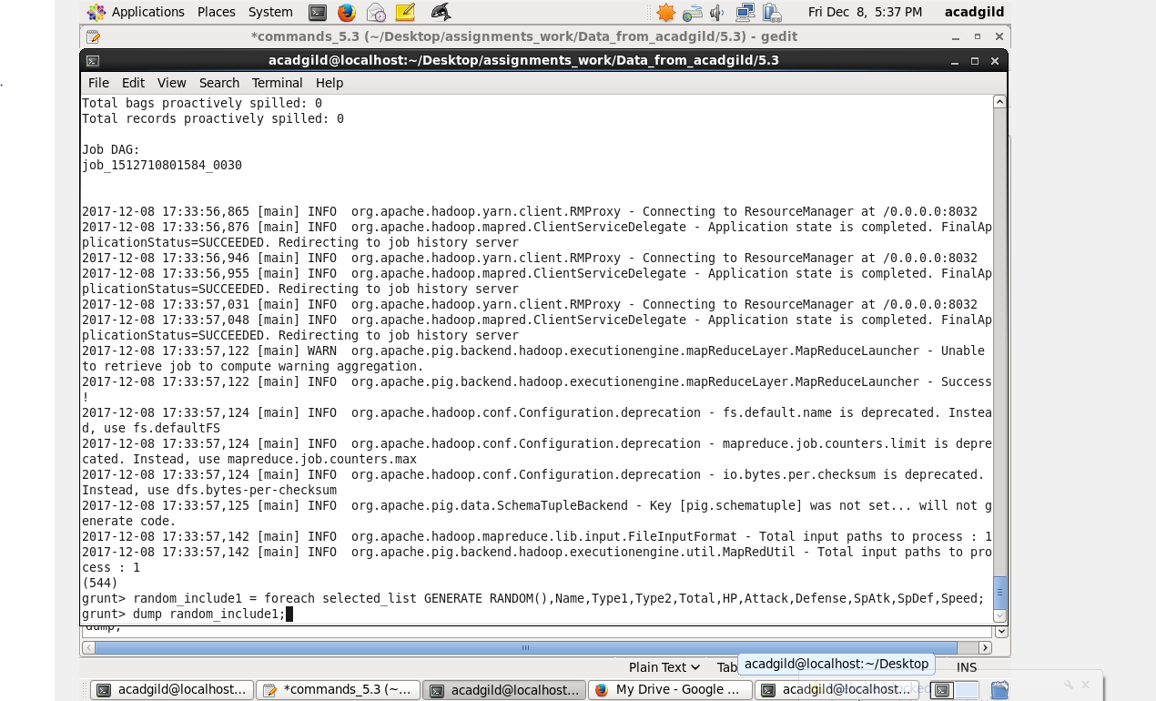

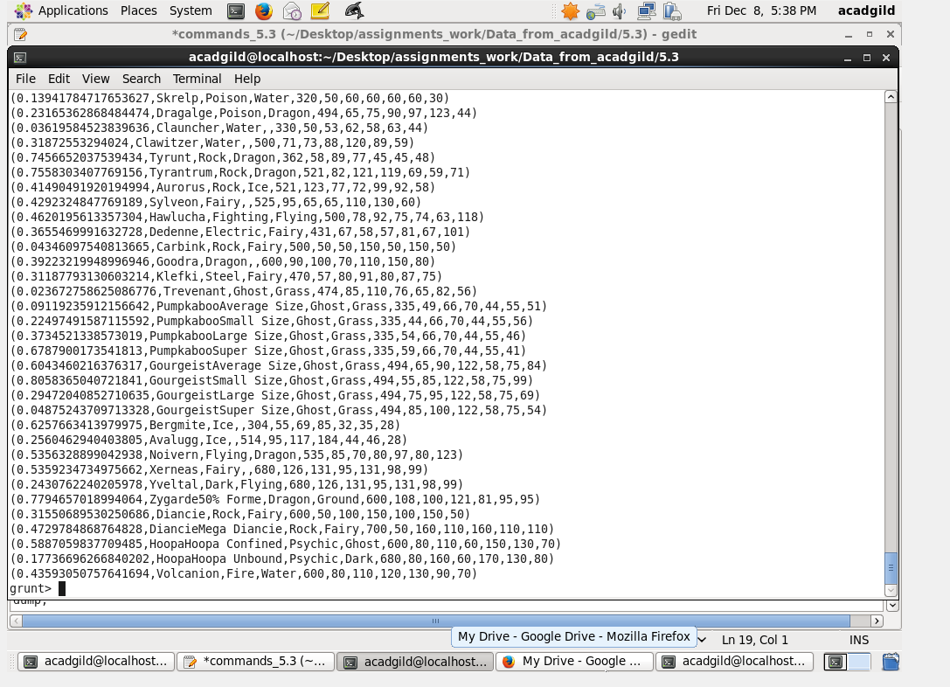

**Ques 4**: **Arrange the new list in a descending order according to a column randomly.**

random1_desending = ORDER random_include1 BY $0 DESC;

dump random1_desending;

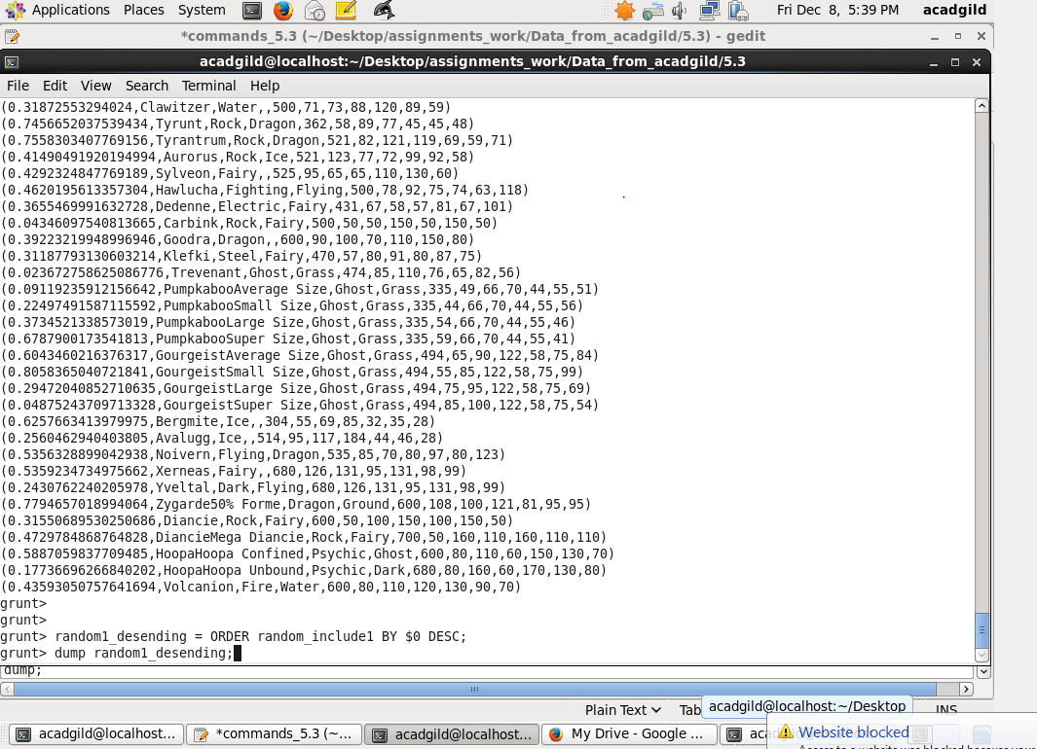

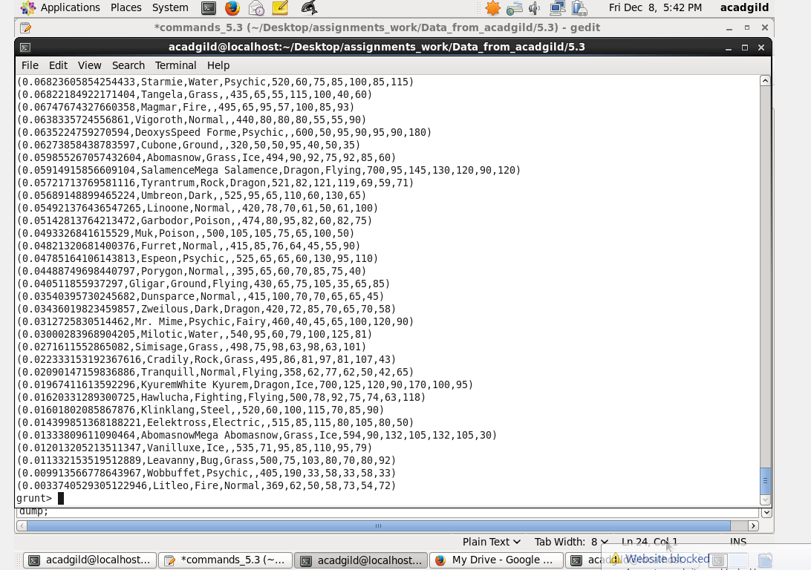

**Ques 5**: **Now on a new relation again associate random numbers for each Pokémon and arrange in descending order according to column random.**

random_include2 = foreach selected_list GENERATE RANDOM(),Name,Type1,Type2,Total,HP,Attack,Defense,SpAtk,SpDef,Speed;

random2_desending = ORDER random_include2 BY $0 DESC;

dump random2_desending;

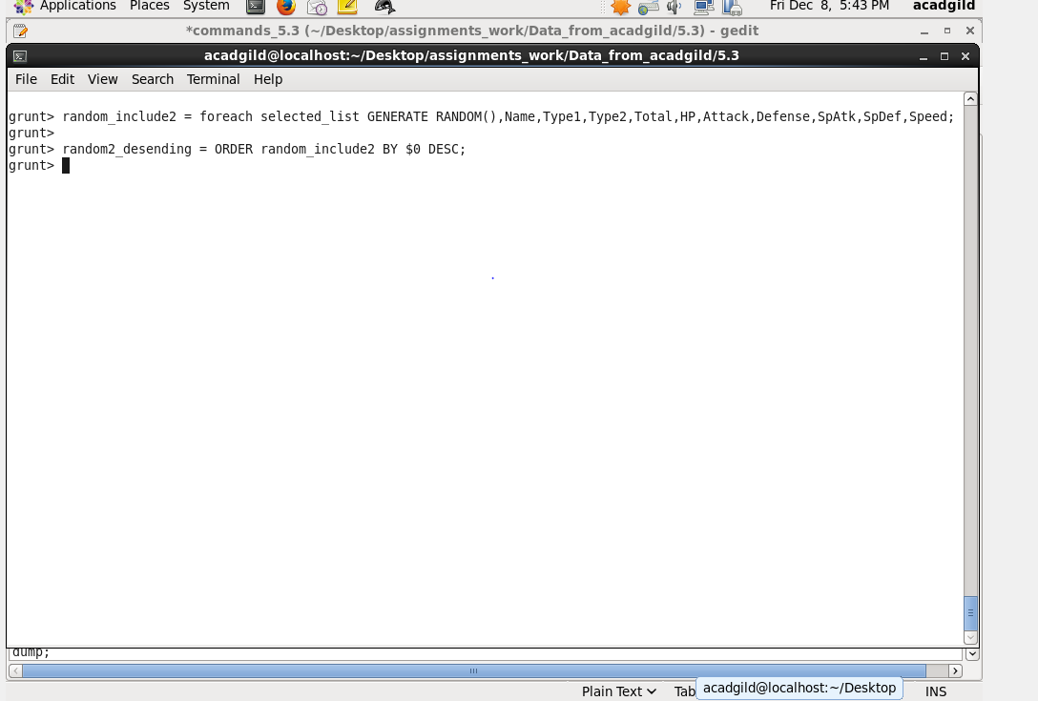

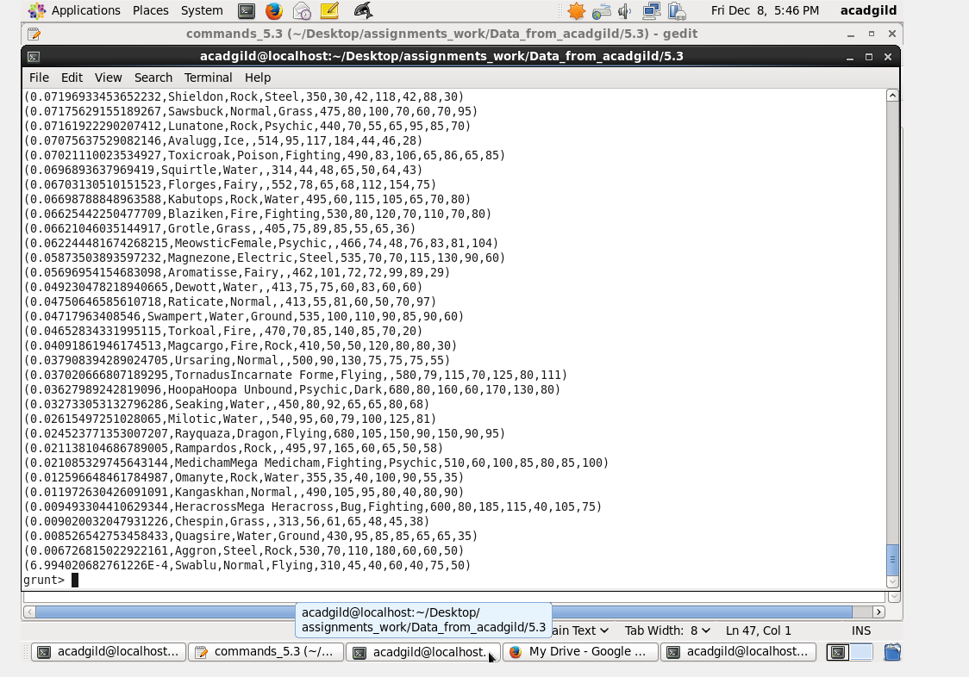

**6. Ques**: **From the two different descending lists of random Pokémons, select the top 5 Pokémons for 2 different players.**

limit_data_random1_desending = LIMIT random1_desending 5 ;

limit_data_random2_desending = LIMIT random2_desending 5 ;

dump limit_data_random1_desending;

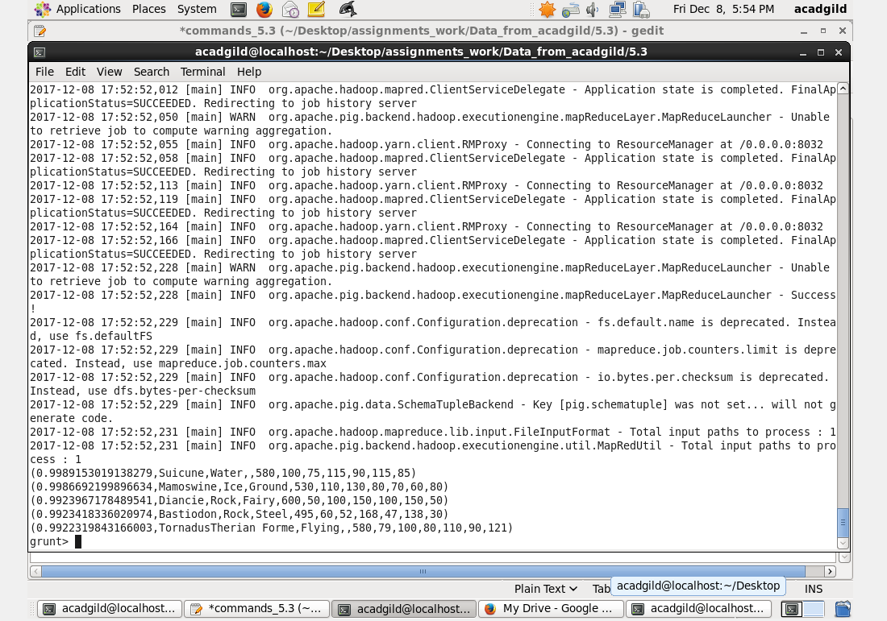

dump limit_data_random2_desending;

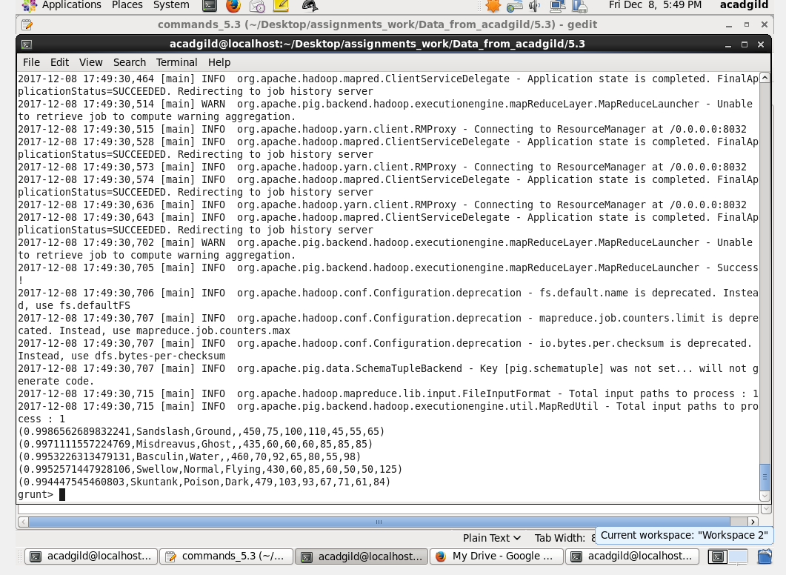

**7. Ques**: **Store the data on a local drive to announce for the final match. By the name player1 and player2 (only show the NAME and HP).**

filter_only_name1 = foreach limit_data_random1_desending Generate ($1,HP);

dump filter_only_name1;

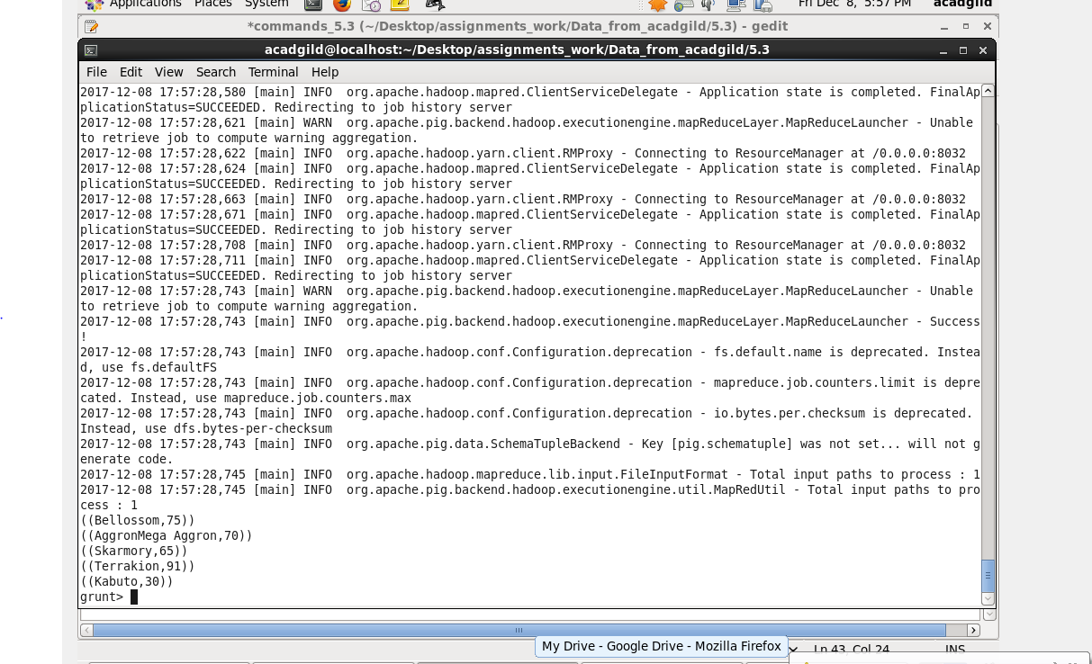

filter_only_name2 = foreach limit_data_random2_desending Generate ($1,HP);

dump filter_only_name2;

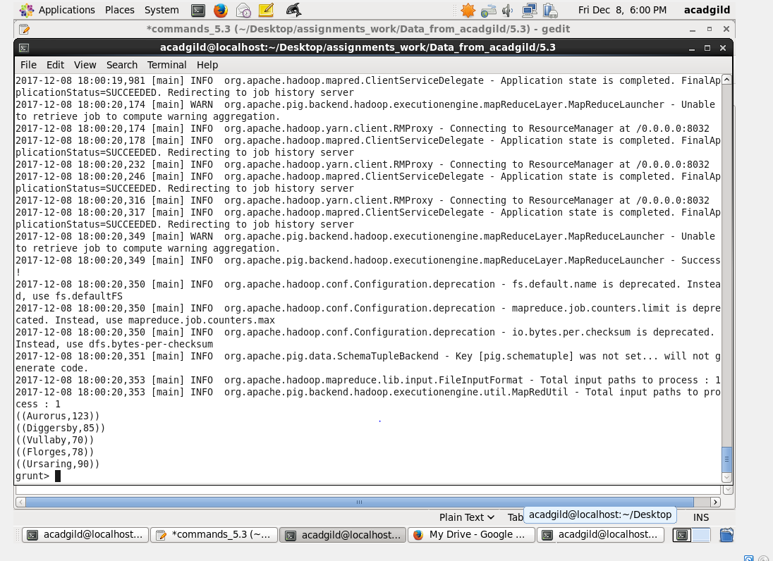

8.

STORE limit_data_random1_desending INTO ‘/home/acadgild/Documents/prateek/PIG/player1.txt’

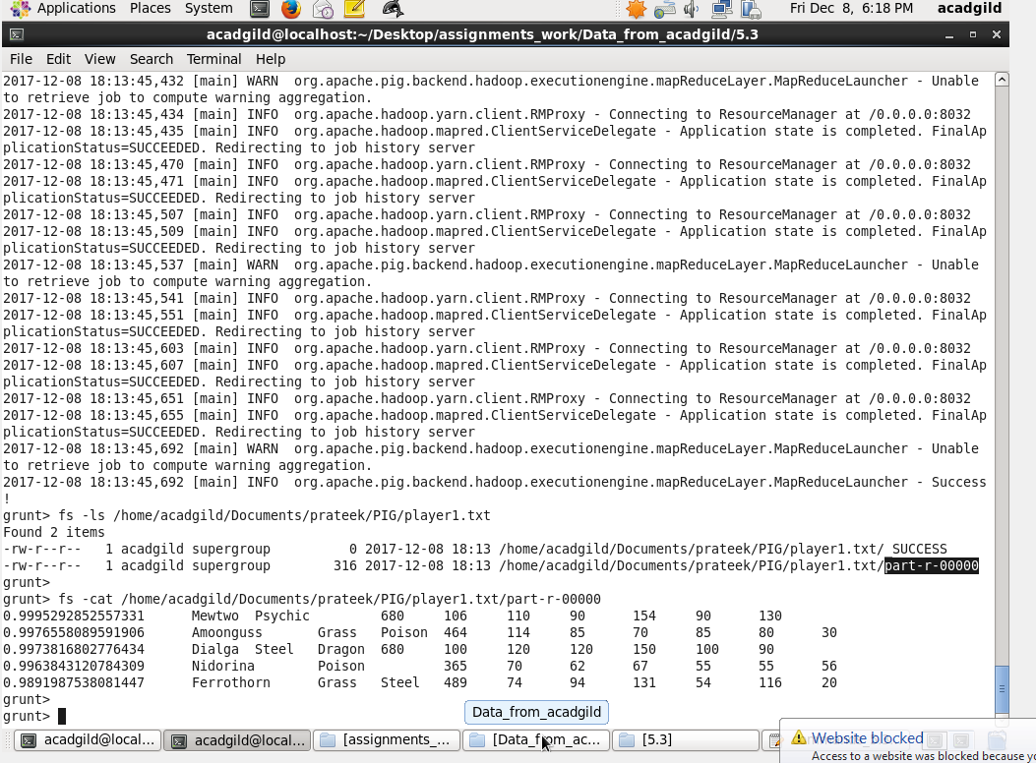

9.

STORE limit_data_random2_desending INTO ‘/home/acadgild/Documents/prateek/PIG/player2.txt’;

