1. Fetch date and temperature from temperature_data where zip code is greater than 300000 and less than 399999.

**Solutions:**

SELECT date, temperature from TEMPERATURE_DATA where zip_code >300000 and zip_code <399999;

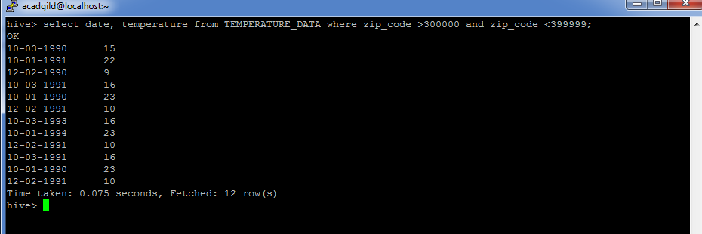

2. Calculate maximum temperature corresponding to every year from temperature_data table.

SELECT date, MAX(temperature) FROM temperature_data GROUP BY date;