**HIVE ARCHITECTURE:**

**What is Hive :** Apache Hive is a data warehouse system built on top of Hadoop and is used for analyzing structured and semi-structured data. Hive abstracts the complexity of Hadoop MapReduce. Basically, it provides a mechanism to project structure onto the data and perform queries written in HQL (Hive Query Language) that are similar to SQL statements.

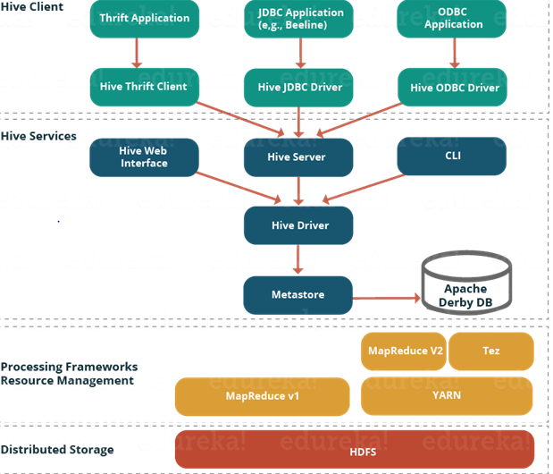

**HIVE ARCHITECTURE**

**User Interface :** Hive is a data warehouse infrastructure software that can create interaction between user and HDFS. The user interfaces that Hive supports are Hive Web UI, Hive command line, and Hive HD Insight.

**Meta Store :** Hive chooses respective database servers to store the schema or Metadata of tables, databases, columns in a table, their data types, and HDFS mapping.

Hive stores the schema of the Hive tables in a Hive Metastore. Metastore is used to hold all the information about the tables and partitions that are in the warehouse. By default, the metastore is run in the same process as the Hive service and the default Metastore is DerBy Database.

**HiveQL Process Engine:** HiveQL is similar to SQL for querying on schema info on the Metastore. It is one of the replacements of traditional approach for MapReduce program. Instead of writing MapReduce program in Java, we can write a query for MapReduce job and process it

**Execution Engine :** The conjunction part of HiveQL process Engine and MapReduce is Hive Execution Engine. Execution engine processes the query and generates results as same as MapReduce results. It uses the flavor of MapReduce.

**HDFS or HBASE:** Hadoop distributed file system or HBASE are the data storage techniques to store data into file system.

**SerDe :** Serializer, Deserializer gives instructions to hive on how to process a record.

### ****Hive Clients:****

Apache Hive supports different types of client applications for performing queries on the Hive. These clients can be categorized into three types:

* Thrift Clients: As Hive server is based on Apache Thrift, it can serve the request from all those programming language that supports Thrift.
* JDBC Clients: Hive allows Java applications to connect to it using the JDBC driver which is defined in the class org.apache.hadoop.hive.jdbc.HiveDriver.
* ODBC Clients: The Hive ODBC Driver allows applications that support the ODBC protocol to connect to Hive. (Like the JDBC driver, the ODBC driver uses Thrift to communicate with the Hive server.)

### ****Hive Services:****

Hive provides many services as shown in the image above. Let us have a look at each of them:

* **Hive CLI (Command Line Interface):**This is the default shell provided by the Hive where you can execute your Hive queries and commands directly.
* **Apache Hive Web Interfaces:**Apart from the command line interface, Hive also provides a web based GUI for executing Hive queries and commands.
* **Hive Server:**Hive server is built on Apache Thrift and therefore, is also referred as Thrift Server that allows different clients to submit requests to Hive and retrieve the final result.
* **Apache Hive Driver:**It is responsible for receiving the queries submitted through the CLI, the web UI, Thrift, ODBC or JDBC interfaces by a client. Then, the driver passes the query to the compiler where parsing, type checking and semantic analysis takes place with the help of schema present in the metastore. In the next step, an optimized logical plan is generated in the form of a DAG (Directed Acyclic Graph) of map-reduce tasks and HDFS tasks. Finally, the execution engine executes these tasks in the order of their dependencies, using Hadoop.
* **Metastore:**You can think metastore as a central repository for storing all the Hive metadata information. Hive metadata includes various types of information like structure of tables and the partitions along with the column, column type, serializer and deserializer which is required for Read/Write operation on the data present in HDFS. The metastore comprises of two fundamental units:
  + A service that provides metastore access to other Hive services.
  + Disk storage for the metadata which is separate from HDFS storage.

## ****Metastore Configuration:****

### ****Embedded Metastore:**** Both the metastore service and the Hive service runs in the same JVM by default using an embedded Derby Database instance where metadata is stored in the local disk. This is called embedded metastore configuration. In this case, only one user can connect to metastore database at a time. If you start a second instance of Hive driver, you will get an error. This is good for unit testing, but not for the practical solutions.

### ****Local Metastore:**** This configuration allows us to have multiple Hive sessions i.e. Multiple users can use the metastore database at the same time. This is achieved by using any JDBC compliant database like MySQL which runs in a separate JVM or a different machine than that of the Hive service and metastore service which are running in the same JVM as shown above. In general, the most popular choice is to implement a MySQL server as the metastore database.

### ****Remote Metastore:**** In the remote metastore configuration, the metastore service runs on its own separate JVM and not inthe Hive service JVM. Other processes communicate with the metastore server using Thrift Network APIs. You can have one or more metastore servers in this case to provide more availability. The main advantage of using remote metastore is you do not need to share JDBC login credential with each Hive user to access the metastore database.