7.1 **Calculate the number of employees corresponding to each skill from the table 'employee' which is loaded in the Demo.**

**Solution:**

**Created a table employee and Loaded the data with the below commands:**

CREATE TABLE IF NOT EXISTS custom.employee (name string,course string,rank int, location string)

ROW FORMAT DELIMITED FIELDS TERMINATED BY ',';

LOAD DATA LOCAL INPATH '/home/acadgild/Desktop/assignments_work/Data_from_acadgild/7.1/emp_details.txt' into table custom.employee;

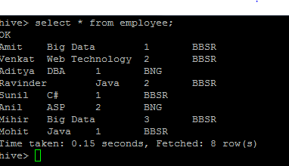

select course, count(course) from custom.employee group by course;

