CREATE TABLE IF NOT EXISTS

custom.olympix_data (athlete_name string,athlete_age int,athlete_country string, year int,closing_date string,sport string,gold_medals int,

silver_medals int,bronze_medals int,total_medals int)

ROW FORMAT DELIMITED FIELDS TERMINATED BY '\t'

LOAD DATA LOCAL INPATH '/home/acadgild/Desktop/assignments_work/Data_from_acadgild/7.2/olympix_data.csv' into table custom.olympix_data;

1. **Write a Hive program to find the number of medals won by each country in swimming.**

**Solution:**

select athlete_country,sum(total_medals)

from custom.olympix_data

where sport = "Swimming"

group by athlete_country;

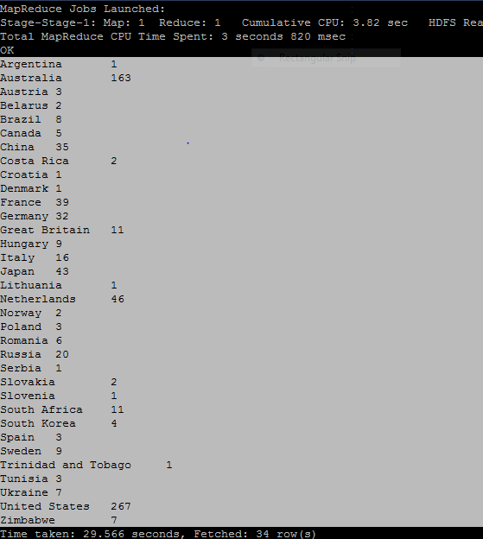

2. **Write a Hive program to find the number of medals that India won year wise.**

**Solution:**

select year, sum(total_medals)

from custom.olympix_data

where athlete_country = "India"

group by year;

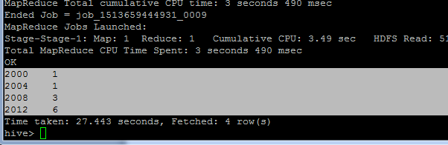

3.**Write a Hive Program to find the total number of medals each country won.**

**Solution**:

select athlete_country,sum(total_medals)

from custom.olympix_data

group by athlete_country;

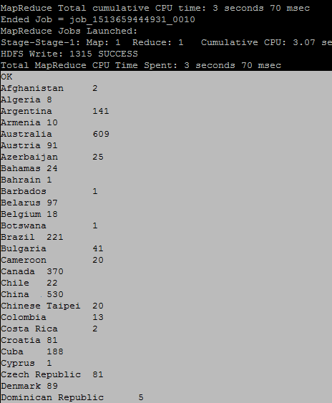

4. **Write a Hive program to find the number of gold medals each country won.**

**Solution:**

select athlete_country,sum(gold_medals)

from custom.olympix_data

group by athlete_country;

