8.1

Data used for this assignment is attached below.



(I) **Get a list of employees who receive a salary less than 100, compared to their immediate employee with higher salary in the same unit**

**Solution:**

select emp_name,department_id,salary from

(SELECT emp_name, salary, department_id,LEAD(salary,1) OVER (PARTITION BY unit order by department_id,salary) - salary sal_diff

FROM custom.employee_data) e

where e.sal_diff =100;

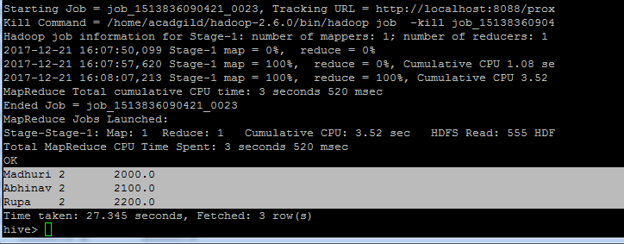

(II**) List of all employees who draw higher salary than the average salary of that department**

**Solution:**

select emp_name,department_id,salary,avg_sal from

(select emp_name,department_id,salary,avg(salary) over(partition by department_id) avg_sal

from custom.employee_data ed) e

where e.salary>e.avg_sal;

