8.3

Set the properties in hive for hive transactions.

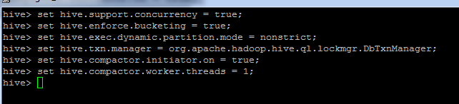

**Creating a Table That Supports Hive Transactions**

CREATE TABLE college(clg_id int,clg_name string,clg_loc string) clustered by (clg_id) into 5 buckets stored as orc TBLPROPERTIES('transactional'='true');

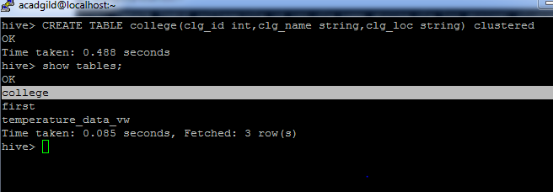

## Inserting Data into a Hive Table

INSERT INTO table college values(1,'nec','nlr'),(2,'vit','vlr'),(3,'srm','chen'),(4,'lpu','del'),(5,'stanford','uk'),(6,'JNTUA','atp'),(7,'cambridge','us');

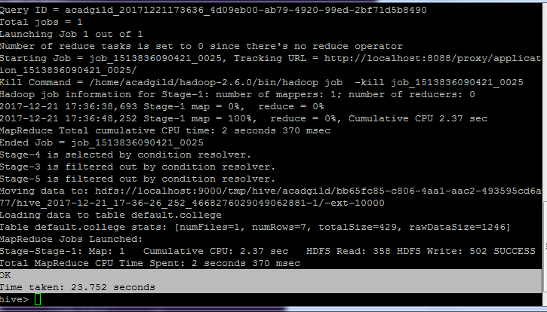

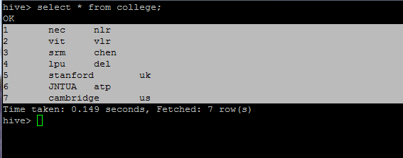

## Re-inserting the same data in the table college.

INSERT INTO table college values(1,'nec','nlr'),(2,'vit','vlr'),(3,'srm','chen'),(4,'lpu','del'),(5,'stanford','uk'),(6,'JNTUA','atp'),(7,'cambridge','us');

## It is appended to the previous data in the table like below:

## 

## Updating the Data in Hive Table

UPDATE college set clg_id = 8 where clg_id = 7;

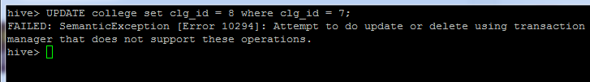

|  |  |
| --- | --- |
|  |  |

UPDATE college set clg_name = 'IIT' where clg_id = 6;

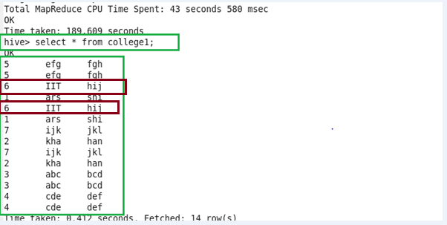

## Deleting a Row from Hive Table

delete from college where clg_id=5;

