**Problem 1:**

Create an HBase table named 'clicks' with a column family 'hits' such that it should be able to store last 5 values of qualifiers inside 'hits' column family.

TO CREATE TABLE

create 'clicks','hits'

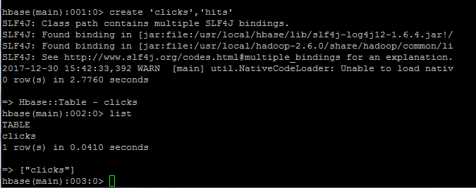

**Inserts Records**

put 'clicks', '10.81.256.127', 'hits:google', '25'

put 'clicks', '10.81.256.127', 'hits:yahoo', '26'

put 'clicks', '10.81.256.127', 'hits:teoco', '12'

put 'clicks', '10.81.256.127', 'hits:aicom', '28'

put 'clicks', '10.81.256.127', 'hits:koinex', '14'

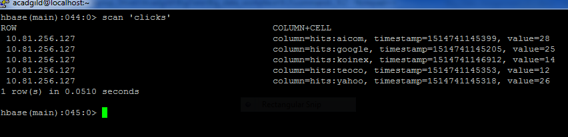

**Problem 2:**

Add few records in the table and update some of them. Use IP Address as row-key. Scan the table to view if all the previous versions are getting displayed.

**To store 5 different versions of records of column ‘hits’**

alter 'clicks',{NAME=>'hits',VERSIONS=>5}

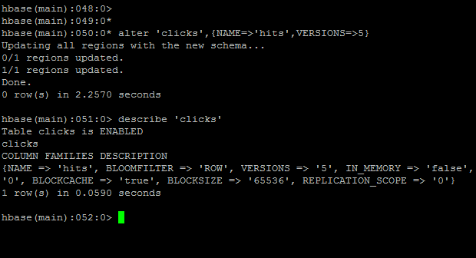

**To show 5 version of the update records**

get 'clicks', '10.81.256.127', {COLUMN=>'hits:google', VERSIONS=>5}

