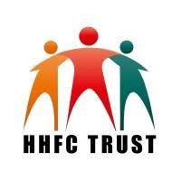

**HELPING HANDS FRIENDS CHARITABLE TRUST (HHFC)**

Study Centre: Vijay Nagar

**QUARTERLY REPORT**

|  |  |  |  |
| --- | --- | --- | --- |
| **Name :** |  | **Level :** | **0** |

|  |  |  |  |  |  |  |
| --- | --- | --- | --- | --- | --- | --- |
| **Subjects** | **Quarterly**  **I** | **Quarterly**  **II** | **Quarterly**  **III** | **Total Marks** | **Marks Obtained** | **Percentage**  **(%)** |
| **English** |  |  |  | **150** |  |  |
| **Hindi** |  |  |  | **150** |  |  |
| **Maths** |  |  |  | **150** |  |  |
| **Evs/Science** |  |  |  | **150** |  |  |
| **Sst** | **N/A** | **N/A** | **N/A** | **N/A** | **N/A** | **N/A** |

**Remarks**

**Dated: 12/04/2025**

**Centre Coordinator**