Profiles for new Website

Basudev Gangopadhyay 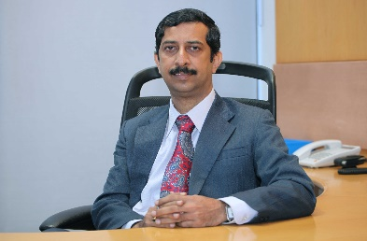
Basudev is a highly accomplished technology executive with over 35 years of strategic and operational leadership across information technology, data center engineering, and cybersecurity. Recognized for transforming technology landscapes, he has held multiple senior management roles with global responsibility.
He has worked for multi-national companies like TCS & Cognizant. At Cognizant, besides other responsibilities, he was also the Global Head for End-User services catering to IT infrastructure needs for 280,000+ users worldwide.
He has championed Cybersecurity practice implementation, maturity improvements, establishing frameworks, governance models, and cybersecurity audits, aligned with global best practices.
He holds a Bachelors degree in Engineering from IISc, Bangalore & Post Graduate Diploma in Business Management from IIM, Calcutta.

Vishy Narayan 
Vishy Narayan leads ITOrigin's AI Strategy and Cybersecurity Practice across North America. As a trusted advisor to C-suite executives, Vishy specializes in translating complex business challenges into actionable AI and security strategies that deliver measurable outcomes. His expertise spans enterprise transformation, responsible AI governance, cloud modernization, and comprehensive cybersecurity frameworks. At ITOrigin, Vishy partners with clients across industry sectors to architect scalable solutions aligned with business objectives and regulatory requirements including SOC 2, ISO 27001, and FedRAMP.
Prior to ITOrigin, Vishy built and led enterprise consulting practices at Cognizant and Infosys and built wide area research networks at NASA. He holds degrees from IIM Bangalore and Louisiana State University, has been awarded patents for technology innovation.

