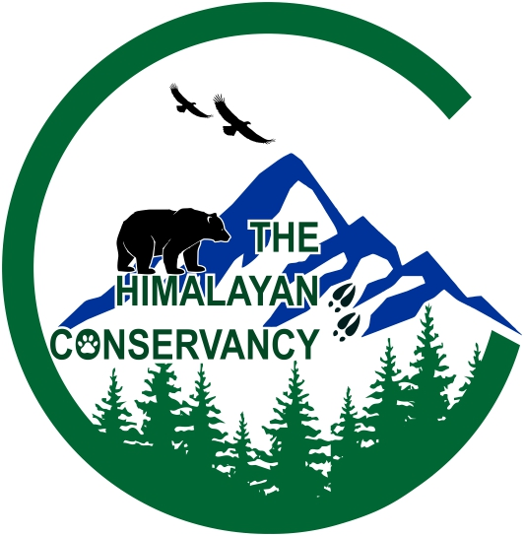

**Home About us Our projects Events News Resources Library Donate**

Hello from The Himalayan Conservancy

The Himalayan Conservancy is a non-governmental, non-political and not for profit organization registered under Social Welfare Council of the Nepal Government according to the Social Council Act, 1992. The organization is focused on wildlife research and conservation initiatives to sustain wildlife conservation throughout Nepal.

Our Vision

The vision of the Conservation Himalaya is to create a world where the diversity of life on Earth is conserved, protected, and valued. This involves ensuring that all species and ecosystems are able to thrive and evolve, and that the natural world is sustained for future generations.

Our Objectives

* Conduct research and monitor biodiversity to identify conservation needs
* Encourage biodiversity conservation and environment management
* Conduct awareness and educational outreach programs to inform about biodiversity conservation
* To evaluate the impact of climate change on wildlife and propose sustainable mitigation methods.
* Organize workshops, seminars, discussion forums to sustain biodiversity conservation

Explore Our Publications

About Us

Team members

What we do?

Our projects

Events

News

Resources

Library

Donate