# **Publications with R4TLI – Instructions to Authors**

### **Susan. B. Sumith, Micheal.P.Bore, Samuel.B.Corn**

**Abstract:** This guideline describes the requirements to be fulfilled by authors for preliminary consideration in publishing their articles with Research for Transport & Logistics Industry. A soft copy of this document could be obtained from the Institution website <www.ciltsl.com> or by e-mailing a request to [kumarage@sltnet.lk](mailto:kumarage@sltnet.lk), to be used as a basic template in structuring the prospective articles.

**Keywords:** Guideline, Transport, Logistics, template

**1. Introduction**

This paper is intended to serve the dual purpose of providing instructions to prospective authors and acting as a template for structuring the intended papers in the required format. Strict adherence to this format is a pre requisite for a paper to be considered.

# **2. General Information**

The paper must be an **Original** Technical Paper based on research by the author(s) on topics of direct local relevance under the following areas

* Airline Operations
* Airport Planning and Operations
* Consumer & Demand Studies for Mobility
* ERP Solutions for Transport & Logistics
* Economic Appraisal of T&L Projects
* Freight Transport
* ICT Solutions for Transport & Logistics
* Intermodal Transport
* Operations Management
* Port Planning and Operations
* Public Transport
* Safety in Mobility
* Shipping Operations
* Supply Chain Management
* Transport Planning
* Transport Policy and Regulation
* Urban Transport Planning
* Warehousing & Inventory Management

On matters regarding publications, decision of the Editor in consultation with the Editorial Board shall be final. Manuscripts **should not contain** any derogatory remark/s whatsoever about any person or organization.

* Presentation of the paper should be in **‘Third Person’**.
* A representative abstract of **not more than 300 words** should be provided as indicated above.
* It is expected that the **International System of Units (SI)** is used. If other units are used, relevant SI unit should be given within brackets or in a supplementary dual unit table.
* Name(s) and Contact details of Author(s) should be provided in the text box placed at the right hand bottom corner of the first page of the Paper.
* The soft copy may be submitted to [Log in to EasyChair for R4TLI 2016](https://easychair.org/conferences/?conf=r4tli2016) or e-mailed to [**ganga.s@sliit.lk**](mailto:ganga.s@sliit.lk)

# **3. Format**

***Eng. (Prof.) S. B. Sumith,***  *Int. PEng.(SL), C. Eng., FIE(SL), B.Sc. Eng. (Peradeniya), M.Eng. (MIT), Dr. Eng. (Tokyo), Professor of Civil Engineering, Department of Civil Engineering, The Open University of Sri Lanka.*

The Journal is published in standard **A4** size with a two-column layout for text. Diagrams and tables should be in portrait orientation with either one or two column width.

**3.1 Size of the Paper**

Size of the paper composed in the required format is limited to eight (8) pages. On special occasions this maximum may be waived on the discretion of the Editor.

**3.2 Font and Margins**

The Font for general text should be **‘Times New Roman’** with 10-point size. Main headings shall be with the same font of 12-point size, bolded while sub headings shall be 10-point size, bolded. Main and sub headings should be numbered in the manner adopted in this paper.

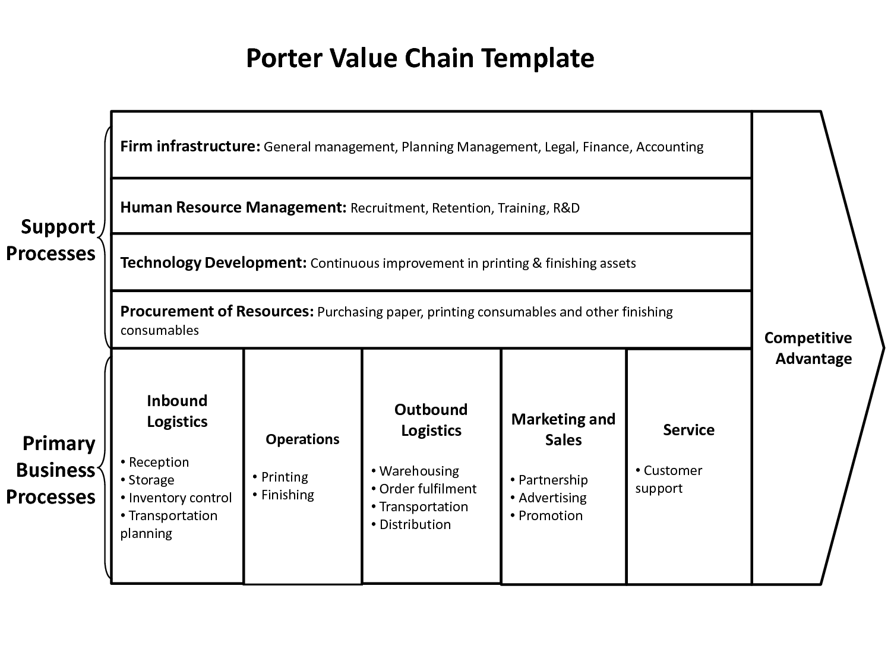Margins shall be 20 mm all around and an additional binding gutter of 10 mm on the appropriate edge (Mirror Margins). Width of a text column shall be 75 mm with a space of 10 mm in between.

**3.3 Headings and Order of Presentation**

The author is free to name headings according to the context and content of the paper. However, it is preferable to have main headings in the following order for consistency.

*Introduction*

*Literature Review*

*....*

*....*

*....*

*Conclusions*

#### References

*Acknowledgement (if any)*

References (all cited in main text) and Acknowledgement should not be given a paragraph number.

**3.4 Format Limitations**

Due to the adopted format, authors are advised not to use ‘headers’, ‘footers’ or ‘foot notes’.

# **4. Presentation**

For the message delivered by the article to be more effective, the text should be supplemented by ‘tables’, ‘figures’ ‘equations’ & ‘photographs’ as appropriate and references to other publications.

**4.1 Tables**

Tables should be either one or two column width in portrait orientation. Each table should be sequentially numbered and titled above its top. (e.g.: **Table 1 – Sri Lanka Population Rate**.)

**Table 1 – Sri Lanka Population Rate**

|  |  |
| --- | --- |
| **Year** | **Population Rate (%)** |
| 2000 | **8** |
| 2010 | **8.6** |

***Source- Abeykoon, 2001, Demographic trends among major ethnic groups in Sri Lanka***

**4.2 Figures and Photographs**

Figures and photographs should be either one or two column width in portrait orientation. Photographs should be preferably scanned (at 100 dpi in **.jpg** or **.tif** format) and sized before placement in the manuscript. Each figure should be sequentially numbered and titled below.

**Figure 1: Value Chain**

**4.3 Equations (Mathematical Expressions)**

Equations should be indented and separated from the text and identified by consecutive numbers placed at the far right side of the line within brackets.

{e.g.: F = 9C/5 + 32.... (3)}

**4.4 Citing References**

References should be cited within square brackets in the main text. (e.g.: [1], Wu et al. [2]) Formats for listing references vary according to the type of publication. Authors should therefore adhere to following formats given in the reference list (in Book Antiqua 9 pt.), which should be listed and numbered sequentially; Books [1], Journals [2], Conferences [3], and Internet references [4].

# **5. Conclusions**

It is expected that by complying with the simple guidelines presented in this paper, the authors would be able to present their research and professional articles in a logical and coherent manner so as to comply with internationally accepted standards.

# **Acknowledgement**

Author wishes to acknowledge the assistance given by the SLSTL in preparation of this guide.

# **References**

1. Andreas, R. & Matthias, H. (2006), “Co-located supplier clusters: forms, functions and theoretical perspectives”, International Journal of Operation & Production Management, Vol. 28. No. 1, pp. 55-73

2. Catalin, B. (2011), “Clusters Models, Factors and Characteristics”, International Journal of Economic Practices and Theories, Vol. 1 No. 1, pp. 36-38

3. Gardner, J.T. & Cooper, M.C. (2003), “Strategic supply chain mapping mapping approaches”, Journal of Business Logistics, Vol. 24, No. 3, pp. 37-64