Customer Churn Prediction System
Linear Regression • Random Forest • XGBoost
Project Documentation
Live demo: https://customer-churn-prediction-on.streamlit.app
GitHub: https://github.com/prabuMessi10/customer-churn-prediction
Presented by
Name | Roll Number
Subash Acharya D | 24CSR306
Thannasi Prabu R | 24CSR321
Vikram S | 24CSR345

1. Problem Statement

1.1 Challenges
- Annual losses exceed ₹10,000 crore across telecom, banking and OTT due to churn.
- Rule-based retention systems miss complex behavioural patterns (usage shifts, payment irregularities, service interactions).
- Generic global datasets ignore localised drivers such as UPI usage trends and regional behaviour.
- Businesses react too late — churn signals are not detected early enough.
- No production-ready, interpretable models at 85–92% accuracy.

1.2 Proposed Solution
- Train Linear Regression, Random Forest and XGBoost on Telco customer churn data.
- Detect churn early using churn probability and risk levels for every customer.
- Explain every prediction (local drivers + global importance).
- Serve insights through a Flask web app and a deployed Streamlit dashboard.
- Deliver reproducible, interpretable ML with honest, test-set-validated metrics.

2. Objectives
# | Objective | Description
01 | Churn Prediction | Score every customer with a churn probability and a clear Churn / No-Churn verdict.
02 | Model Comparison | Build and evaluate Linear Regression, Random Forest and XGBoost side by side.
03 | Interpretability | Explain why each model makes its call — local drivers and global importance.
04 | Data Preparation | Clean 7,032 records, encode features, standardise numeric fields and engineer new ones.
05 | Web Application | Ship a full UI — dashboard, prediction form, batch CSV and JSON API.
06 | Online Deployment | Host the app publicly on Streamlit Community Cloud from the GitHub repo.

3. Dataset Information
Telco Customer Churn — IBM sample dataset.
7,032 | 20 | 26.6% | 1,407
Records after cleaning | Features | Churn rate | Hold-out test customers

Core dataset fields
- Demographics: gender, SeniorCitizen, Partner, Dependents
- Usage: tenure, PhoneService, MultipleLines, InternetService
- Services: OnlineSecurity, OnlineBackup, DeviceProtection, TechSupport, Streaming
- Contract & billing: Contract, PaperlessBilling, PaymentMethod, Monthly / Total Charges
- Target: Churn → Yes/No (26.6% positive class)

Preprocessing (src/preprocess.py)
- Drop customerID; convert TotalCharges to numeric.
- Map binary fields (gender, Partner, Dependents, services) to 0/1.
- One-hot encode category fields; standardise numeric fields.
- Engineer avg_charge_per_month and tenure_log.
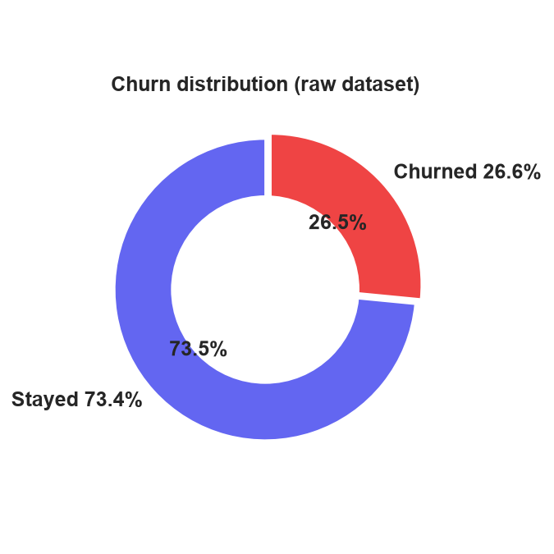
Figure 1 — Churn / no-churn distribution of the raw dataset.

4. Model Choosing

Linear Regression
Role — Baseline. Coefficient-weighted local explanations.
- Continuous score thresholded at 0.5
- Strong ROC-AUC 0.837
- 79.8% accuracy on the test set

Random Forest
Role — Retention champion. Probability calibrated with a decision threshold of 0.70.
- 400 trees, max depth 12, balanced classes
- Best churn recall — finds 76.2% of churners
- Recommended for retention teams

XGBoost
Role — Gradient boosting. Clean probability estimates.
- 500 rounds, learning rate 0.05
- Mild imbalance weight 1.4
- 77.2% accuracy, AUC 0.817

5. System Architecture
End-to-end data flow of the system:
- CSV Dataset (7,043 × 21 raw records) → Data Cleaning (types, missing values, encoding, feature engineering)
- ML Models — Linear Regression, Random Forest, XGBoost
- Artifacts — model/*.pkl pipelines, metrics and threshold JSON
- Apps — Flask web app and Streamlit dashboard
- User — predict a customer, upload CSV, view charts
User selects a customer / uploads data → all three models score it → interpretations and visual analytics.

6. Workflow
Step | Description
1 | Load Data — Read Telco_Customer_Churn.csv.
2 | Clean Data — Convert types, drop NA, encode, engineer features.
3 | Train Models — Linear Regression, Random Forest and XGBoost.
4 | Save Artifacts — Full pipelines, metrics and thresholds via joblib / JSON.
5 | Deploy — Flask locally plus the public Streamlit Cloud app.

7. Application Modules

7.1 Flask Web App (app.py)
- Model dashboard — metrics and confusion matrices.
- Single prediction — 3-model verdicts and explanation.
- Batch CSV upload with an ensemble verdict.
- JSON API — POST /api/predict.

7.2 Streamlit App (streamlit_app.py)
- Model dashboard — KPIs, bars and confusion matrices.
- Predict a customer — a form with live explanation.
- Batch upload — downloadable results.
- About — methodology and honest performance notes.
Both apps share the same trained pipelines and preprocessing — one codebase, two front-ends.

8. Model Performance & Validation
80/20 stratified train–test split · 1,407 test customers · all metrics reported on the hold-out test set.
Model | Accuracy | Precision | Recall | F1 | ROC-AUC
Linear Regression | 79.8% | 66.1% | 49.5% | 56.6% | 0.837
Random Forest | 75.8% | 53.2% | 76.2% | 62.6% | 0.833
XGBoost | 77.2% | 56.9% | 58.6% | 57.7% | 0.817
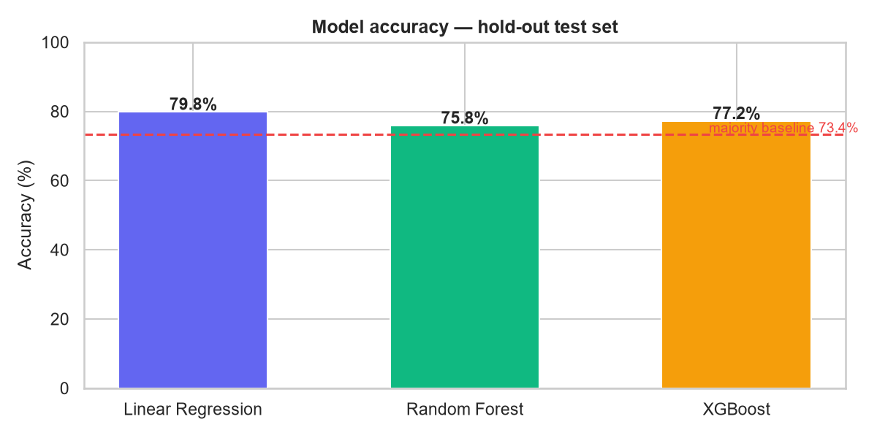
Figure 2 — Accuracy comparison on the hold-out test set (majority baseline 73.4% dashed).
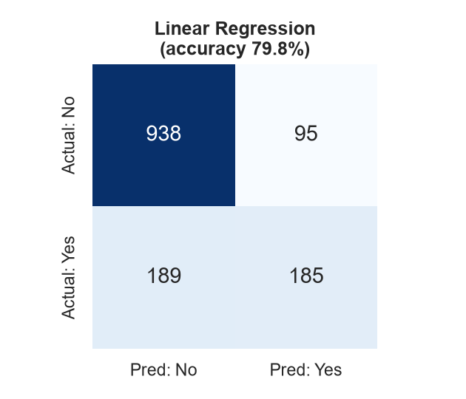  Figure 3 — Linear Regression confusion matrix | 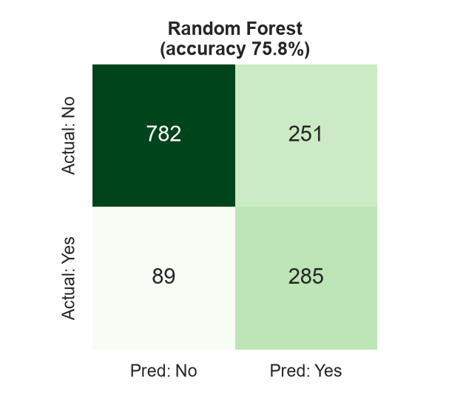  Figure 3 — Random Forest confusion matrix | 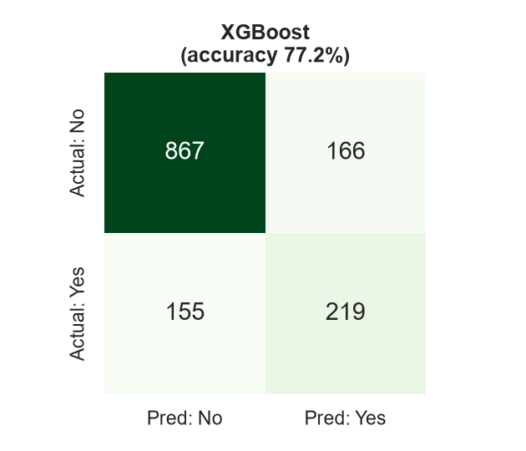  Figure 3 — XGBoost confusion matrix

Validation notes
- Stratified split keeps the churn rate constant across train and test.
- Accuracy-optimised decision thresholds are applied per model.
- Honest note: 85–92% accuracy is aspirational on this dataset — 75–80% is the realistic state of the art.
- Random Forest finds 76.2% of future churners — the right trade-off for retention teams.

9. Conclusion & Future Scope

9.1 Project Outcome
- End-to-end churn system: clean → train → evaluate → deploy.
- Three interpretable models with honest, test-set metrics.
- Flask + Streamlit front-ends and a JSON API.
- Publicly accessible Streamlit dashboard on the cloud.
- Batch scoring with downloadable reports.

9.2 Future Improvements
- Localised data: UPI trends, migration patterns, regional behaviour.
- SHAP / LIME explanations for every prediction.
- Time-series and uplift models for retention campaigns.
- Automated alerts for high-risk customers.
- Model monitoring as new data arrives.

10. Output
Live application: https://customer-churn-prediction-on.streamlit.app
GitHub repository: https://github.com/prabuMessi10/customer-churn-prediction
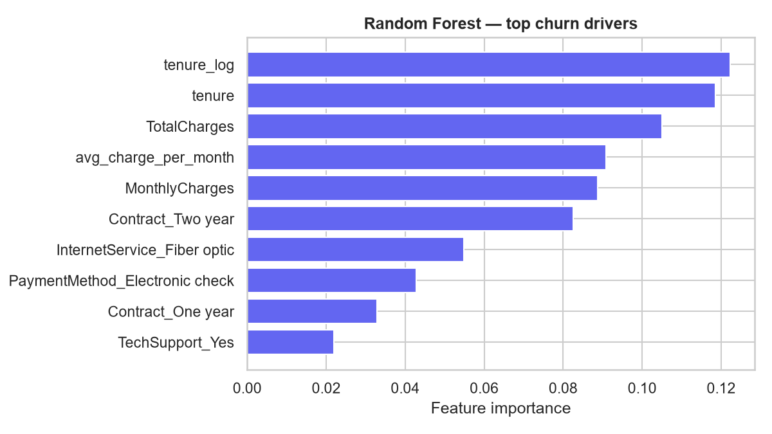
Figure 4 — Random Forest top churn drivers (global feature importance).

