Brain Tasks – DevOps Project Documentation

1. Overview
This project demonstrates a complete DevOps workflow using Docker, Amazon ECR, Amazon EKS, GitHub Actions, and CloudWatch Observability.

2. Architecture Diagram
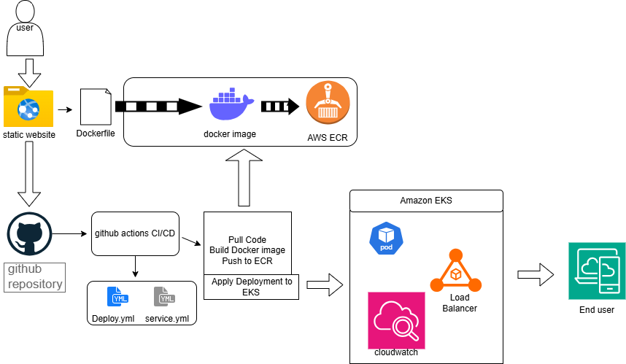
3. Worked Environment:
1. Linuxmint 22.2 xfce installed in virtualbox
2. Aws Freetire account
3. Browser

4. Tools Used
1. Docker
2.AWSCLI
3. Create Amazon ECR
4. Amazon EKS
5. GitHub Actions
6. CloudWatch
7. Kubernetes

5. Steps Performed
1. Created static website.
2. Dockerized the application.
3. Pushed image to Amazon ECR.
4. Created EKS cluster using eksctl.
5. Deployed application using Deployment & Service YAML.
6. Exposed LoadBalancer to access application.
7. Added CloudWatch Observability Add-on.
8. Optional Auto-deployment using GitHub Actions.

6. Kubernetes Deployment YAML
apiVersion: apps/v1
kind: Deployment
metadata:
name: brain-static-deployment
spec:
replicas: 2
selector:
matchLabels:
app: brain-static
template:
metadata:
labels:
app: brain-static
spec:
containers:
- name: brain-static
image: <ECR_URL>:latest
imagePullPolicy: Always
ports:
- containerPort: 80

7. Service YAML
apiVersion: v1
kind: Service
metadata:
name: brain-static-service
spec:
type: LoadBalancer
selector:
app: brain-static
ports:
- port: 80
targetPort: 80

8. Screenshots
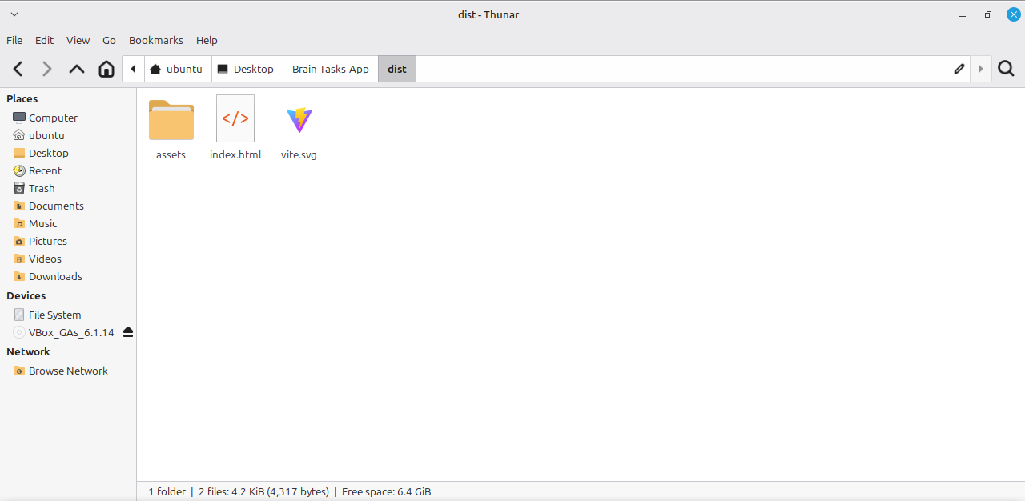
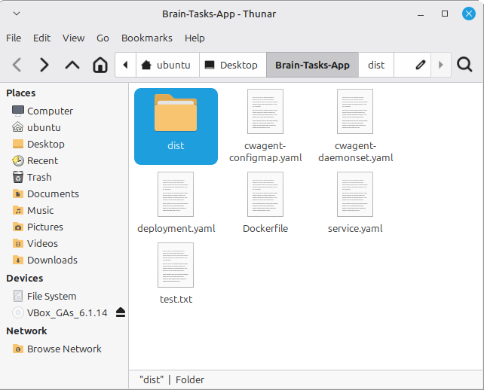

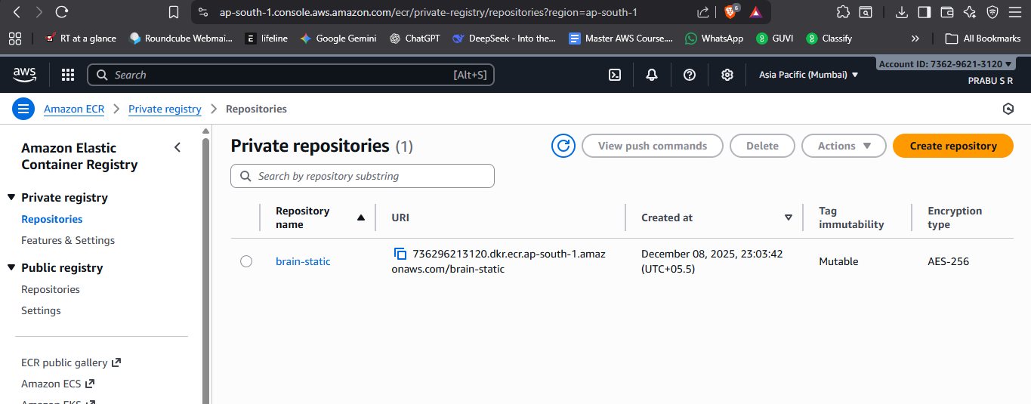
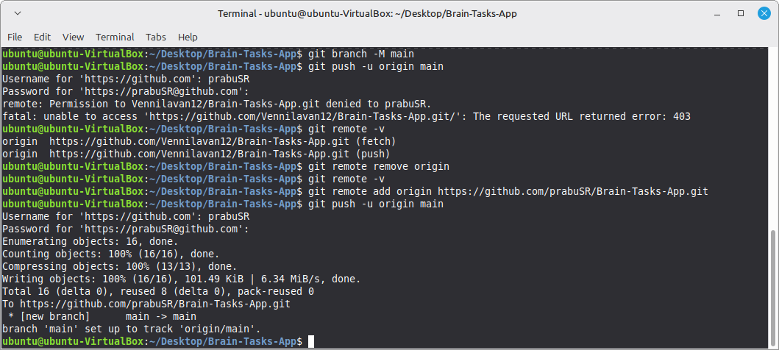
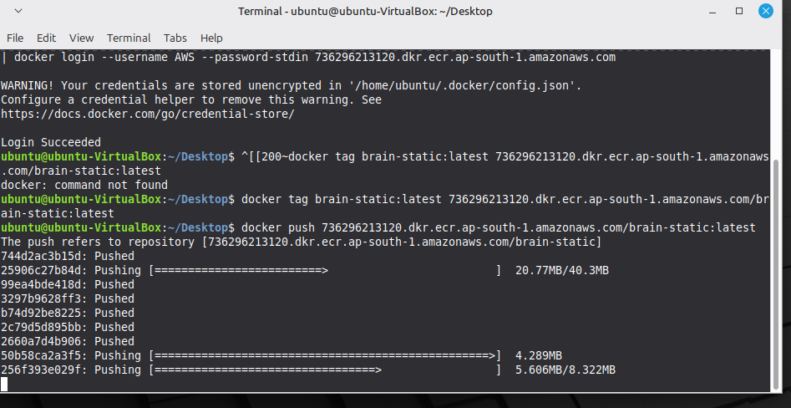

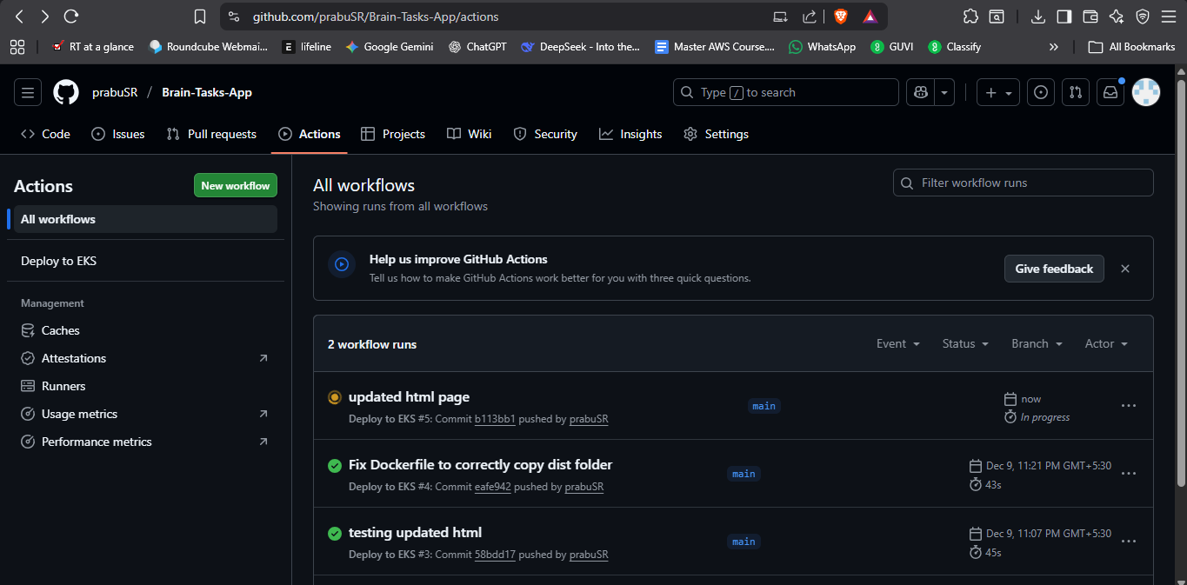

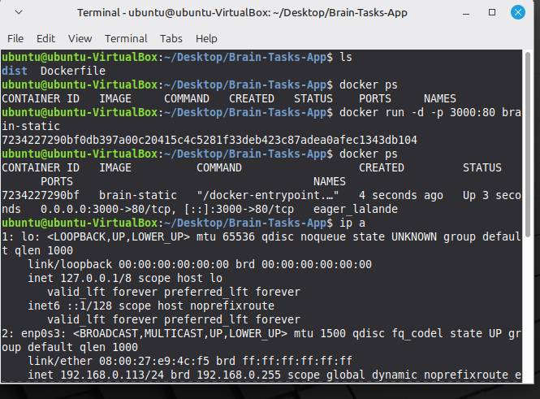
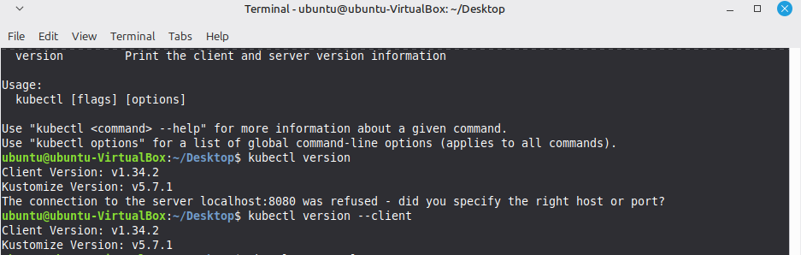
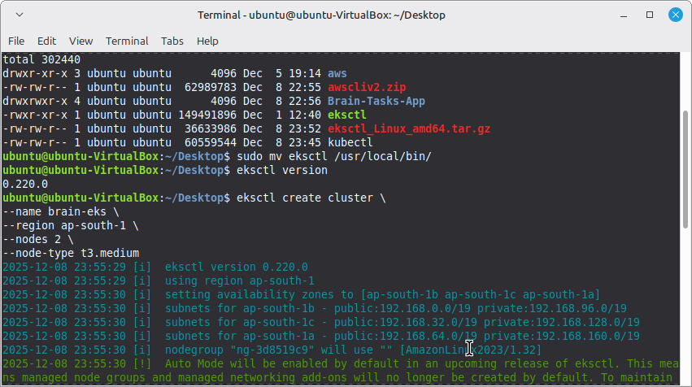
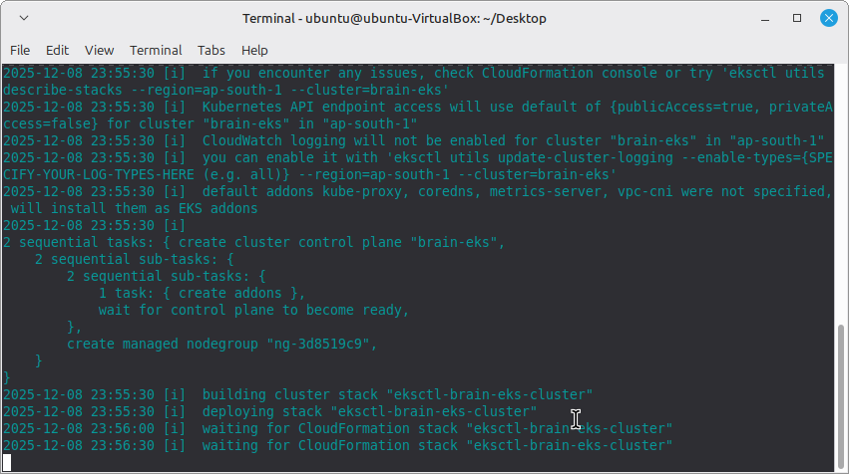

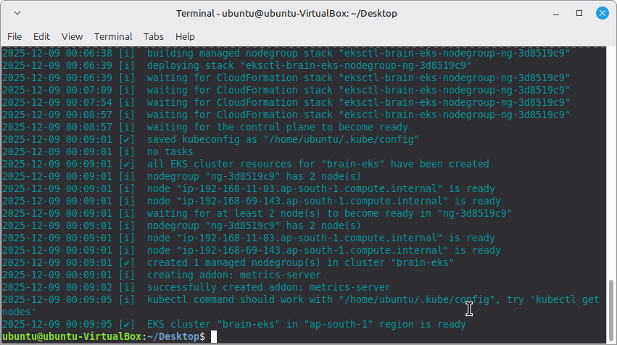
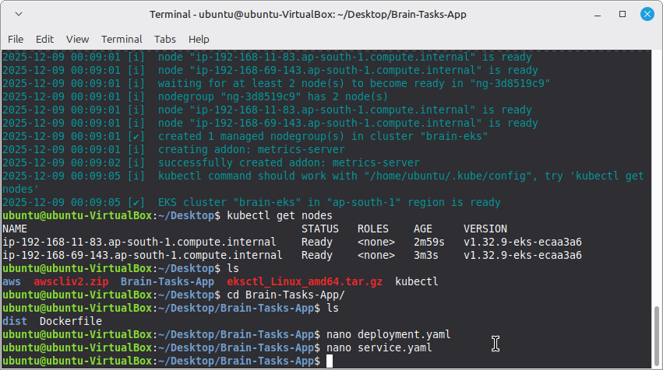

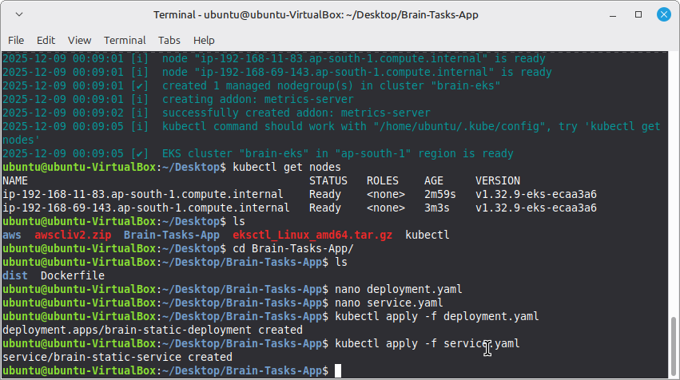
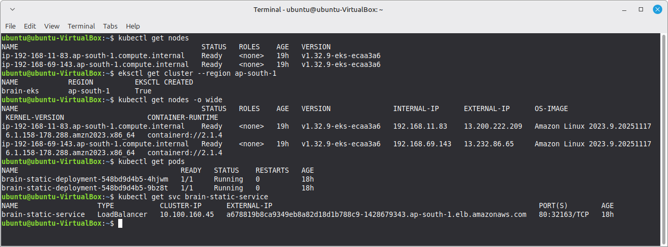

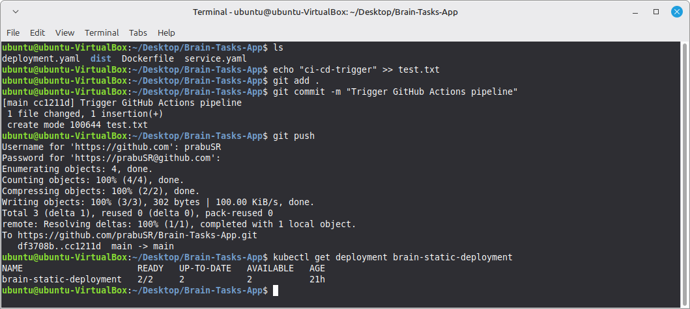
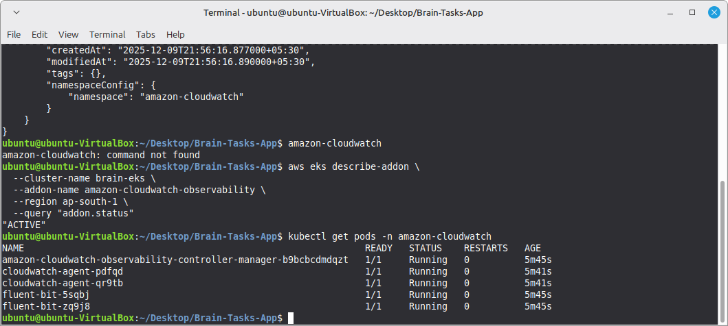
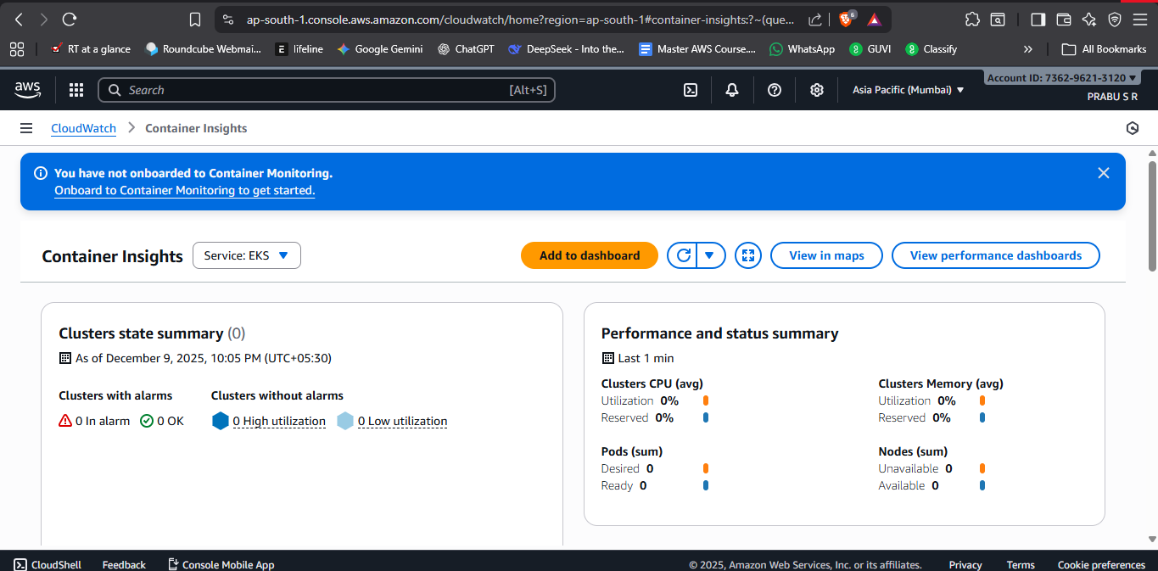
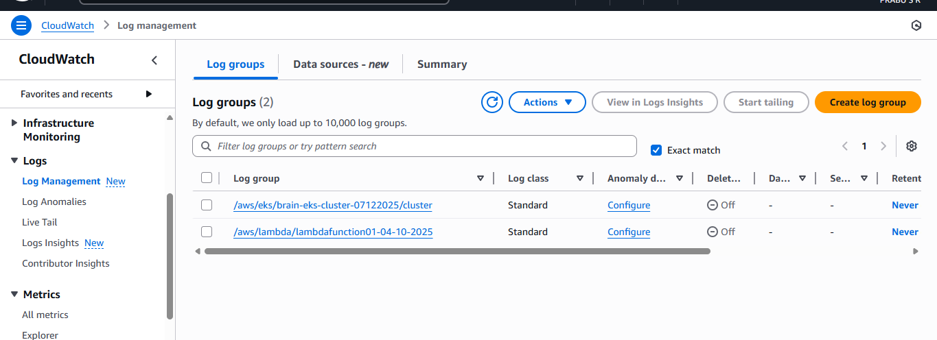

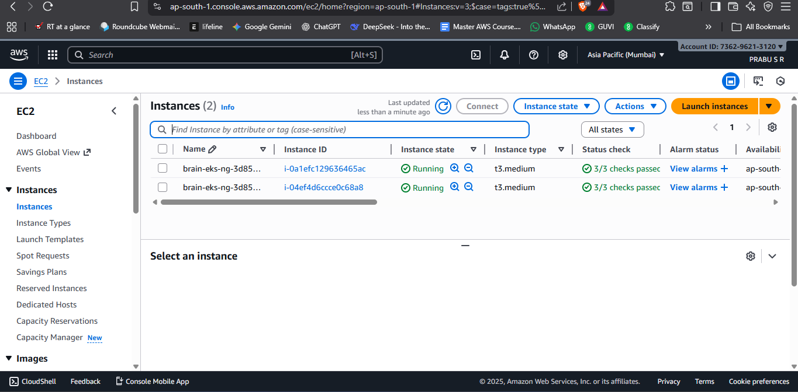
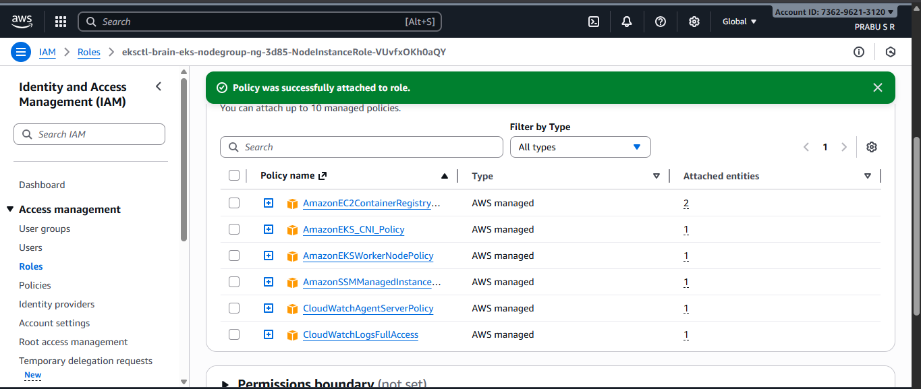
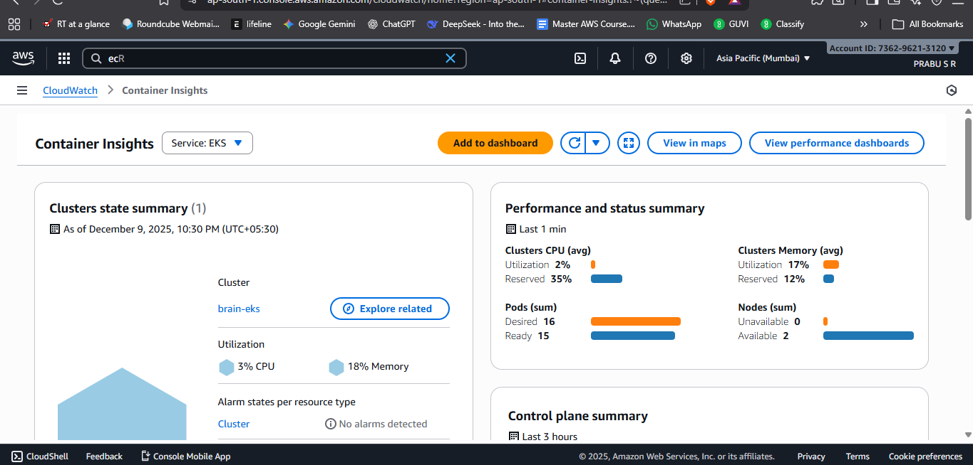

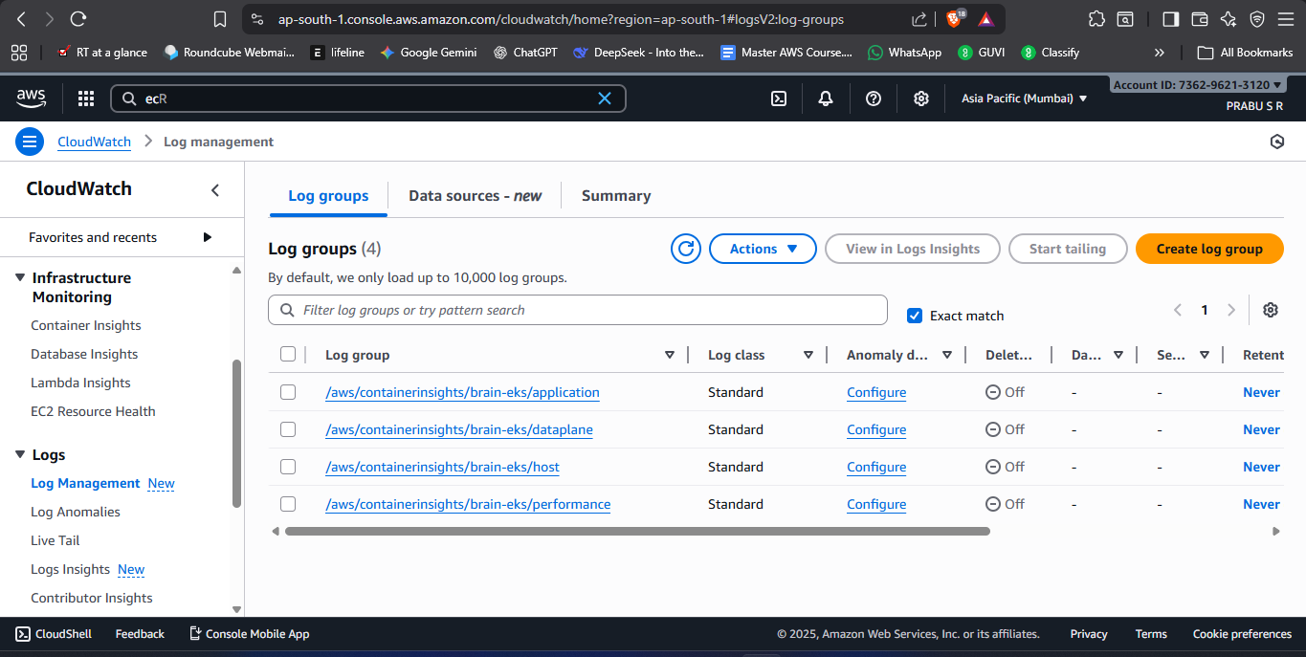
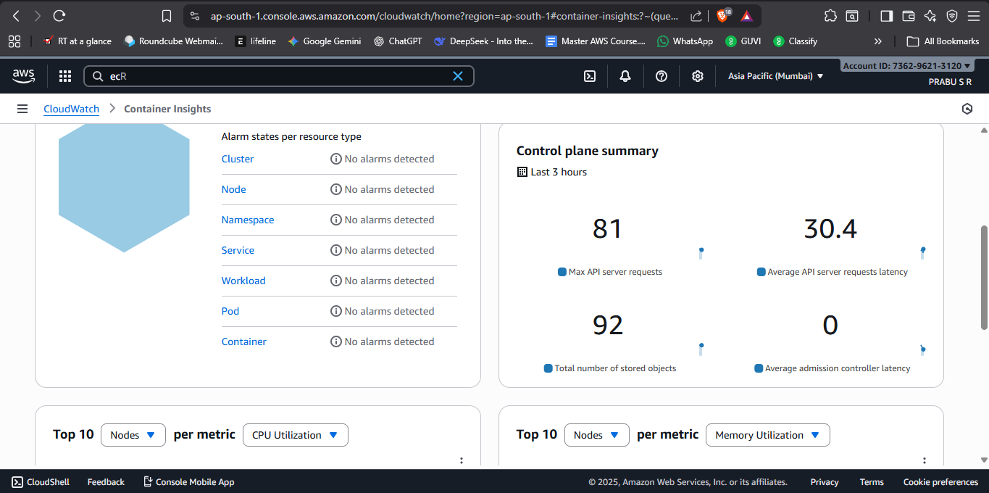

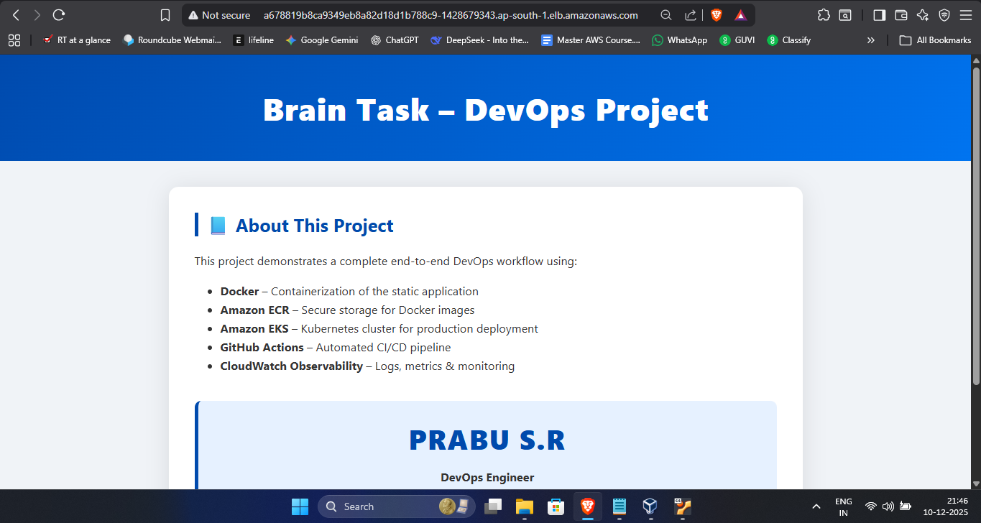
Project Conclusion:
This project successfully demonstrates a complete end-to-end DevOps pipeline for deploying a containerized static web application on Amazon EKS using a fully automated CI/CD workflow. Starting from local development, the application was Dockerized and integrated with GitHub Actions, enabling seamless and repeatable builds. Upon each code change, the pipeline automatically builds a new Docker image, pushes it to Amazon ECR, and updates the deployment running in the EKS cluster.
The system implements core DevOps principles, including automation, scalability, observability, and container orchestration. Kubernetes ensures reliable workload distribution through replica sets and provides high availability using the LoadBalancer service. With Amazon CloudWatch integrated, logs and performance metrics from the cluster are continuously monitored, offering insights into application health and cluster performance.
By completing this project, the full lifecycle of modern cloud-native application deployment is demonstrated—from coding, containerization, CI/CD automation, and image versioning, to Kubernetes orchestration and monitoring. The final setup ensures that any new code pushed to GitHub results in an automated, zero-downtime deployment, allowing end users to always access the latest version of the application.
Overall, the project achieves a production-ready deployment workflow and reflects real-world DevOps practices widely used in the industry today.

