1. ***What is an ideal use case of creating a static inner class in Java?***
2. ***What are the advantage and disadvantage of using static factory methods instead of constructors?***

1.

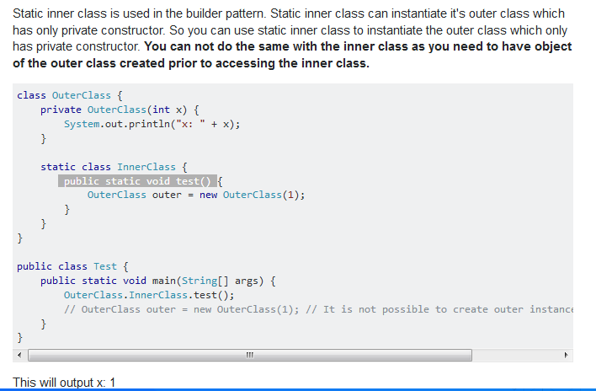

2.

**Advantage:**

1. static factory methods have names unlike constructors.

* a static factory with a well-chosen name is easier to use and the resulting client code easier to read.

1. Unlike constructors, static factory methods are not required to create a new object each time they’re invoked.

* Allow instance controlled class.

1. Unlike constructors, static factory method can return an object of any subtype of their return type. - This can return objects without making their classes public.

**Disadvantage:**

The main limitation of providing only static factory methods is that classes without public or protected constructors cannot be sub-classed.

1. ***What is the use case of creating a builder pattern?***
2. ***Can we instantiate a static inner class?***
3. ***What is the importance of AccessibleObject.setAccessible(true) method in Java API?***

3.

Consider a builder when faced with many constructor parameters.

4.

Static nested classes are themselves **not static** at all. In java, no class is static. Static keyword in static nested classes implies that it is another static member of the outer class. But it is just another raw class . That is why we can instantiate this class.

5.

A privileged client can invoke the

private constructor/method reflectively with the assistance of the **AccessibleObject.setAccessible method**.

