Cassandra KeySpaces, Tables and Columns:

In Cassandra, the top level data structure is the Keyspace. This is like a schema in relational databases. Keyspaces are logical containers for tables, indexes, and other data structures.

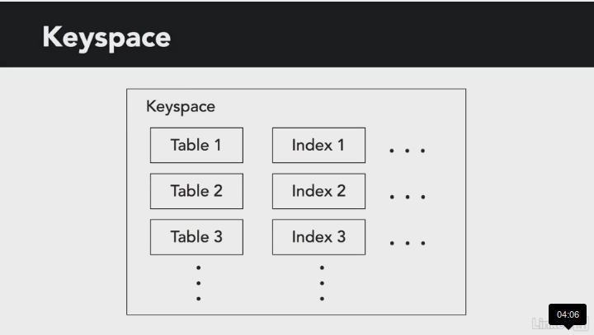
When you define a keyspace, you also define a replication strategy. This determines how replicas of data are made. Remember, replicas are an important, high availability feature of Cassandra.

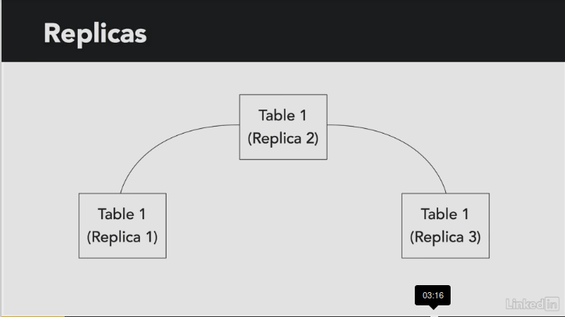

The simple replication strategy is used to set a number of replicas when all nodes will be in a single data center.


The simple replication strategy is used to set a number of replicas when all nodes will be in a single data center.



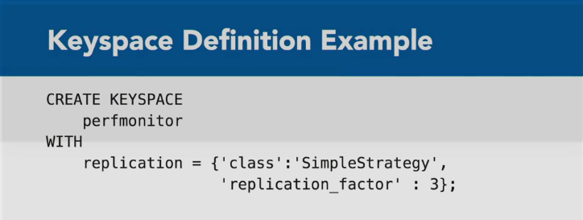

Once we have our keyspace defined, we can define a table using the CREATE TABLE command. We'll need to define our table name and a set of columns.
Let's assume we want to keep track of performance monitoring statistics in a Cassandra table, which we'll call App_Instance. We'll include columns for attributes about each application instance that we'd like to track. In this example, let's track several attributes, including the application's name, the ID's of its process and the host on which it runs, the operating system priority, as well as some measures, such as CPU time, and the number of IO operations.

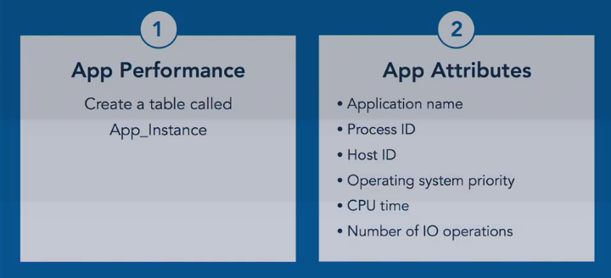

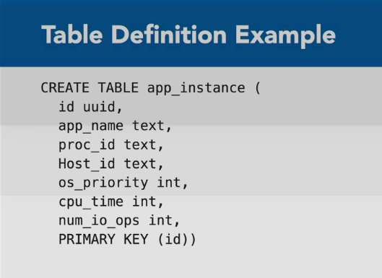

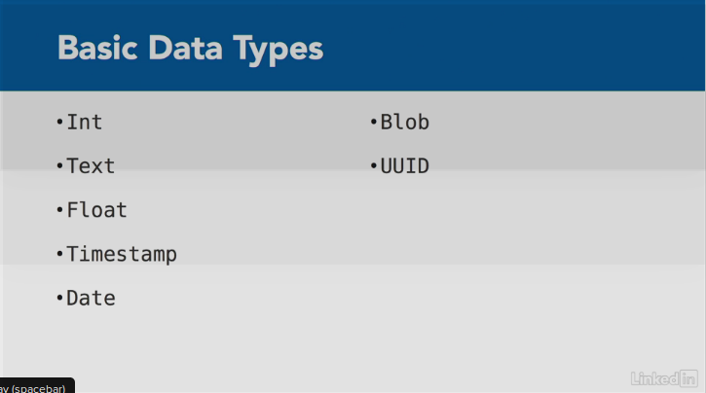

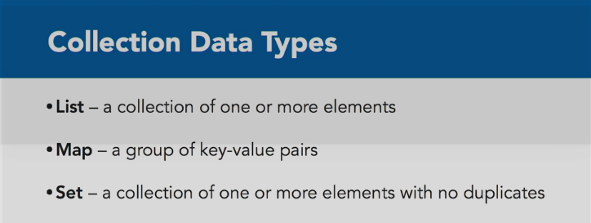

For example, you might want to change your app_instance table to store the average, minimum, and maximum, OS priority over some period of time, such as the last 10 minutes.
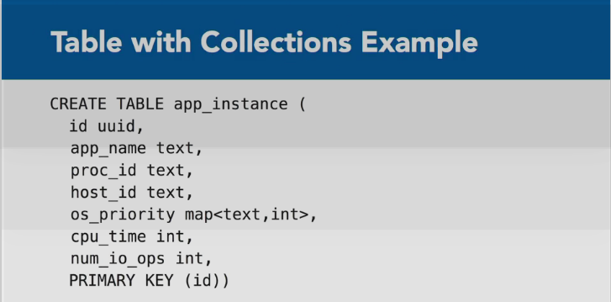
We can do this by specifying a collection, called os_priority, in which we will store three pairs. The string average, followed by the average value, the string minimum, followed by the minimum value, and maximum, followed by the maximum value.

Cassandra Primary Keys, Partitions and Secondary Indexes:

An important consideration in data modeling is selecting the appropriate primary key. The key will uniquely identify a row, but it will also limit how we can retrieve rows.
For example, we'll assume that the process ID and host ID uniquely identify an application instance.

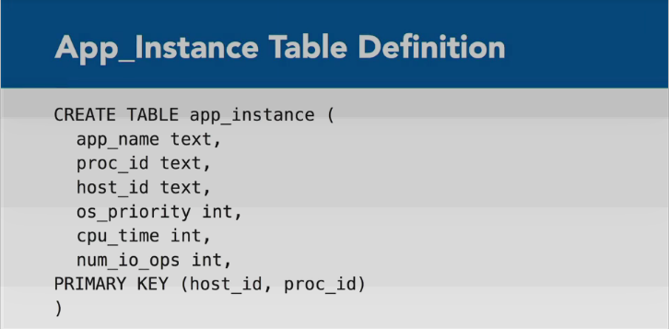

You'll notice the first attribute in the primary key is host ID. This is because the first attribute specified in the primary key list is used as the partition key, which determines which node the row is stored on. The rest of the primary key is used as the clustering key, which determines how data is ordered on the disk.
Also We need to choose our primary keys carefully because they are used to retrieve data using select statements. When we query a table and specify a where clause, we have to use columns in the primary key, or a secondary index, which we'll discuss in a moment.
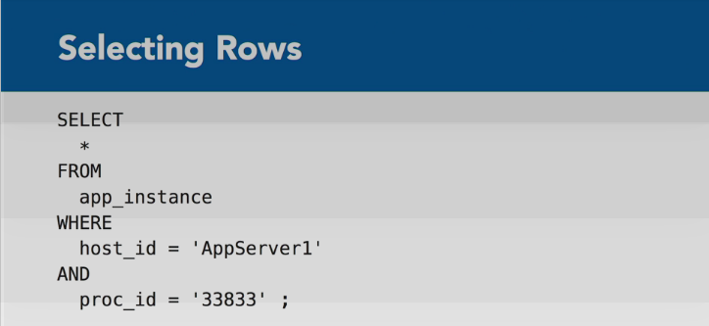
Valid Query:
Cassandra gives us the option to change the default sort order of rows on the disk, but we have to do this when we create tables.

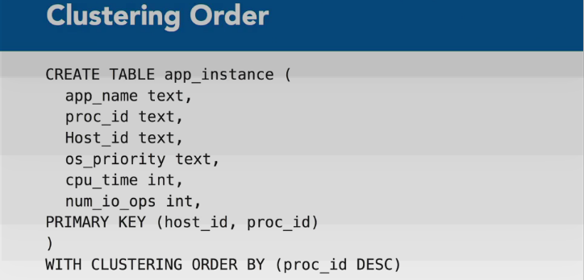
Here's an example of ordering by process ID in descending order. Cassandra does not provide a mechanism to sort query results at query time, so we have to consider sort order when creating a table. Let's look at an example of a five node cluster. A row of data is inserted with host ID equal to AppServer1 and process ID equal to 38383. Host ID is the partition key in this example. That means Cassandra will map each host ID to a node in the cluster. It does this using a hash function.
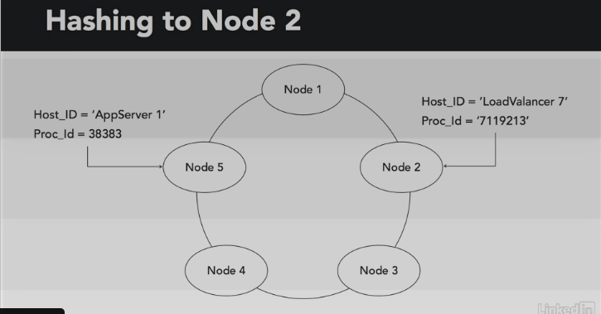
In this example, the host ID is mapped to Node 5. Another row of data with host LoadValancer 7 is mapped to Node 2. Within each node, the data is written to the Cassandra table in descending order of process ID.
Benefit of Primary Key: Knowing the primary key value allows us to look up data efficiently.
Sometimes, however, we want to look up by other values. So, for example, if we tried to run this below query, we'll actually get an error message.

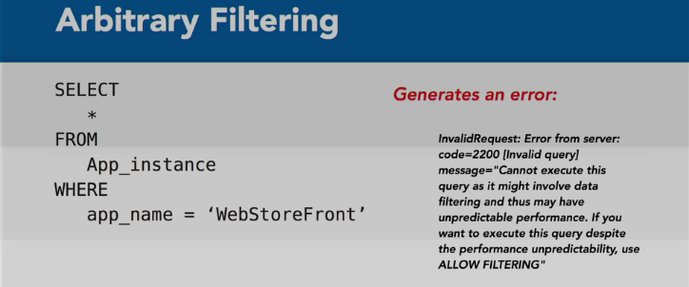
Now, if you really want to do this, you can add another clause called ALLOW FILTERING to your query.
But again, that may lead to unpredictable results. Now, Cassandra could spend a lot of time and CPU resources scanning large tables with a query like that. We can help Cassandra filter data by the app name by using a secondary index. We can create an index ON app name using the following command.
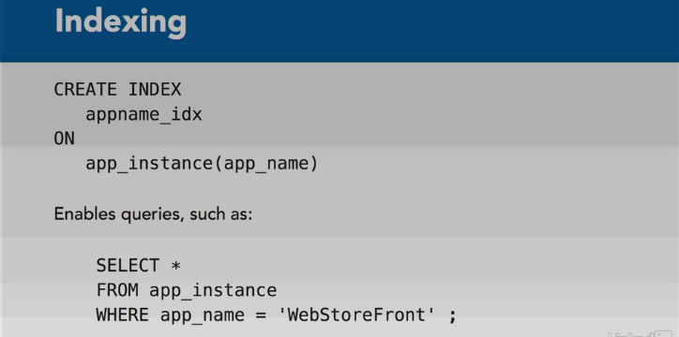

We have to be careful when using secondary indexes. It is important not to use secondary indexes on columns with very low or very high numbers of unique values.

Cassandra Clusters:

When designing Cassandra data models, it helps to understand how data is organized on a single node and across nodes. We've talked about how the clustering key and the partition key are used when querying. Now, let's look at how they're used when we write data to the cluster.

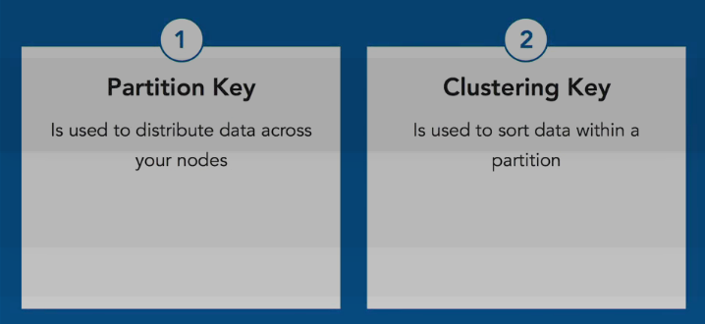
In this example, we have a cluster of five nodes. All nodes perform the same kinds of operations and can communicate with other nodes. There's no distinction between master and worker nodes in Cassandra. All nodes run the same services.
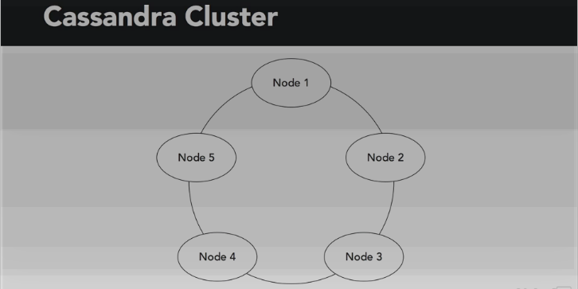
A partitioner is a hash function that maps from the partition key to a node in the cluster. The default partitioner keeps data evenly distributed across nodes and is generally a good choice. The partitioner is designed to minimize the amount of data that has to be moved when a node is added or removed from the cluster. This type of hash function is called a consistent hash function. When data is written to a node, replicas are created. The number of replicas and the placement of replicas will depend on the cluster's configuration.

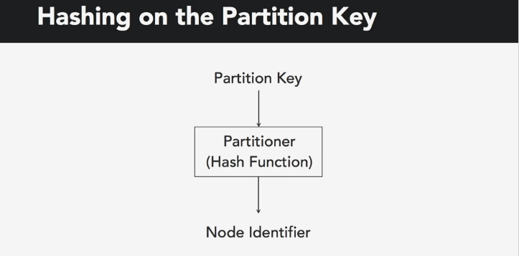

We specify a replication strategy and the number of replicas when we create a key space. Tables in that key space will use that strategy and replication factor. When the simple replication strategy is used, the replicas are placed on the next nodes in the ring. This works well with small clusters.
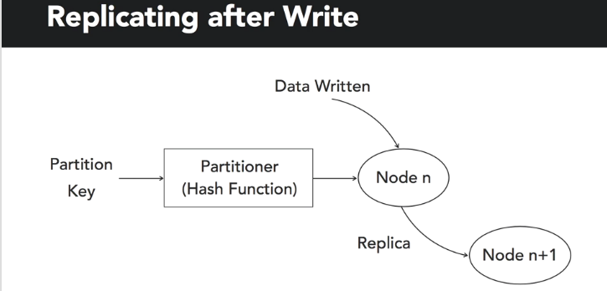
Large clusters, especially those that span multiple data centers, can use the network typology strategy to take into account the rack and the data center locations of various nodes. This way replicas can be placed on nodes in different racks and different data centers, thus improving the fault tolerance and availability of the cluster.
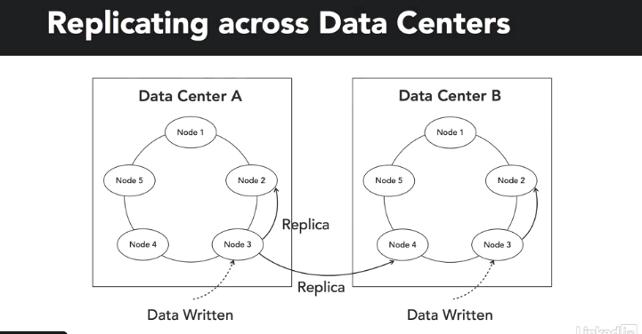
Creating a KeySpace in Tables:

