The Cassandra Query Language

Cassandra uses a special primary key called a composite key to represent wide rows, also called partitions. The composite key consists of a partition key, plus an optional set of clustering columns.

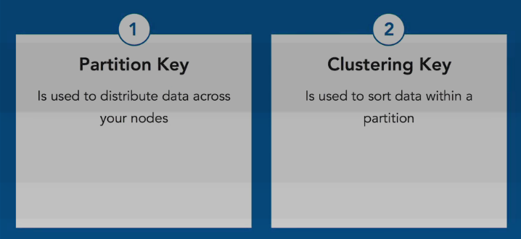
Note: A partitioner is a hash function that maps from the partition key to a node in the cluster.

Static Column: A normal column is stored within the clustering key, within the partition. This column

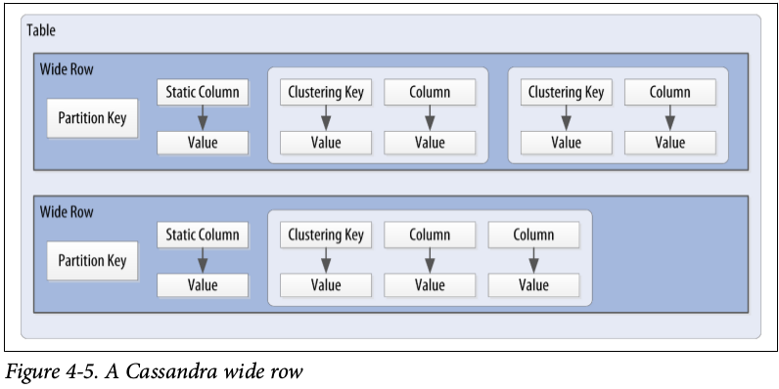

has a value for every combination of partitioning key and clustering key. A static column resides one level higher, directly within the partition key. Therefore, A static column is a special column that is shared by all the rows of the same partition. Let's take an example: suppose that we want to store per-user bills that needs to be paid and keep a per-user balance amount of what remains to be paid. The invariant we want to maintain is that the balance is always the sum of all unpaid bills:

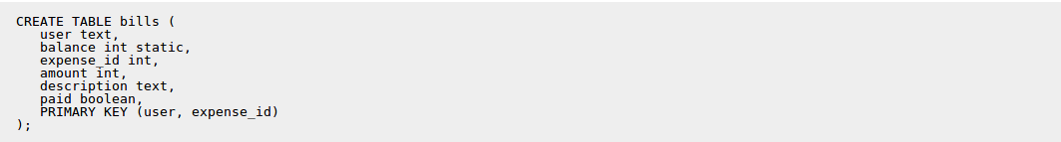

Because the balance is static, we will only have one balance for each user in practice, no matter how many bills a user have. We can then insert a few expenses:

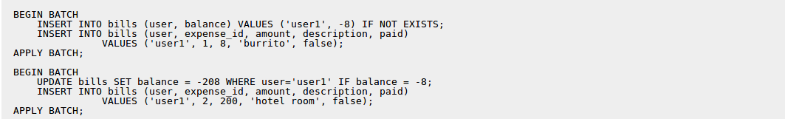

Note that we are allowed to update a static column in a statement that only provide the partition key, which wouldn't be correct for a normal column (since the primary key contains a clustering column). Also note that due to the use of (batched) conditional updates, we guarantee that the balance will always correspond to the amount due for the unpaid bills. This wouldn't be possible if the balance was stored in a separate table since a batch with conditional updates cannot span multiple partitions. At that point we will have:

Note that both rows share the same balance. I would then be possible to pay a bill with:

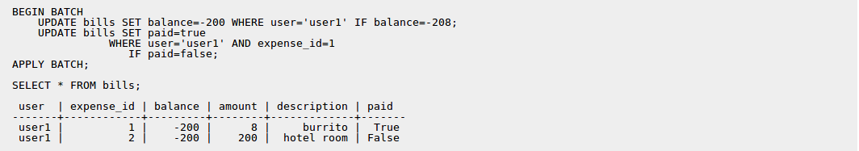

This example is just one use of static columns, but they can be more generally used for optimizations, when you want to store some per-partition "static" information alongside clustered rows and still want to be able to query both of those with a single SELECT.

Please note that:
- only columns not part of the PRIMARY key can be static.
- only tables with at least one clustering column can have static columns (a table with no clustering column has only one row per partition and as such all columns are already static by construction).
- tables with the COMPACT STORAGE option cannot have static columns.
Basic Cassandra data structures:

• The cluster, which is a container for keyspaces that spans one or more nodes. As previously mentioned, the Cassandra database is specifically designed to be distributed over several machines operating together that appear as a single instance to the end user. So the outermost structure in Cassandra is the cluster, sometimes called the ring,
• The keyspace, which is a container for tables.
• The table, which is a container for rows
• The row, which is a container for columns referenced by a primary key
• The column, which is a name/value pair

What is Timestamps?

Each time you write data into Cassandra, a timestamp is generated for each column value that is updated. Internally, Cassandra uses these timestamps for resolving any conflicting changes that are made to the same value. Generally, the last timestamp wins.

We can view the generated timestamp value using writetime() function to our SELECT command like below.

cqlsh:my_keyspace> SELECT first_name, last_name,writetime(last_name) FROM user;

Note: We’re not allowed to ask for the timestamp on primary key columns.

Cassandra also allows us to specify a timestamp we want to use when performing writes. To do this, we’ll use the CQL UPDATE command for the first time. We’ll use the optional USING TIMESTAMP option to manually set a timestamp.

Use case of manually set timestamp in Cassandra:

Setting the time-stamp is not required for writes. However, this functionality is typically used for writes in which there is a concern that some of the writes may cause fresh data to be overwritten with stale data (e.g. from a test data load process triggered automatically). This is advanced behavior and should be used with caution.

What is Time to live (TTL)?

One very powerful feature that Cassandra provides is the ability to expire data that is no longer needed.
- The TTL value defaults to null , meaning that data that is written will not expire.
- TTL is stored on a per-column level.
- As with the timestamp, there is no way to obtain or set the TTL value of a primary key column.

Performance - TTL vs Deleting a row in Cassandra?
Deleting rows from Cassandra table need to run Job which may cause heavy load on the existing system. Whereas using TTL, we can automatically delete column values those are not required anymore. Therefore, performance wise, TTL is better approach.
Special CQL Types:
How can we specify ENUM values on Cassandra?
While enumerated types are common in many languages, there is no direct equivalent in CQL. A common practice is to store enumerated values as strings. For example, using the Enum.name() method to convert an enumerated value to a String for writing to Cassandra as text, and the Enum.valueOf() method to convert from text back to the enumerated value.
Which data types in Cassandra can be used as Identity Data Types?Among them which one is the best in terms of uniqueness?

- Timestamp
- date , time
- uuid
- timeuuid [Only timeuuid can guarantee the uniqueness ]
When to use Blobs in a Cassandra (and CQL) table and what are blobs exactly?
1. Blobs (Binary Large Objects) are the solution for when your data doesn't fit into the standard types provided by Cassandra. For example, say you wanted to make a forum where users were allowed to upload files of any type. To store these in Cassandra you would use a Blob column (or possibly several blob columns since you don't want individual cells to become to large).
2. Another example might be a table where users are allowed to have a current photo, this photo could be added as a blob and be stored along with the rest of the user information.
3. a use-case in which you receive properties in run-time from client in JSON.
{ ..., "pname" : "country", "value" : "USA", "ptype" : "String" }
{ ..., "pname" : "gdp", "value" : 7.4 , "ptype" : "double"}
For this use case, pvalue can be used as blob because application receive properties of different data type from client in run time. It is good practice to insert ascii, bigint, boolean, decimal, double, float, inet, int, timestamp, timeuuid, uuid, varchar, varint into blob field. It's also memory efficient to insert double or int as blob, it will take only 32 bit for int and 64 bit for double.

Counter Data Type:
Cassandra is one of the few databases that provides race-free increments across data centers. Counters are frequently used for tracking statistics such as numbers of page views, tweets, log messages, and so on.

Procedure:
1. Create a keyspace. For example, on Linux create a keyspace for use in a single data center having a replication factor of 3. Use the default data center name from the output of the nodetool status command, for example datacenter1.
2. Create a table for the counter column.
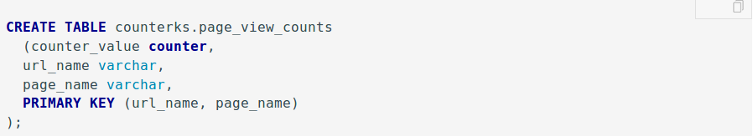

3. Load data into the counter column.

4. Take a look at the counter value.
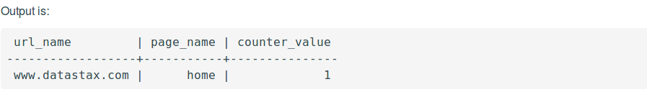

5. Increase the value of the counter.
6. Take a look at the counter value.

Note:
- Counter columns do not exist with non-counter columns, so every other column in the table should be a primary key/clustering keys.
- A counter column cannot be indexed or deleted.
- To load data into a counter column, or to increase or decrease the value of the counter, use the UPDATE command. Cassandra rejects USING TIMESTAMP or USING TTL when updating a counter column.
- To create a table having one or more counter columns, use CREATE TABLE to define the counter and non-counter columns. Use all non-counter columns as part of the PRIMARY KEY definition.
- You cannot create an index on a counter column or set data in a counter column to expire using the Time-To-Live (TTL) property.
- To generate sequential numbers for surrogate keys, use the timeuuid type instead of the counter type.

Collections Data Type:
set:
The set data type stores a collection of elements. The elements are unordered,
but cqlsh returns the elements in sorted order.
Note: If we do not use concatenation, adding the second element in the collection will replace the first content. We can add multiple elements without replacing the whole set by using concatenation:

List:
The list data type contains an ordered list of elements. By default, the values are stored in order of insertion.
Map:
The map data type contains a collection of key/value pairs. The keys and the values can be of any type except counter.

User Defined Types:
Use Case:
I am planning to use a Java object as a custom type and store it Cassandra. I am taking out 2 data members from the class and making them into primary key and keeping the rest of the data members in the custom type.
data members of my class:
- name,
- date_of_birth,
- occupation,
- last_visit,
- total_income
primary key:
- name,
- date_of_birth
Cassandra custom type members:
- occupation,
- last_visit,
- total_income
Will the custom data type have any performance benefits while writing or reading when compared to storing the individual data members in terms of Cassandra data types.
Answer:
Not really. Data for user defined types (UDTs) is stored in a single column in the row, and that should be a faster read than multiple individual columns. But whatever performance gain you achieve there will quickly be erased as the data is serialized for the result set. While CQL will allow you to read individual fields of the UDT if you desire, Cassandra still has to read all contents of that column regardless.
It is important to note that user defined types are not about improving performance. They're about offering the flexibility to achieve small amounts of denormalization.

Secondary Indexes:
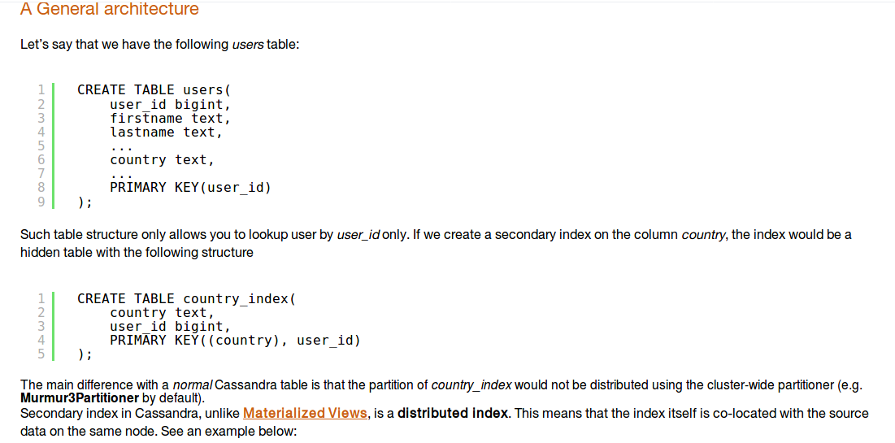
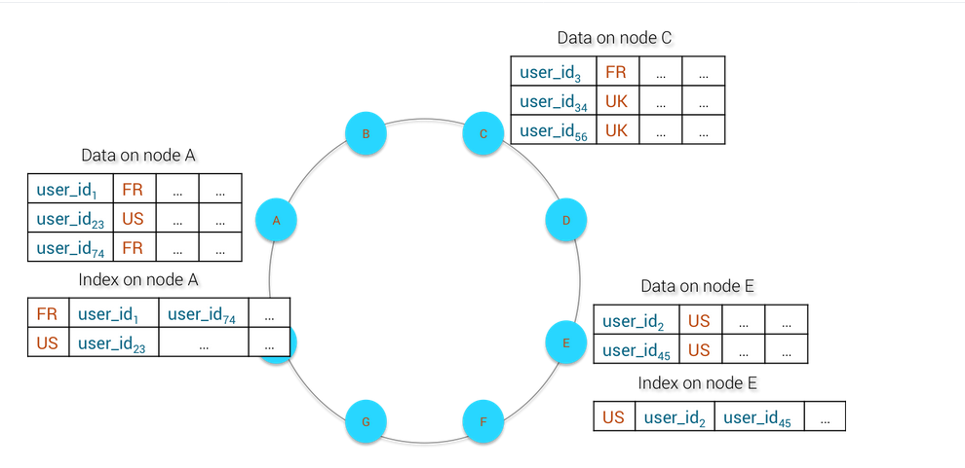

What’s the problem with secondary indexes?

So, let’s say you’re running Cassandra on a ring of seven machines, with a primary index of user IDs and a secondary index of user countrys. If you were to query for a user by their ID—or by their primary indexed key—any machine in the ring would know which machine has a record of that user. One query, one read from disk. However to query a user by their country—or their secondary indexed value—each machine has to query its own record of users. One query, seven reads from disk. By either scaling the number of users system wide, or by scaling the number of machines in the ring, the noise to signal-to-ratio increases and the overall efficiency of reading drops - in some cases to the point of timing out on API calls. This is a problem.

