The Cassandra Query Language

Cassandra uses a special primary key called a composite key to represent wide rows, also called partitions. The composite key consists of a partition key, plus an optional set of clustering columns.

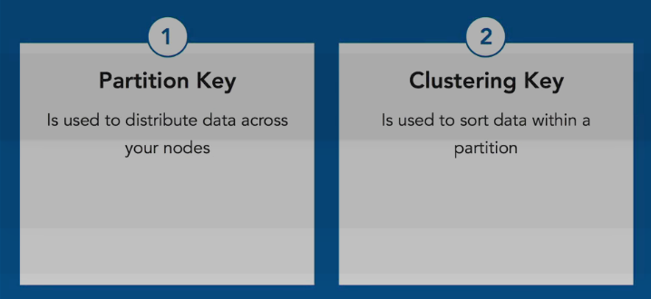
Note: A partitioner is a hash function that maps from the partition key to a node in the cluster.

Static Column: A normal column is stored within the clustering key, within the partition. This column

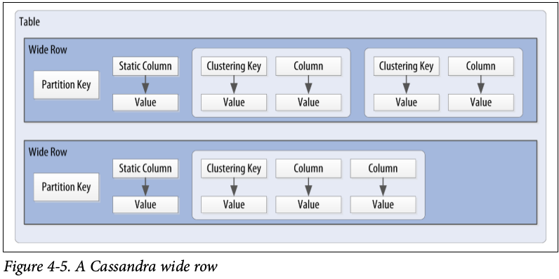

has a value for every combination of partitioning key and clustering key. A static column resides one level higher, directly within the partition key. Therefore, A static column is a special column that is shared by all the rows of the same partition. Let's take an example: suppose that we want to store per-user bills that needs to be paid and keep a per-user balance amount of what remains to be paid. The invariant we want to maintain is that the balance is always the sum of all unpaid bills:

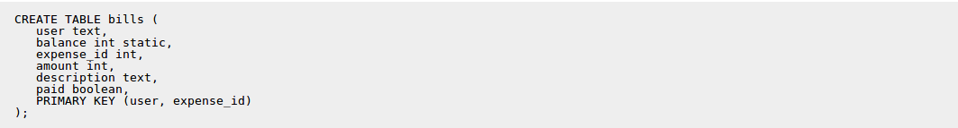

Because the balance is static, we will only have one balance for each user in practice, no matter how many bills a user have. We can then insert a few expenses:

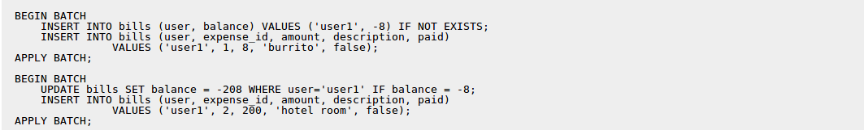

Note that we are allowed to update a static column in a statement that only provide the partition key, which wouldn't be correct for a normal column (since the primary key contains a clustering column). Also note that due to the use of (batched) conditional updates, we guarantee that the balance will always correspond to the amount due for the unpaid bills. This wouldn't be possible if the balance was stored in a separate table since a batch with conditional updates cannot span multiple partitions. At that point we will have:

Note that both rows share the same balance. I would then be possible to pay a bill with:

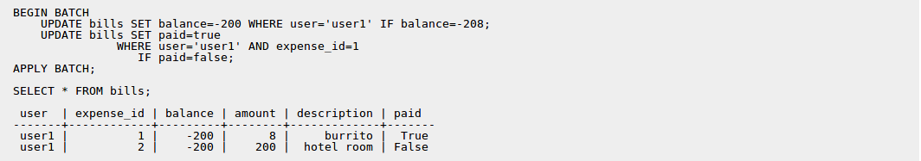

This example is just one use of static columns, but they can be more generally used for optimizations, when you want to store some per-partition "static" information alongside clustered rows and still want to be able to query both of those with a single SELECT.

Please note that:
- only columns not part of the PRIMARY key can be static.
- only tables with at least one clustering column can have static columns (a table with no clustering column has only one row per partition and as such all columns are already static by construction).
- tables with the COMPACT STORAGE option cannot have static columns.
Basic Cassandra data structures:

• The cluster, which is a container for keyspaces that spans one or more nodes. As previously mentioned, the Cassandra database is specifically designed to be distributed over several machines operating together that appear as a single instance to the end user. So the outermost structure in Cassandra is the cluster, sometimes called the ring,
• The keyspace, which is a container for tables.
• The table, which is a container for rows
• The row, which is a container for columns referenced by a primary key
• The column, which is a name/value pair

What is Timestamps?

Each time you write data into Cassandra, a timestamp is generated for each column value that is updated. Internally, Cassandra uses these timestamps for resolving any conflicting changes that are made to the same value. Generally, the last timestamp wins.

We can view the generated timestamp value using writetime() function to our SELECT command like below.

cqlsh:my_keyspace> SELECT first_name, last_name,writetime(last_name) FROM user;

Note: We’re not allowed to ask for the timestamp on primary key columns.

Cassandra also allows us to specify a timestamp we want to use when performing writes. To do this, we’ll use the CQL UPDATE command for the first time. We’ll use the optional USING TIMESTAMP option to manually set a timestamp.

Use case of manually set timestamp in Cassandra:

Setting the time-stamp is not required for writes. However, this functionality is typically used for writes in which there is a concern that some of the writes may cause fresh data to be overwritten with stale data (e.g. from a test data load process triggered automatically). This is advanced behavior and should be used with caution.

What is Time to live (TTL)?

One very powerful feature that Cassandra provides is the ability to expire data that is no longer needed.
- The TTL value defaults to null , meaning that data that is written will not expire.
- TTL is stored on a per-column level.
- As with the timestamp, there is no way to obtain or set the TTL value of a primary key column.

Performance - TTL vs Deleting a row in Cassandra?
Deleting rows from Cassandra table need to run Job which may cause heavy load on the existing system. Whereas using TTL, we can automatically delete column values those are not required anymore. Therefore, performance wise, TTL is better approach.
Special CQL Types:
How can we specify ENUM values on Cassandra?
While enumerated types are common in many languages, there is no direct equivalent in CQL. A common practice is to store enumerated values as strings. For example, using the Enum.name() method to convert an enumerated value to a String for writing to Cassandra as text, and the Enum.valueOf() method to convert from text back to the enumerated value.
Which data types in Cassandra can be used as Identity Data Types?Among them which one is the best in terms of uniqueness?

- Timestamp
- date , time
- uuid
- timeuuid [Only timeuuid can guarantee the uniqueness ]
When to use Blobs in a Cassandra (and CQL) table and what are blobs exactly?
1. Blobs (Binary Large Objects) are the solution for when your data doesn't fit into the standard types provided by Cassandra. For example, say you wanted to make a forum where users were allowed to upload files of any type. To store these in Cassandra you would use a Blob column (or possibly several blob columns since you don't want individual cells to become to large).
2. Another example might be a table where users are allowed to have a current photo, this photo could be added as a blob and be stored along with the rest of the user information.
3. a use-case in which you receive properties in run-time from client in JSON.
{ ..., "pname" : "country", "value" : "USA", "ptype" : "String" }
{ ..., "pname" : "gdp", "value" : 7.4 , "ptype" : "double"}
For this use case, pvalue can be used as blob because application receive properties of different data type from client in run time. It is good practice to insert ascii, bigint, boolean, decimal, double, float, inet, int, timestamp, timeuuid, uuid, varchar, varint into blob field. It's also memory efficient to insert double or int as blob, it will take only 32 bit for int and 64 bit for double.

Counter Data Type:
Cassandra is one of the few databases that provides race-free increments across data centers. Counters are frequently used for tracking statistics such as numbers of page views, tweets, log messages, and so on.

Procedure:
1. Create a keyspace. For example, on Linux create a keyspace for use in a single data center having a replication factor of 3. Use the default data center name from the output of the nodetool status command, for example datacenter1.
2. Create a table for the counter column.
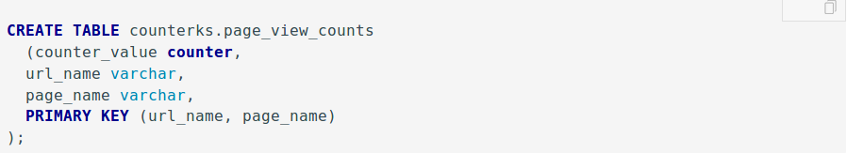

3. Load data into the counter column.

4. Take a look at the counter value.
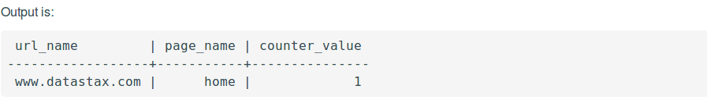

5. Increase the value of the counter.
6. Take a look at the counter value.

Note:
- Counter columns do not exist with non-counter columns, so every other column in the table should be a primary key/clustering keys.
- A counter column cannot be indexed or deleted.
- To load data into a counter column, or to increase or decrease the value of the counter, use the UPDATE command. Cassandra rejects USING TIMESTAMP or USING TTL when updating a counter column.
- To create a table having one or more counter columns, use CREATE TABLE to define the counter and non-counter columns. Use all non-counter columns as part of the PRIMARY KEY definition.
- You cannot create an index on a counter column or set data in a counter column to expire using the Time-To-Live (TTL) property.
- To generate sequential numbers for surrogate keys, use the timeuuid type instead of the counter type.

Collections Data Type:
set:
The set data type stores a collection of elements. The elements are unordered,
but cqlsh returns the elements in sorted order.
Note: If we do not use concatenation, adding the second element in the collection will replace the first content. We can add multiple elements without replacing the whole set by using concatenation:

List:
The list data type contains an ordered list of elements. By default, the values are stored in order of insertion.
Map:
The map data type contains a collection of key/value pairs. The keys and the values can be of any type except counter.

User Defined Types:
Use Case:
I am planning to use a Java object as a custom type and store it Cassandra. I am taking out 2 data members from the class and making them into primary key and keeping the rest of the data members in the custom type.
data members of my class:
- name,
- date_of_birth,
- occupation,
- last_visit,
- total_income
primary key:
- name,
- date_of_birth
Cassandra custom type members:
- occupation,
- last_visit,
- total_income
Will the custom data type have any performance benefits while writing or reading when compared to storing the individual data members in terms of Cassandra data types.
Answer:
Not really. Data for user defined types (UDTs) is stored in a single column in the row, and that should be a faster read than multiple individual columns. But whatever performance gain you achieve there will quickly be erased as the data is serialized for the result set. While CQL will allow you to read individual fields of the UDT if you desire, Cassandra still has to read all contents of that column regardless.
It is important to note that user defined types are not about improving performance. They're about offering the flexibility to achieve small amounts of denormalization.

Secondary Indexes:
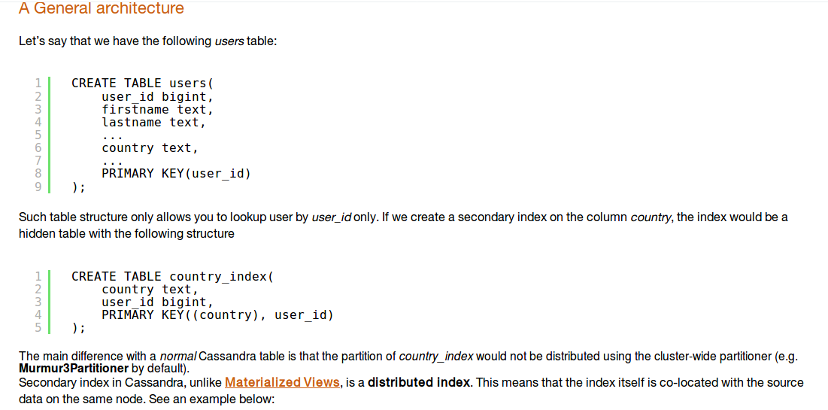
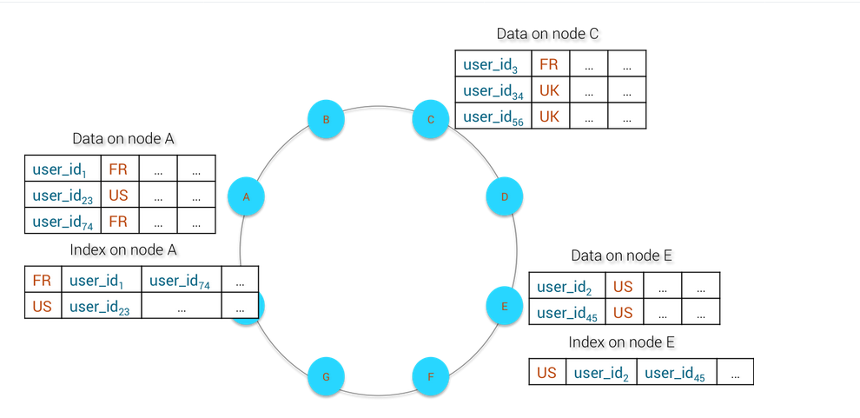

What’s the problem with secondary indexes?

So, let’s say you’re running Cassandra on a ring of seven machines, with a primary index of user IDs and a secondary index of user countrys. If you were to query for a user by their ID—or by their primary indexed key—any machine in the ring would know which machine has a record of that user. One query, one read from disk. However to query a user by their country—or their secondary indexed value—each machine has to query its own record of users. One query, seven reads from disk. By either scaling the number of users system wide, or by scaling the number of machines in the ring, the noise to signal-to-ratio increases and the overall efficiency of reading drops - in some cases to the point of timing out on API calls. This is a problem.

Secondary Index Fitfalls:
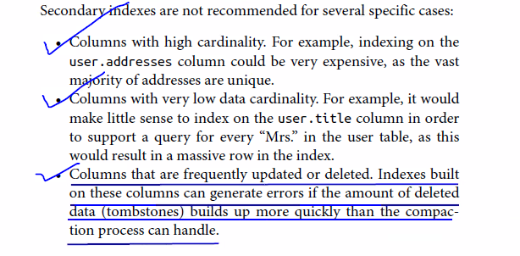

Materialized View:

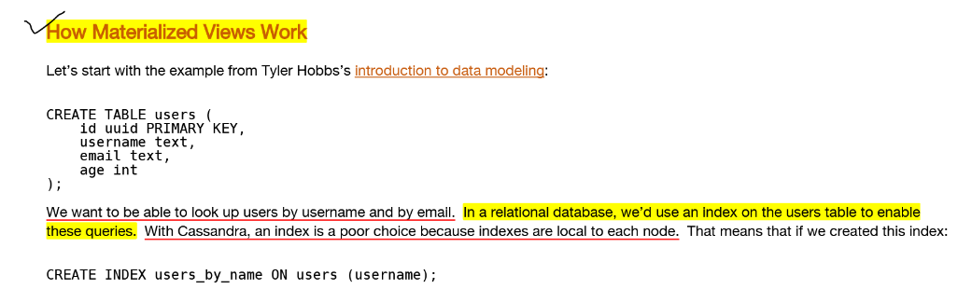
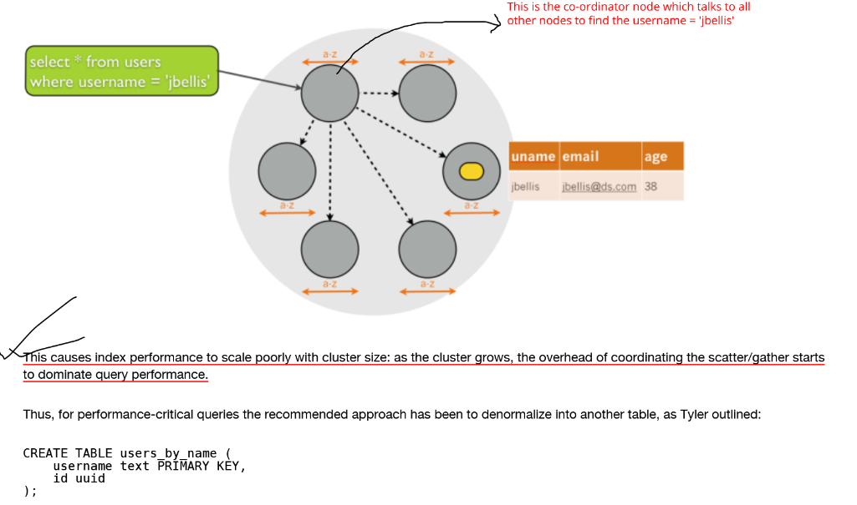
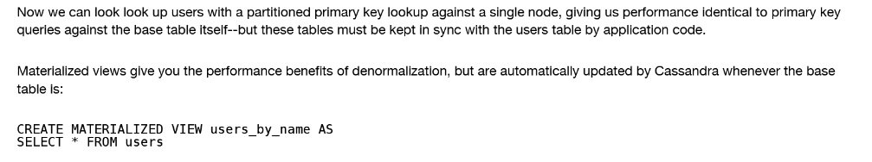
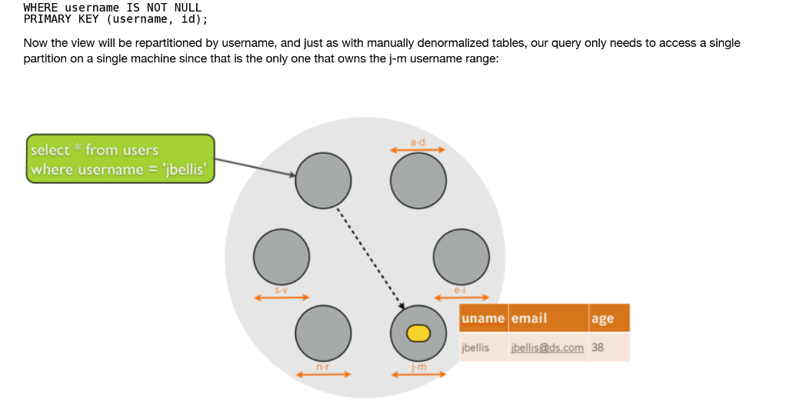
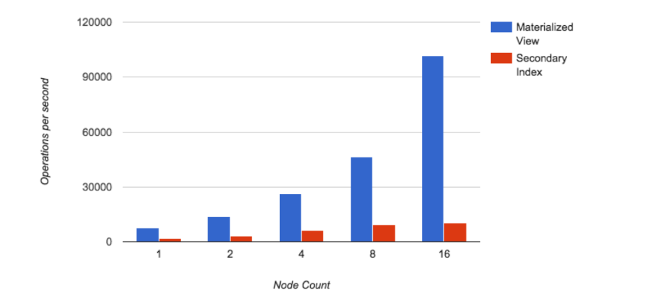
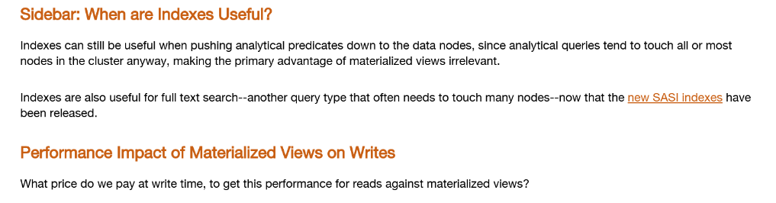
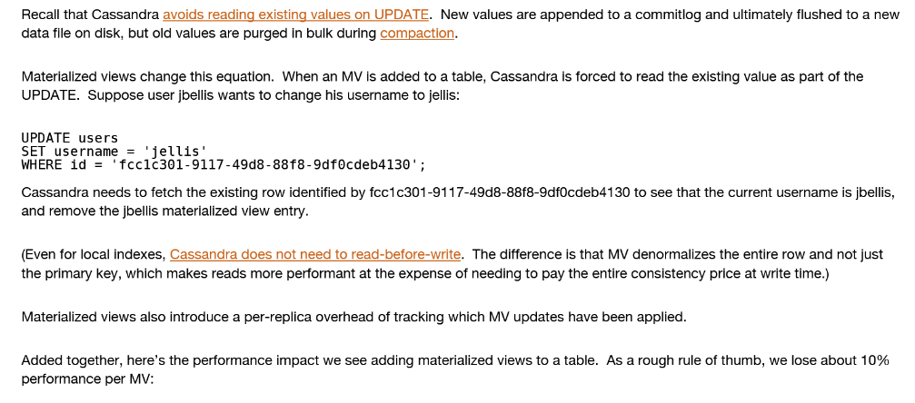

Basic Rules of Cassandra Data Modeling

Picking the right data model is the hardest part of using Cassandra. If you have a relational background, CQL will look familiar, but the way you use it can be very different. The goal of this post is to explain the basic rules you should keep in mind when designing your schema for Cassandra. If you follow these rules, you'll get pretty good performance out of the box. Better yet, your performance should scale linearly as you add nodes to the cluster.

Non-Goals
Developers coming from a relational background usually carry over rules about relational modeling and try to apply them to Cassandra. To avoid wasting time on rules that don't really matter with Cassandra, I want to point out some non-goals:

Minimize the Number of Writes
Writes in Cassandra aren't free, but they're awfully cheap. Cassandra is optimized for high write throughput, and almost all writes are equally efficient. If you can perform extra writes to improve the efficiency of your read queries, it's almost always a good tradeoff. Reads tend to be more expensive and are much more difficult to tune.

Minimize Data Duplication (De-Normalization)
De-normalization and duplication of data is a fact of life with Cassandra. Don't be afraid of it. Disk space is generally the cheapest resource (compared to CPU, memory, disk IOPs, or network), and Cassandra is architected around that fact. In order to get the most efficient reads, you often need to duplicate data.
Besides, Cassandra doesn't have JOINs, and you don't really want to use those in a distributed fashion.

Basic Goals
These are the two high-level goals for your data model:
- Spread data evenly around the cluster
- Minimize the number of partitions read
There are other, lesser goals to keep in mind, but these are the most important. For the most part, I will focus on the basics of achieving these two goals. There are other fancy tricks you can use, but you should know how to evaluate them, first.

Rule 1: Spread Data Evenly Around the Cluster
You want every node in the cluster to have roughly the same amount of data. Cassandra makes this easy, but it's not a given. Rows are spread around the cluster based on a hash of the partition key, which is the first element of the PRIMARY KEY. So, the key to spreading data evenly is this: pick a good primary key. I'll explain how to do this in a bit.

Rule 2: Minimize the Number of Partitions Read
Partitions are groups of rows that share the same partition key. When you issue a read query, you want to read rows from as few partitions as possible.
Why is this important? Each partition may reside on a different node. The coordinator will generally need to issue separate commands to separate nodes for each partition you request. This adds a lot of overhead and increases the variation in latency. Furthermore, even on a single node, it's more expensive to read from multiple partitions than from a single one due to the way rows are stored.

Conflicting Rules?
If it's good to minimize the number of partitions that you read from, why not put everything in a single big partition? You would end up violating Rule #1, which is to spread data evenly around the cluster.
The point is, these two goals often conflict, so you'll need to try to balance them.

Model Around Your Queries
The way to minimize partition reads is to model your data to fit your queries. Don't model around relations. Don't model around objects. Model around your queries. Here's how you do that:

Step 1: Determine What Queries to Support
Try to determine exactly what queries you need to support. This can include a lot of considerations that you may not think of at first. For example, you may need to think about:
- Grouping by an attribute
- Ordering by an attribute
- Filtering based on some set of conditions
- Enforcing uniqueness in the result set
Changes to just one of these query requirements will frequently warrant a data model change for maximum efficiency.

Step 2: Try to create a table where you can satisfy your query by reading (roughly) one partition
In practice, this generally means you will use roughly one table per query pattern. If you need to support multiple query patterns, you usually need more than one table.
To put this another way, each table should pre-build the "answer" to a high-level query that you need to support. If you need different types of answers, you usually need different tables. This is how you optimize for reads.
Remember, data duplication is okay. Many of your tables may repeat the same data.

Applying the Rules: Examples
To show some examples of a good thought process, I will walk you through the design of a data model for some simple problems.

Example 1: User Lookup
The high-level requirement is "we have users and want to look them up". Let's go through the steps:
Step 1: Determine what specific queries to support
Let's say we want to either be able to look up a user by their username or their email. With either lookup method, we should get the full set of user details.
Step 2: Try to create a table where you can satisfy your query by reading (roughly) one partition
Since we want to get the full details for the user with either lookup method, it's best to use two tables:
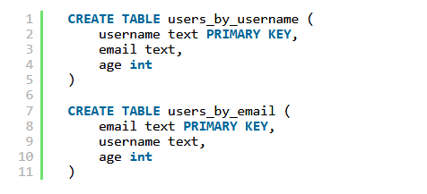
Now, let's check the two rules for this model:
Spreads data evenly? Each user gets their own partition, so yes.
Minimal partitions read? We only have to read one partition, so yes.

Now, let's suppose we tried to optimize for the non-goals, and came up with this data model instead:
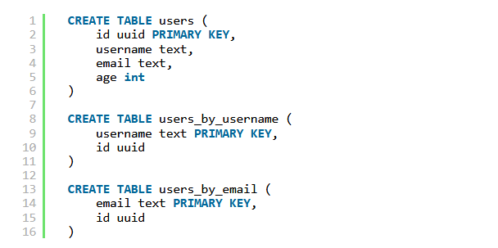
This data model also spreads data evenly, but there's a downside: we now have to read two partitions, one from users_by_username (or users_by_email) and then one from users. So reads are roughly twice as expensive.

Example 2: User Groups
Now the high-level requirement has changed. Users are in groups, and we want to get all users in a group.
Step 1: Determine what specific queries to support
We want to get the full user info for every user in a particular group. Order of users does not matter.
Step 2: Try to create a table where you can satisfy your query by reading (roughly) one partition
How do we fit a group into a partition? We can use a compound PRIMARY KEY for this:
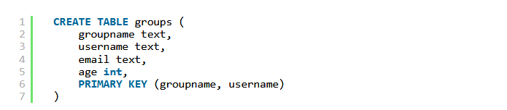
Note that the PRIMARY KEY has two components: groupname, which is the partitioning key, and username, which is called the clustering key. This will give us one partition per groupname. Within a particular partition (group), rows will be ordered by username. Fetching a group is as simple as doing the following:

This satisfies the goal of minimizing the number of partitions that are read, because we only need to read one partition. However, it doesn't do so well with the first goal of evenly spreading data around the cluster. If we have thousands or millions of small groups with hundreds of users each, we'll get a pretty even spread. But if there's one group with millions of users in it, the entire burden will be shouldered by one node (or one set of replicas).
If we want to spread the load more evenly, there are a few strategies we can use. The basic technique is to add another column to the PRIMARY KEY to form a compound partition key. Here's one example:
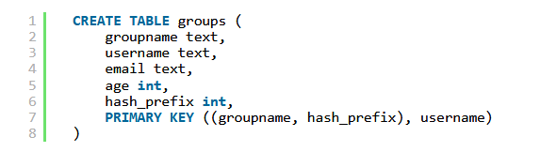
The new column, hash_prefix, holds a prefix of a hash of the username. For example, it could be the first byte of the hash modulo four. Together with groupname, these two columns form the compound partition key. Instead of a group residing on one partition, it's now spread across four partitions. Our data is more evenly spread out, but we now have to read four times as many partitions. This is an example of the two goals conflicting. You need to find a good balance for your particular use case. If you do a lot of reads and groups don't get too large, maybe changing the modulo value from four to two would be a good choice. On the other hand, if you do very few reads, but any given group can grow very large, changing from four to ten would be a better choice.
There are other ways to split up a partition, which I will cover in the next example.
Before we move on, let me point out something else about this data model: we're duplicating user info potentially many times, once for each group. You might be tempted to try a data model like this to reduce duplication:
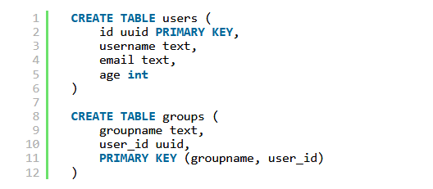
Obviously, this minimizes duplication. But how many partitions do we need to read? If a group has 1000 users, we need to read 1001 partitions. This is probably 100x more expensive to read than our first data model. If reads need to be efficient at all, this isn't a good model. On the other hand, if reads are extremely infrequent, but updates to user info (say, the username) are extremely common, this data model might actually make sense. Make sure to take your read/update ratio into account when designing your schema.

Example 3: User Groups by Join Date
Suppose we continue with the previous example of groups, but need to add support for getting the X newest users in a group.
We can use a similar table to the last one:
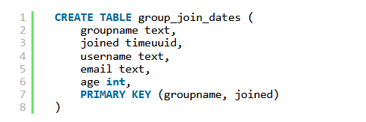
Here we're using a timeuuid (which is like a timestamp, but avoids collisions) as the clustering column. Within a group (partition), rows will be ordered by the time the user joined the group. This allows us to get the newest users in a group like so:

This is reasonably efficient, as we're reading a slice of rows from a single partition. However, instead of always using ORDER BY joined DESC, which makes the query less efficient, we can simply reverse the clustering order:
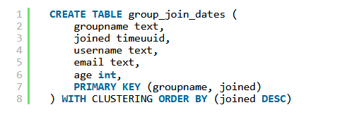
Now we can use the slightly more efficient query:

As with the previous example, we could have problems with data being spread evenly around the cluster if any groups get too large. In that example, we split partitions somewhat randomly, but in this case, we can utilize our knowledge about the query patterns to split partitions a different way: by a time range.
For example, we might split partitions by date:
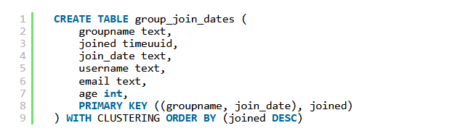
We're using a compound partition key again, but this time we're using the join date. Each day, a new partition will start. When querying the X newest users, we will first query today's partition, then yesterday's, and so on, until we have X users. We may have to read multiple partitions before the limit is met.
To minimize the number of partitions you need to query, try to select a time range for splitting partitions that will typically let you query only one or two partitions. For example, if we usually need the ten newest users, and groups usually acquire three users per day, we should split by four-day ranges instead of a single day.

The Cassandra Architecture

Data Centers and Racks:
A rack is a logical set of nodes in close proximity to each other, perhaps on physical machines in a single rack of equipment.

A data center is a logical set of racks, perhaps located in the same building and connected by reliable
network.
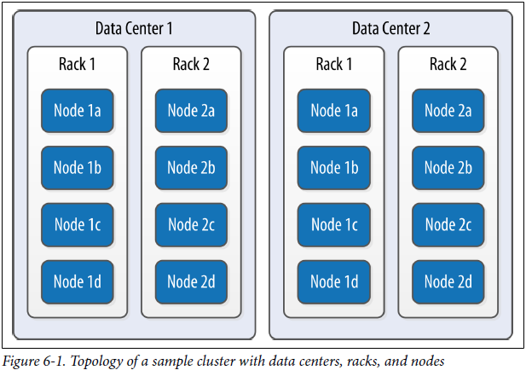

Gossip Protocol
Gossip is used to broadcast members' state around the cluster. It is the internal communication technique for nodes in a cluster to talk to each other. Part of the information exchanged:
- status
- health
- tokens
- schema version
- addresses
- data size
In Cassandra, the communication between nodes is often like peer-to-peer communication, where every node talks to the other. If that’s the case, then all the nodes talk to one another, and there is a lot of communication happening. The Gossip Protocol is a method to resolve this communication chaos. In Cassandra, when one node talks to another, the node which is expected to respond, not only provides information about its status, but also provides information about the nodes that it had communicated with before. Through this process, there is a reduction in network log, more information is kept and efficiency of information gathering increases. The main feature of the protocol is to provide the latest information of any node respectively.

Failure Detection
An important feature of Gossip Protocol is Failure Detection. Basically, when two nodes communicate with one another; for instance, Node A to Node B, then Node A sends a message ‘gossip-digest-syn-message’ to Node B. Here, Node B, once receives the message, sends an acknowledgement message ‘ack’ to Node A, and then Node A responds with an acknowledgement message to Node B’s ‘ack’ message. This is known as the 3 way handshake.
If in case, the node goes down and does not send the ack message, then it will be a mark down. Even when the nodes are down, the other nodes will be periodically pinging that node to find out whether or not the node has become available. This is how the failure detection happens.

Snitches
A snitch determines which data centers and racks are to be written to and read from. The job of a snitch is to simply determine relative host proximity. Hence, if a node has 3 options to copy the data, which host should it select? Which host should it prefer the data from?
If this is the kind of information the host would like to receive, it will call a particular snitch to see which host is relatively nearer. Snitches gather information about network topology. Depending on what type of snitch is being used, they will be aware about the network topology and they can efficiently route the requests.

Rings and Tokens
A Cassandra cluster is visualized as a ring because it uses a consistent hashing algorithm to distribute data. At start up each node is assigned a token range which determines its position in the cluster and the rage of data stored by the node. Each node receives a proportionate range of the token ranges to ensure that data is spread evenly across the ring.
The figure below illustrates dividing a 0 to 255 token range evenly amongst a four node cluster. Each node is assigned a token range and is responsible for token values from the previous token (exclusive) to the node's token (inclusive). Each node in a Cassandra cluster is responsible for a certain set of data which is determined by the partitioner. A partitioner is a hash function for computing the resultant token for a particular row key. This token is then used to determine the node which will store the first replica. Currently Cassandra offers a
  - Murmur3Partitioner (default),
  - RandomPartitioner and
  - ByteOrderedPartitioner
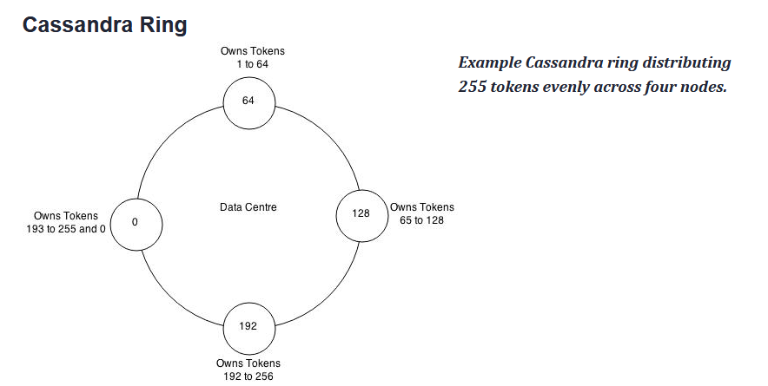
Virtual Nodes
There is only one token per node, and that is the reason a node owns exactly one contiguous range in the ring-space. Vnodes change this paradigm from one token or range per node, to many per node. Within a cluster these can be randomly selected and be non-contiguous, giving us many smaller ranges that belong to each node.

What advantages does this bring to the table?
Prior to virtual node, you had to set initial num token at each node. Now if you add/remove a new node you have to recalculate token ranges to balance your cluster. After Cassandra 1.2 (vNodes introduced) token assignment task is automated, you don’t have to worry about recalculating token ranges after adding/removing nodes.
Partitioners
A partitioner determines how data is distributed across the nodes in the cluster. Basically, a partitioner is a hash function for computing the token (it's hash) of a partition key. Each row of data is uniquely identified by a partition key and distributed across the cluster by the value of the token.
[see Rings and Tokens section for more info]
Consistency Levels
As a general rule, the replication factor should not exceed the number of Cassandra nodes in the cluster.
The Cassandra consistency level is defined as the minimum number of Cassandra nodes that must acknowledge a read or write operation before the operation can be considered successful. Different consistency levels can be assigned to different key-spaces.
When connecting to Cassandra for read and write operations, it typically use the Cassandra value of LOCAL_QUORUM to specify the consistency level for a key-space. However, some key-spaces are defined to use a consistency level of one.
The calculation of the value of LOCAL_QUORUM for a data center is:
As described above, the default replication factor for an production environment with three Cassandra nodes is three. Therefore, the default value of LOCAL_QUORUM = (3/2) +1 = 2 (the value is rounded down to an integer).
With LOCAL_QUORUM = 2, at least two of the three Cassandra nodes in the data center must respond to a read/write operation for the operation to succeed. For a three node Cassandra cluster, the cluster could therefore tolerate one node being down per data center.
Note: A higher consistency level means that more nodes need to respond to a read or write query, giving you more assurance that the values present on each replica are the same.

Distinguishing Consistency Levels and Replication Factors
If you’re new to Cassandra, the replication factor can sometimes be confused with the consistency level. The replication factor is set per key-space. The consistency level is specified per query, by the client. The replication factor indicates how many nodes you want to use to store a value during each write operation. The consistency level specifies how many nodes the client has decided must respond in order to feel confident of a successful read or write operation. The confusion arises because the consistency level is based on the replication factor, not on the number of nodes in the system.

How are write requests accomplished?

Configuring Cassandra

Question: Can we create a multi-node cluster on a single machine?

There is a tool called the Cassandra Cluster Manager or ccm which is a set of Python scripts that allow you to run a multi-node cluster on a single machine. This allows you to quickly configure a cluster
without having to provision additional hardware.

Question: What is the key configuration file in Cassandra?

The key file for configuring each node in a cluster is the cassandra.yaml file, which you can find in the conf directory under your Cassandra installation.

Question: What are the key values that need to be specified while creating a Cassandra cluster?

The key values in configuring a cluster are
  - the cluster name,
  - the partitioner,
  - the snitch, and
  - the seed nodes.
The cluster name, partitioner, and snitch must be the same in all of the nodes participating in the cluster. The seed nodes are not strictly required to be exactly the same for every node across the cluster, but it is a good idea to do so.

The name of the default cluster in the cassandra.yaml file is ‘Test Cluster’.

Create a Cluster using ccm tool:

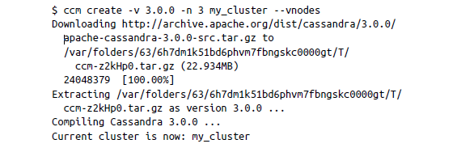

List all existing cluster using ccm tool and print the status of it:

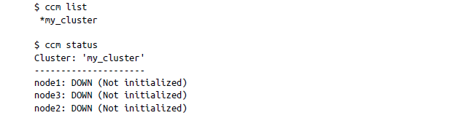

At this point, none of the nodes have been initialized. Let’s start our cluster and then check status again:

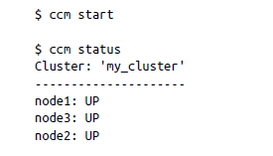
Display the status of each node:

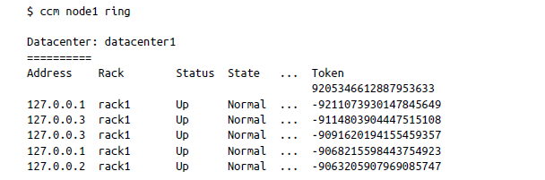

Question: Can you change the partitioner once you have inserted data into a
Cluster?
  - No

Question: Where can you check the topology of a cluster ?
  - cassandra-topology.properties

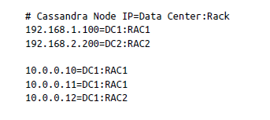
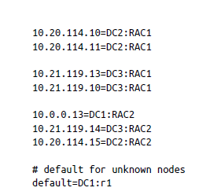
Here we see that there are three data centers (DC1, DC2, and DC3), each with two racks (RAC1 and RAC2). Any nodes that aren’t identified here will be assumed to be in the default data center and rack (DC1, r1).

