Assignment No:05

Title of Experiment: Implement setting up and releasing of special permissions (SGID,
SUID and sticky bit) and state their effects.

Theory:
Sharing Files
permissions of the new file using your default UID and GID. To allow others access to the file, you need to either change the security permissions for the everyone security group or assign the file a different default group that contains other users.
This can be a pain in a large environment if you want to create and share documents among several people. Fortunately, there's a simple solution for how to solve this problem.
There are three additional bits of information that Linux stores for each file and directory:
The set user id (SUID): When a file is executed by a user, the program runs under the permissions of the file owner.
The set group id (SGID): For a file, the program runs under the permissions of the file group. For a directory, new files created in the directory use the directory group as the default group.
The sticky bit: The file remains (sticks) in memory after the process ends.
The SGID bit is important for sharing files. By enabling the SGID bit, you can force all new files created in a shared directory to be owned by the directory's group and now the individual user's group.
The SGID is set using the chmod command. It's added to the beginning of the standard three-digit octal value (making a four-digit octal value), or you can use the symbol s in symbolic mode.
If you're using octal mode, you'll need to know the arrangement of the bits, shown in Table
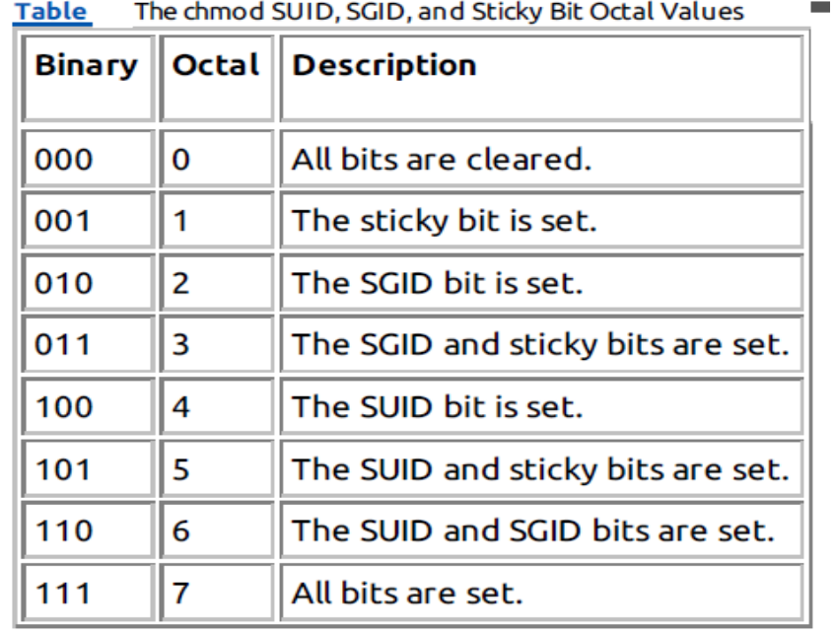
So, to create a shared directory that always sets the directory group for all new files, all you need to do is set the SGID bit for the directory:
$ mkdir testdir
$ ls -l
drwxrwxr-x 2 rich rich 4096 Sep 20 23:12 testdir/
$ chgrp shared testdir
$ chmod g+s testdir
$ ls -l
drwxrwsr-x 2 rich shared 4096 Sep 20 23:12 testdir/
$ umask 002
$ cd testdir
$ touch testfile
$ ls -l
total 0
-rw-rw-r-- 1 rich shared 0 Sep 20 23:13 testfile

The first step is to create a directory that you want to share using the mkdir command. Next, the chgrp command is used to change the default group for the directory to a group that contains the members who need to share files. Finally, the SGID bit is set for the directory to ensure that any files created in the directory use the shared group name as the default group.
For this environment to work properly, all of the group members need to have their umask values set to make files writable by group members. In the preceding example, the umask is changed to 002 so that the files are writable by the group.
After all that's done, any member of the group can go to the shared directory and create a new file. As expected, the new file uses the default group of the directory, not the user account's default group. Now any user in the shared group can access this file.

