# **Preparation of DjangoApp**

apt install python3-django  
  
django-admin startproject djangokubernetesproject

cd djangokubernetesproject

**Build the image and push to Docker**

vi Dockerfile

FROM ubuntu:20.04

RUN apt-get update && apt-get install -y tzdata && apt install -y python3.8 python3-pip

RUN apt install python3-dev libpq-dev nginx -y

RUN pip install django gunicorn psycopg2

ADD . /app

WORKDIR /app

EXPOSE 8000

CMD ["gunicorn", "--bind", ":8000", "--workers", "3", "djangokubernetesproject.wsgi"]

docker build -t djangokubernetesproject.

docker run -i -t djangokubernetesproject sh

## Creating Database Schema

python3 manage.py makemigrations && python3 manage.py migrate

python3 manage.py createsuperuser

Ctrl+D

docker tag djangokubernetesproject:latest vpr1cob/djangokubernetesproject:latest

docker push vpr1cob/djangokubernetesproject:latest

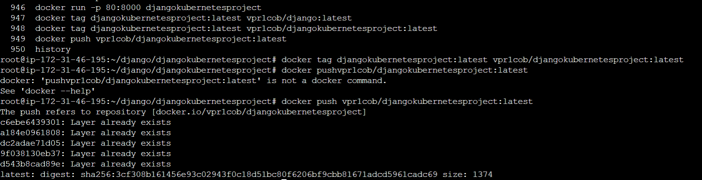

# **Kubernetes**

Deployment file  
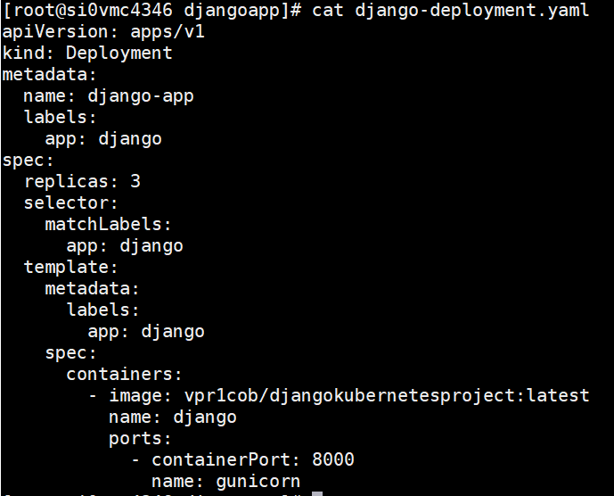

Service file

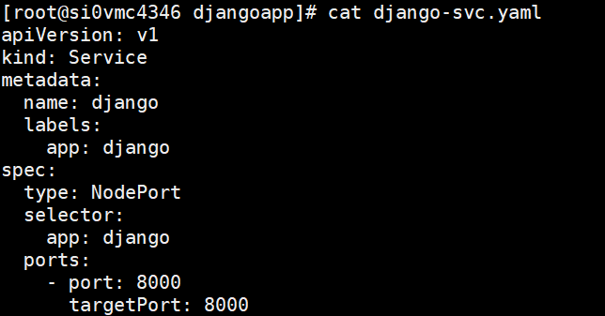

ingress file

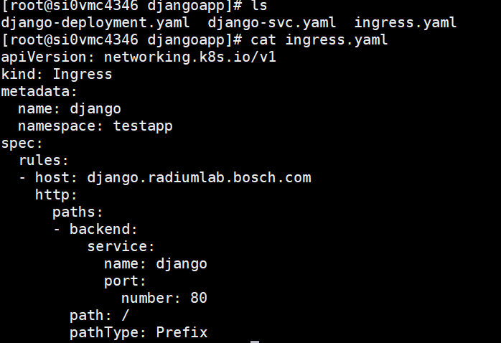

**Adding the codes to Git repository**

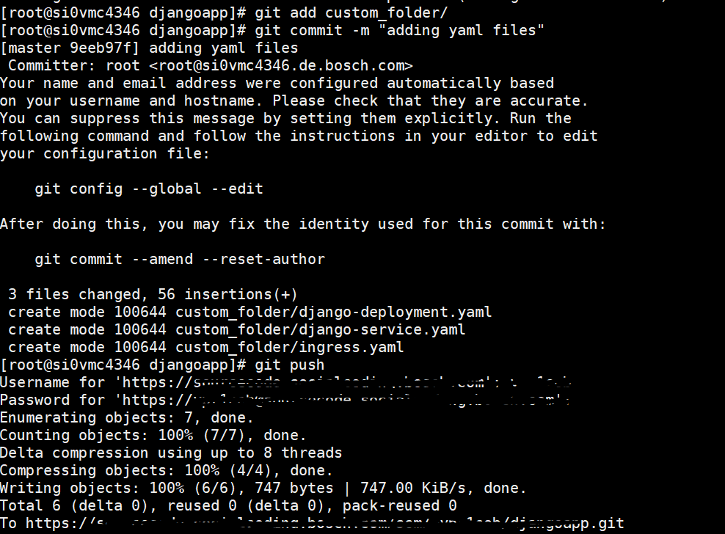

**Deploy Using Argocd**

Creating Namespace using kubectl command  
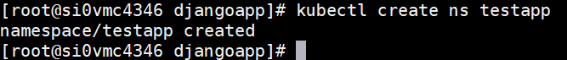  
  
Adding repository in ArgoCD

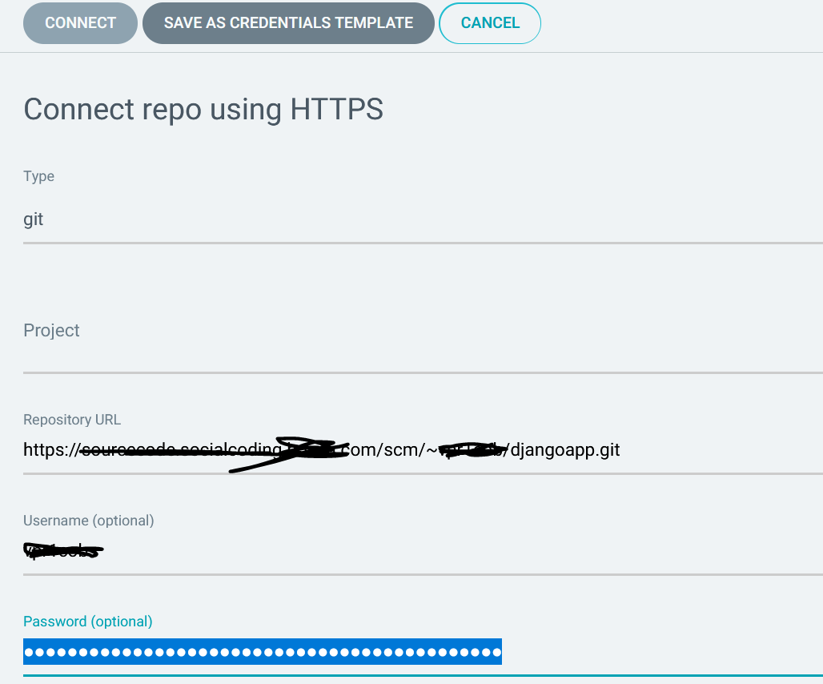

**Creating application in Argocd**

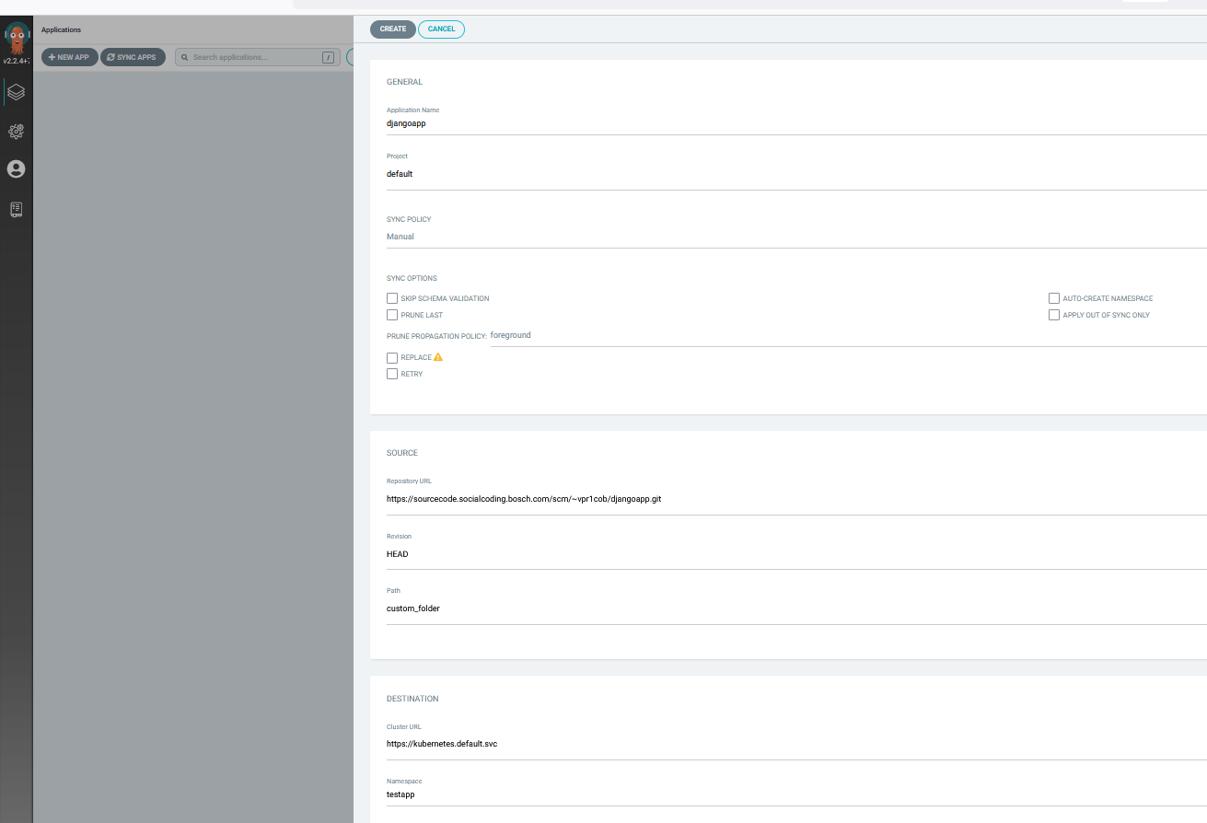

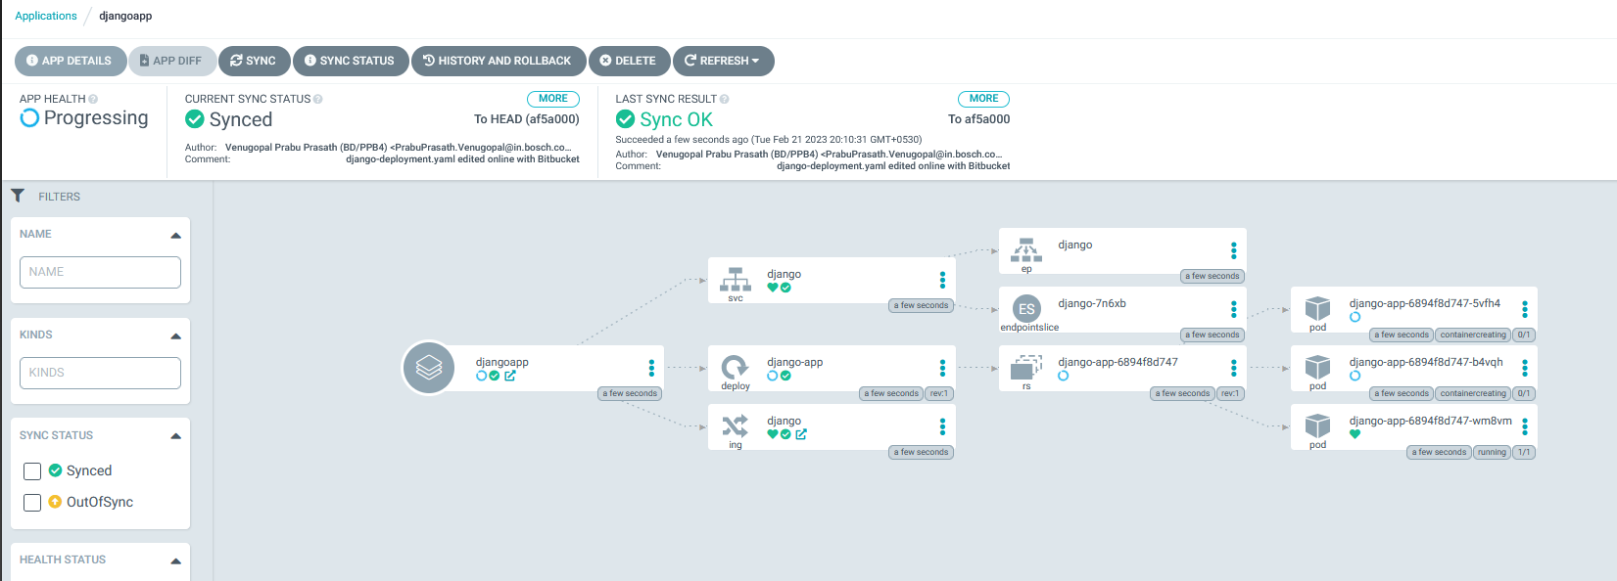

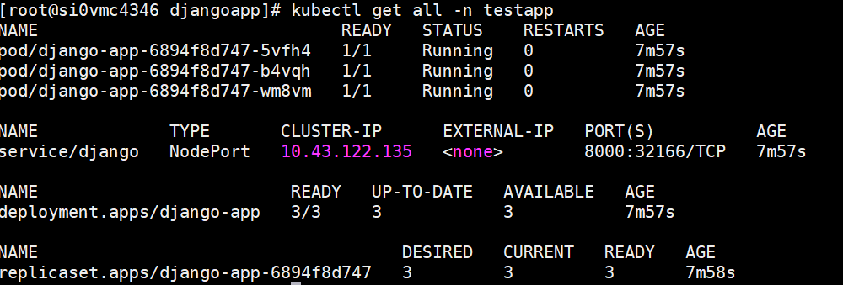

URL : This HOST is not allowed in my network. So I could not bring this Up.   
  
