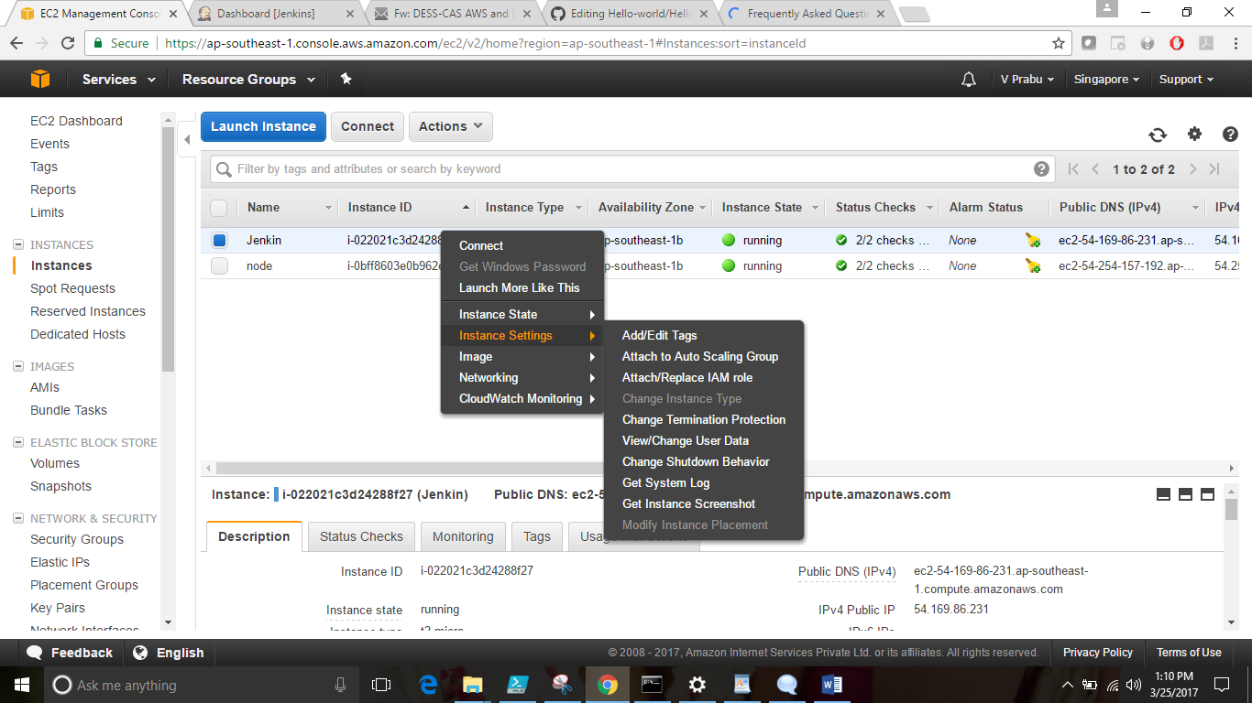

<https://docs.bitnami.com/aws/faq/> -- for password infor

ec2-54-169-8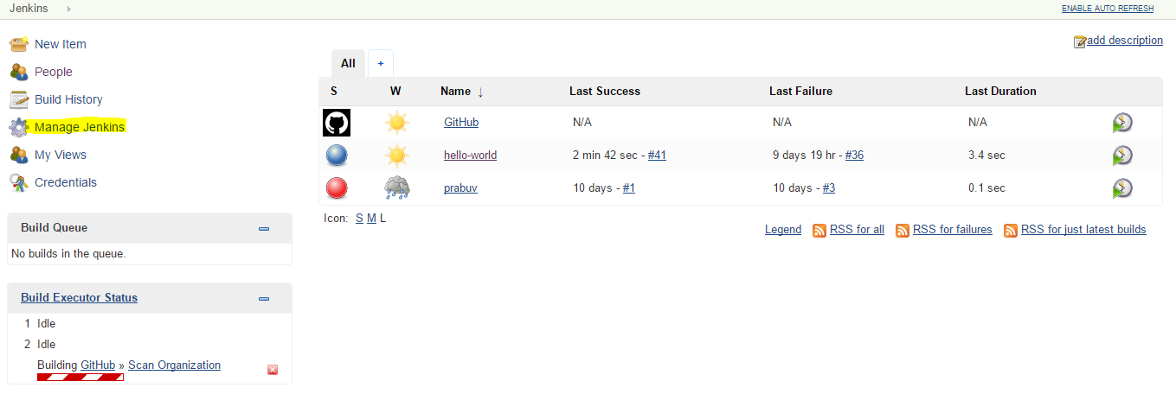6-231.ap-southeast-1.compute.amazonaws.com

install plugins git hub and publish over ssh

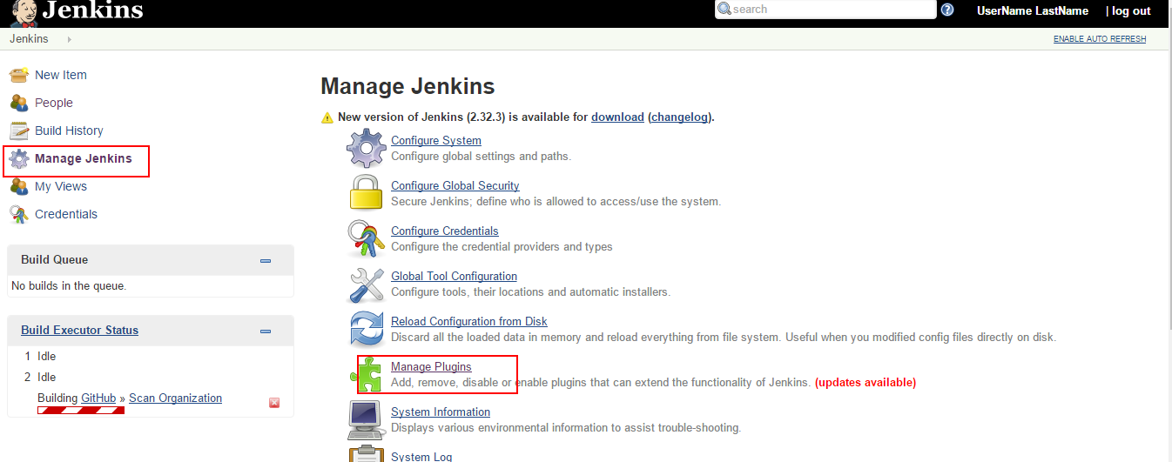

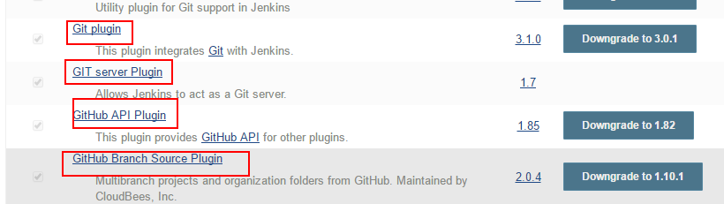

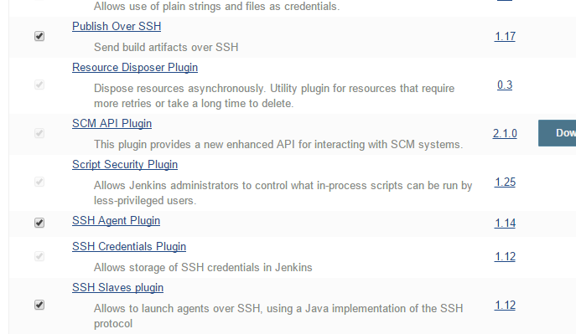

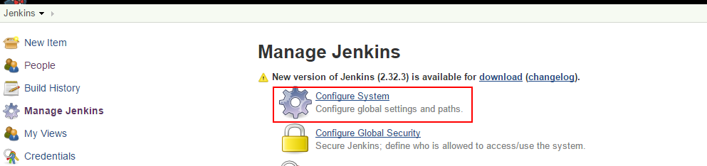

For secret text login to git hub and edit profile

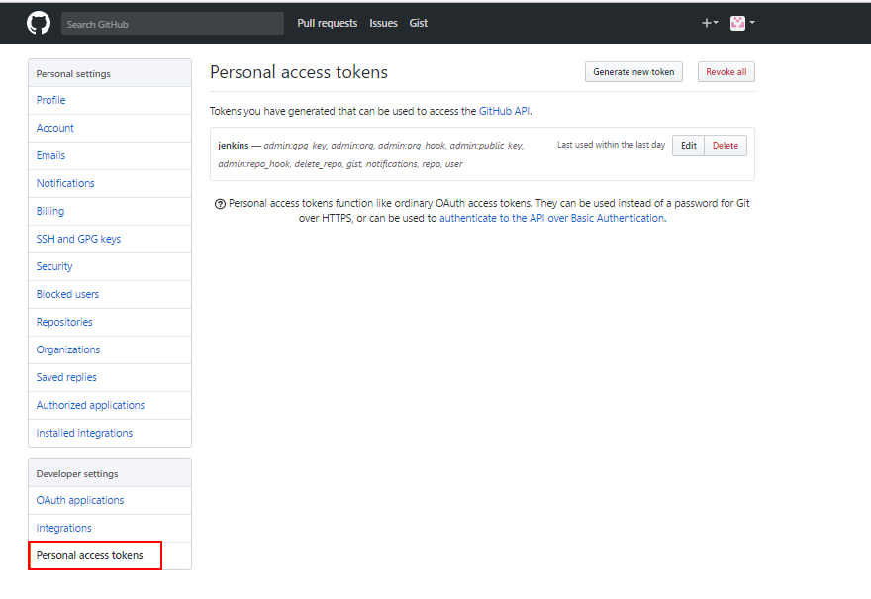

Generate token and update the secret text in the Jenkins

Update the token in git hub

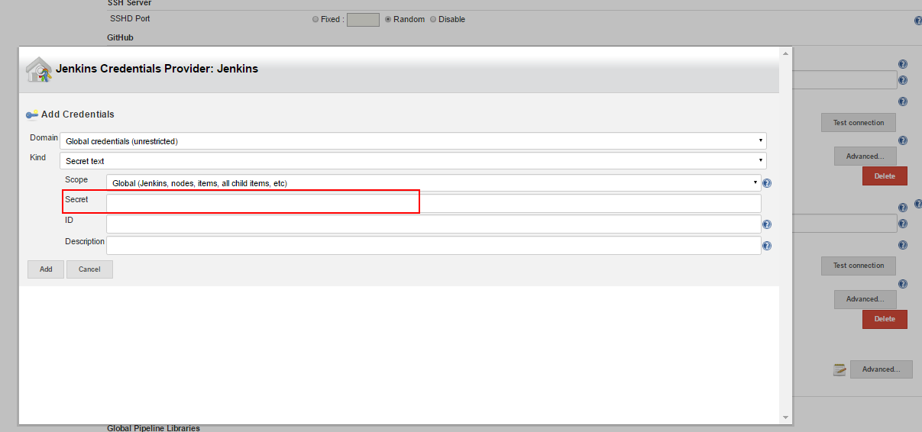

And then open pem file and update the information of the node server

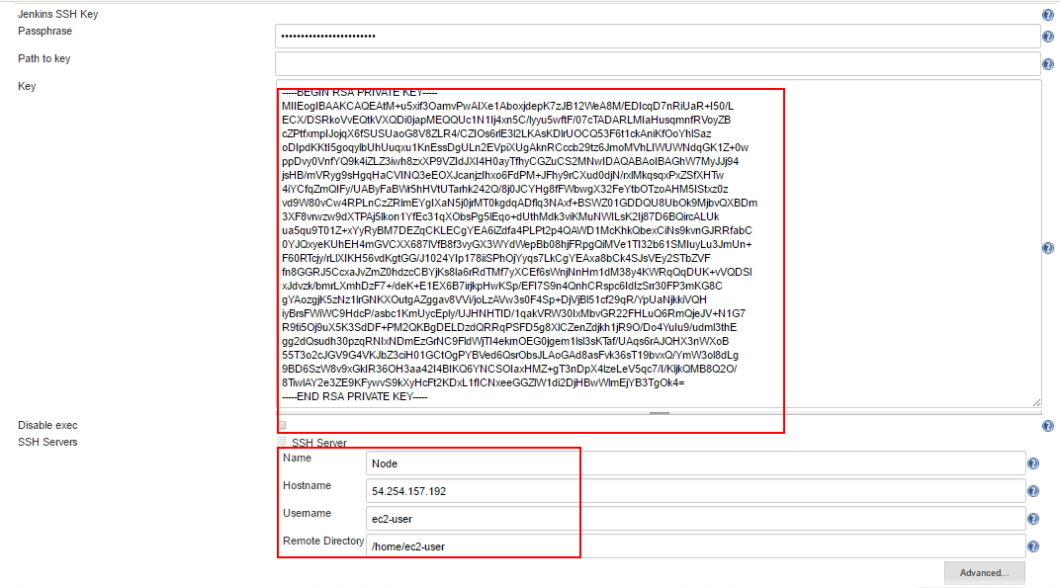

Click on new item on Jenkins

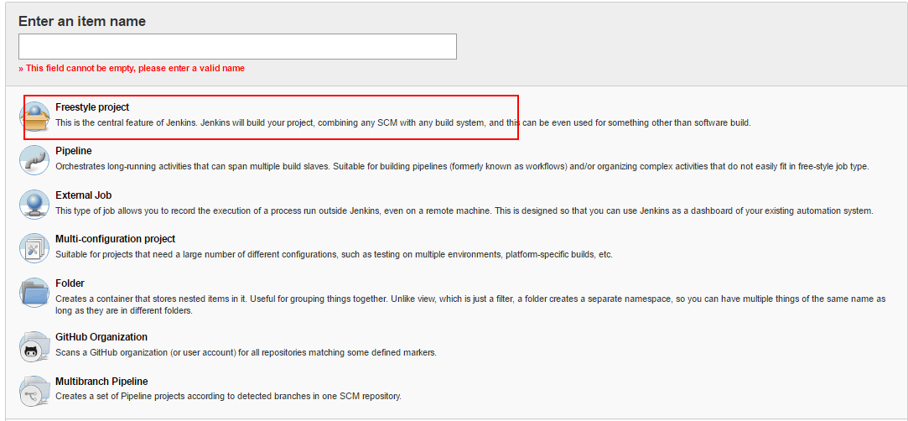

After providing details click ok

And then open the item and click on configure



Transferring file using git hub to Jenkins and to node

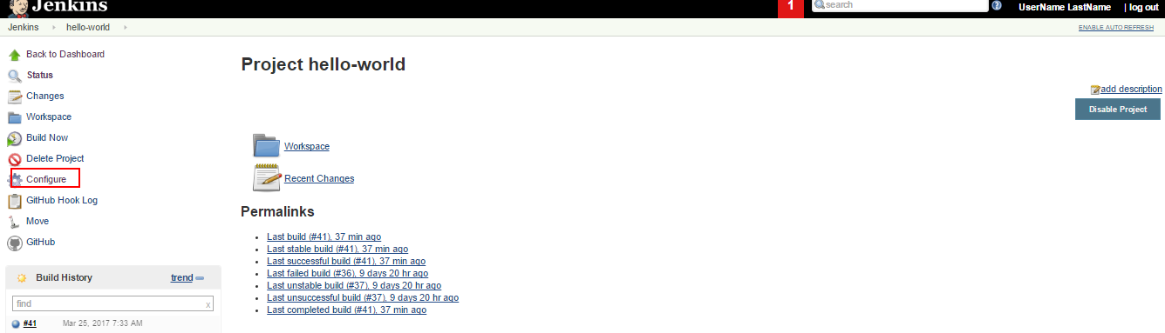

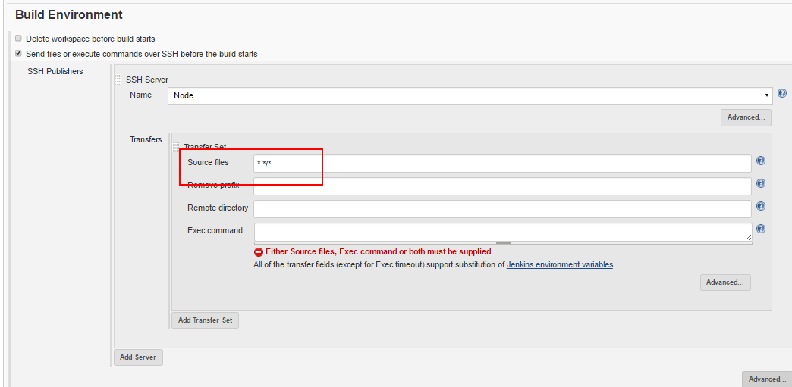

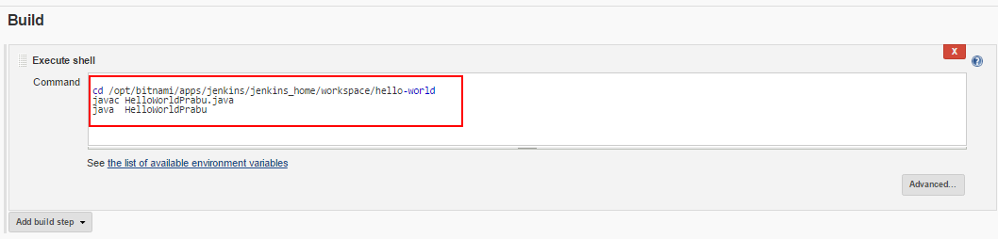

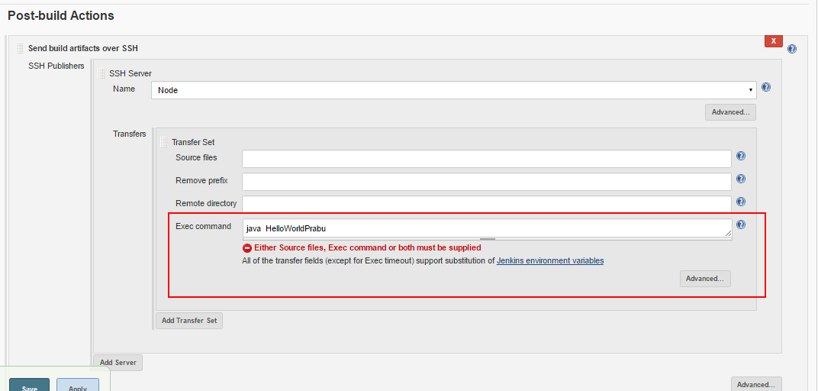

It will execute in the node server and it will display the output