Experiment No 3

Aim: Draw class diagram and use case diagram using any opensource tool.
a.UseCase Diagram
1. Description of the Diagram
A Use Case Diagram is a behavioural UML diagram that captures the functional requirements of a system from an end-user's perspective. It shows the system as a set of use cases (units of functionality), the actors (users or external systems) that interact with those use cases, and the relationships between them. It does not describe how the functionality is implemented internally — it only captures what the system does and who uses it.
In the PIIT system, four actors interact with the system:
- Citizen — the primary end user who reports civic issues.
- Municipal Officer — reviews, verifies and assigns complaints to field staff.
- Field Worker — receives assigned work, resolves it on-site, and updates progress.
- Administrator — manages users, departments, and system-wide reports.
The main use cases include Submit Complaint, Track Complaint Status, Provide Feedback (for the Citizen); Review & Verify Complaints and Assign Complaint to Worker (for the Municipal Officer); View Assigned Tasks, Update Work Progress and Upload Completion Photo (for the Field Worker); and Manage User Accounts, Manage Departments and Generate Reports & Analytics (for the Administrator). The diagram also models supporting relationships: Submit Complaint includes Detect GPS Location, Upload Issue Photo and Authenticate/Login (mandatory sub-behaviours); Pin Location Manually extends Submit Complaint only when GPS detection fails (an optional, conditional behaviour); Upload Completion Photo extends Update Work Progress on resolution; Update Work Progress includes Send Notification; and Generate Department Analytics is a specialised (generalised) form of Generate Reports & Analytics.
2. Explanation of Notations Used
The table below lists every UML use-case notation used in the PIIT diagram, a rendered symbol/snippet of the notation, and an explanation of where and why it is used in this system.
Notation | Symbol | Description / Where Used
Actor | 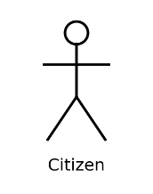 | A stick figure representing a role played by a user or external entity that interacts with the system. Used for Citizen, Municipal Officer, Field Worker and Administrator, each placed outside the system boundary.
Use Case | 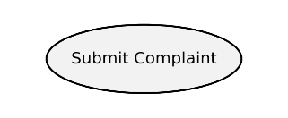 | An oval containing a verb phrase that names a discrete piece of system functionality. Used for every behaviour offered by PIIT, e.g. Submit Complaint, Track Complaint Status, Assign Complaint to Worker.
System Boundary | 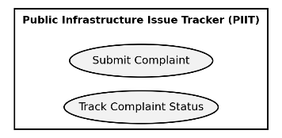 | A rectangle that encloses all use cases and is labelled with the system's name. It marks the scope of the system — everything inside is functionality PIIT provides; actors stay outside it.
Association | 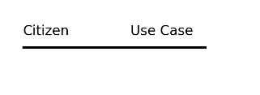 | A plain solid line connecting an actor to a use case, showing that the actor participates in / triggers that use case. Used, e.g., between Citizen and Submit Complaint, or Field Worker and View Assigned Tasks.
«include» | 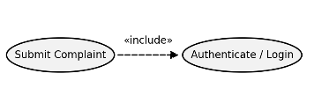 | A dashed arrow labelled «include», pointing from a base use case to a use case whose behaviour is always required. Used because Submit Complaint always needs Authenticate/Login, Detect GPS Location and Upload Issue Photo to complete.
«extend» | 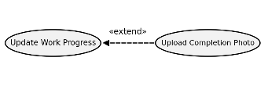 | A dashed arrow labelled «extend», pointing from the optional/extending use case back to the base use case, invoked only under a condition. Used because Pin Location Manually extends Submit Complaint only “if GPS fails”, and Upload Completion Photo extends Update Work Progress “on resolution”.
Generalization | 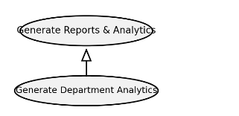 | A solid line with a hollow (unfilled) triangular arrowhead pointing to the more general use case. Used between Generate Department Analytics and the more general Generate Reports & Analytics, indicating the former is a specialised variant of the latter.
3. Advantages and Disadvantages
Advantages | Disadvantages
1. Gives a clear, high-level view of system functionality without implementation detail, making it easy for non-technical stakeholders to understand. | 1. Does not show the internal logic, algorithms, or the order/sequence in which steps occur.
2. Helps identify all actors and their interactions early, ensuring no functional requirement is missed. | 2. Can become cluttered and hard to read as the number of actors and use cases grows in a large system.
3. «include» and «extend» relationships allow reuse of common behaviour and clean modelling of optional/conditional flows. | 3. Provides no information about data structures, timing, or non-functional requirements (performance, security, etc.).
4. Serves as a communication bridge between clients, analysts and developers during requirement gathering. | 4. Overuse or misuse of «include»/«extend» can make the diagram ambiguous or confusing if not applied consistently.
5. Forms the basis for later artefacts such as use case specifications, test cases and acceptance criteria. | 5. Being a fairly abstract view, it can be interpreted differently by different readers without accompanying textual descriptions.

4. Output
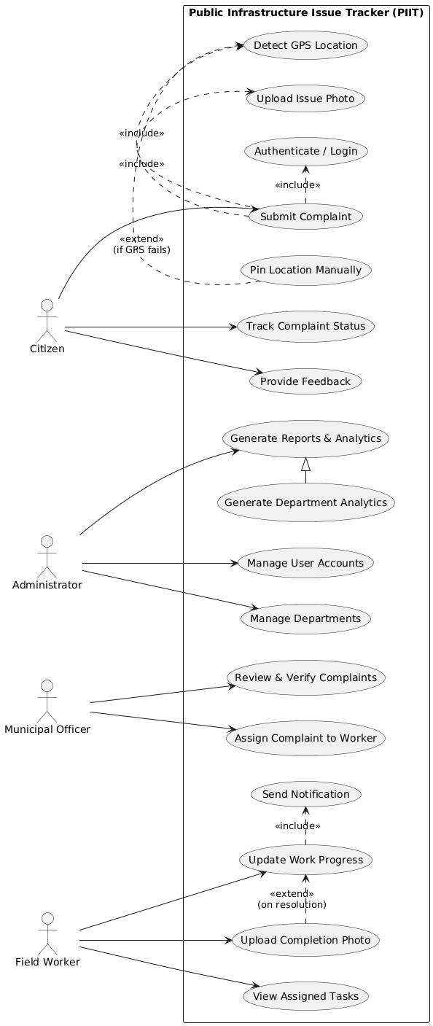
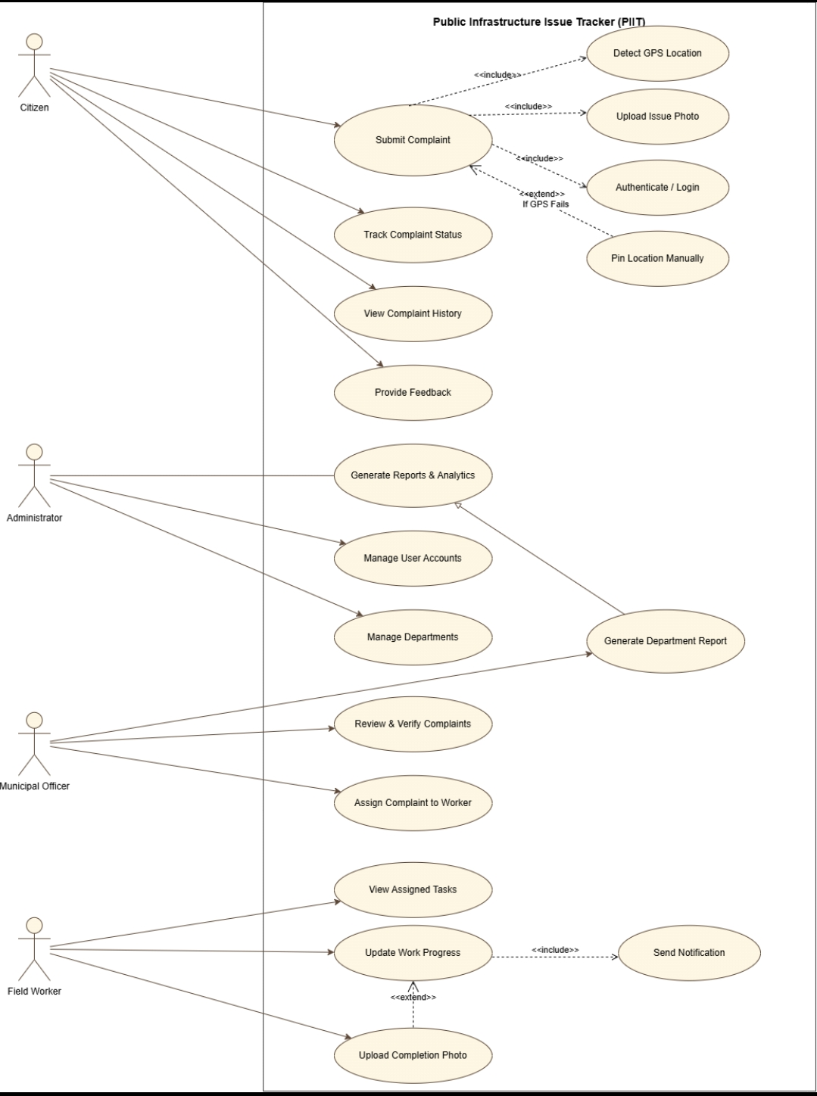
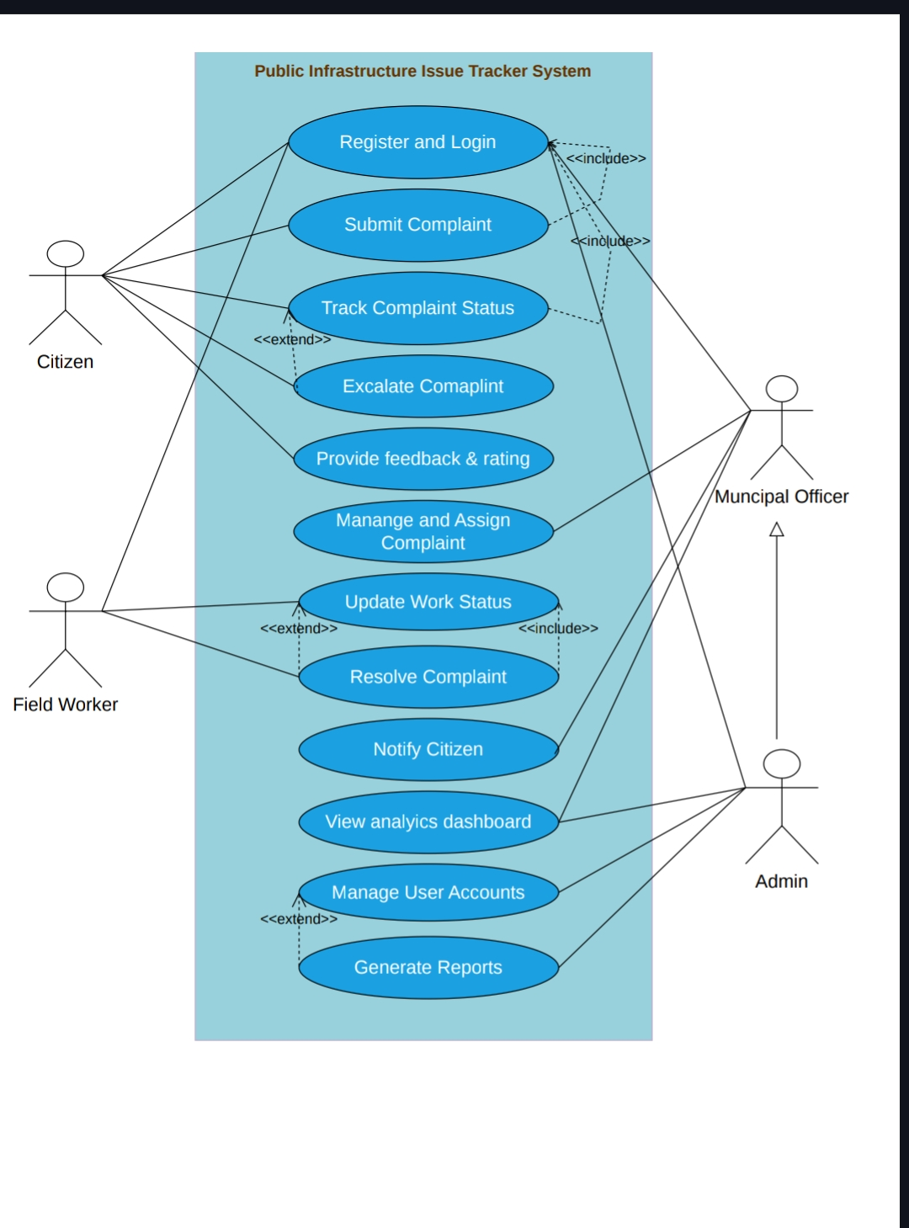

b.Class Diagram
1. Description of the Diagram
A Class Diagram is a structural UML diagram that models the static design of a system. It shows the classes that make up the system, each class's attributes and operations, and the relationships (association, aggregation, composition, generalization, dependency) that connect classes to one another. Unlike the use case diagram, it captures what the system is made of, rather than what it does.
In the PIIT class model, User is an abstract superclass holding common attributes (userId, name, email, role) and common operations (login(), logout()). Administrator, MunicipalOfficer, Citizen and FieldWorker all inherit from User, each adding role-specific attributes and operations — for instance, Citizen adds submitComplaint(), trackComplaint() and giveFeedback(). The central class is Complaint, which a Citizen submits, which belongs to exactly one Category, which is handled by one Department, and which contains one or more ComplaintPhoto objects. A MunicipalOfficer creates an Assignment linking a Complaint to a FieldWorker, and generates Report objects that summarise complaint/department data. Every status change on a Complaint is tracked through StatusUpdate objects, which in turn trigger Notification objects sent to the relevant users. A Location class stores geographic coordinates linked to each complaint, and a Department employs many FieldWorker instances.
2. Explanation of Notations Used
The table below lists every UML class-diagram notation used in the PIIT diagram, a rendered symbol/snippet, and where it appears in this system.
Notation | Symbol | Description / Where Used
Class | 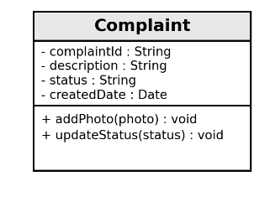 | A rectangle divided into three compartments — class name, attributes (with visibility and type), and operations (with signature and return type). Used for every entity in the system, e.g. Complaint, Department, Assignment.
Abstract Class | 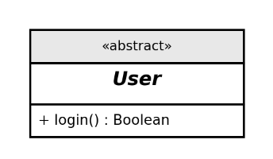 | A class box whose name is shown in italics and/or tagged with the «abstract» stereotype, indicating it cannot be instantiated directly and only serves as a base for subclasses. Used for the User class.
Generalization / Inheritance | 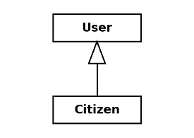 | A solid line ending in a hollow triangular arrowhead pointing at the parent (super) class. Used to show that Administrator, MunicipalOfficer, Citizen and FieldWorker all inherit from the abstract User class.
Association | 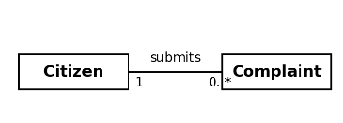 | A solid line connecting two classes that collaborate, usually labelled with a verb phrase and multiplicities at each end. Used, e.g., between Citizen (1) and Complaint (0..*) labelled “submits”.
Aggregation | 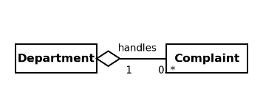 | A solid line with a hollow (unfilled) diamond at the “whole” end, representing a weak “has-a” relationship where the part can exist independently of the whole. Used between Department (whole) and Complaint (part) labelled “handles”.
Composition | 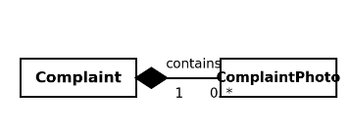 | A solid line with a filled (solid black) diamond at the “whole” end, representing a strong “owns-a” relationship where the part cannot exist without the whole. Used between Complaint (whole) and ComplaintPhoto (part) labelled “contains”, since a photo cannot exist without its complaint.
Multiplicity |  | Numbers or ranges (1, 0..*, 1..*) placed near the ends of an association line, indicating how many instances of one class relate to one instance of the other. E.g. “1” Citizen to “0..*” Complaint means one citizen can submit many complaints.
Dependency | 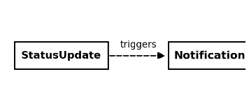 | A dashed line with an open arrowhead pointing from the dependent class to the class it depends on, showing a weaker, often transient relationship. Used between StatusUpdate and Notification, since a status update triggers a notification without permanently owning it.
3. Advantages and Disadvantages
Advantages | Disadvantages
1. Provides a precise blueprint of the system's data structure, which can be mapped almost directly to code (classes, attributes, methods) or a database schema. | 1. Does not capture dynamic/runtime behaviour such as the order of operations, so it must be paired with sequence or activity diagrams for that.
2. Clearly documents relationships (association, aggregation, composition, inheritance) so the strength and nature of coupling between entities is unambiguous. | 2. Large systems can produce very complex diagrams with many classes and relationships, reducing readability.
3. Improves reusability and maintainability by highlighting shared behaviour through generalization (e.g. the abstract User class). | 3. Designing an accurate class diagram requires good domain understanding; incorrect multiplicities or relationship types can mislead implementation.
4. Acts as a common reference for developers, testers and database designers throughout the project lifecycle. | 4. Frequent changes in requirements mean the class diagram must be kept in sync with code, which adds maintenance overhead.
5. Helps detect design flaws (redundant classes, missing relationships, wrong multiplicities) early, before coding begins. | 5. It shows only the static structure and provides no information about performance, concurrency, or error-handling concerns.

4. Output
