EAPERIMENT -5
AIM: Develop Activity and State Transition diagram for the project using any opensource tool.
A. Activity Diagram
An Activity Diagram is a UML (Unified Modeling Language) behavioral diagram used to represent the workflow of a system or process. It shows how different activities are performed step-by-step, from the starting point to the final outcome.
It is similar to a flowchart, but it is specifically used in software engineering to model the flow of activities, decisions, and actions within a system.
Main Purpose
Activity diagrams are used to:
- Represent the workflow of a system.
- Show the sequence of activities.
- Display decision-making conditions.
- Show different possible paths in a process.
- Understand how users and the system interact during a process.
Main Notations Used
- Initial Node (●): Represents the starting point of the process.
- Activity/Action: Represents an operation or task being performed.
- Control Flow (→): Shows the direction of the process.
- Decision Node (◇): Represents a condition where the process can follow different paths.
- Merge Node: Combines different alternative paths into one.
- Final Node (◎): Represents the end of the process.
- Fork and Join: Used when multiple activities occur simultaneously.

Activity Diagram in PIIT Project
- In the Public Infrastructure Issue Tracker (PIIT) system, an Activity Diagram represents the workflow of a complaint. The process starts when a citizen submits a complaint. The system validates the complaint details and forwards it to the appropriate authority.
- The municipal officer reviews and verifies the complaint. If the complaint is valid, it is assigned to the relevant department and then to a field worker. The field worker performs the required work and updates the progress. After completion, the work is reviewed and verified. Once approved, the complaint is marked as resolved and the citizen is notified.
- If the complaint is invalid, incomplete, or requires additional work, the process follows an alternative path until the issue is properly handled.
Step | Actor/Component | Activity | Description
1 | Citizen | Register / Login | The citizen registers as a new user or logs into the PIIT system.
2 | Citizen | Submit Complaint | The citizen submits a complaint along with issue details, image, and location.
3 | System | Validate Complaint Details | The system checks whether the submitted complaint information is complete and valid.
4 | System | Valid Complaint? | The system makes a decision based on the validity of the complaint.
5 | System / Citizen | Show Error / Retry | If the complaint is invalid or incomplete, an error is shown and the citizen can correct and resubmit it.
6 | System | Store Complaint Details | If valid, the complaint information is stored in the Complaint Database.
7 | System | Generate Complaint ID & Acknowledgment | The system generates a unique Complaint ID and sends an acknowledgment to the citizen.
8 | Citizen | Receive Acknowledgment | The citizen receives confirmation that the complaint has been successfully registered.
9 | Municipal Officer | View New Complaints | The Municipal Officer views newly submitted complaints from the Complaint Database.
10 | Municipal Officer | Review Complaint | The officer examines the complaint and decides whether it should be assigned for resolution.
11 | Municipal Officer | Assign Complaint? | A decision is made whether to assign the complaint to a Field Worker.
12 | Municipal Officer | Assign to Field Worker | If approved, the complaint is assigned to the appropriate Field Worker.
13 | System | Update Status (Assigned) | The system updates the complaint status as Assigned in the Complaint Status Database.
14 | Municipal Officer / System | Reject / Close Complaint | If the complaint is not approved, its status is updated as Rejected or Closed.
15 | Field Worker | View Assigned Complaint | The Field Worker views the complaint and its issue details.
16 | Field Worker | Resolve Complaint | The Field Worker performs the required work to resolve the public infrastructure issue.
17 | Field Worker | Upload Resolution Details / Proof | The Field Worker uploads resolution details and supporting proof such as images or videos.
18 | System | Update Complaint Status | The system updates the complaint status after the resolution work is completed.
19 | System | Notify Citizen | The system sends a notification to inform the citizen about the complaint update.
20 | Citizen | Receive Notification | The citizen receives the notification regarding the complaint status or resolution.
21 | Citizen | View / Track Complaint Status | The citizen can check the current progress and status of the complaint.
22 | Citizen | View Final Resolution | The citizen views the final resolution details and proof of completed work.
23 | System | End Process | The complaint resolution process is completed and reaches the final state.
Advantages of Activity Diagram
- Easy to Understand
It provides a simple visual representation of the workflow of a system.
- Shows Complete Process Flow
It clearly shows the sequence of activities from the start to the end of a process.
- Represents Decision Making
Decision points and alternative paths can be easily represented.
- Identifies User Responsibilities
Swimlanes can show which user or component is responsible for each activity.
- Helps in System Analysis
It helps developers understand the business process and system requirements before implementation.
- Useful for Communication
Both technical and non-technical users can understand the workflow easily.
- Helps Identify Errors
Missing steps, unnecessary activities, and possible process problems can be identified.
Disadvantages of Activity Diagram
- Can Become Complex
Large systems with many activities can make the diagram difficult to understand.
- Limited Detail
It shows the workflow but does not explain detailed implementation or program logic.
- Difficult to Modify Large Diagrams
Changes in a complex process may require significant modifications to the diagram.
- Not Suitable for Showing Data Structure
Activity diagrams focus on activities and workflow rather than database structure or object relationships.
- Can Be Time-Consuming
Creating detailed diagrams for complex systems may require considerable time.
- May Become Confusing
Too many decisions, parallel flows, and arrows can reduce readability.
OUTPUT

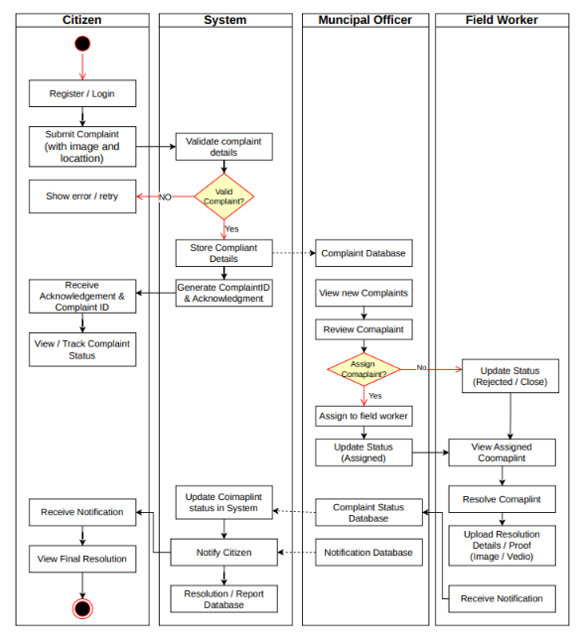

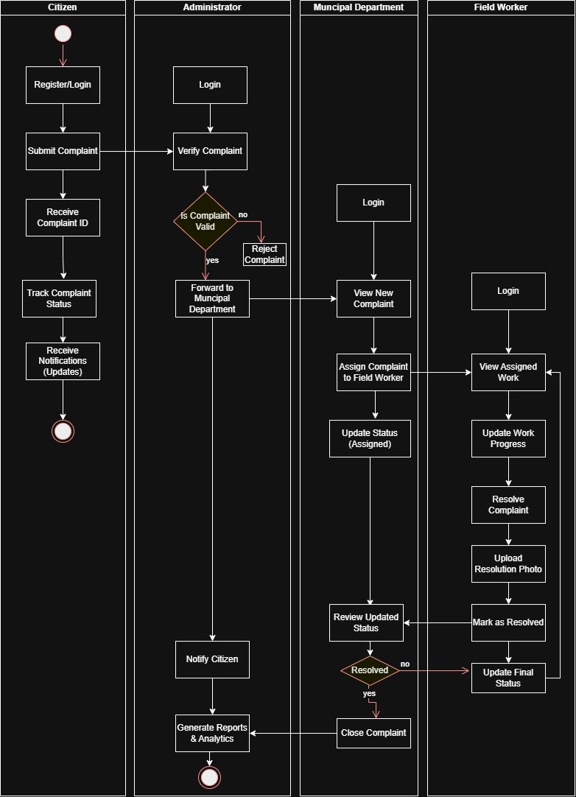

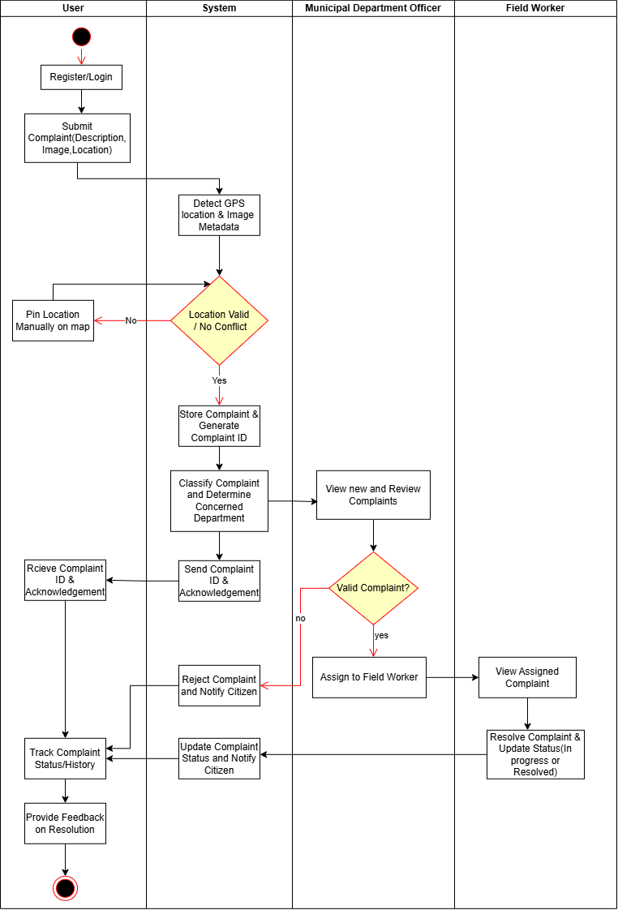

B. State Transaction Diagram
A State Transition Diagram (STD) is a behavioral diagram used to represent the different states of an object or system and the changes that occur between those states.
it shows:
Current State → Event/Condition → Next State
An object does not remain in the same condition throughout its life cycle. It changes its state when a particular event occurs. A State Transition Diagram visually represents these changes.
For example:
New → Processing → Completed
Here, the object changes from one state to another based on actions or events.
Main Components of a State Transition Diagram
Component | Description
Initial State | Represents the starting point of the process, usually shown using a filled black circle (●).
State | Represents a particular condition or situation of an object.
Transition | Shows the movement from one state to another using an arrow.
Event | An action or occurrence that causes a state to change.
Condition/Guard | A condition that determines whether a transition can take place.
Final State | Represents the end of the process, usually shown using a circle with a filled dot (◎).

Purpose of State Transition Diagram
A State Transition Diagram is used to:
- Show the complete life cycle of an object.
- Represent different possible states of a system.
- Show how events cause changes between states.
- Identify valid and invalid transitions.
- Represent normal and alternative flows.
- Help developers understand the dynamic behavior of a system.

State Transition Diagram for the PIIT Project
In the Public Infrastructure Issue Tracker (PIIT) system, the State Transition Diagram represents the different stages through which a complaint passes, from submission until final closure.
Current State | Event / Condition | Next State | Explanation
Start | Citizen submits complaint | Submitted | The complaint lifecycle begins when the citizen submits a complaint.
Submitted (Pending Validation) | [Invalid] Retry | Submitted | If the submitted complaint is invalid, the citizen corrects the details and retries submission.
Submitted (Pending Validation) | [Valid] Store & Generate ID | Registered | A valid complaint is stored in the Complaint Database and a Complaint ID is generated.
Registered (Complaint Database) | Officer reviews complaint | Under Review | The Municipal Officer starts reviewing the registered complaint.
Under Review | [Incomplete] | Needs More Info | If the complaint information is incomplete, additional details are requested from the citizen.
Needs More Info (Awaiting Citizen) | Information received | Registered | After receiving the required information, the complaint returns to the registered stage.
Under Review | [Not Approved] Reject | Rejected | If the complaint is not approved, it is rejected.
Under Review | [Approved] Assign | Assigned | If approved, the complaint is assigned to a Field Worker.
Rejected | Re-evaluate | In Progress | According to your diagram, a rejected complaint can be re-evaluated and moved forward for further action.
Assigned (Field Worker) | Field worker starts work | In Progress | The Field Worker begins working on resolving the infrastructure issue.
In Progress | SLA breached / Escalate | Escalated | If the issue is delayed beyond the allowed time, the complaint is escalated.
Escalated (SLA Breach) | Reassign | Assigned | The escalated complaint can be reassigned to a Field Worker.
In Progress | Work completed and proof uploaded | Resolved | After completing the work, the Field Worker uploads proof and the complaint moves to the resolved state.
Resolved (Pending Confirmation) | [Confirmed] Close | Closed | Once the resolution is confirmed, the complaint is officially closed.
Resolved | Issue persists / Reopen | Reopened | If the issue still exists or further action is required, the complaint is reopened.
Reopened | Re-evaluation | In Progress | The complaint returns for additional work and resolution.
Closed (Notified) | Notify citizen | End | The citizen is notified, and the complaint lifecycle is completed.

Simple Complaint Lifecycle
Start → Submitted → Registered → Under Review → Assigned → In Progress → Resolved → Closed → End
This State Transition Diagram helps clearly understand how a complaint changes from one status to another throughout its lifecycle in the PIIT system.
OUTPUT

