**Screenshots of Module 2 Task**

**Subtask 2: Resource Groups: --**

* Screenshot of the Bash terminal showing variables set for both permanent and temporary resource groups.

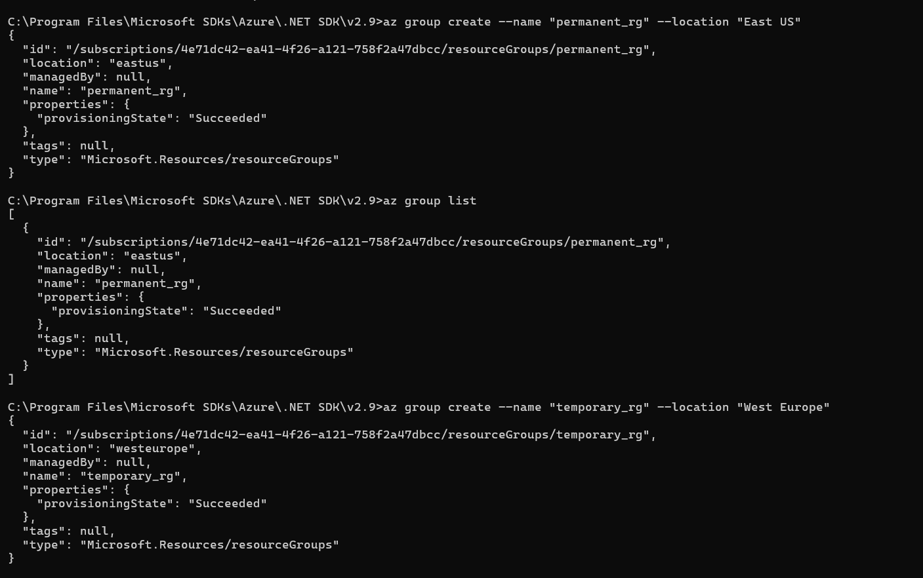

* Screenshot of the az group list command and its output, listing available resource groups.

* Screenshot of the az group list command and its output, formatted as a table.

* Screenshot of the az group show command and its output for the permanent resource group.

* Screenshot of the az group list command and its output, filtered by location.

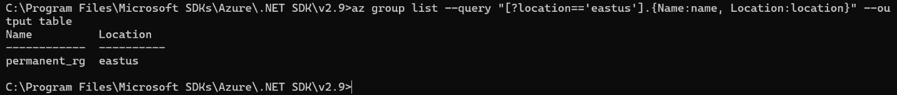

* Screenshot of saving the permanent resource group ID to a variable.

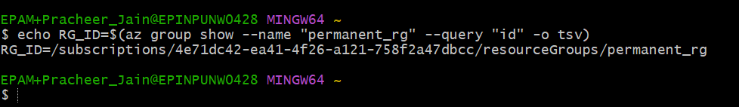

* Screenshot of the successful deletion of the temporary resource group.

* Screenshot of the az group list command and its output after deletion, showing only the permanent resource group.

**Subtask 3: Azure Container Registry: --**

* Screenshot of setting a variable for the Azure Container Registry name.

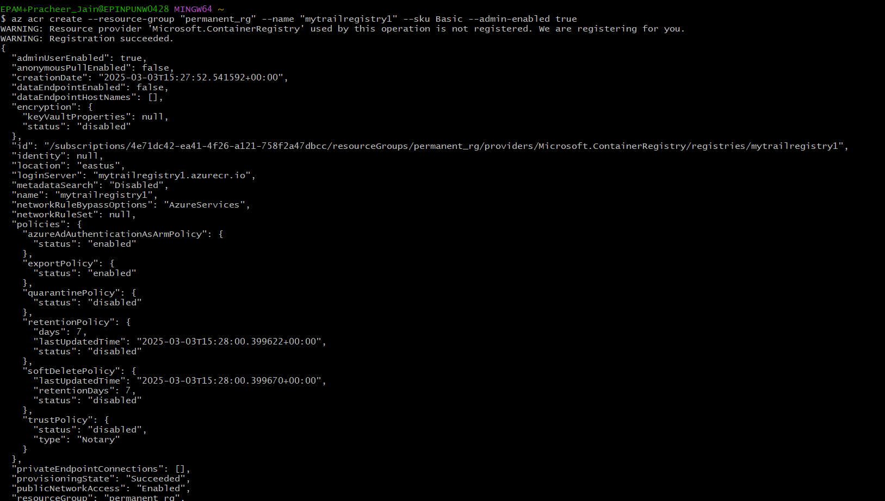

* Screenshot of the successful creation of an Azure Container Registry.



* Screenshot of the az resource list command and its output, showing the created Azure Container Registry.

**Subtask 6: Creating a Web App in Azure App Services: --**

* + Screenshots of the Bash terminal showing:
    - Creation of a temporary resource group.

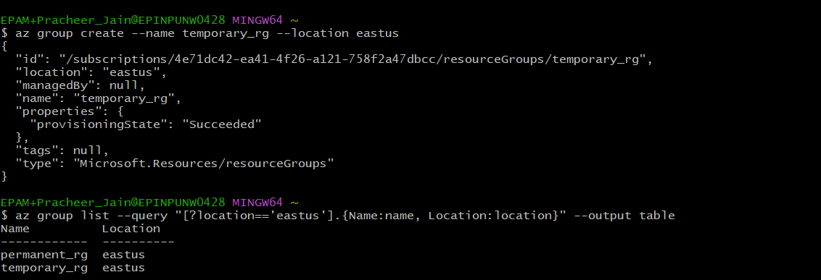

* + - Creation of an App Service plan.

* + - Creation of a web app and deployment of the container image.

* + - Successful deletion of the temporary resource group.

* + Screenshot of the web app running in a web browser.

