1. Create an Instance of Application Insights
   * Screenshot showing the creation of an Application Insights instance in the Azure portal.

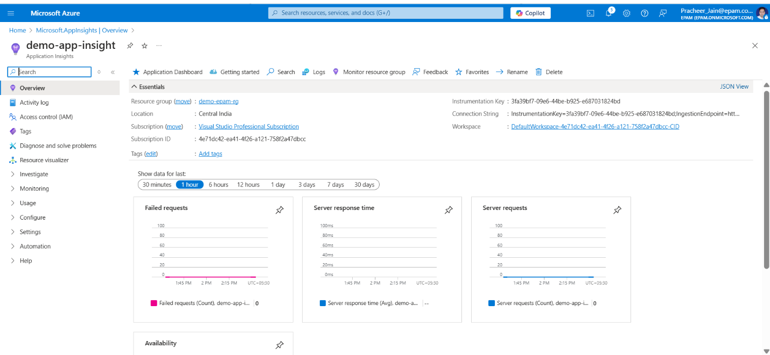

1. Enable Connection to Application Insights
   * Screenshot demonstrating integration with Application Insights.

* + Screenshots of the deployed PetStore services with enabled Application Insights connections.

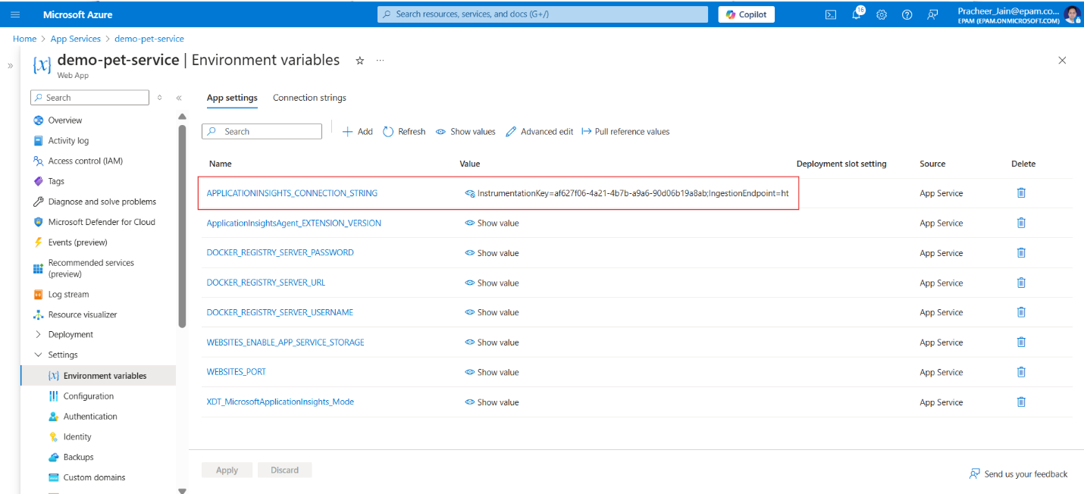

1. Browse the Pet Store Website
   * Screenshots capturing the process of adding multiple products to the shopping cart on the Pet Store website.

1. Check Application Insights
   * Screenshots of the Application Insights dashboard:
     + Overview tab displaying incoming requests and failures.

* + - Live metrics tab displaying real-time metrics.

* + - Transaction search results.

* + - Performance metrics relevant to the PetStore services.

1. Implement Changes in the Code
   * Screenshot of the added custom metric in PetStoreServiceImpl.getProducts().

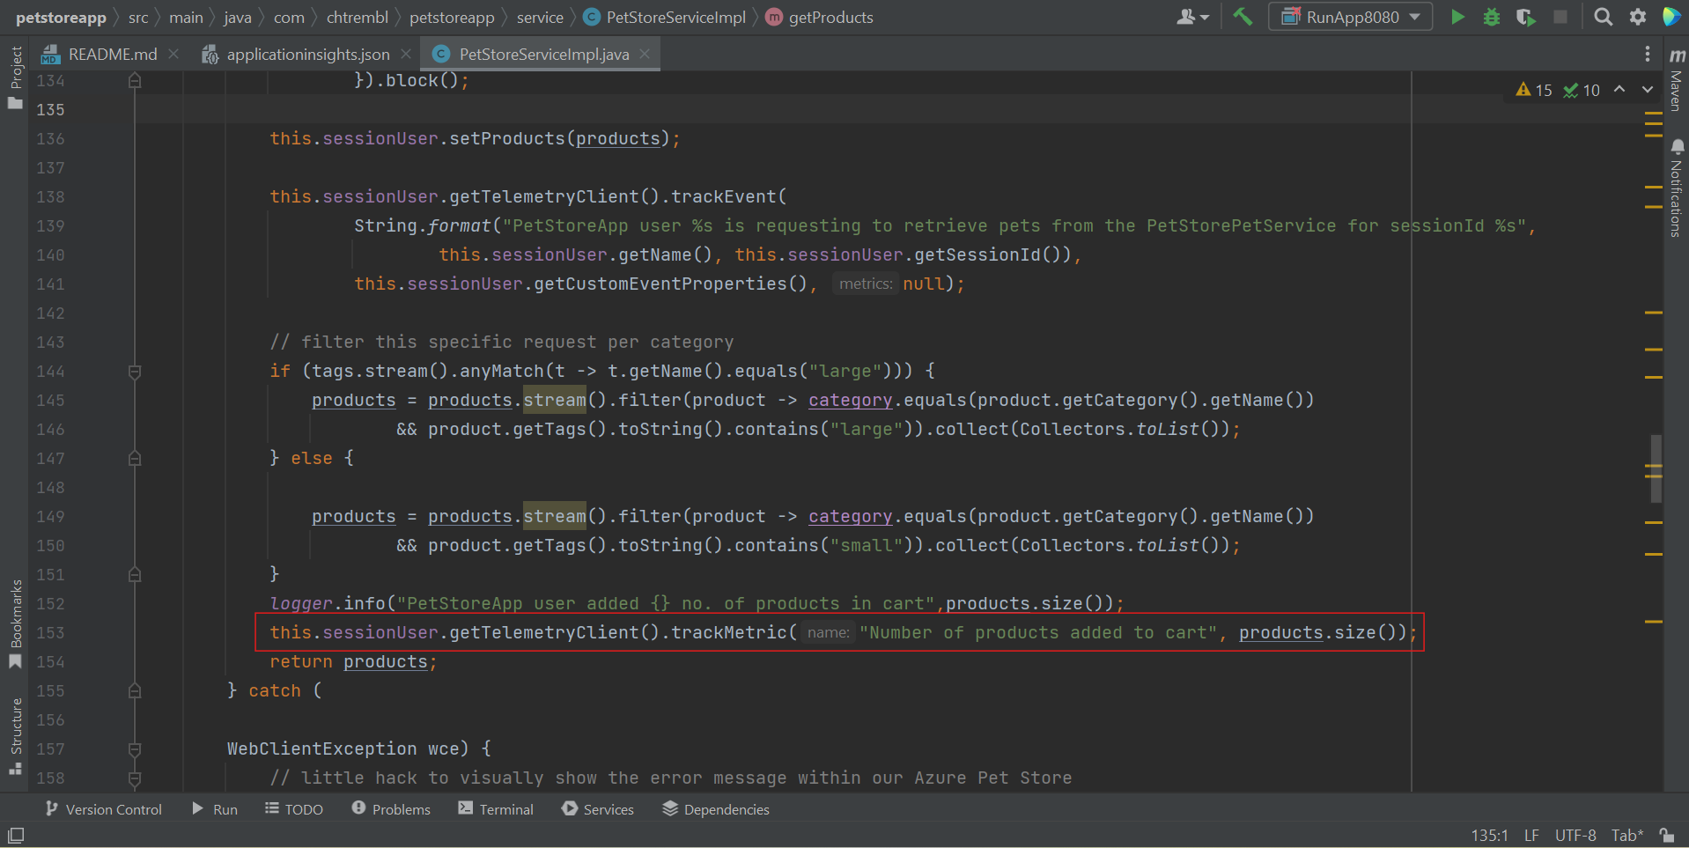

* + Screenshot showing added logging for the number of returned items.

* + Screenshots of the deployed PetStore services with implemented code changes.

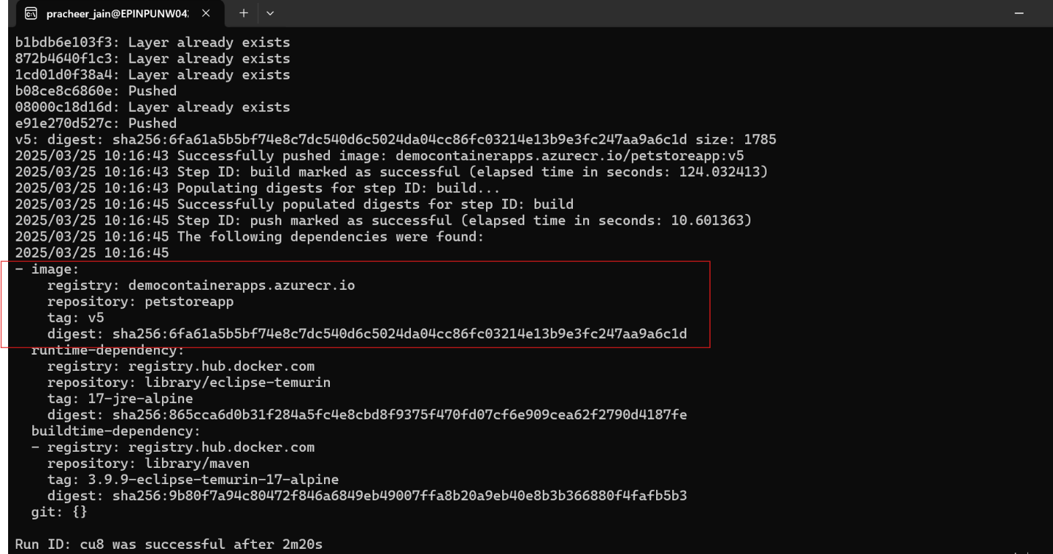

1. Examine Logs and Custom Events
   * Screenshots of Application Insights displaying logged events and custom metrics.

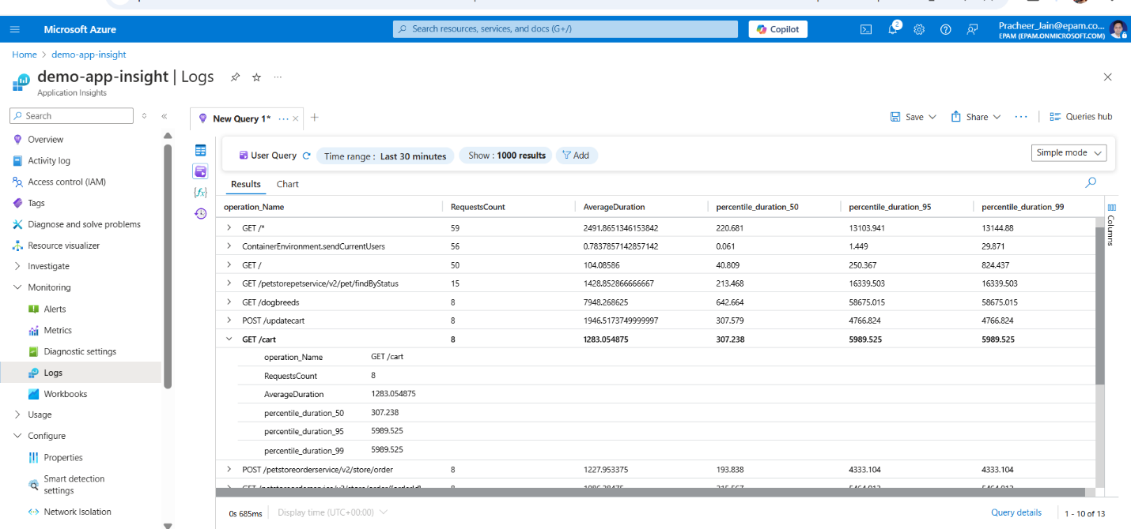

1. Use Kusto Query to Filter Logs
   * Screenshot of a Kusto query filtering logs by the current session ID.

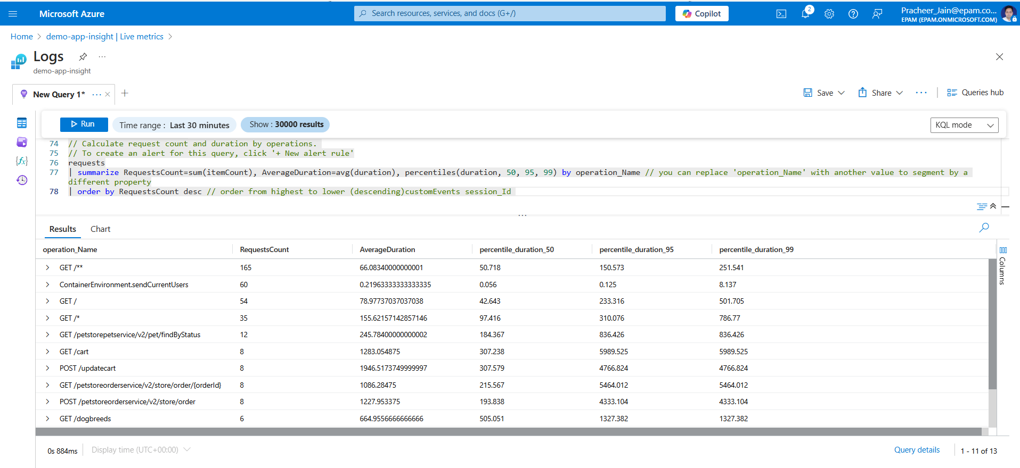

1. Introduce an Error in the Code
   * Screenshot of the code with the introduced error line.

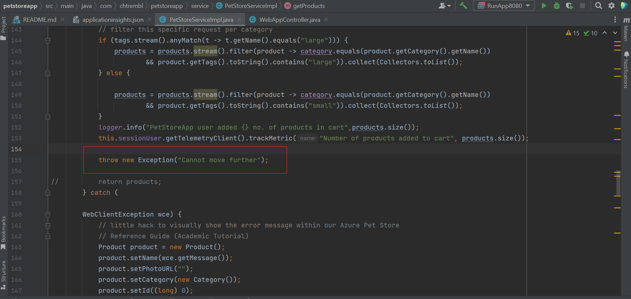

1. Redeploy Service and Check Logs
   * Screenshots of the deployed PetStore services with the introduced error.



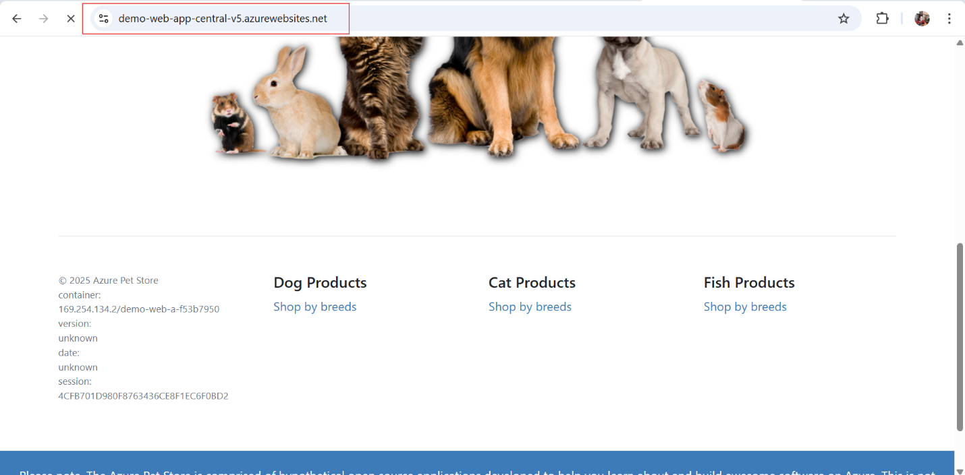

* + Screenshots of Application Insights displaying logs related to the error.

1. Use Kusto Query to Count Exceptions

* Screenshot of a Kusto query counting exceptions with specific error messages.

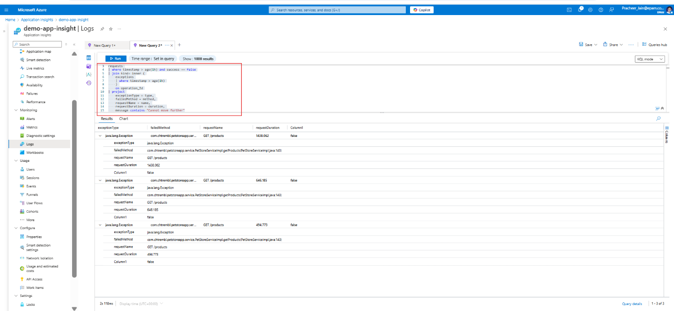

1. Examine Error in Detail

* Screenshot of the "Failures" tab in Application Insights displaying the stack trace of the error.

