SonarQube + SonarScanner Setup and Java Project Analysis

Install SonarQube
- Download SonarQube
- Open the SonarQube website.
- Go to the Download section.
- Download the SonarQube Community Build for Windows as a ZIP file.
- Save the ZIP file on your computer.
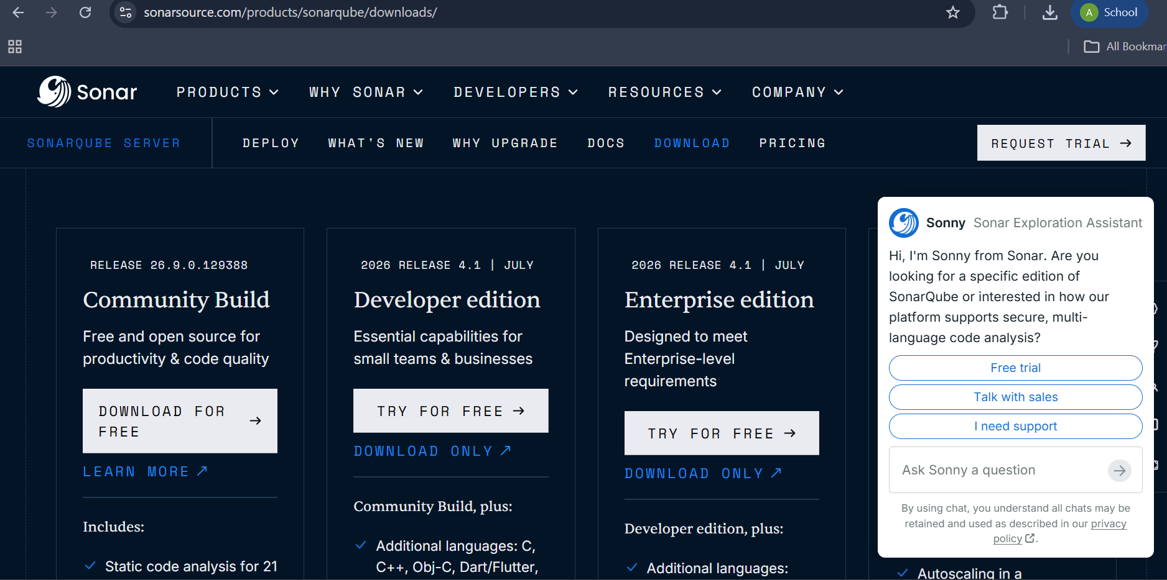

2. Start SonarQube
Open Command Prompt and go to the SonarQube Windows executable folder. Start the SonarQube server and keep this Command Prompt window running while analysis is performed.
Step 1: Open the SonarQube Windows folder
cd C:\Users\DELL\sonarqube-26.9.0.129388\bin\windows-x86-64
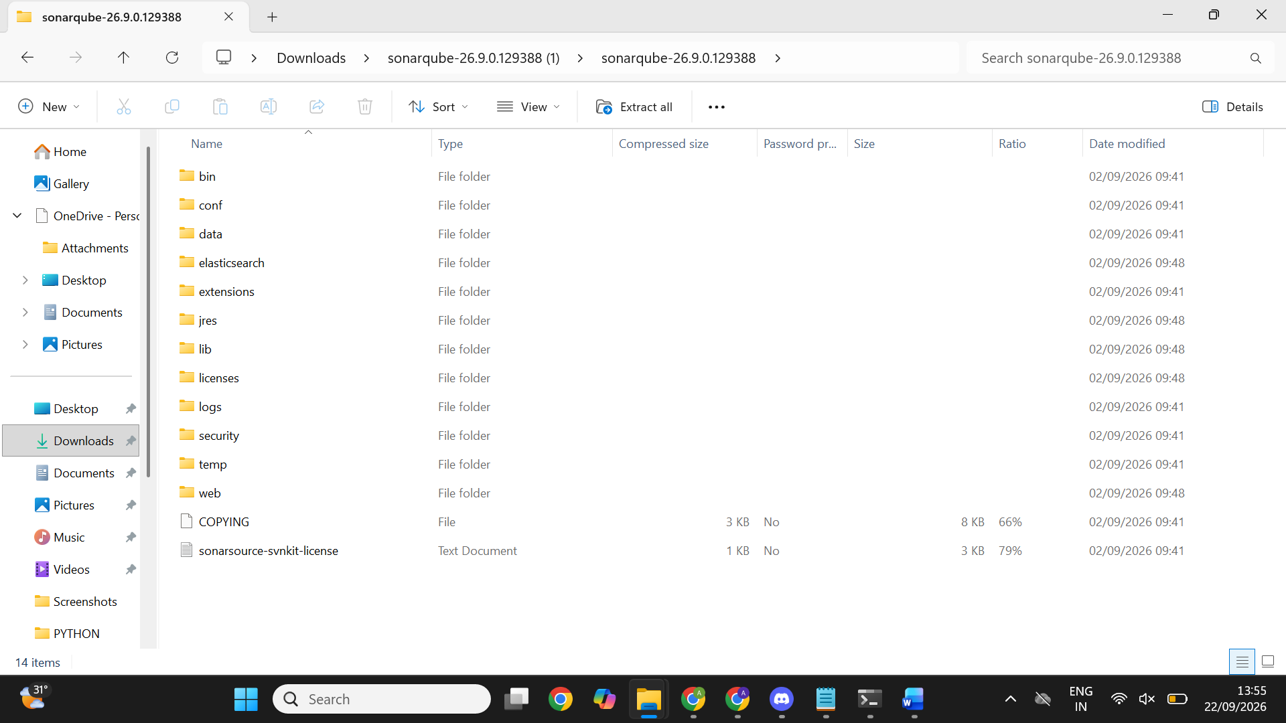
Step 2: Start SonarQube
StartSonar.bat
Wait until the log shows that SonarQube is operational. Then open http://localhost:9000 in a browser.

3. Create the SonarQube Project
Log in to SonarQube and create the project used for analysis.
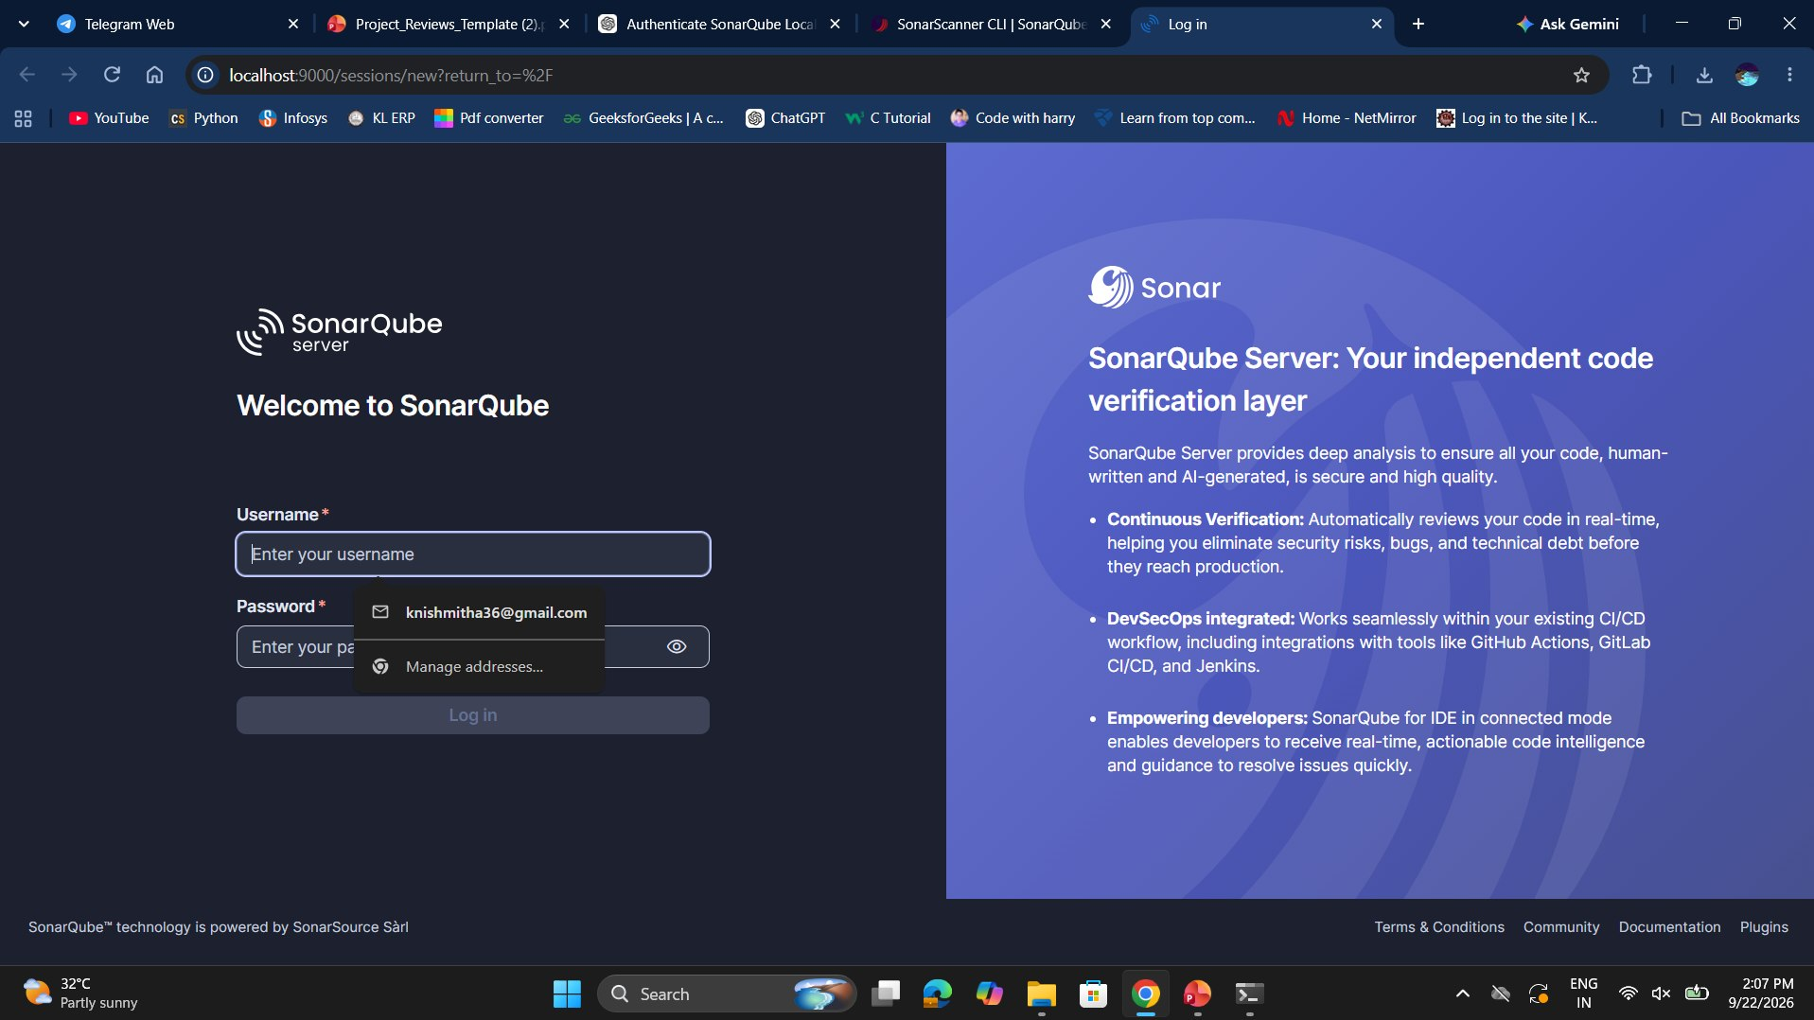

Step 3: Create the project
Create a project named QualityDemo1 and use QualityDemo1 as the project key.
The project page used in this setup was the local analysis page for QualityDemo1.

4. Generate a SonarQube Token
A token is required so SonarScanner can authenticate with the local SonarQube server.
Step 4: Open the account/security area
In SonarQube, open the profile/account area and go to the Security section.
Step 5: Generate a token
Create a token such as QualityDemoScanner and copy it when SonarQube displays it.
Security note: Never include a real token in screenshots, reports, source files, or documents. If a token is accidentally exposed, revoke it and generate a fresh token.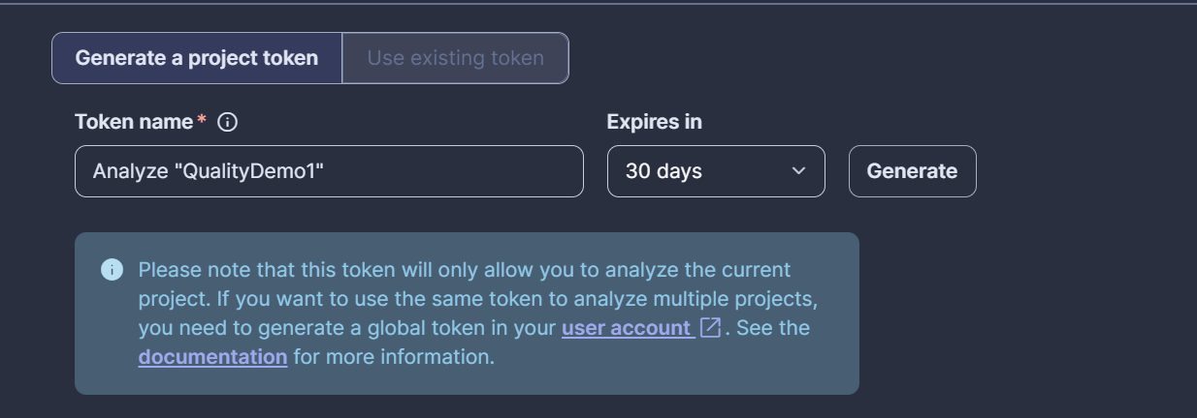

5. Download and Extract SonarScanner CLI
Download the Windows x64 SonarScanner CLI ZIP and extract it.
Step 6: Extract SonarScanner
The scanner was extracted so the actual installation folder became:
C:\sonar-scanner\sonar-scanner-8.1.0.6389-windows-x64
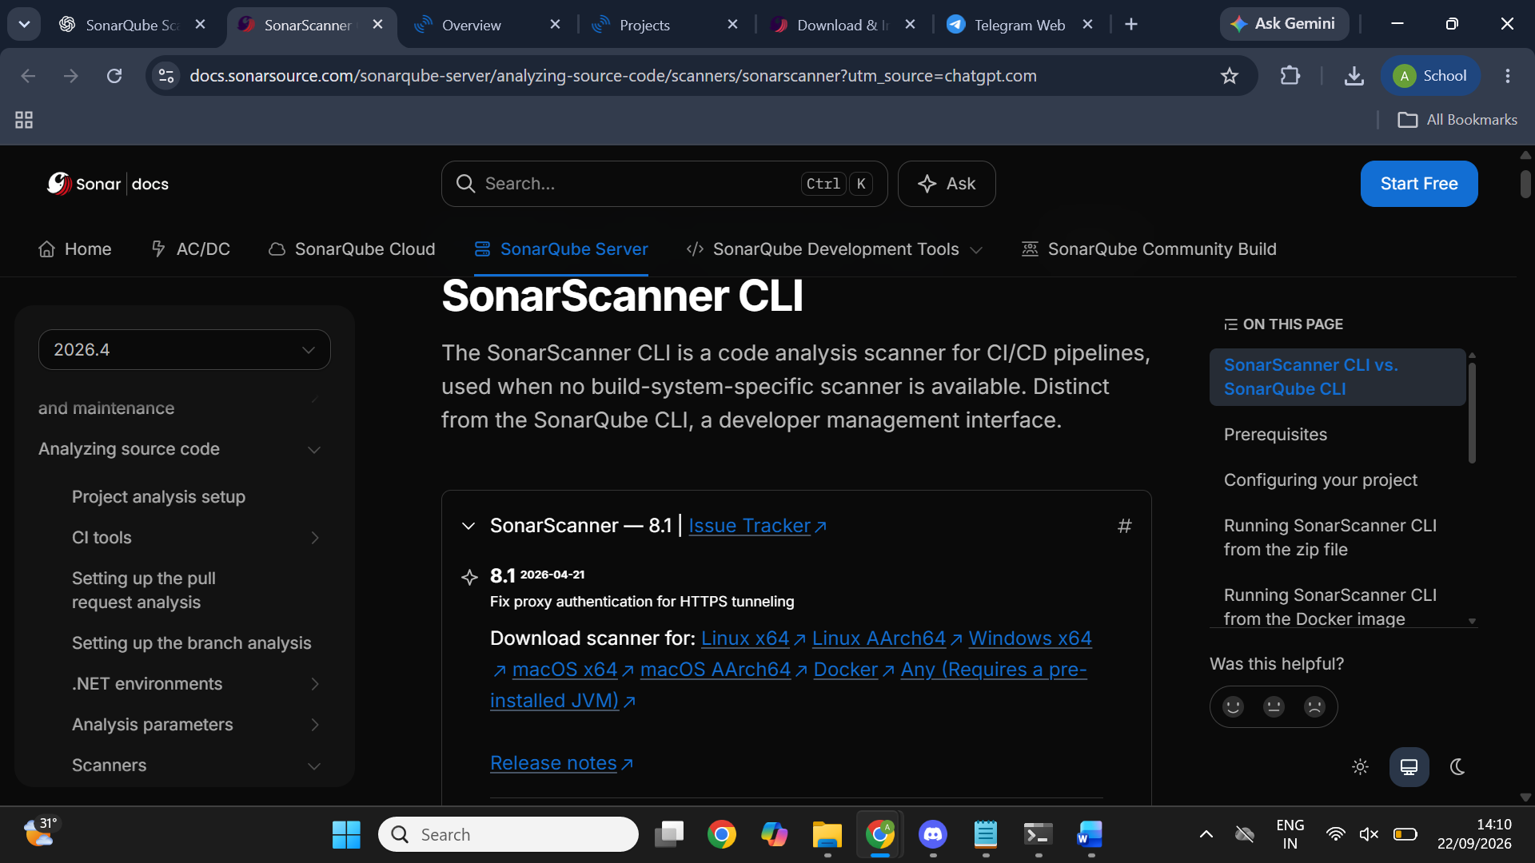

6. Add SonarScanner to PATH
The correct directory to add to the Windows PATH is the scanner's actual bin directory.
Step 7: Add the scanner bin directory to PATH
Add this directory to the Windows PATH environment variable:
C:\sonar-scanner\sonar-scanner-8.1.0.6389-windows-x64\bin
Close the old Command Prompt and open a new one so the updated PATH is loaded.
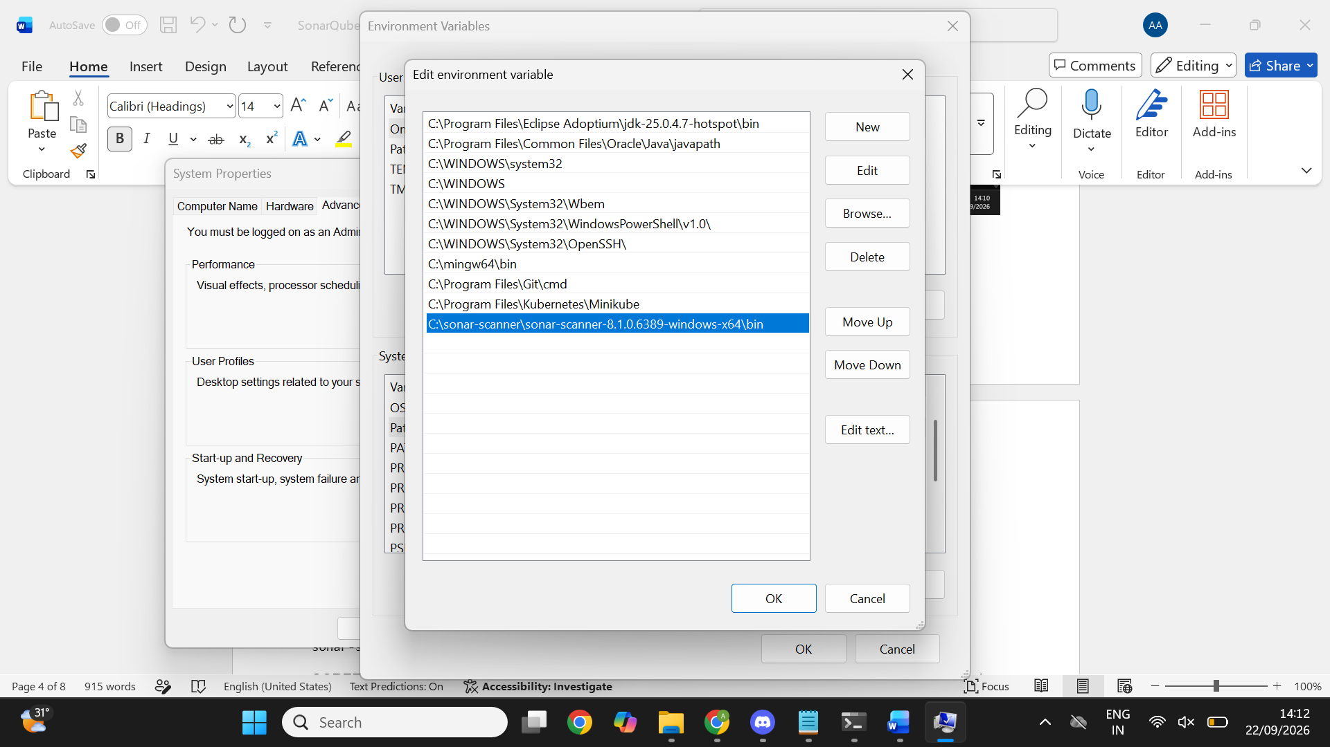
Step 8: Verify PATH
sonar-scanner -v.

7. Create the Local Java Project
Step 9: Create the project folders
mkdir C:\SonarProjects
mkdir C:\SonarProjects\QualityDemo
cd /d C:\SonarProjects\QualityDemo
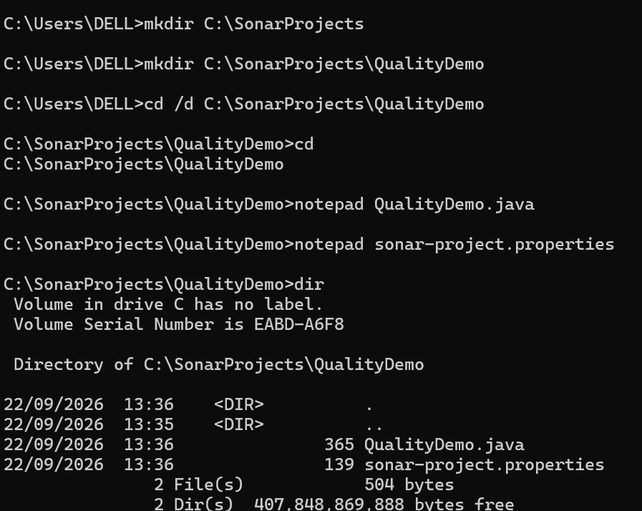
Step 10: Create QualityDemo.java
Run the following command and paste the Java code into Notepad:
notepad QualityDemo.java
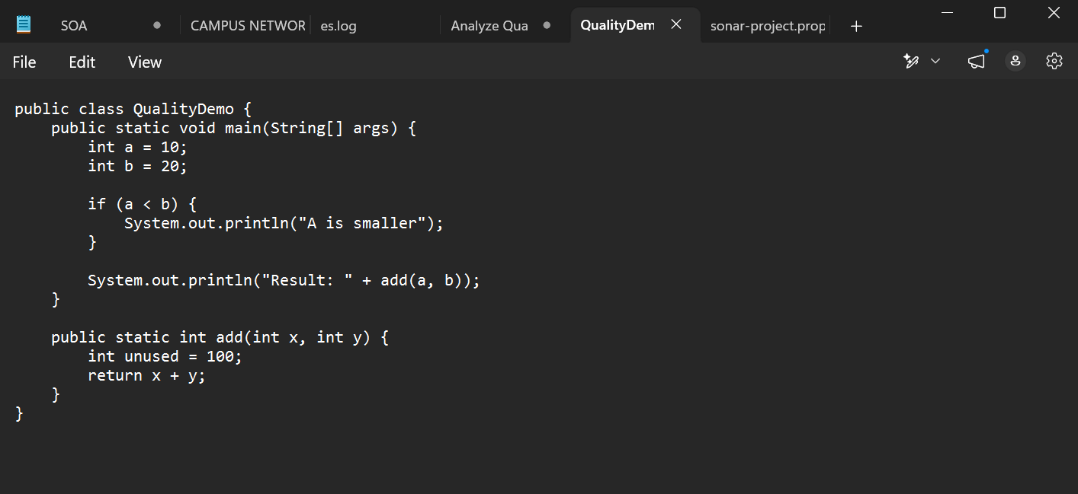

8. Create sonar-project.properties
Inside C:\SonarProjects\QualityDemo, create the file sonar-project.properties.
Step 11: Open the properties file
notepad sonar-project.properties
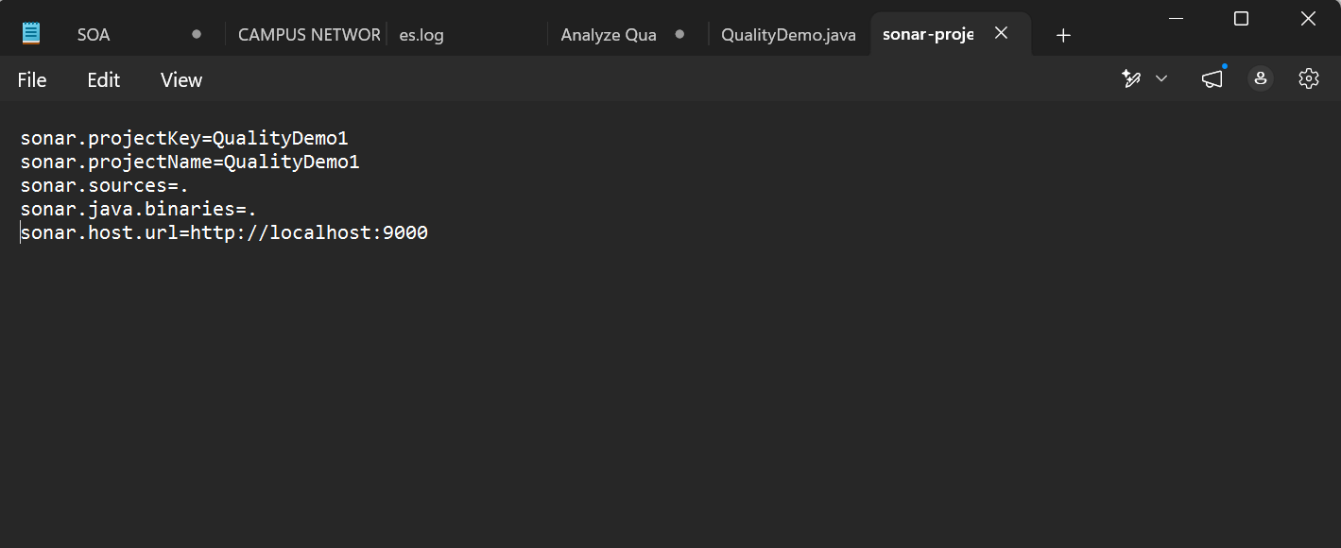

9. Compile the Java Project
Step 12: Go to the project folder
cd /d C:\SonarProjects\QualityDemo
Step 13: Compile the Java source
javac QualityDemo.java
Step 14: Check the files
Dir
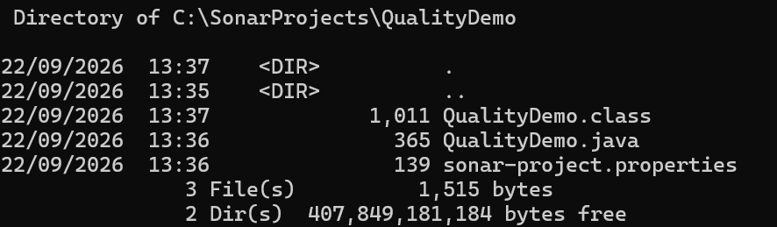

10. Set the SonarQube Token
In the same Command Prompt, set the fresh token as an environment variable. Replace the placeholder locally with the actual token; do not paste the real token into this document.
Step 15: Set SONAR_TOKEN

11. Run SonarScanner

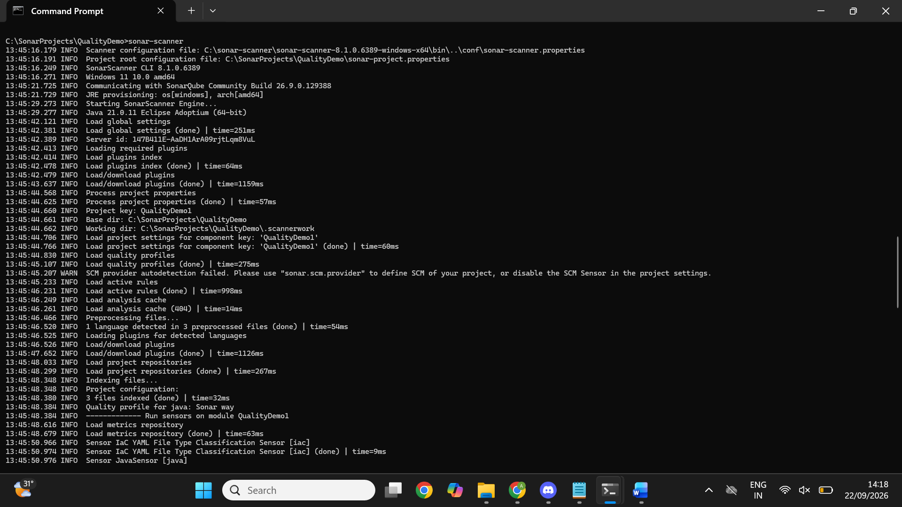
Step 16: Run the analysis
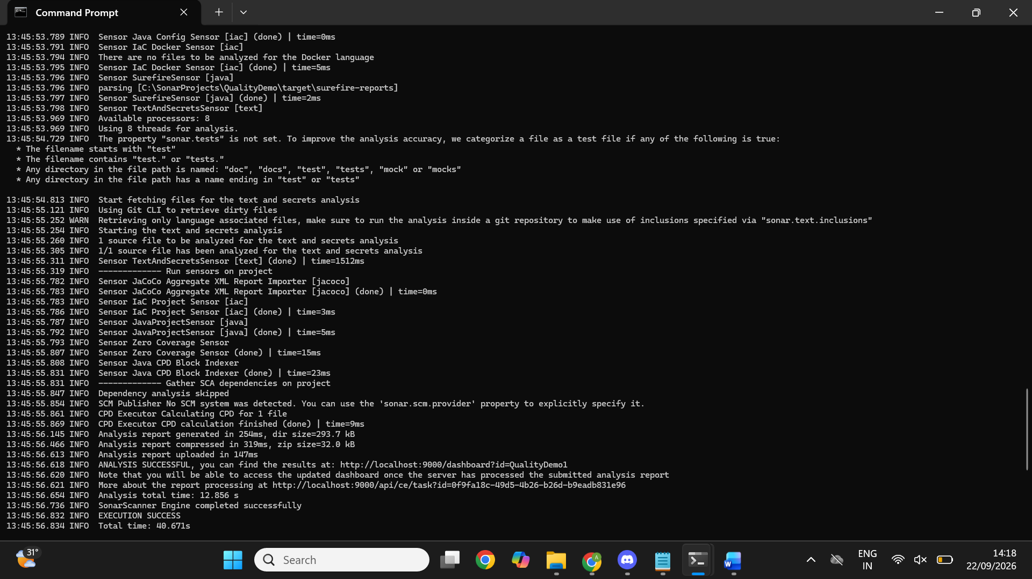

12. View the SonarQube Results
Step 17: Open the SonarQube Projects page
http://localhost:9000/projects
Step 18: Open QualityDemo1
Click the QualityDemo1 project.
The completed analysis in this setup showed: Quality Gate Passed; Security A with 0 issues; Reliability A with 0 issues; Maintainability B with 5 issues; Coverage 0.0%; and Duplications 0.0%.
The project card also showed 14 lines of Java code at the time of the successful analysis.
