**Experiment No. 11**

**Title:** Program to demonstrate data frame creation and Manipulation using Pandas **Aim:** To study and implement data frame creation and Manipulation using Pandas **Objective**: To introduce Pandas package for python

**Theory:**

Pandas is an open-source library that is built on top of NumPy library. It is a Python package that offers various data structures and operations for manipulating numerical data and time series. It is mainly popular for importing and analyzing data much easier. Pandas is fast and it has high-performance & productivity for users.

**Code:**

import pandas

mydataset = {

'cars': ["BMw","Volvo","Ford"],

'passings':[3,7,2]

}

myvar = pandas.DataFrame(mydataset)

print(myvar)

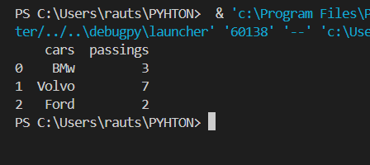

**Create Labels**

import pandas as pd

a = [1,7,2]

myvar = pd.Series(a,index=["x","y","z"])

print(myvar)

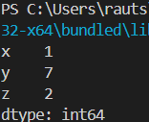

**Data Frames**

import pandas as pd

data = {

"calories":[420,380,390],

"duration":[50,40,45]

}

myvar = pd.DataFrame(data)

print(myvar)

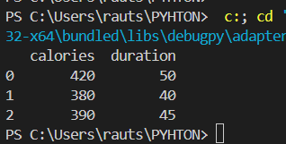

Read CSV Files

import pandas as pd

pd.options.display.max_rows = 90

df = pd.read_csv('File.csv')

print(df)

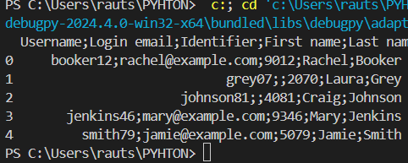

**Conclusion:** Dataframes have been created and manipulated using Pandas