Experiment No. 8

Title: Creating GUI with python containing widgets such as labels, textbox, radio, checkboxes and custom dialog boxes

Aim: To study and create GUI with python containing widgets such as labels, textbox, radio, checkboxes and custom dialog boxes

Objective: To introduce GUI, TKinter in python

Theory:

Python offers multiple options for developing GUI (Graphical User Interface). Out of all the GUI methods, tkinter is the most commonly used method. It is a standard Python interface to the Tk GUI toolkit shipped with Python. Python with tkinter is the fastest and easiest way to create the GUI applications. Creating a GUI using tkinter is an easy task.

To create a tkinter app:

Importing the module – tkinter

Create the main window (container)

Add any number of widgets to the main window

Apply the event Trigger on the widgets.

Importing tkinter is same as importing any other module in the Python code. Note that the name of the module in Python 2.x is ‘Tkinter’ and in Python 3.x it is ‘tkinter’.

**Code:**

import tkinter as tk

from tkinter import messagebox

def show_dialog():

messagebox.showinfo("Custom Dialog", "This is a custom dialog box!")

def main():

root = tk.Tk()

root.title("GUI with tkinter")

label1 = tk.Label(root, text="Label 1")

label1.pack()

label2 = tk.Label(root, text="Label 2")

label2.pack()

textbox = tk.Entry(root)

textbox.pack()

radio_var = tk.StringVar()

radio_var.set("Option 1")

radio1 = tk.Radiobutton(root, text="Option 1", variable=radio_var, value="Option 1")

radio1.pack()

radio2 = tk.Radiobutton(root, text="Option 2", variable=radio_var, value="Option 2")

radio2.pack()

checkbox1 = tk.Checkbutton(root, text="Checkbox 1")

checkbox1.pack()

checkbox2 = tk.Checkbutton(root, text="Checkbox 2")

checkbox2.pack()

dialog_button = tk.Button(root, text="Show Dialog", command=show_dialog)

dialog_button.pack()

root.mainloop()

if __name__ == "__main__":

main()

**Output:**

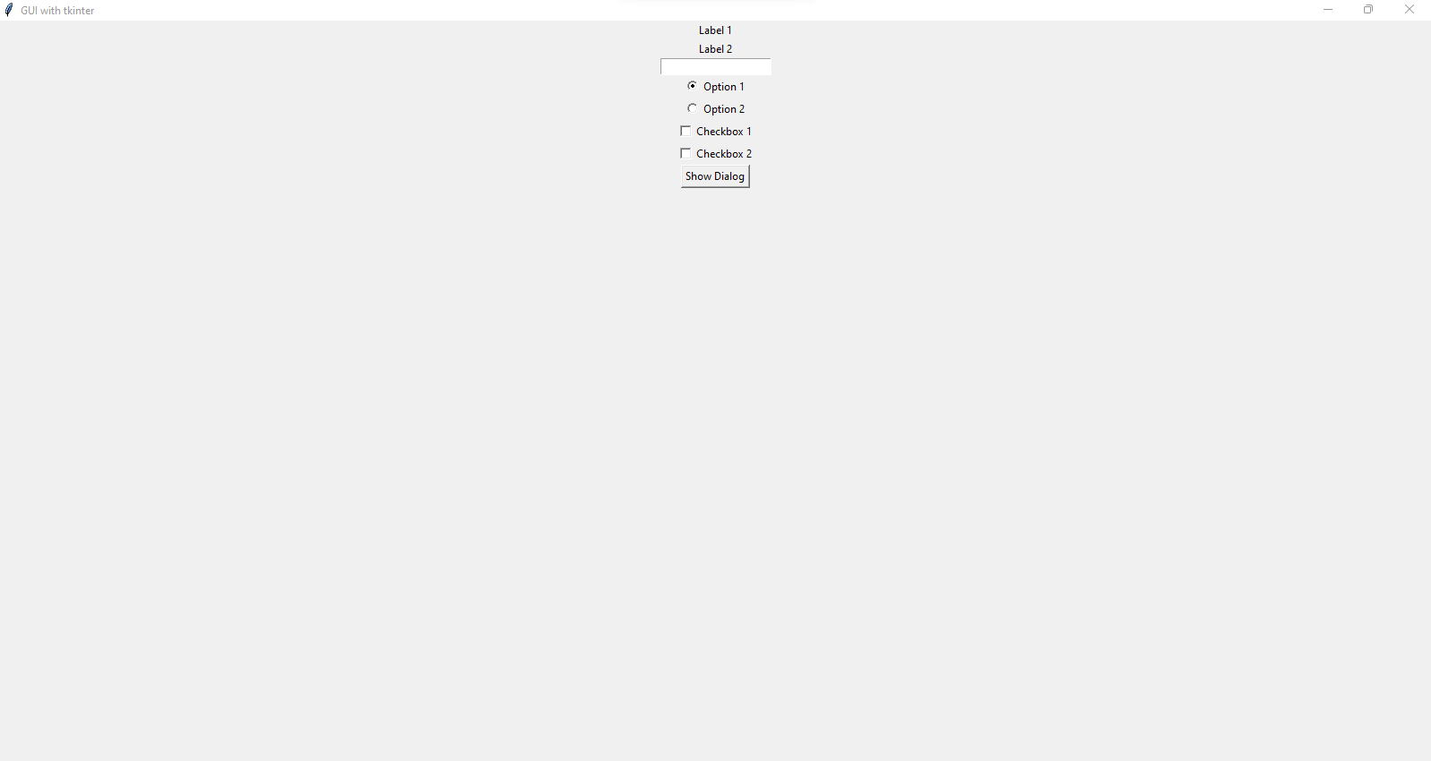

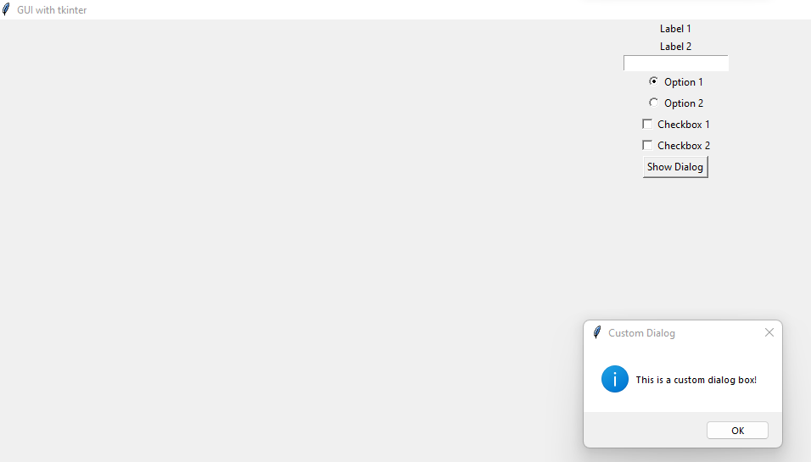

**Conclusion:**

GUI package TKinter has been studied and implemented.