**Experiment No. 9**

**Title:** Program to manipulate arrays using NumPy

**Aim:** To study and implement arrays manipulation using NumPy

**Objective:** To introduce NumPy package

**Theory:**

Numpy is a general-purpose array-processing package. It provides a high-performance

multidimensional array object, and tools for working with these arrays. It is the fundamental

package for scientific computing with Python.

Besides its obvious scientific uses, Numpy can also be used as an efficient multi-dimensional

container of generic data.

Arrays in Numpy

Array in Numpy is a table of elements (usually numbers), all of the same type, indexed by a

tuple of positive integers. In Numpy, number of dimensions of the array is called rank of the

array. A tuple of integers giving the size of the array along each dimension is known as shape of

the array. An array class in Numpy is called as ndarray. Elements in Numpy arrays are

accessed by using square brackets and can be initialized by using nested Python Lists.

Creating a Numpy Array

Arrays in Numpy can be created by multiple ways, with various number of Ranks, defining the

size of the Array. Arrays can also be created with the use of various data types such as lists,

tuples, etc. The type of the resultant array is deduced from the type of the elements in the

sequences.

Note: Type of array can be explicitly defined while creating the array.

**Code:**

import numpy

arr = numpy.array([1,2,6,8,9,10,53])

print(arr)

x = int(input("enter the index of the number you want too search: "))

print("Element:",arr[x])

sum = 0

for i in arr:

sum+=i

print(sum)

**Output:**

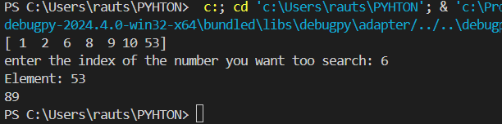

**Conclusion**: NumPy package has been studied and arrays have been implemented and

manipulated.