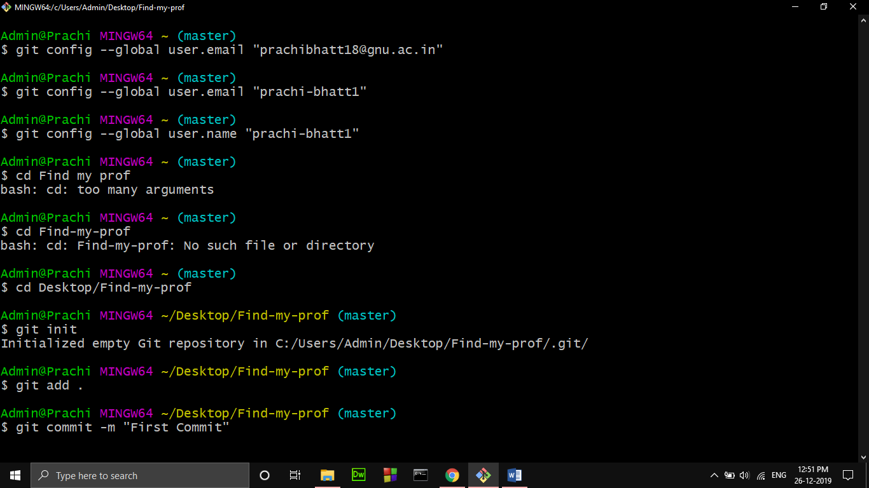

* git init will initialize a repository
* git add . (will add only required files)
* name your commit

