Q.3.Ranking Data - Understanding the co-relation between keyword rankings with description or any other attribute.

1) Is there any co-relation between short description, long description and ranking? Does the placement of keyword (for examples - using a keyword in the first 10 words - have any co-relation with the ranking)?

2) Does APP ID (Also known as package name) play any role in ranking?

3) Any other pattern or good questions that you can think of and answer?

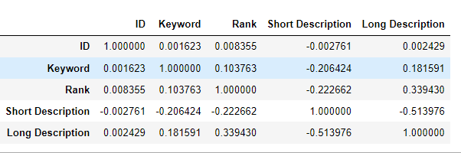

**Answer1:** *Yes, there is positive linear correlation between Long Description and Rank, and negative linear correlation between Short Description and Rank. However, the placement of keyword does not affect the ranking.*

**Answer2:** *The correlation number of ID is very small w.r.t Rank hence we can say that ID doesn’t play any role in ranking*.

**Answer3:** *I can’t of any other relation. Every column has been discussed*.