Freight Rate Prediction Challenge
Assessment submission report

1. Executive summary
The objective is to predict posted freight rates for 12,000 November–December 2025 loads using 48,000 labeled January–October 2025 loads. The final solution uses CatBoost regression with log-transformed targets, route/location features, distance and weight information, market and quote signals, and calendar/cyclical date features.
Because the final prediction period is later than every labeled observation, the primary validation design is a chronological holdout: January–September for training and October for validation. A random 80/20 split is included as a secondary sanity check, but it is not used as the main estimate of forward performance.

2. Data understanding
Dataset | Shape / coverage
Development / train_test.csv | 48,000 rows × 14 columns; Jan 1–Oct 31, 2025
Final validation.csv | 12,000 rows × 13 columns; Nov 1–Dec 31, 2025
December chart inputs | 31 rows; Dec 1–Dec 31, 2025
The development target is posted_rate. Missing values occur in weight and market_index. The validation file contains the same predictive fields except posted_rate. The December chart file intentionally contains a smaller set of fixed operational inputs.

3. Validation and split strategy
The temporal split is: training = dates before 2025-10-01; validation = October 2025. This approximates the real forecasting task because the unlabeled evaluation period follows the development period. No October labels are used to train the model used for the reported October metrics.
Validation | MAE ($) | RMSE ($) | R²
October forward holdout | 108.61 | 647.25 | 0.8207
Random 80/20 sanity check | 90.06 | 526.86 | 0.8702
The random split is expected to be easier because train and validation observations are interleaved in time. The October result is therefore the more relevant validation estimate for the final Nov–Dec task.

4. Feature engineering
- Categorical: pickup city, delivery city, equipment type, and a combined pickup→delivery route.
- Operational/numeric: distance, weight, pickup/delivery latitude and longitude, market_index, quote_signal.
- Geographic: great-circle distance calculated from pickup/delivery coordinates and a ratio comparing reported road distance with geographic distance.
- Calendar: year, month, day, day-of-week, day-of-year, ISO week, weekend indicator.
- Cyclical time: sine/cosine encodings for day-of-year and day-of-week, allowing smooth seasonal representation.
- Missingness: explicit indicators for missing weight and market_index; missing numeric values are median-imputed.

5. Model
CatBoostRegressor is trained on log1p(posted_rate). Log-target training reduces the influence of very large freight-rate observations and produced lower forward-holdout MAE than training directly on the raw target during model comparison. The final configuration uses 520 trees, depth 8, learning rate 0.04, L2 regularization 8, and random seed 42.
The final production model is refit on all 48,000 labeled development rows before generating the 12,000 validation predictions.

6. Feature importance
- Geographic distance — 48.3% of CatBoost split importance in the selected validation-trained model.
- Reported distance — 43.6%.
- Equipment — 2.8%.
- Weight — 0.9%.
- Other engineered/location/calendar/market/quote variables contribute the remainder.
These importances are model split-importance values, not causal effects. The dominant role of distance is consistent with the freight-rate target and provides a useful sanity check on the fitted model.

7. December chart methodology
The fixed December scenario is Lexington → Fort Wayne, 360 miles, Dry Van, 32,000 lb, with only the date changing. The chart input file does not contain coordinates, market_index, or quote_signal. For consistency with the main model, city coordinates are reconstructed from the labeled city records and the unavailable market/quote signals are filled with their development-set medians. The resulting 31 predictions are then passed through the supplied scorer.
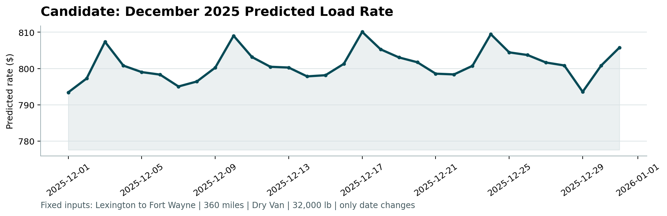
Figure 1. Candidate December 2025 predicted load rate produced by score.py.

8. Output validation
The supplied scorer completed successfully. It validated exactly 12,000 unique TE-000001 through TE-012000 prediction IDs, positive predicted rates, and all 31 December dates and fixed scenario fields. It generated scorer_results/candidate_december.png.

9. Reproduction instructions
Install dependencies:
python -m pip install -r requirements.txt
Train the final model and generate outputs:
python train_and_predict.py
Run the scorer:
python score.py --predictions validation_predictions.csv --december-predictions data/december_chart_inputs.csv

10. Limitations
The local scorer validates output structure and creates the required chart but does not expose the final hidden evaluation metric. Consequently, the reported MAE/RMSE/R² are development-set validation metrics, not the official Spotter test score. The December auxiliary imputations are also necessary because those fields are absent from the provided chart-input schema.

