CS400M MINOR PROJECT

AI-Assisted Cross-Border Tax & Compliance System
SRS + SDS Report
BY
Prachi Sharma (BTECH/25189/23)
Shreya Verma (BTECH/25202/23)
B.Tech – Artificial Intelligence, 7th Semester
Under the Guidance of
[Supervisor Name]
(Designation)
DEPARTMENT OF COMPUTER SCIENCE & ENGINEERING
BIRLA INSTITUTE OF TECHNOLOGY, MESRA
JAIPUR CAMPUS, JAIPUR
SEPTEMBER – 2026

Table of Contents
1. Introduction | 3
1.1 Purpose | 3
1.2 Scope | 3
1.3 Users of the System | 3
1.4 Technology Stack | 4
2. Software Requirements (SRS Part) | 5
2.1 Functional Requirements | 5
2.2 Non-Functional Requirements | 5
2.3 Constraints | 6
3. System Design (SDS Part) | 7
3.1 System Architecture | 7
3.2 Module Design | 7
3.3 Database Design | 8
3.4 User Interface Design | 8
3.5 Data Flow Diagrams (DFD) | 9
3.6 Sequence Diagram | 10
4. Conclusion | 11
5. References | 12
5.1 Research Papers (Peer-Reviewed / Preprint) | 12
5.2 Technical Resources, Tools & Datasets | 12

1. Introduction

1.1 Purpose
Freelancers and independent consultants based in India who earn consulting income from clients in the United States face a fragmented compliance landscape: they must reconcile multi-currency income, determine which business expenses are legally deductible, apply India's presumptive taxation scheme for professionals under Section 44ADA of the Income Tax Act, and invoke the India–US Double Taxation Avoidance Agreement (DTAA) to avoid being taxed twice on the same income. The rules governing this are spread across dense official publications — the Indian Income Tax Act, IRS guidance on source-of-income rules, and the treaty text itself — making consistent, correct interpretation difficult for a non-expert.
This project develops an AI-assisted decision-support system that ingests a user's transactions and invoices, classifies expenses, retrieves and cites the specific tax and treaty provisions relevant to their situation using a Retrieval-Augmented Generation (RAG) pipeline, and computes an estimated India tax liability with DTAA relief through a deterministic, auditable rules engine. The system is an educational prototype intended to demonstrate applied AI system design; it does not constitute legally binding tax advice.

1.2 Scope
- Ingestion of user transactions (CSV) and invoices (PDF) for a defined set of synthetic freelancer/consultant personas.
- LLM-based classification of expenses into a fixed deductibility taxonomy, with a confidence score attached to every classification.
- A Retrieval-Augmented Generation pipeline over a curated, version-tagged corpus of Indian IT Act provisions (Section 44ADA), the India–US DTAA text (Articles 15 and 25), and relevant IRS guidance, with retrieval constrained to the tax year in question.
- A deterministic, unit-tested tax engine that computes Section 44ADA presumptive income, applies the DTAA Article 15 “90-day” test, and calculates Article 25 foreign tax credit relief — all arithmetic performed in code, never by the language model.
- Source citations attached to every rule-based statement shown to the user, with an automated check that the cited passage actually supports the claim.
- A rule-based audit-risk report flagging transactions that need further documentation.
- A Next.js web dashboard, accessible from any modern browser, backed by a single containerized FastAPI + PostgreSQL/pgvector deployment on one cloud instance.
- Out of scope: real user financial data (synthetic personas only), jurisdictions/treaties other than India–US, model fine-tuning, and multi-tenant production infrastructure — these are explicitly deferred (see Section 4, Future Scope).

1.3 Users of the System
- Freelancer / Consultant (primary user) – uploads transactions and invoices, reviews expense classifications, and views the tax estimate, DTAA relief, and audit-risk report with source citations.
- Faculty Mentor / Evaluator – reviews system outputs, verifies citation accuracy against primary sources, and assesses the accompanying technical report and evaluation results.
- Developer / Maintainer (project team) – curates and version-tags the source document corpus, updates rule parameters when tax thresholds change, and monitors evaluation metrics.

1.4 Technology Stack
- Frontend: Next.js (React)
- Backend: Python, FastAPI, Pydantic, SQLAlchemy
- Database: PostgreSQL with the pgvector extension — one database for both relational data and vector embeddings
- Embeddings: a free / self-hosted model (e.g., BGE-M3 or Nomic Embed Text v1.5) by default, given the small, curated document corpus
- Retrieval: hybrid search combining BM25 (keyword) and vector similarity over PostgreSQL
- LLM API: one hosted API, a cost-effective tier for expense classification and citation-grounded answer generation; no fine-tuning, no self-hosted LLM
- Deployment: Docker & Docker Compose, single cloud-hosted instance (PaaS free/hobby tier or a small VM), managed/automatic TLS
- Evaluation: pytest and hypothesis for the tax engine; RAGAS for RAG quality metrics
- Version control / CI: Git, GitHub Actions (lint, type-check, test on every push)

2. Software Requirements (SRS Part)

2.1 Functional Requirements
ID | Requirement
FR-1 | The user can upload transactions (CSV) and invoices (PDF) for a persona.
FR-2 | The system classifies each transaction into an expense category and a deductibility flag using an LLM-based, few-shot classifier.
FR-3 | The system computes Indian presumptive tax under Section 44ADA for a given persona and tax year.
FR-4 | The system applies DTAA Article 15 (the 90-day physical-presence test) and, where US tax applies, calculates Article 25 foreign tax credit relief.
FR-5 | The system retrieves the specific source passages (IT Act, DTAA text, IRS guidance) that justify each classification or tax decision.
FR-6 | Retrieval is constrained to the document versions valid for the persona's tax year (temporal filtering on jurisdiction, effective date, and tax year).
FR-7 | Every number and classification shown to the user is accompanied by the specific source section it came from.
FR-8 | Citations are verified — the system checks that the cited passage actually supports the claim before displaying it.
FR-9 | When retrieval confidence is low, or a user question contains an unsupported premise, the system hedges or declines rather than answering confidently.
FR-10 | The system produces a rule-based audit-risk flag per transaction (missing documentation, threshold proximity, low classification confidence).
FR-11 | The user can view a dashboard summarizing tax liability, DTAA relief applied, and the audit-risk report.
FR-12 | Every retrieval and computation decision is logged (rule version, chunks used, confidence) to support evaluation and the technical report.

2.2 Non-Functional Requirements
ID | Requirement
NFR-1 | Correctness: all tax arithmetic is performed by deterministic, unit-tested code — never by the LLM.
NFR-2 | Reliability against hallucination: the system is evaluated on an adversarial false-premise question set before being considered complete, not just on happy-path demos.
NFR-3 | Auditability: no model fine-tuning; all LLM use is via prompting, so behavior can be inspected and updated without retraining.
NFR-4 | Deployability: single-instance Docker Compose deployment; no orchestration platform required.
NFR-5 | Privacy: no real user financial data at any point — synthetic personas only.
NFR-6 | Explainability: every retrieval and computation decision is logged in enough detail to reconstruct why the system produced a given answer.
NFR-7 | Graceful degradation: a retrieval miss or low-confidence classification produces a flagged, hedged answer rather than a silent wrong one.
NFR-8 | Performance: the dashboard should return a tax estimate for a persona within a few seconds under demo load.
NFR-9 | Cost boundedness: embedding and LLM API usage stays within a student-project budget (see Section 1.4 for the default free-tier choices).
NFR-10 | Usability: responsive web dashboard usable on both desktop and mobile browsers.

2.3 Constraints
- Two-person student team, working within a single academic semester (≈ 15 weeks).
- No real financial data may be used; all personas and transactions are synthetic, hand-crafted for realism and known-correct tax outcomes.
- Requires a stable internet connection (for the hosted LLM API and, if used, a managed database).
- Works on current versions of Chrome, Firefox, and Edge.
- Single cloud-hosted instance with modest specs (a small VM or a PaaS free/hobby tier is sufficient — no autoscaling or multi-region requirement).
- The system is an educational decision-support prototype; it does not provide legally binding tax advice and must state this clearly in the UI.
- Scope is limited to India–US cross-border consulting income; no other jurisdiction/treaty pair is supported in v1.

3. System Design (SDS Part)

3.1 System Architecture
The system follows a modular-monolith, client–server architecture: a single Next.js frontend talks to a single FastAPI backend over REST/JSON; the backend's internal modules (ingestion, expense classification, RAG retrieval, the deterministic tax engine, and the audit-risk scorer) are Python packages within one deployable service, not separate microservices. The backend is the only component that talks to PostgreSQL/pgvector and to the hosted LLM API.
Simplified flow: [ User / Browser ] → [ Next.js Frontend ] → [ FastAPI Backend ] → [ PostgreSQL + pgvector / Hosted LLM API ]
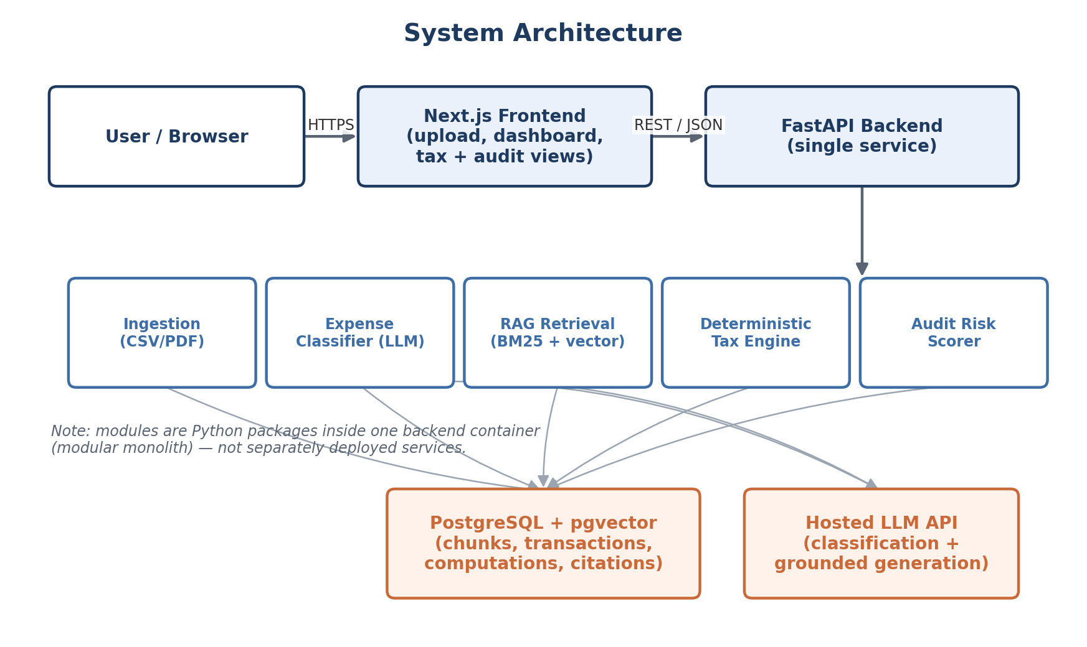
Figure 3.1 — System architecture (modular monolith, single deployable backend).

3.2 Module Design
- Ingestion module – parses uploaded CSV transactions and PDF invoices into structured records.
- Expense Classifier – few-shot LLM classification of each transaction into a category and deductibility flag, with a confidence score.
- RAG Retrieval module – hybrid BM25 + vector search over the versioned document corpus, filtered by jurisdiction/tax year, followed by citation verification.
- Deterministic Tax Engine – Pydantic-validated calculation of Section 44ADA presumptive income and DTAA Article 15/25 relief; the only component permitted to produce a final number.
- Audit Risk Scorer – rule-based scoring over missing documentation, threshold proximity, and low-confidence classifications.

3.3 Database Design
Core entities: Persona, Transaction, Document, DocumentChunk, TaxComputation, Citation, AuditFlag, and EvalRun. Representative schema:
- Persona (id, name, base_country, has_us_presence, notes)
- Transaction (id, persona_id, date, amount, currency, description, category, deductible, classification_confidence)
- Document (id, title, jurisdiction, source_url, tax_year, effective_date, version_note)
- DocumentChunk (id, document_id, section_id, text, embedding, jurisdiction, effective_date, tax_year)
- TaxComputation (id, persona_id, tax_year, presumptive_income, india_tax, us_tax_applicable, dtaa_relief_amount, form67_required)
- Citation (id, tax_computation_id, document_chunk_id, verified, claim_text)
- AuditFlag (id, transaction_id, flag_type, severity, reason)
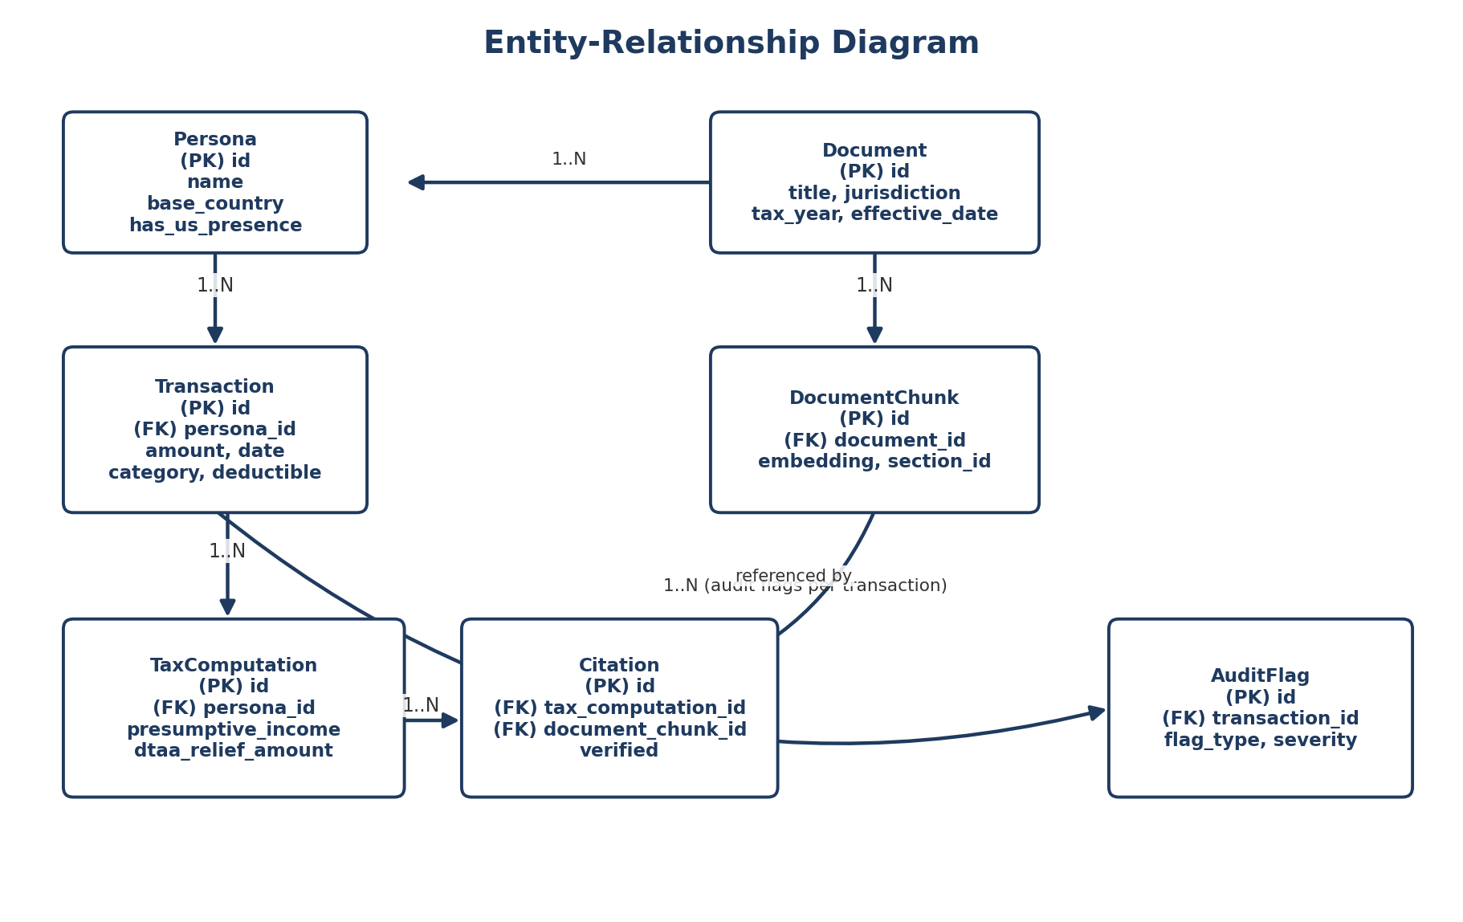
Figure 3.2 — Entity-Relationship diagram.

3.4 User Interface Design
As this document precedes implementation, the screens below are planned wireframe descriptions; annotated screenshots will be added once the frontend is built, ahead of final submission.
- Upload page – transaction CSV / invoice PDF upload, persona selection.
- Classification review – list of transactions with predicted category, deductibility, and confidence; user can correct a classification.
- Tax & DTAA summary – computed 44ADA liability and DTAA relief, each figure accompanied by its source citation.
- Audit risk report – flagged transactions with severity and reason, and any documentation still required.
Navigation flow: Upload Transactions → Classification Review → Tax & DTAA Summary (with citations) → Audit Risk Report.

3.5 Data Flow Diagrams (DFD)
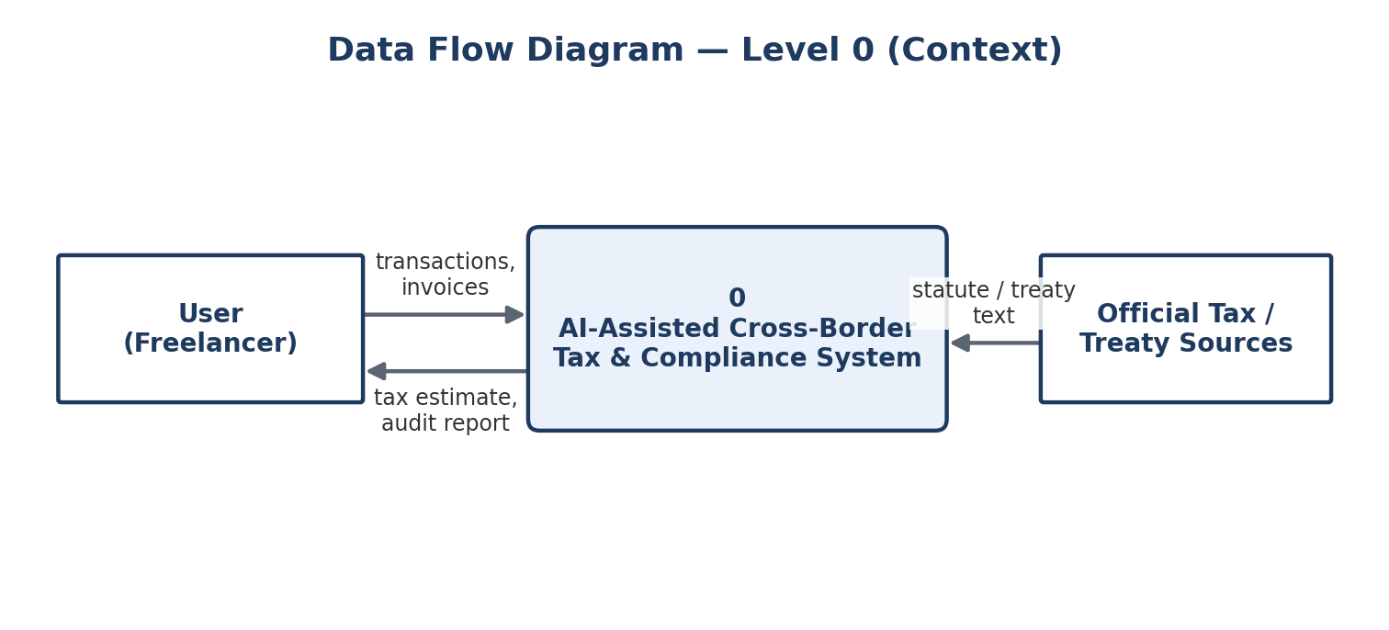
Figure 3.3 — DFD Level 0 (context diagram).
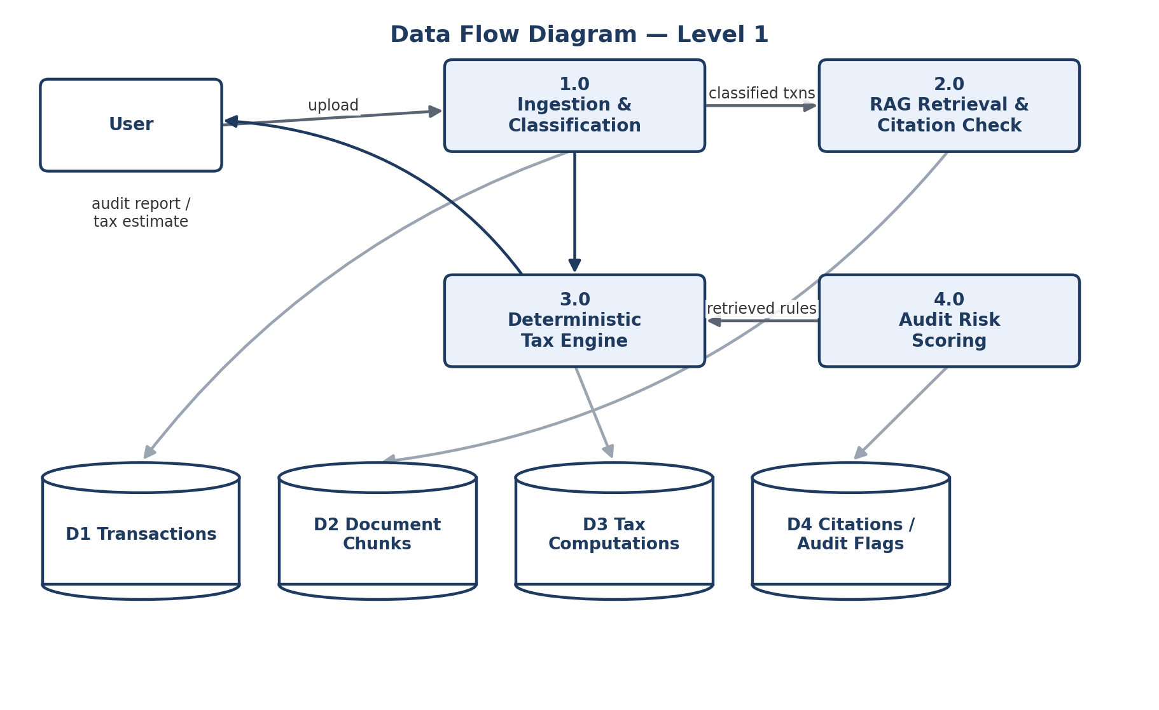
Figure 3.4 — DFD Level 1 (ingestion/classification, RAG retrieval, tax computation, audit scoring, and their data stores).

3.6 Sequence Diagram
Example flow: a user requests a tax estimate; the backend retrieves tax-year-filtered rules, computes 44ADA and DTAA relief deterministically, verifies citations, logs the computation, and returns figures, citations, and an audit flag to the dashboard.
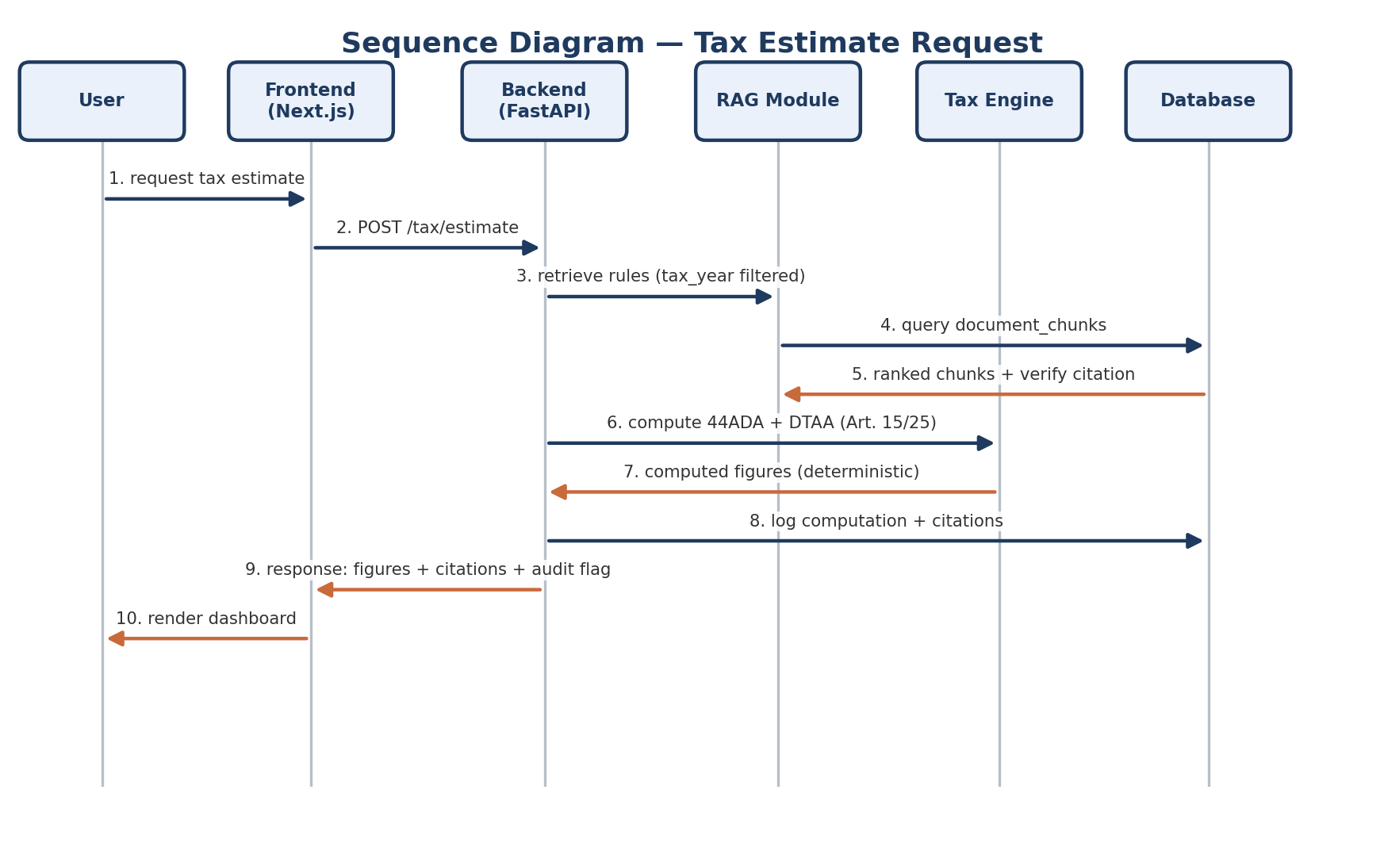
Figure 3.5 — Sequence diagram for a tax-estimate request.

4. Conclusion
This project delivers an explainable, source-grounded, and auditable decision-support prototype for India–US cross-border freelance tax compliance. Unlike existing single-jurisdiction legal-RAG tools, it retrieves and reconciles rules across two legal corpora — Indian tax law and the India–US DTAA — while keeping all arithmetic in deterministic, unit-tested code rather than in the language model, directly addressing the hallucination and temporal-misgrounding risks identified in the literature reviewed for this project.

Benefits
- Consistent, source-cited interpretation of a fragmented, multi-document compliance landscape.
- Deterministic, testable tax and DTAA-relief calculations, auditable independently of the AI layer.
- An explicit audit-risk report that highlights under-documented or borderline transactions before filing.
- A single-instance, containerized deployment that a two-person team can build, evaluate, and demo within one semester.

Future Scope
- A knowledge-graph layer (in the style of statutory KG-RAG systems) to capture cross-references between sections that pure vector/keyword retrieval may miss.
- Support for additional jurisdictions and treaties beyond India–US.
- A reranking stage, added only if retrieval evaluation shows ordering — not recall — is the bottleneck.
- Mobile app integration and multi-language support for the dashboard.
- Expanded persona and transaction coverage once the deterministic engine and RAG pipeline are validated on the current scope.

5. References
All web and preprint sources below were verified as accessible at the time of writing (September 2026). Author names not confirmed from the source metadata are omitted rather than assumed; readers verifying citations for formal submission should confirm bibliographic details against the linked source before final print.

5.1 Research Papers (Peer-Reviewed / Preprint)
[1] P. Lewis et al, “Retrieval-Augmented Generation for Knowledge-Intensive NLP Tasks,” in Advances in Neural Information Processing Systems (NeurIPS), 2020. [Online]. Available: arXiv:2005.11401
[2] J. J. Nay and B. Karamardian, “Large Language Models as Tax Attorneys: A Case Study in Legal Capabilities Emergence,” Philosophical Transactions of the Royal Society A, vol. 382, no. 2270, 2024. [Online]. Available: arXiv:2306.07075
[3] R. Cymbler, D. Guez, and L. Fabre, “Temporal Misgrounding in Legal RAG: A Versioned-Corpus Benchmark for French Tax Law,” arXiv preprint arXiv:2608.09393, 2026.
[4] “Large Language Models in Austrian VAT Law: A Comparison of Retrieval-Augmented Generation and Fine-Tuning,” arXiv preprint arXiv:2507.08468, 2025.
[5] M. Reuter, T. Lingenberg, R. Liepiņa, F. Lagioia, M. Lippi, G. Sartor, A. Passerini, and B. Sayin, “Towards Reliable Retrieval in RAG Systems for Large Legal Datasets,” arXiv preprint arXiv:2510.06999, 2025.
[6] S. Das, S. Abualhaija, and D. Bianculli, “How Much Do Legal RAG Systems Still Hallucinate?,” arXiv preprint arXiv:2608.14210, 2026.
[7] D. Garsia, “RAG Is Judgment: Why Grounding Does Not Solve the Legal Hallucination Problem,” SSRN Electronic Journal, 2026.
[8] V. Ovcharov, “Citation Grounding Measures the Oracle: Graph Coverage Determines Reported LLM Hallucination Rates in Law,” arXiv preprint arXiv:2606.00898, 2026.
[9] S. Es, J. James, L. Espinosa-Anke, and S. Schockaert, “RAGAS: Automated Evaluation of Retrieval Augmented Generation,” arXiv preprint arXiv:2309.15217, 2023.
[10] H. Yu, A. Gan, K. Zhang, S. Tong, Q. Liu, and Z. Liu, “Evaluation of Retrieval-Augmented Generation: A Survey,” arXiv preprint arXiv:2405.07437, 2024.
[11] F. Ariai and G. Demartini, “Natural Language Processing for the Legal Domain: A Survey of Tasks, Datasets, Models, and Challenges,” arXiv preprint arXiv:2410.21306, 2024.
[12] S. Wind et al, “SteuerLLM: Local Specialized Large Language Model for German Tax Law Analysis,” Scientific Reports, 2026.
[13] “Explainable Artificial Intelligence in Accounting and Financial Auditing: A Systematic Review,” PMC (National Library of Medicine), 2026.
[14] “The Impact of AI on Tax Compliance and Reporting,” International Journal of Modern Science and Research Technology (IJMSRT), 2024.

5.2 Technical Resources, Tools & Datasets
[15] srijanshukla18, “ita-kg: Income Tax Act Knowledge Graph + RAG System,” GitHub, 2025. [Online]. Available: github.com/srijanshukla18/ita-kg
[16] rohitthink, “freefile: Open-Source Privacy-First Freelancer Tax Tracker,” GitHub, 2026. [Online]. Available: github.com/rohitthink/freefile
[17] mralaminahamed, “bd-legal-rag: Hierarchy-Aware Statutory RAG Engine,” GitHub, 2025. [Online]. Available: github.com/mralaminahamed/bd-legal-rag
[18] Mbehbahani, “Tax-Authority-RAG: Citation-First Tax Assistant,” GitHub, 2025. [Online]. Available: github.com/Mbehbahani/Tax-Authority-RAG
[19] ri-sh, “Form16x: Offline Tax Document Parsing Engine,” GitHub, 2025. [Online]. Available: github.com/ri-sh/Form16x
[20] MahalakshmiAdabala, “Financial-Transactions-Fraud-Detection (PaySim Synthetic Dataset),” GitHub / Kaggle, 2025.
[21] OpenFisca, “Write Rules as Code,” 2026. [Online]. Available: openfisca.org
[22] ZenML, “ANNA: Cost-Effective LLM Transaction Categorization for Business Banking,” LLMOps Database, 2026.
[23] PremAI, “Best Embedding Models for RAG (2026): Ranked by MTEB Score, Cost, and Self-Hosting,” 2026.
[24] “Reranking in RAG: Cross-Encoders and When They Pay Off,” 2026.
[25] TaxTap, “44ADA for Software Developers — Rules, AIS, and Foreign Receipts,” 2026.
[26] TaxClue, “Freelancer Tax India: Section 44ADA, Foreign Clients & BRC,” 2025.
[27] “DTAA Between India and USA — Complete Guide,” 2026.

