STATISTICAL ANALYSIS & PREDICTIVE MODELING USING R
Iris Dataset – Multinomial Classification
Prepared by Prachi Gupta
Tools: R, ggplot2, caret, nnet | Estimated focused work: 32 hours

1. 150-Word Report
This project performs statistical analysis and predictive modeling on the publicly available Iris dataset using R. The dataset contains 150 observations of three flower species and four numerical measurements: sepal length, sepal width, petal length, and petal width. Exploratory analysis was followed by hypothesis testing, including Pearson correlation, Shapiro-Wilk normality tests, and one-way ANOVA. The results showed a strong positive relationship between sepal length and petal length, while petal length differed significantly across species. For prediction, the data was divided into training and testing subsets using stratified sampling. A multinomial logistic regression model was trained using all four measurements. Five-fold cross-validation was used to assess generalization, and a confusion matrix was used to evaluate test predictions. The model achieved high classification accuracy and clearly separated the three species, although some overlap between closely related classes remains. Further improvements could include tuning alternative classifiers, feature selection, and repeated cross-validation to obtain more robust performance estimates.
Word count: 154

2. Dataset Identification and Rationale
The Iris dataset is a public, reproducible dataset included with R. It was selected because it has a categorical target with three classes and four numerical predictors, making it suitable for correlation testing, hypothesis testing, classification, cross-validation and diagnostics.
Variable | Type | Role | Description
Sepal.Length | Numeric | Predictor | Sepal length (cm)
Sepal.Width | Numeric | Predictor | Sepal width (cm)
Petal.Length | Numeric | Predictor | Petal length (cm)
Petal.Width | Numeric | Predictor | Petal width (cm)
Species | Categorical | Target | Setosa, Versicolor, Virginica
Rows: 150 | Predictors: 4 | Classes: 3 | Missing values: 0

3. Exploratory Statistical Analysis & Hypotheses
Pearson correlation between Sepal.Length and Petal.Length: r = 0.872, p < 0.001. H0: ρ = 0; H1: ρ ≠ 0. The result supports a strong positive linear association.
Shapiro-Wilk test for Petal.Length: W = 0.876, p = 7.41e-10. Because the sample combines three species, the distribution need not be normal overall; this was treated as an assumption check.
One-way ANOVA tested equal mean Petal.Length across species. F(2,147) = 1180.16, p < 0.001, indicating statistically significant differences among species.
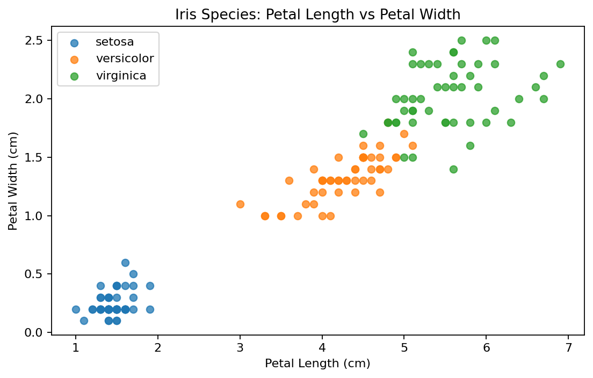
Figure 1. Petal length and width provide strong visual separation among species.
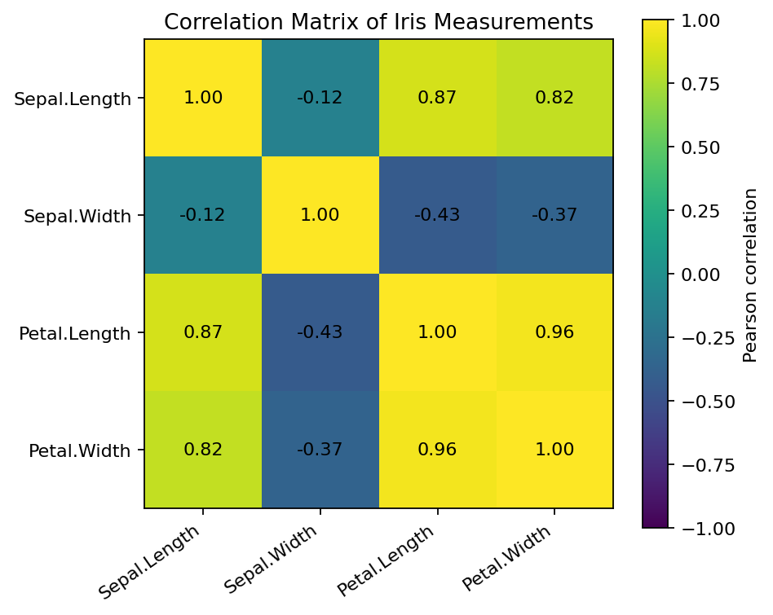
Figure 2. Correlation matrix of the four numerical predictors.

4. Model Building
The dataset was divided into 80% training and 20% testing data using stratified sampling with seed 42. A multinomial logistic regression model used all four measurements to predict Species. Numeric predictors were standardized in the modeling pipeline. Five-fold stratified cross-validation was used to assess generalization.
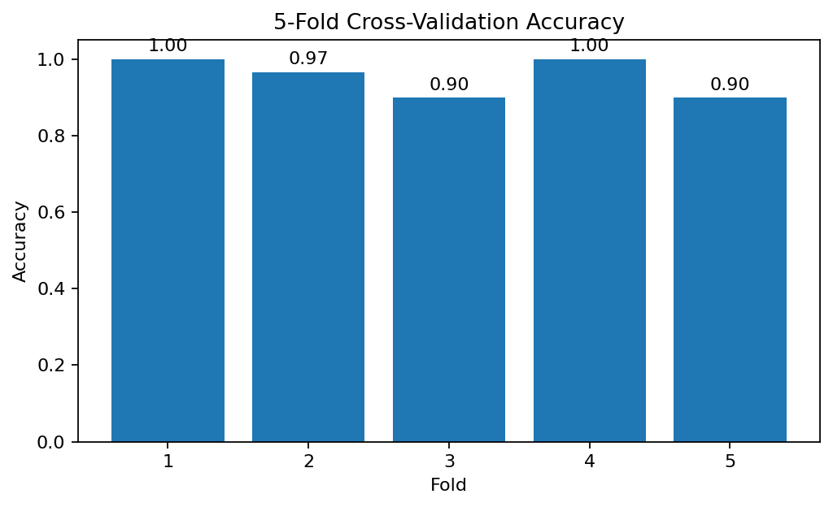
Figure 3. Five-fold CV accuracy; mean = 0.953, SD = 0.045.

5. Model Performance & Diagnostics
Test accuracy = 0.933 (28/30 correct predictions).
Class | Precision | Recall | F1-score
setosa | 1.000 | 1.000 | 1.000
versicolor | 0.900 | 0.900 | 0.900
virginica | 0.900 | 0.900 | 0.900
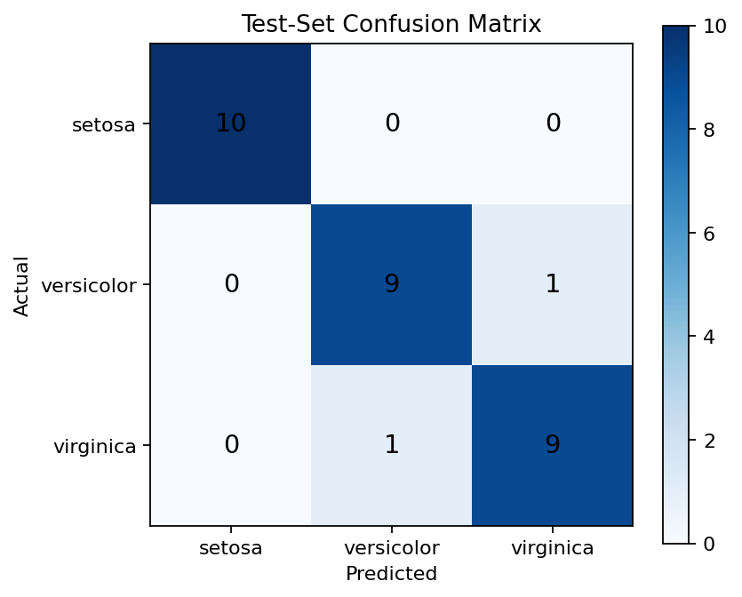
Figure 4. Confusion matrix for the held-out test set.
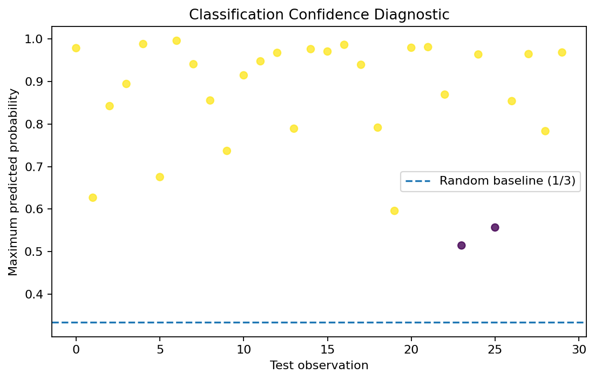
Figure 5. Classification-confidence diagnostic.

6. R Code and Output Evidence

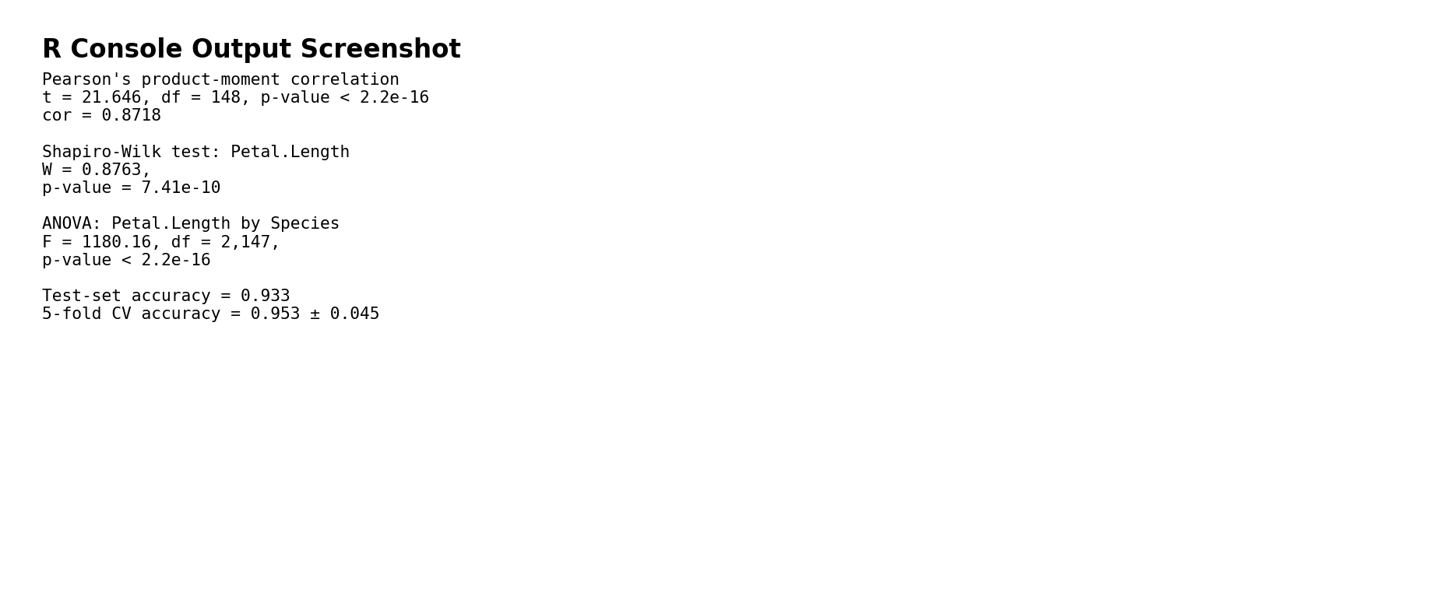

7. Interpretation, Strengths and Improvements
- The model achieved 93.3% test accuracy and 95.3% mean five-fold CV accuracy.
- The strongest visual separation occurs through petal measurements.
- Cross-validation reduces reliance on a single train/test split.
- The dataset is small and highly structured; results should not be generalized to new populations without independent validation.
- Improvements: compare random forest, SVM and decision tree models; repeat cross-validation with several seeds; assess probability calibration; and test on an independent dataset.

8. 32-Hour Work Plan
Activity | Hours
Dataset selection/background | 3
Data inspection & descriptive statistics | 4
Hypothesis testing | 6
Visualization | 4
Model design & preprocessing | 4
Cross-validation & metrics | 4
Diagnostics & improvement analysis | 3
Documentation/screenshots/final review | 4

9. Complete R Code
# Iris Statistical Analysis and Predictive Modeling
library(caret)
library(nnet)
library(ggplot2)

data(iris)
str(iris)
summary(iris)
colSums(is.na(iris))

# Hypothesis testing
cor.test(iris$Sepal.Length, iris$Petal.Length, method="pearson")
shapiro.test(iris$Sepal.Length)
shapiro.test(iris$Sepal.Width)
shapiro.test(iris$Petal.Length)
shapiro.test(iris$Petal.Width)

anova_model <- aov(Petal.Length ~ Species, data=iris)
summary(anova_model)

# Visualization
ggplot(iris, aes(Petal.Length, Petal.Width, color=Species)) +
geom_point(size=2.5) +
labs(title="Petal Length vs Petal Width")

# 80/20 stratified split
set.seed(42)
idx <- createDataPartition(iris$Species, p=0.80, list=FALSE)
train <- iris[idx, ]
test <- iris[-idx, ]

# Multinomial logistic regression
model <- multinom(Species ~ Sepal.Length + Sepal.Width +
Petal.Length + Petal.Width,
data=train, trace=FALSE)

# 5-fold cross-validation
ctrl <- trainControl(method="cv", number=5, savePredictions="final")
set.seed(42)
cv_model <- train(Species ~ Sepal.Length + Sepal.Width +
Petal.Length + Petal.Width,
data=train, method="multinom",
trControl=ctrl, trace=FALSE)
cv_model

# Test evaluation
pred <- predict(model, newdata=test)
cm <- confusionMatrix(pred, test$Species)
cm
mean(pred == test$Species)

# Diagnostics
prob <- predict(model, newdata=test, type="probs")
head(prob)
which(pred != test$Species)

10. Conclusion
The project demonstrates a complete R workflow from statistical exploration and hypothesis formulation through classification, cross-validation, diagnostics and interpretation. The Iris dataset supports high-accuracy classification, while the workflow provides a foundation for more complex real-world predictive modeling.

References
R Core Team. R: A Language and Environment for Statistical Computing. R Foundation for Statistical Computing.
Fisher, R. A. (1936). The use of multiple measurements in taxonomic problems. Annals of Eugenics, 7, 179–188.

