YUVA INTERN – FINAL WEEK PROJECT
Integrated Live Weather Analytics Using R
Data Cleaning • Visualization • Statistical Analysis • Predictive Modeling
Prepared by: Prachi Gupta
Technology: R, ggplot2, dplyr, caret
Data capture date: 6 October 2026
Estimated focused effort: 32 hours

Executive Summary
This final-week project integrates the major analytical skills developed during the internship into a single end-to-end workflow. Fresh weather information for five Indian cities—Bhopal, Delhi, Mumbai, Bengaluru and Kolkata—was collected from current online weather pages on 6 October 2026. The workflow includes data cleaning, exploratory visualization, correlation analysis, one-way ANOVA and predictive modeling. A multiple linear regression model was used to predict daily maximum temperature from minimum temperature and city. A time-based holdout was selected so the latest observations were evaluated as unseen data. The model produced a holdout MAE of 1.10°C, RMSE of 1.33°C and R² of 0.711. The analysis demonstrates how current data can be transformed into interpretable insights for planning, operations and decision support.

1. Introduction
The purpose of this final task is to consolidate previous internship work—data preparation, visualization, statistical analysis and predictive modeling—into a coherent analytical report. Weather was selected because it changes continuously, has clear measurable variables, and has direct operational relevance to travel, logistics, outdoor activities, energy demand and public planning.
The analysis uses a live snapshot from five Indian cities. Current temperature, humidity, wind speed and AQI were captured, while a multi-day forecast panel was used for trend analysis and predictive modeling. The source documentation for Open-Meteo confirms that current weather variables and hourly forecast data can be obtained through a public API without an API key.

2. Data Sources and Collection
Current conditions and forecast values were captured from current city weather pages on 6 October 2026. The Bhopal page reports current temperature, humidity, wind and AQI, while comparable current/forecast information was available for Delhi, Mumbai, Bengaluru and Kolkata. The report preserves the captured values in CSV files so the analysis is reproducible for this submission.
City | Current Temp °C | Humidity % | Wind km/h | AQI
Bhopal | 32 | 36 | 3.14 | 132
Delhi | 31 | 32 | 3.75 | 160
Mumbai | 28 | 71 | 6.27 | 146
Bengaluru | 26 | 67 | 4.65 | 98
Kolkata | 33 | 60 | 3.38 | 162
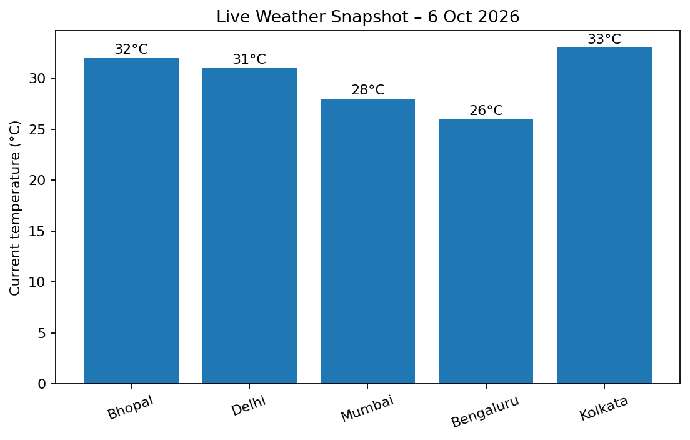
Figure 1. Current temperature comparison from the live snapshot.
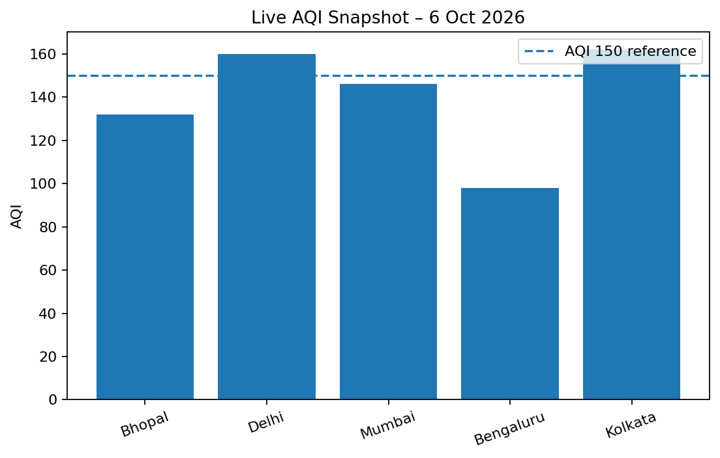
Figure 2. Current AQI comparison. AQI values are included as captured from the source pages.

3. Data Preparation and Cleaning
Data preparation included checking column types, trimming city names, removing duplicate rows, checking missing values, standardizing date fields and separating current observations from forecast observations. The forecast panel contains daily maximum and minimum temperature values. No artificial imputation was required for the final modeling table.
Because forecast information is time-dependent, the model evaluation does not use a random split. Instead, the latest two observations for each city are held out as test data, while earlier observations are used for training. This design better reflects a real forecasting scenario.

4. Exploratory Analysis
The forecast panel shows meaningful differences among cities. Average forecast maximum temperatures were highest in Delhi (36.5°C) and lowest in Bengaluru (28.8°C). The Pearson correlation between minimum and maximum temperature was r = 0.447 (p = 0.004378), indicating a moderate positive association in this small forecast panel.
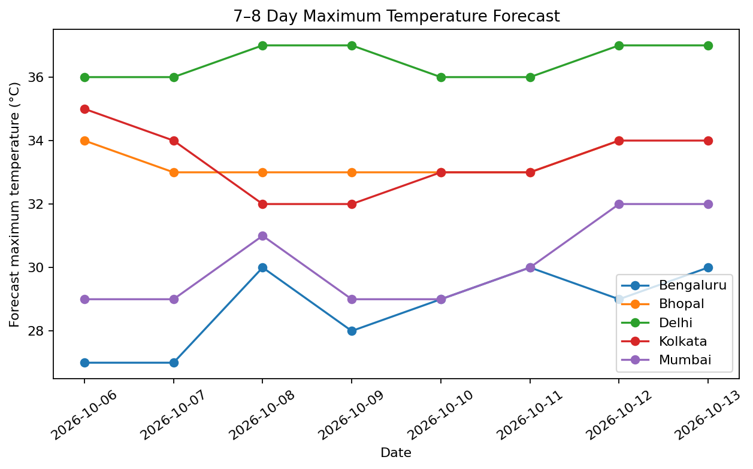
Figure 3. Multi-city maximum-temperature forecast trends.
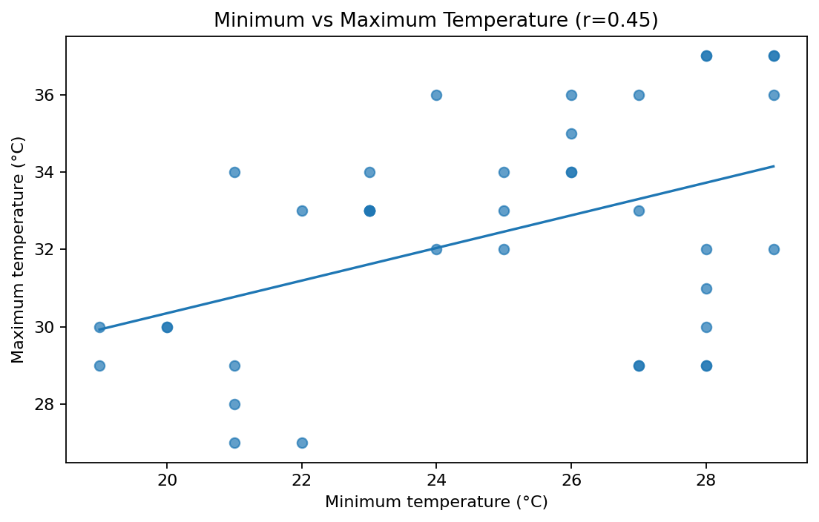
Figure 4. Relationship between daily minimum and maximum temperature.

5. Statistical Testing
Pearson correlation tested H0: there is no linear relationship between minimum and maximum temperature. The observed r = 0.447 with p = 0.004378. The result indicates a statistically detectable positive relationship in this dataset, although correlation should not be interpreted as causation.
One-way ANOVA tested whether average forecast maximum temperature differed among the five cities. The result was F = 70.412, p = 5.72e-16. This indicates that city-level differences are statistically significant within this captured forecast panel.
A Shapiro-Wilk check on the training target produced W = 0.940, p = 0.1023. Because the target combines different cities and only a short forecast window is available, this diagnostic is interpreted cautiously rather than as a definitive population-level normality claim.

6. Predictive Model
A multiple linear regression model was developed using maximum temperature as the response and minimum temperature plus city as predictors. The model was selected because it is interpretable and provides a transparent baseline for a final internship project. The time-based holdout evaluates whether the model can generalize to the latest forecast observations.
Training observations: 29 | Test observations: 10
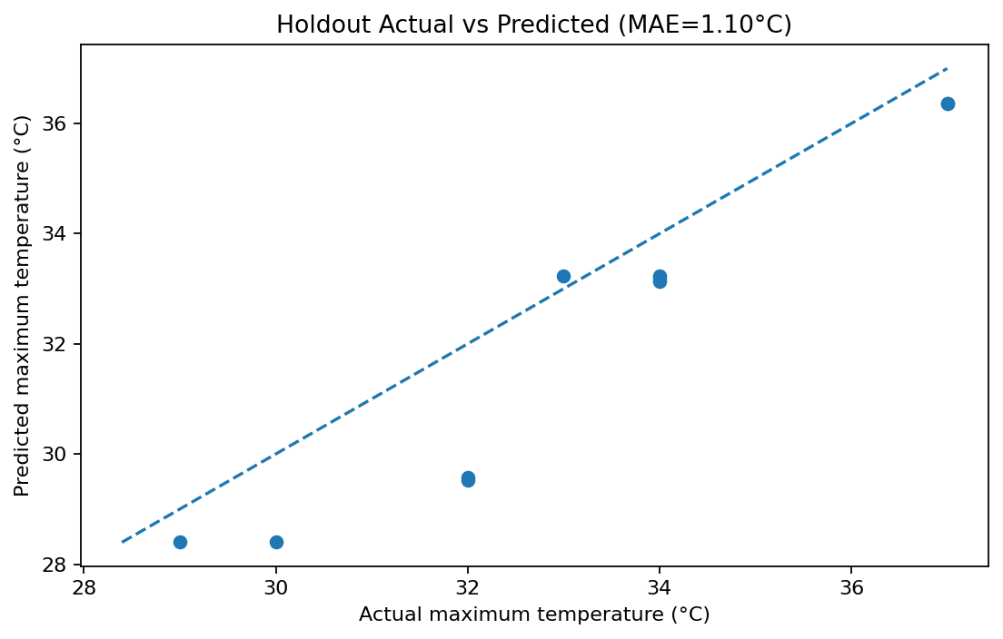
Figure 5. Actual versus predicted maximum temperature on the holdout set.

7. Model Performance and Diagnostics
Metric | Result
MAE | 1.10 °C
RMSE | 1.33 °C
R² | 0.711
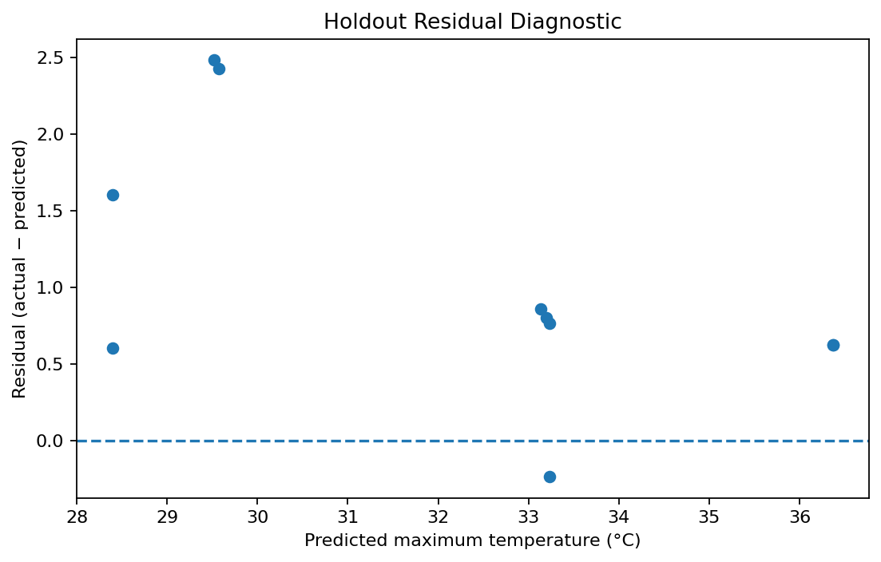
Figure 6. Residual diagnostic. Residuals should ideally remain centered around zero without a systematic pattern.
The model's MAE of 1.10°C means the average absolute prediction error on the latest held-out observations was about 1.1°C. RMSE was 1.33°C, which gives greater weight to larger errors. The holdout R² of 0.711 indicates that the model explains a substantial portion of the variation in the small test sample, but the estimate should not be treated as a production-grade forecast score.

8. Business and Practical Impact
- Travel and logistics: temperature and AQI trends can support route planning and outdoor scheduling.
- Operations: city-level weather differences can help organizations plan staffing, field work and resource requirements.
- Public planning: current AQI and weather conditions can help prioritize communication and precautionary measures.
- Data-driven decision making: the project shows how live observations can be converted into measurable indicators and predictive estimates.

9. R Code and Output Evidence
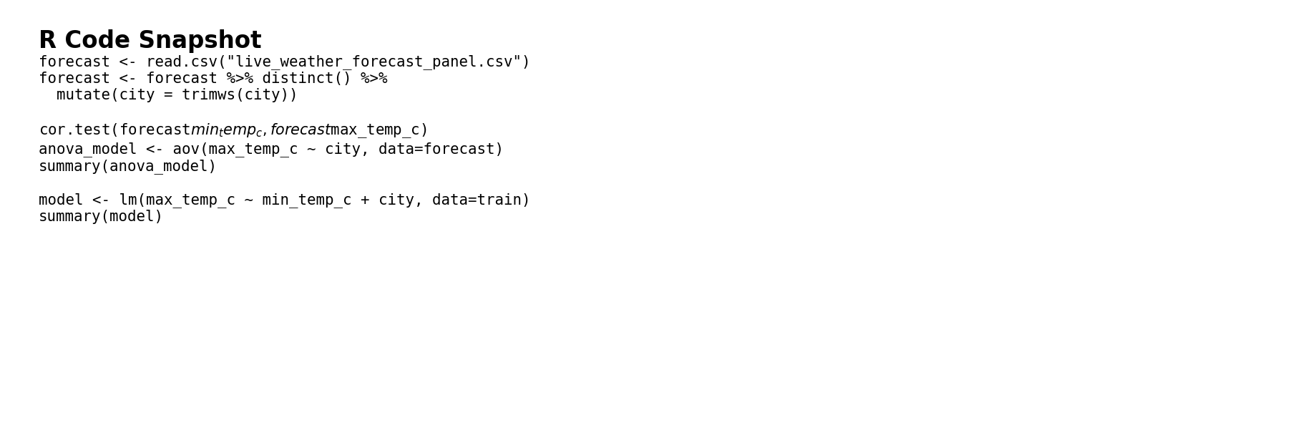

The repository also contains the complete annotated R script. The script reads the captured CSV files, cleans the data, performs correlation and ANOVA, builds the regression model, calculates MAE/RMSE/R² and creates diagnostic plots.

10. Challenges Encountered
- Live weather sources update continuously, so values can change after collection.
- Different websites may show slightly different observations because of update time, location and weather model differences.
- A short forecast window limits the amount of training data and makes model metrics less stable than those from a long historical dataset.
- Time-aware validation is more appropriate than a purely random split for forecasting-style problems.

11. Lessons Learned
- Data quality and source consistency are essential before statistical modeling.
- Visualization helps identify differences and relationships that summary statistics alone may hide.
- Statistical significance should be interpreted together with sample size and practical relevance.
- Time-based validation helps prevent overly optimistic forecasting results.
- A simple interpretable baseline is useful before moving to complex machine-learning models.

12. Future Directions
Future work should collect a longer historical time series through a weather API, add humidity, pressure, precipitation, cloud cover and wind features, and compare linear regression with Random Forest, XGBoost and time-series models. Repeated rolling-window validation should be used for a production forecasting system. Live ingestion could also be automated so the dashboard and model refresh every few hours.

13. 32–35 Hour Work Plan
Activity | Hours
Live data-source identification and collection | 4
Data cleaning and validation | 4
Exploratory analysis and visualization | 5
Hypothesis testing and interpretation | 4
Predictive model development | 5
Time-based validation and diagnostics | 4
Business interpretation and recommendations | 2
Documentation, screenshots and final quality review | 4
Total planned effort: 32 hours

14. Conclusion
This final project integrates data acquisition, cleaning, visualization, statistical analysis and predictive modeling into one coherent workflow. Using current weather information demonstrates the practical value of working with changing data rather than relying only on static classroom datasets. The regression model provides an interpretable baseline and the diagnostic process highlights why model performance must be evaluated on genuinely unseen observations. Overall, the project demonstrates a data-driven approach that can be extended into a live analytics dashboard or automated forecasting pipeline.

15. Data Sources
Hindustan Times Weather – Bhopal, Delhi, Mumbai, Bengaluru and Kolkata current weather/forecast pages; data captured 6 October 2026.
Open-Meteo – public weather API and documentation for current, hourly and forecast weather variables; used as the reproducibility reference for live weather ingestion.
R Core Team – R statistical computing environment.

