**Breast Cancer Detection**

**A PROJECT REPORT**

**Keyur Chaniyara [19BECE30095]**

**Jaivin Gajera [19BECE30075]**

**Prachi Jethwa[19BECE300140]**

**Yatree ladani[19BECE30220]**

**In fulfilment for the award of the degree**

***Of***

**BACHELOR OF ENGINEERING**

**In**

**COMPUTER ENGINEERING**



**LDRP INSTITUTE OF TECHNOLOGY AND RESEARCH, GANDHINAGAR**

**Kadi Sarva Vishwa Vidyalaya, Gandhinagar**

**2021- 2022**

**LDRP Institute of Technology and Research**

Computer Engineering Department

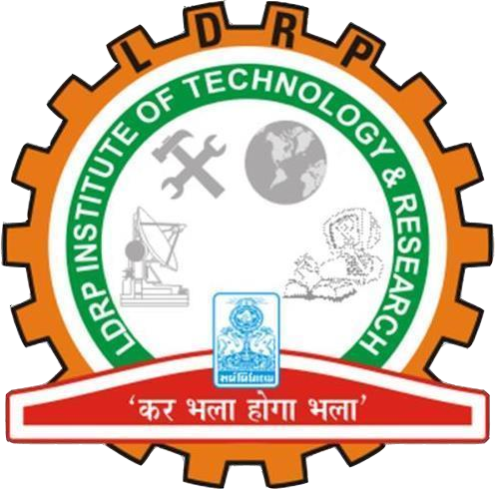

**CERTIFICATE**

This is to certify that the Project Work entitled **“Breast Cancer Detection”** has been carried out by **‘Keyur Chaniyara (19BECE30095)’** under my guidance in fulfilment of the degree of Bachelor of Engineering in Computer Engineering (5th Semester) of Kadi Sarva VishwaVidyalaya University, Gandhinagar during the academic year 2021-22.

**Guide:**

**Mehul Barot Dr. Shivangi Surati**

Internal Guide, H.O.D. CE Dept.,

H.O.D. IT Dept LDRP-ITR.

LDRP ITR.

**LDRP Institute of Technology and Research**

Computer Engineering Department



**CERTIFICATE**

This is to certify that the Project Work entitled **“Breast Cancer Detection”** has been carried out by **‘Jaivin Gajera (19BECE30075)’** under my guidance in fulfilment of the degree of Bachelor of Engineering in Computer Engineering (5th Semester) of Kadi Sarva VishwaVidyalaya University, Gandhinagar during the academic year 2021-22.

**Guide:**

**Mehul Barot Dr. Shivangi Surati**

Internal Guide, H.O.D. CE Dept.,

H.O.D. IT Dept LDRP-ITR.

LDRP ITR.

**LDRP Institute of Technology and Research**

Computer Engineering Department



**CERTIFICATE**

This is to certify that the Project Work entitled **“Breast Cancer Detection”** has been carried out by **‘Prachi Jethwa (19BECE30140)’** under my guidance in fulfilment of the degree of Bachelor of Engineering in Computer Engineering (5th Semester) of Kadi Sarva VishwaVidyalaya University, Gandhinagar during the academic year 2021-22.

**Guide:**

**Mehul Barot Dr. Shivangi Surati**

Internal Guide, H.O.D. CE Dept.,

H.O.D. IT Dept LDRP-ITR.

LDRP ITR.

**LDRP Institute of Technology and Research**

Computer Engineering Department



**CERTIFICATE**

This is to certify that the Project Work entitled **“Breast Cancer Detection”** has been carried out by **‘Yatree Ladani(19BECE30220)’** under my guidance in fulfilment of the degree of Bachelor of Engineering in Computer Engineering (5th Semester) of Kadi Sarva VishwaVidyalaya University, Gandhinagar during the academic year 2021-22.

**Guide:**

**Mehul Barot Dr. Shivangi Surati**

Internal Guide, H.O.D. CE Dept.,

H.O.D. IT Dept LDRP-ITR.

LDRP ITR.