**U.V.PATEL COLLEGE OF ENGINEERING & TECHNOLOGY**

**Department of Computer Science and Engineering**

**B-Tech 6th Semester   Subject – ECAD**

**Name: Kothari Prachi Enrolment Number: 15012101013**

**Stream: Cloud Base Application**

**Practical: - 4 Date:-29/1/2018**

**Practical 4: Developing and Deploying PHP application for displaying product detail using IBM BlueMix and your local station (Eclipse)**

**1. Download PHP Application BuildPack and develop product details system**

**2. Bind MySQL/ClearDB data service to your application**

**3. Interact with your database using Navicat and Eclipse**

**4. Add BlueMix server to your local station**

**5. Deploy application**

**6. Make PDF document for performed tasks**

**1. Download PHP Application BuildPack and develop product details system**

**2. Bind MySQL/ClearDB data service to your application**

**3. Interact with your database using Navicat and Eclipse**

**4. Add BlueMix server to your local station**

**5. Deploy application**

**Code:**

**Index.php:**

<!DOCTYPE html>

<html>

<head>

<title>PHP Starter Application</title>

<meta http-equiv="Content-Type" content="text/html; charset=utf-8">

<!--<link rel="stylesheet" href="style.css" />-->

<style>

.mycomp

{

width:100%;

margin-top:10px;

margin-bottom:20px;

color:white;

font-family:"Georgia";

font-size:20px;

padding:10px;

border:1px solid black;

background:black;

border-radius:10px;

}

.mycomp:hover

{

color:white;

border:1px solid black;

background:black;

border-radius:10px;

}

.mybtn{

background: black;

margin: 0 auto;

font-weight: bold;

margin-top: 10px;

margin-bottom: 20px;

color: white;

font-family: 'Georgia';

font-size: 20px;

padding: 10px;

border: 1px solid white;

border-radius: 20px;

transition:2s ease-in-out

}

</style>

</head>

<body>

<form action="feedback.php" method="post">

<div style="width:400px;margin:0 auto">

<input type="text" name="pname" id="pname" class="mycomp" placeholder="Enter your name">

<br>

<select name="ptype" id="ptype" class="mycomp">

<option>Clothes</option>

<option>Shoes</option>

<option>Utensils</option>

<option>Others</option>

</select>

<br>

<input type="text" name="pqty" id="pqty" class="mycomp" placeholder="Enter Product quantity">

<br>

<input type="text" name="price" id="price" class="mycomp" placeholder="Enter price">

<br>

<textarea name="message" id="message" class="mycomp" ></textarea>

<br>

<input type="submit" class="mybtn" value="Submit Feedback">

<br>

</div>

</form>

</body>

</html>

**Feedback.php:**

<?php

$con=mysqli_connect("au-cdbr-sl-syd-01.cleardb.net","b878dff8665a3a","672e4100","ibmx_3d8cfd6324cafe3");

if(!$con)

{

die('could not connect:'.mysqli_error());

}

echo "connected";

$sql="INSERT INTO product(pname,ptype,pqty,price,msg)VALUES('$_POST[pname]','$_POST[ptype]','$_POST[pqty]','$_POST[price]','$_POST[message]')";

if($con->query($sql)=== TRUE)

{

echo "added successfully";

}

else

{

echo "error".$sql." <br>".$con->error;

}

mysqli_close($con)

?>

**Output:**

**In Localhost:**

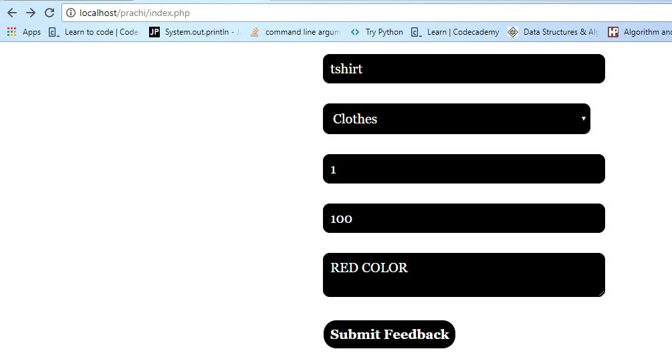

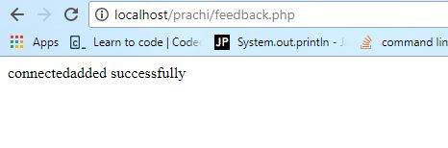

**On Bluemix:**

**Output:**

