Assignment -4

1. Code:

Html:

<!DOCTYPE html>

<html lang="en">

<head>

    <meta charset="UTF-8">

    <meta name="viewport" content="width=device-width, initial-scale=1.0">

    <title>3D Rotating Cube</title>

    <link rel="stylesheet" href="threeD.css">

</head>

<body>

    <div class="cube-container">

        <div class="cube">

            <div class="face front">Front</div>

            <div class="face back">Back</div>

            <div class="face left">Left</div>

            <div class="face right">Right</div>

            <div class="face top">Top</div>

            <div class="face bottom">Bottom</div>

        </div>

    </div>

</body>

</html>

CSS:

/\* General reset \*/

\* {

    margin: 0;

    padding: 0;

    box-sizing: border-box;

}

body, html {

    height: 100%;

    display: flex;

    justify-content: center;

    align-items: center;

    background-color: #f0f0f0;

}

/\* Cube container \*/

.cube-container {

    perspective: 1000px;

}

/\* Cube styles \*/

.cube {

    width: 200px;

    height: 200px;

    position: relative;

    transform-style: preserve-3d;

    transform: rotateX(0deg) rotateY(0deg);

    animation: rotate 5s infinite linear;

}

/\* Cube faces \*/

.face {

    position: absolute;

    width: 200px;

    height: 200px;

    background-color: rgba(255, 255, 255, 0.8);

    border: 2px solid #333;

    display: flex;

    justify-content: center;

    align-items: center;

    font-size: 20px;

    font-weight: bold;

    color: #333;

}

/\* Each face with different background colors \*/

.front  { background-color: #ff5733; transform: rotateY(  0deg) translateZ(100px); }

.back   { background-color: #33ff57; transform: rotateY(180deg) translateZ(100px); }

.left   { background-color: #3357ff; transform: rotateY(-90deg) translateZ(100px); }

.right  { background-color: #ff33ff; transform: rotateY( 90deg) translateZ(100px); }

.top    { background-color: #33ffff; transform: rotateX( 90deg) translateZ(100px); }

.bottom { background-color: #ffff33; transform: rotateX(-90deg) translateZ(100px); }

/\* Cube rotation animation \*/

@keyframes rotate {

    0%   { transform: rotateX(0deg) rotateY(0deg); }

    100% { transform: rotateX(360deg) rotateY(360deg); }

}

OUTPUT:

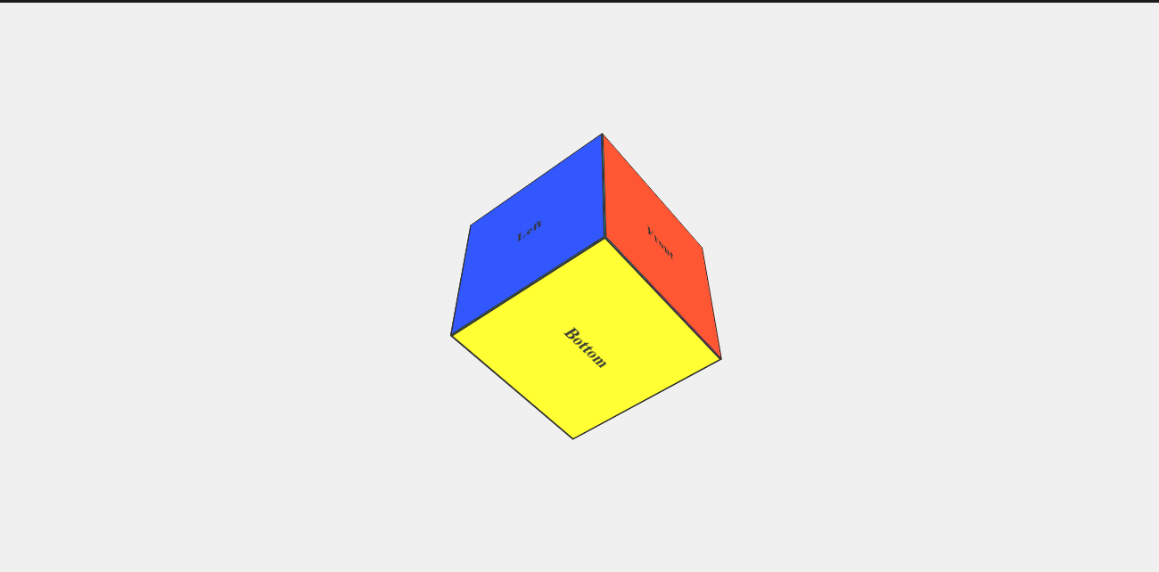

2)Codes:

Html:

<!DOCTYPE html>

<html lang="en">

<head>

    <meta charset="UTF-8">

    <meta name="viewport" content="width=device-width, initial-scale=1.0">

    <title>Rotating Image</title>

    <link rel="stylesheet" href="animations.css">

</head>

<body>

    <div class="image-container">

        <img src="test of love.jpg.png" alt="Rotating Image" class="rotating-image">

    </div>

</body>

</html>

CSS:

/\* General reset \*/

\* {

    margin: 0;

    padding: 0;

    box-sizing: border-box;

}

html, body {

    height: 100%;

    display: flex;

    justify-content: center;

    align-items: center;

    background-color: #f0f0f0;

}

/\* Image container \*/

.image-container {

    display: flex;

    justify-content: center;

    align-items: center;

    height: 100vh;

    width: 100vw;

}

/\* Rotating image \*/

.rotating-image {

    width: 200px;

    height: 200px;

    object-fit: cover;

    border-radius: 50%; /\* Optional: makes the image circular \*/

    animation: rotate 5s linear infinite;

}

/\* Keyframes for smooth rotation \*/

@keyframes rotate {

    0% {

        transform: rotate(0deg);

    }

    100% {

        transform: rotate(360deg);

    }

}

Output:

