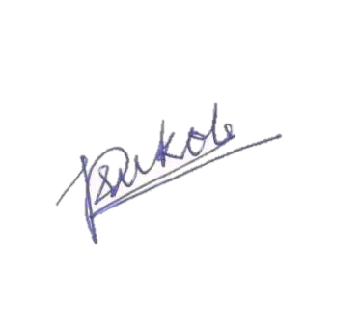

Prachi Sukole
This Certificate is presented to

Signature
Organiser

Date: 11-09-2025
Place: Nagpur
From SIT for her active participation in the event.
CERTIFICATE

