Exercise-1

Initialize your Repository: git init project Exercise-1

Create a file with name index.html

Write code in newly created file

Stage index.html

Commit with message ‘Initial Message.’

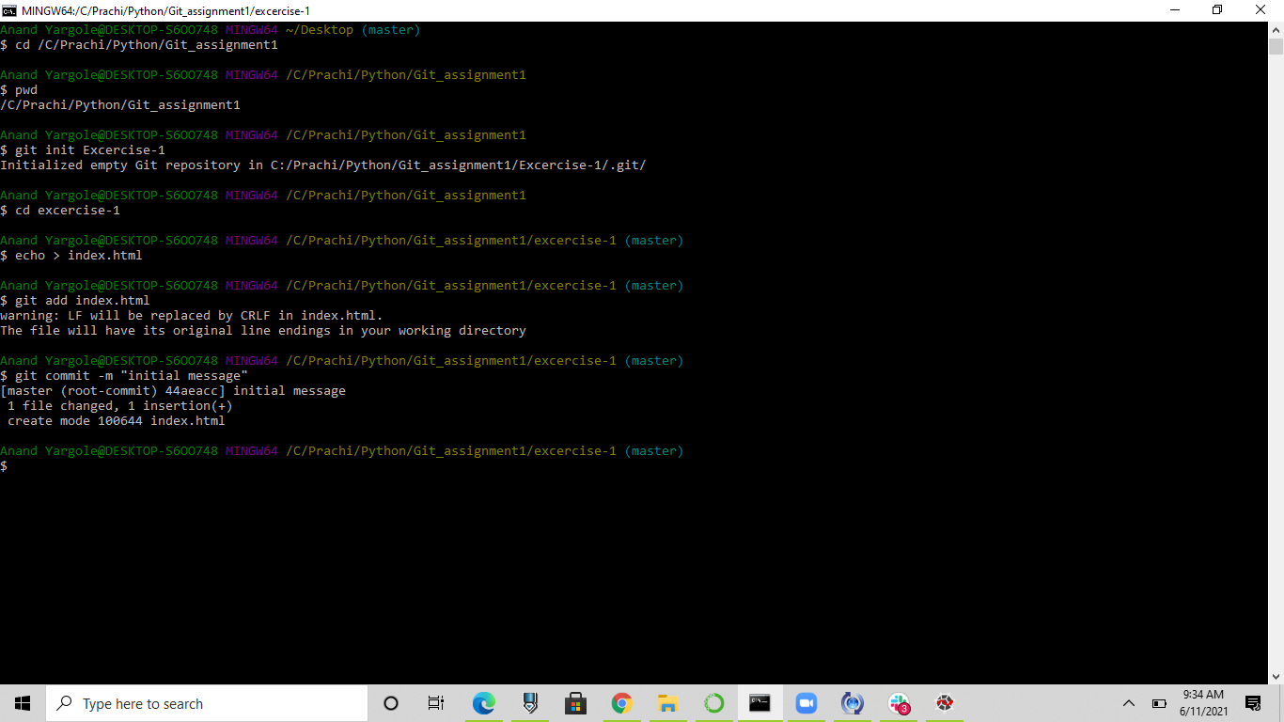

Exercise-2

Initialize your Repository: git init Exercise-2

Create a files with names index.html and about.html

Add code in both files.

Stage only one file.

Commit with message: ‘File x added.’

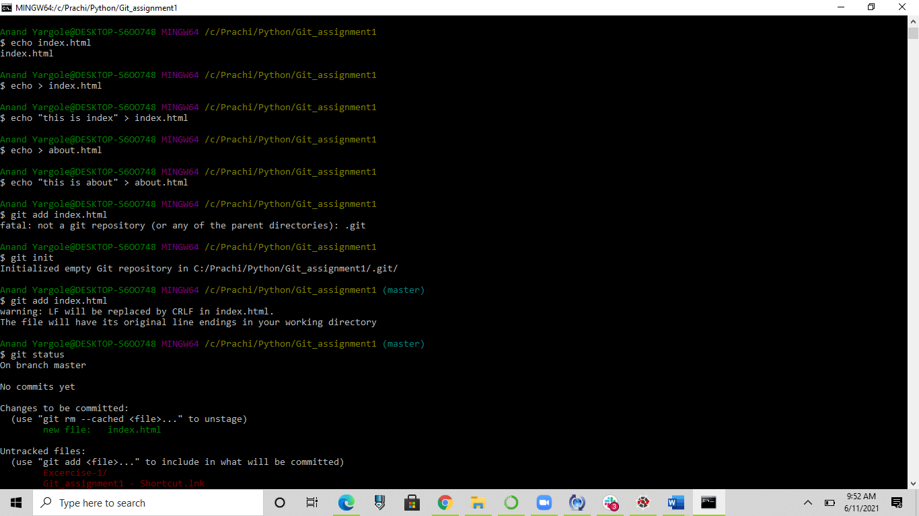

Exercise-3

Initialize your Repository: git init project Exercise-3

Create a file with name index.html

Write code in newly created file

Stage index.html

Commit with message ‘adding index.html.’

Add new about.html file with some code.

Now modify message of previous commit as ‘Adding index.html and

about.html ’and add about.html file in previous commit.

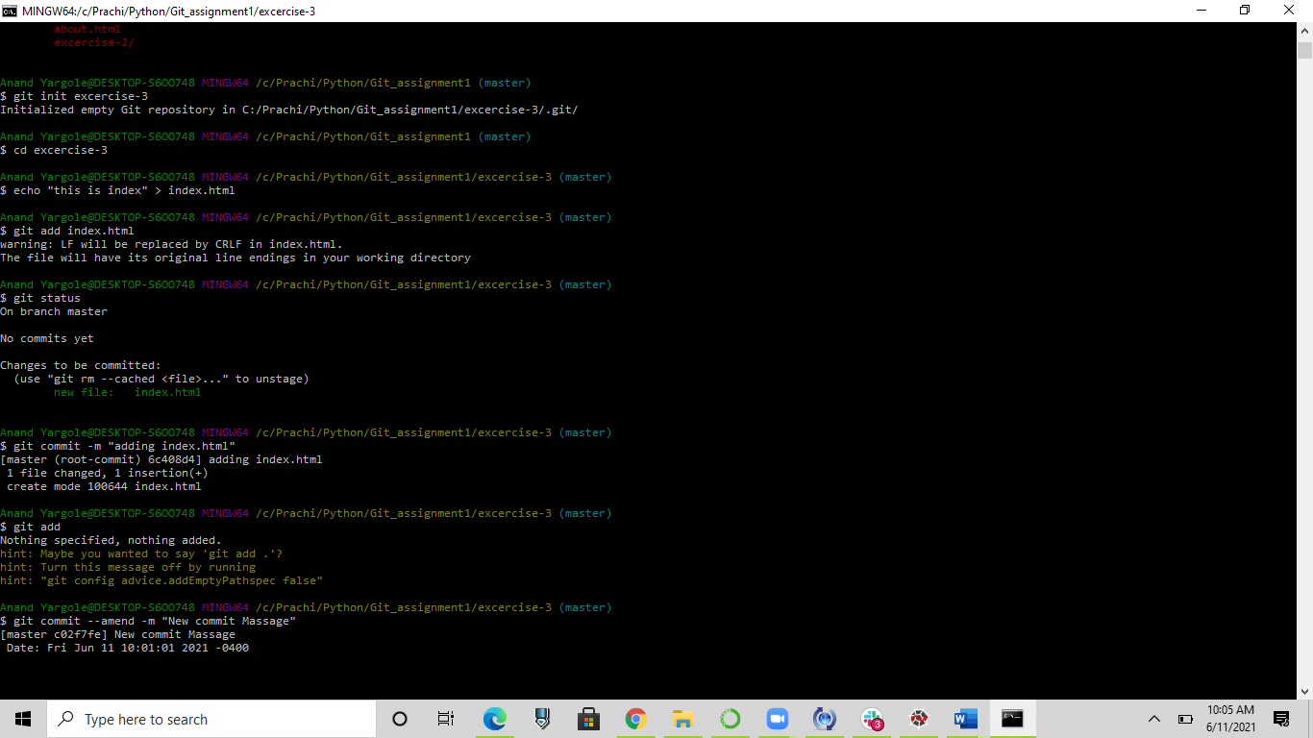

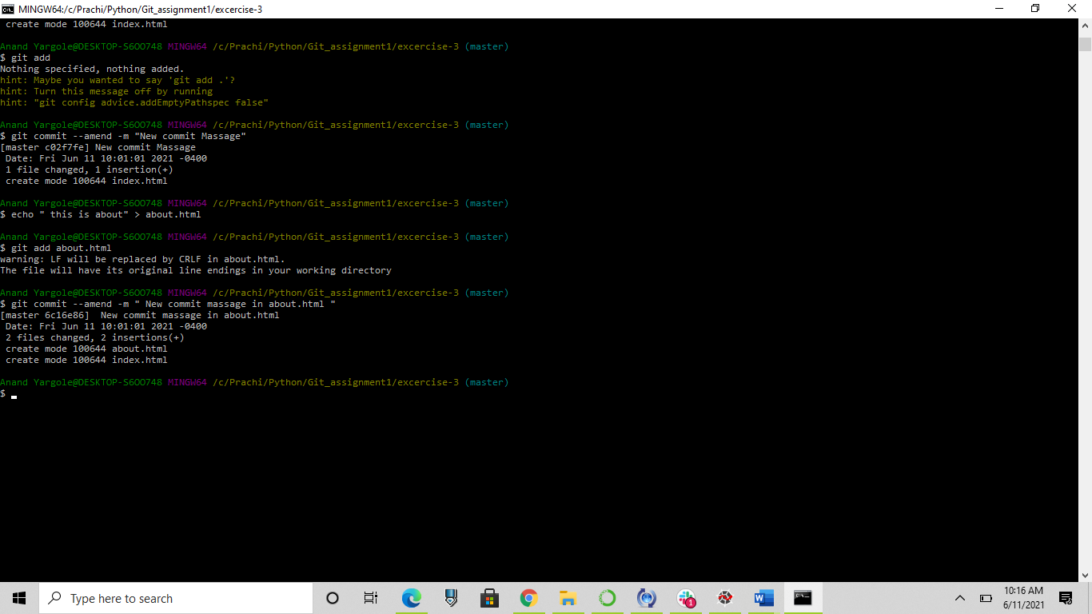

Exercise -4

Initialize your Repository: git init Exercise-4

Create a gitignore file that will ignore

all files with ‘exe’ extension

all files with ‘o’ extension

all files with ‘jar’ extension

the whole libraries directory

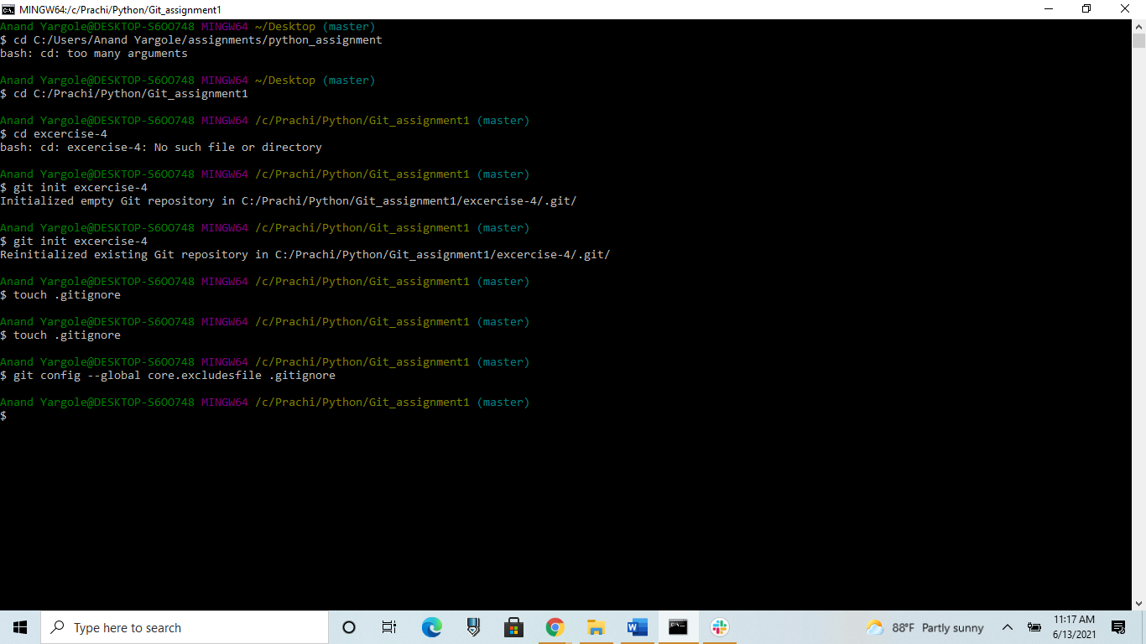

Exercise-5

Task:

Initialize your repository :git init exercise-5

Add some rondom file with code

Use stash command to save required files.

Refered link- https://abdulapopoola.com/2014/06/05/i-git-stashing-explained/

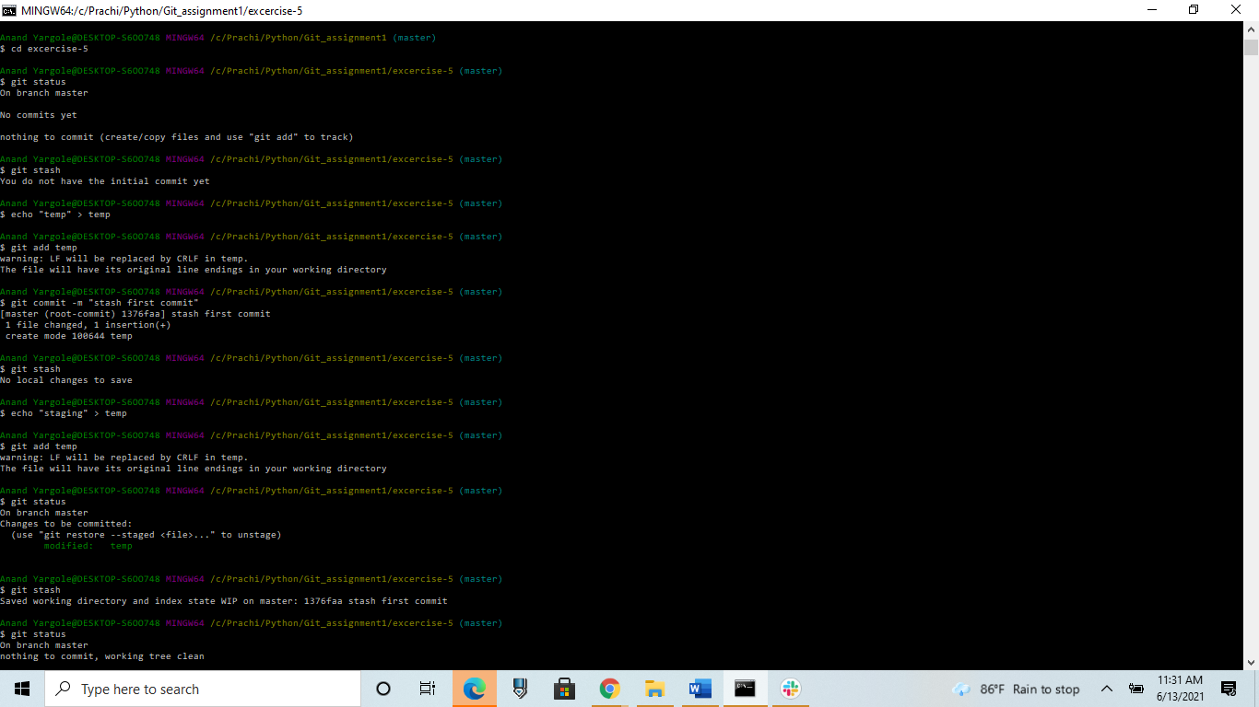

Exercise:6

Task:

Initialize your repository git init exercise-6

Do some series of commit

Now use git reset command to reset the one of the commit and keep it in staging area.

Refered link- <https://www.atlassian.com/git/tutorials/undoing-changes/git-reset>

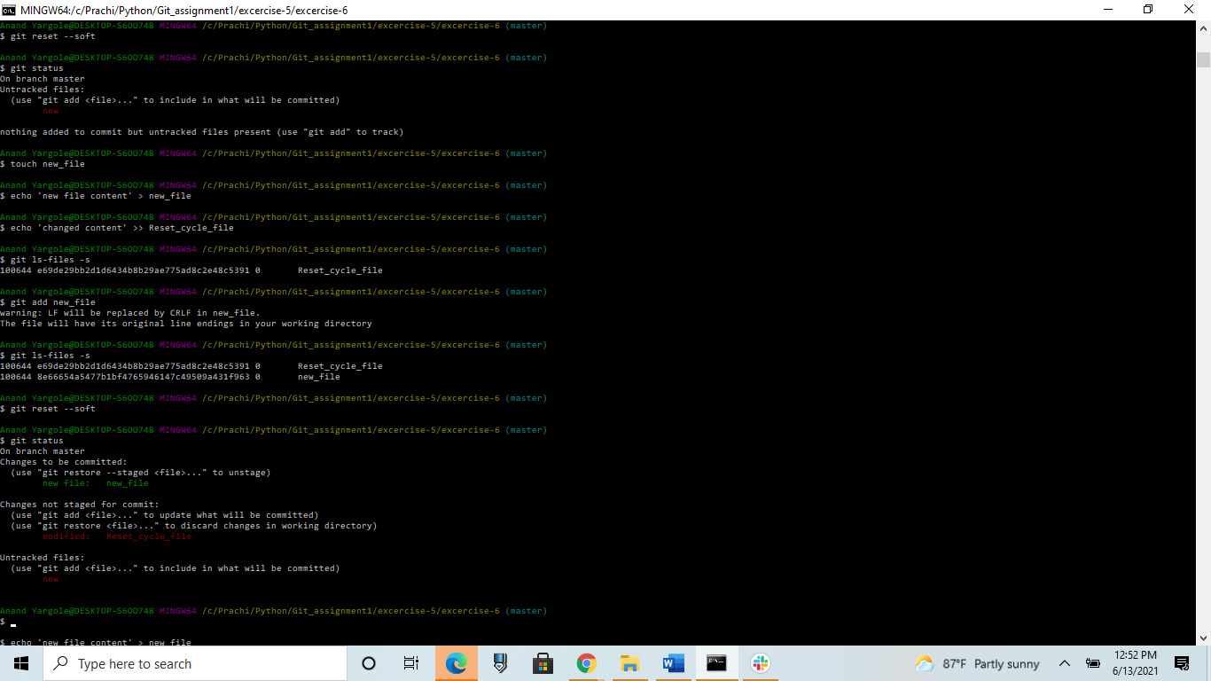

Exercise-7

Initialize repository to git init exercise-7

Do some commits

Use git rest –hard

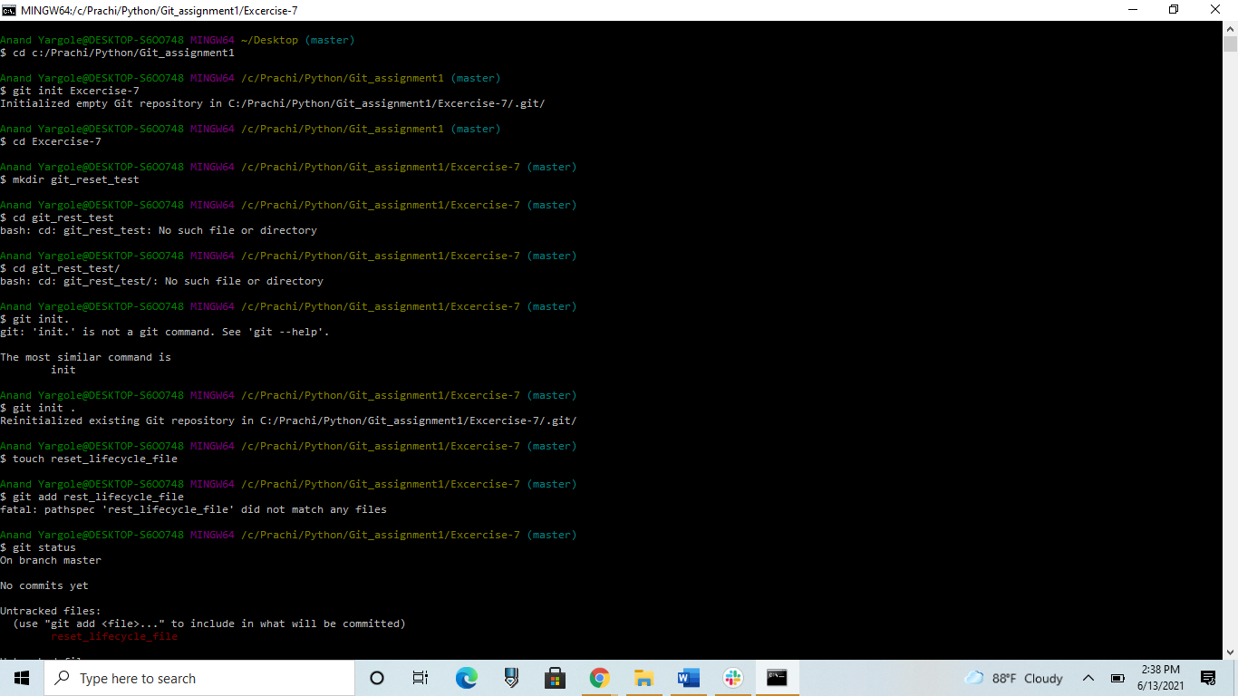

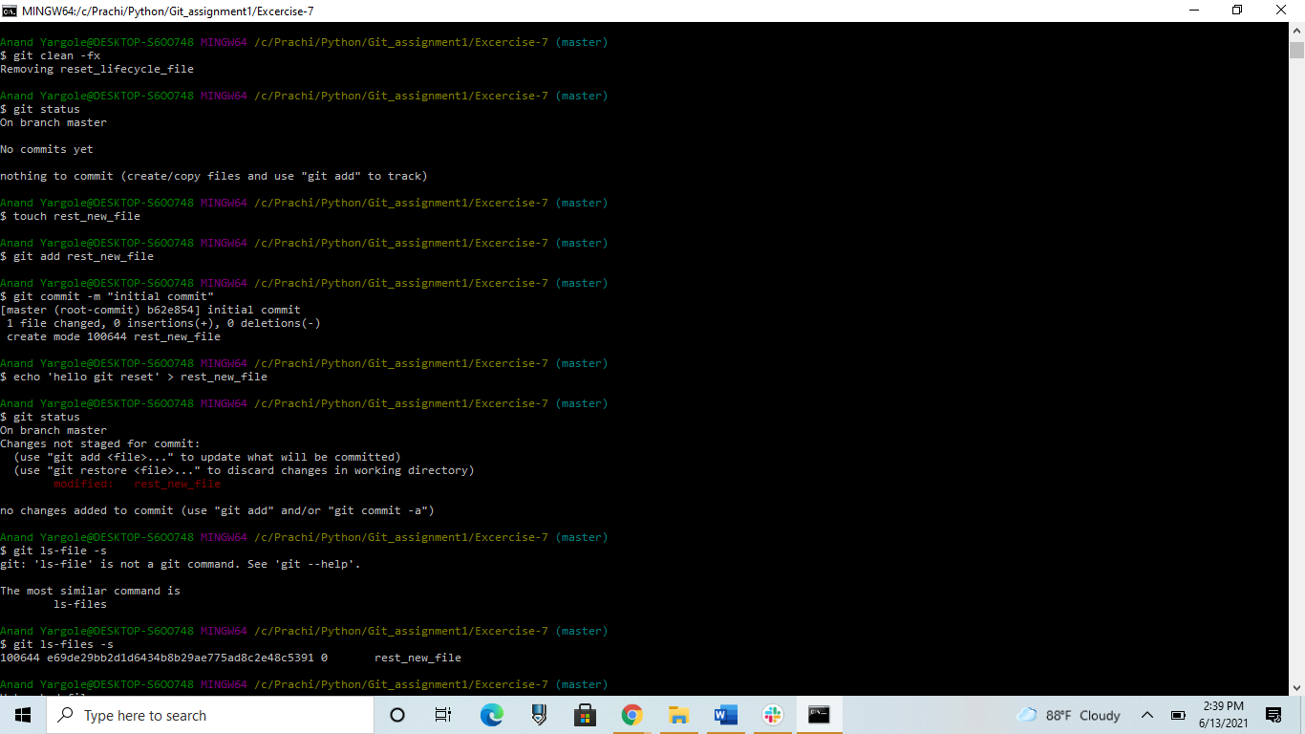

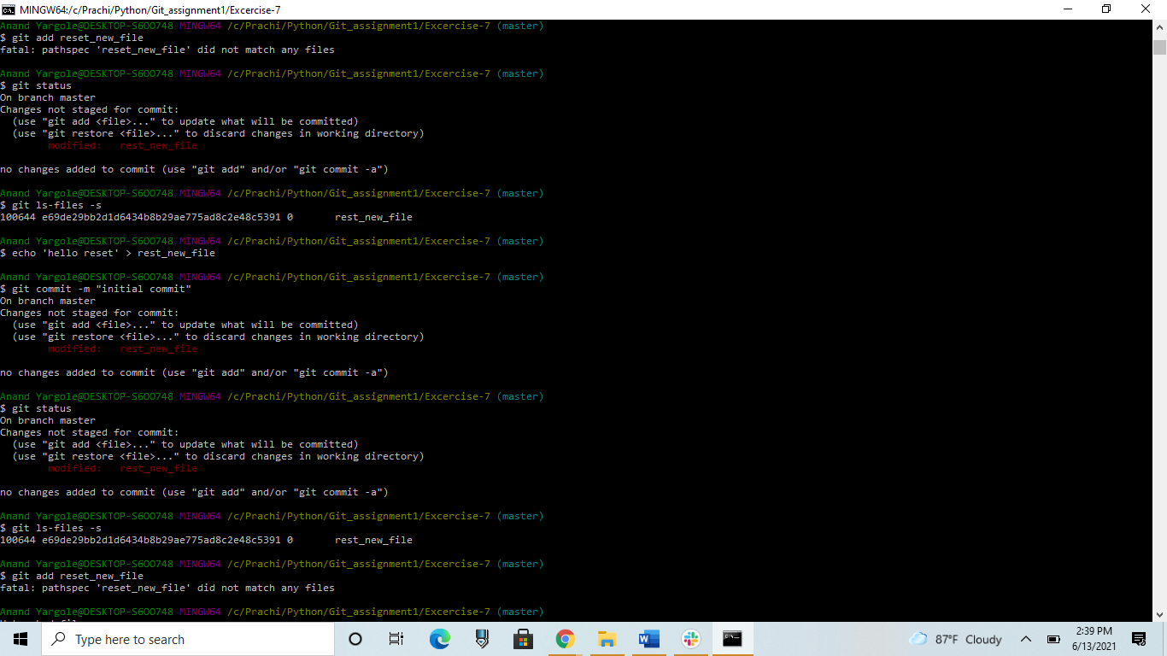

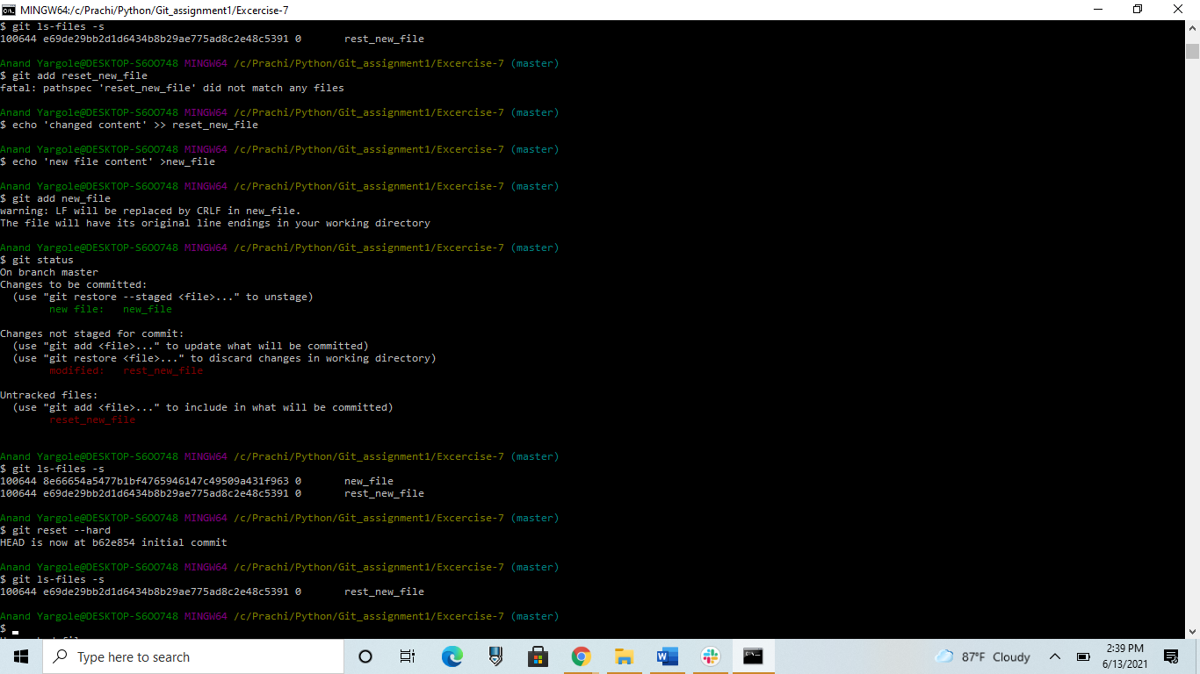

Exercise 8: Merge branch (No Conflicts).

Initialize your Repository: git init Exercise-8

Create index.html file add some code.

Make Commit.

Create new branch from master branch with name my-feature.

Add about-us.html file with code and commit changes in my-feature

Now checkout master branch.

Merge my-feature branch into master.

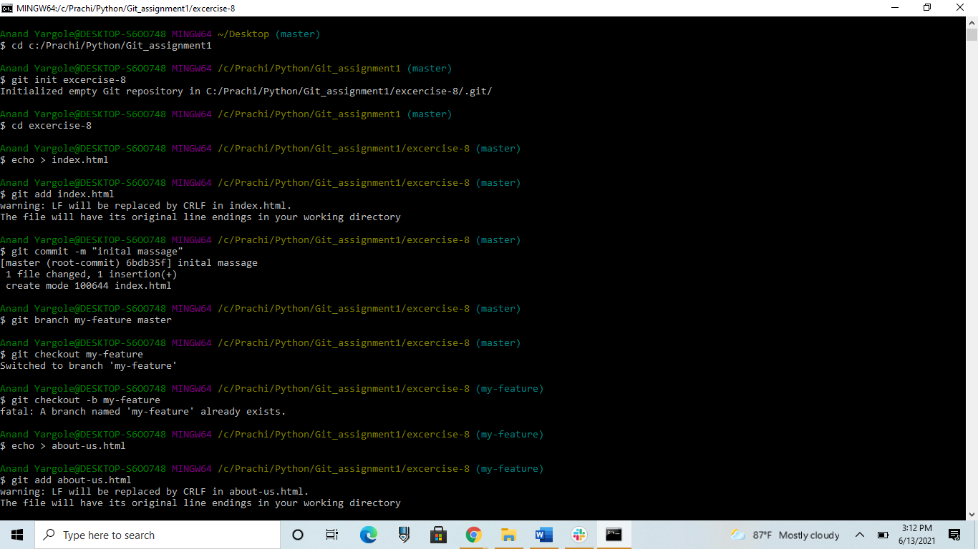

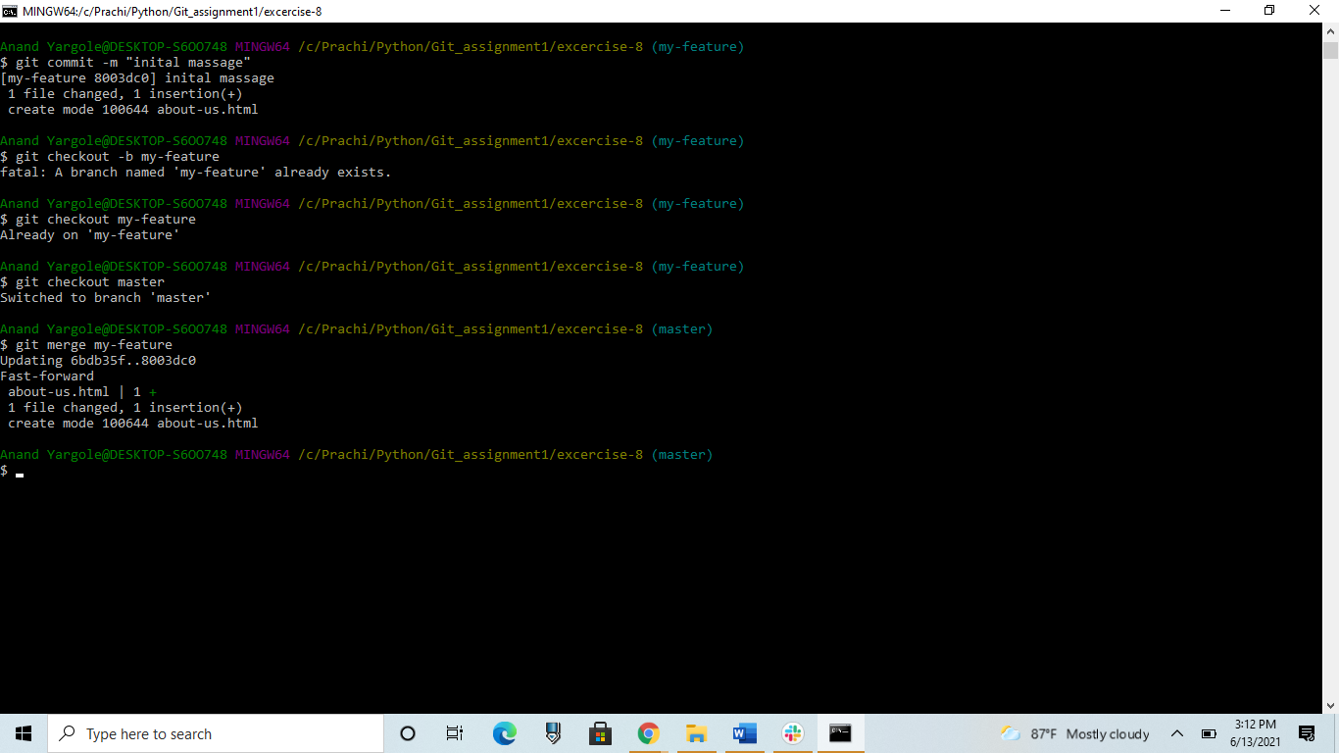

Exercise 9: Merge branch (Conflicts).

Initialize your Repository: git init Exercise-9

Create index.html file add some code.

Make Commit.

Create new branch from master branch with name my-feature.

Add about-us.html file with code

Make changes in index.html

Commit changes in my-feature branch.

Now checkout master branch.

Do some code changes in index.html

Commit changes.

Now merge my-feature branch into master.

You will get conflicts for index.html file. Resolve conflict by selecting both

changes for the same index.html file.

