**2. Write a program to read two numbers from the console, find their sum and**

**display the numbers and the sum on the console.**

import java.util.*;

class Sum{

public static void main(String[]args){

Scanner s=new Scanner(System.in);

System.out.println("Enter the first number n1:");

int n1=s.nextInt();

System.out.println("Enter the second number n2:");

int n2=s.nextInt();

int sum=n1+n2;

System.out.println("sum of two number are:"+sum);

}

}

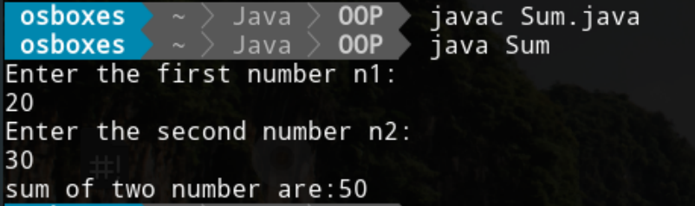

**3. Write a user-defined function to find the sum of an array passed as argument.**

**-Write a program that declares an array of 10 elements and uses this**

**function to**

**a) Find the sum of all elements.**

**b) Find the sum of first 5 elements.**

**c) Find the sum of last 5 elements.**

import java.util.*;

class ArraySum{

public static void main(String []args){

int n=10;

int sum=0;

int []arr=new int [n];

Scanner s=new Scanner(System.in);

System.out.print("Enter the elements of array:");

for(int i=0;i<arr.length;i++)

{ arr[i]=s.nextInt();}

ArraySum a=new ArraySum();

a.ArraySum(arr,n);

}

void ArraySum(int [] arr,int n){ //function

int sum=0;int i;

for( i=0;i<arr.length;i++)

{ sum=sum+arr[i];}

System.out.println("Sum of array elements is:"+sum);

//finding sum of first five elements

int f=0;

for( i=0;i<n/2;i++)

{

f=f+arr[i];

}

System.out.println("Sum of first 5 elements:"+f);

//find sum of last five elements of array

int l=0;

for(i=5;i<n;i++)

{

l=l+arr[i];

}

System.out.println("Sum of last 5 elements:"+l);

}

}

