HOBL Dashboard
Design Document

Date: June 14, 2026
Version: 1.0

Table of Contents
1. Overview
2. End-to-End Data Flow
3. Architecture
4. Authentication
5. Dashboard UI
6. Kusto Table Schema
7. API Endpoints
8. Project Structure
9. How to Run
10. Dependencies
11. Future Enhancements

1. Overview
The HOBL Dashboard is a web-based tool that visualizes performance and power metrics collected from HOBL (Hardware-Optimized Benchmark Lab) scenario runs. It queries the Fungates Kusto database and presents the data in an interactive, filterable HTML table.
The dashboard allows engineers to:
- Select a device and its RAM configuration
- Choose a scenario (e.g., YouTube, Teams, etc.)
- Pick a date when the scenario was run
- View all metrics iteration-wise in a structured table

2. End-to-End Data Flow
The dashboard is the final consumer in a pipeline that starts with HOBL running a scenario:
HOBL runs scenario (PASS)
│
▼
Results extracted to JSON + ETL, uploaded via CSEUploader.exe
│
▼
Fungates Azure Function ingests metrics into Kusto DB (Hobl_RawMetrics)
│
▼
HOBL Dashboard queries Kusto & displays data in browser

Step-by-step:
Step 1 – HOBL (C:\HOBL) runs a scenario on a device. If the result is PASS and fungates_upload_enabled=1, it automatically:
- Extracts results into hobl_result.json (via utilities\extractor\json_builder.py)
- Uploads hobl_result.json + trace.etl to the Fungates portal (via Upload-ToFungates.ps1 → CSEUploader.exe)
Step 2 – Fungates Azure Function (fungates-hobl) picks up the upload:
- Downloads the JSON and ETL blobs
- Runs HoblMetricExtractor.exe to parse hobl_result.json into CSV metrics
- Writes the metrics to the Kusto table Hobl_RawMetrics in the FungatesDataStore database
Step 3 – HOBL Dashboard (C:\hobl-dashboard) queries the Kusto table and renders the data in the browser.

3. Architecture
┌─────────────────────────────────────────┐
│ User's Browser │
│ │
│ HOBL Dashboard (HTML + CSS + JS) │
│ ┌──────────┐ ┌────────┐ ┌──────┐ │
│ │Device/RAM│ │Scenario│ │ Date │ │
│ └────┬─────┘ └───┬────┘ └──┬───┘ │
│ └──── cascading ───────┘ │
│ │ │
│ ┌─────────▼──────────┐ │
│ │ Metrics Table │ │
│ └────────────────────┘ │
└────────────────┬────────────────────────┘
│ HTTP (localhost:5000)
┌──────────▼───────────┐
│ Flask Backend │
│ (app.py) │
└──────────┬───────────┘
│ KQL (azure-kusto-data)
┌──────────▼───────────┐
│ Azure Data Explorer │
│ Cluster: fungateprd │
│ DB: FungatesDataStore│
│ Table: Hobl_RawMetrics│
└──────────────────────┘

Tech Stack
Component | Technology
Backend | Python 3 + Flask
Kusto SDK | azure-kusto-data (KQL queries)
Authentication | azure-identity (InteractiveBrowserCredential)
Frontend | HTML + CSS + vanilla JavaScript
Data Source | Azure Data Explorer (Kusto)

4. Authentication
The dashboard uses Azure AD interactive browser login to authenticate the user. This ensures that only authorized users with Kusto RBAC access can view the data.

How it works:
1. When the Flask app starts, it initializes an InteractiveBrowserCredential from the azure-identity SDK.
2. On the first Kusto query, a browser tab opens automatically showing the Microsoft Azure "Pick an account" login page:
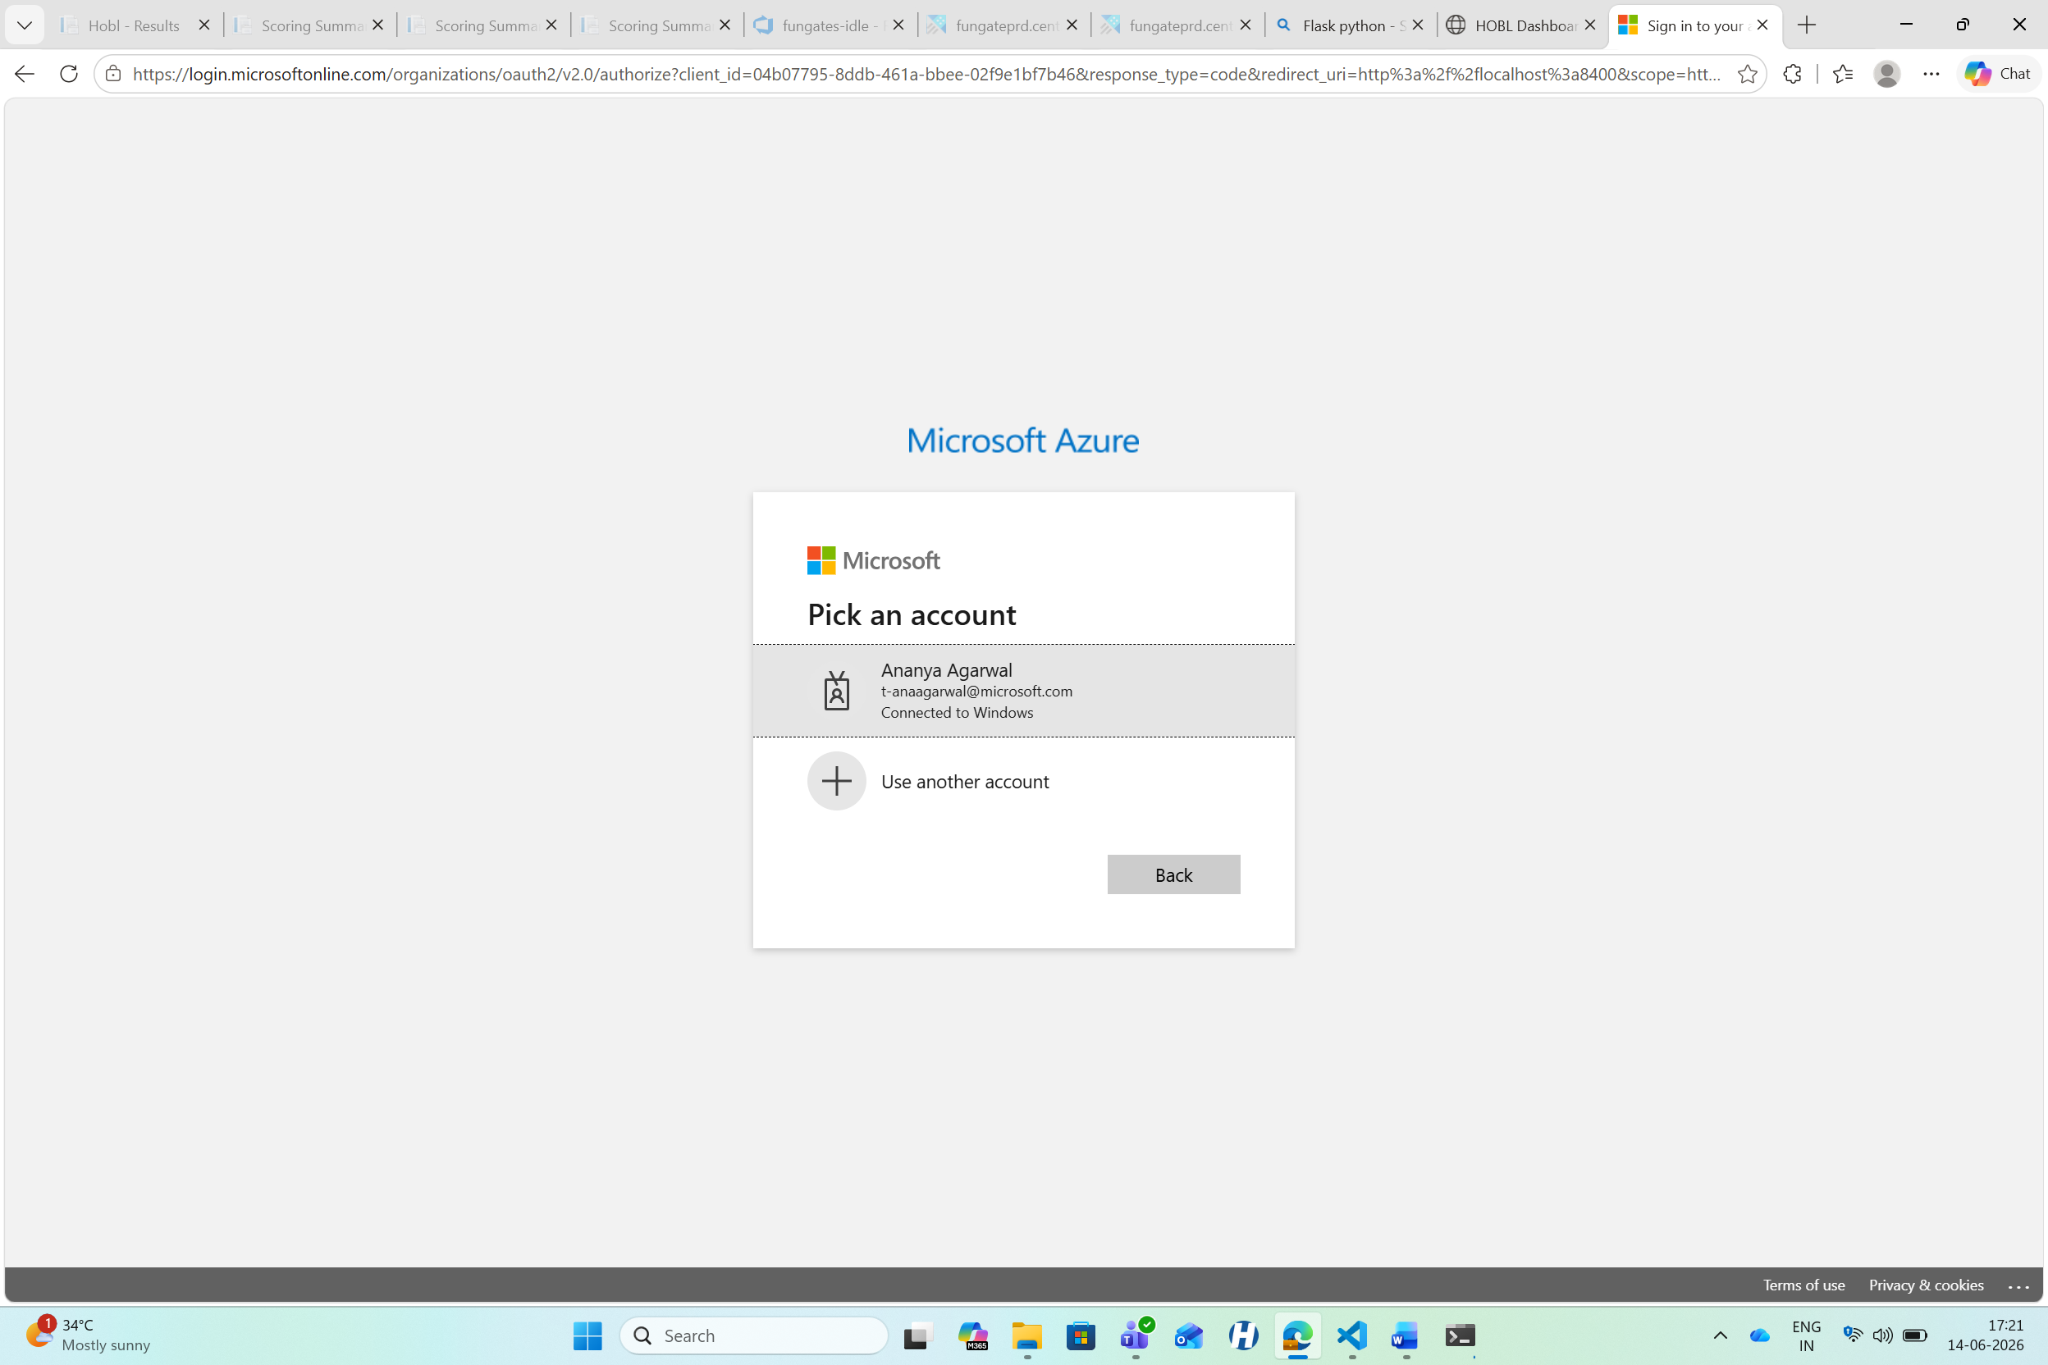
Figure 1: Azure AD Login — Pick an account
3. After successful login, the browser shows "Authentication complete. You can close this window.":
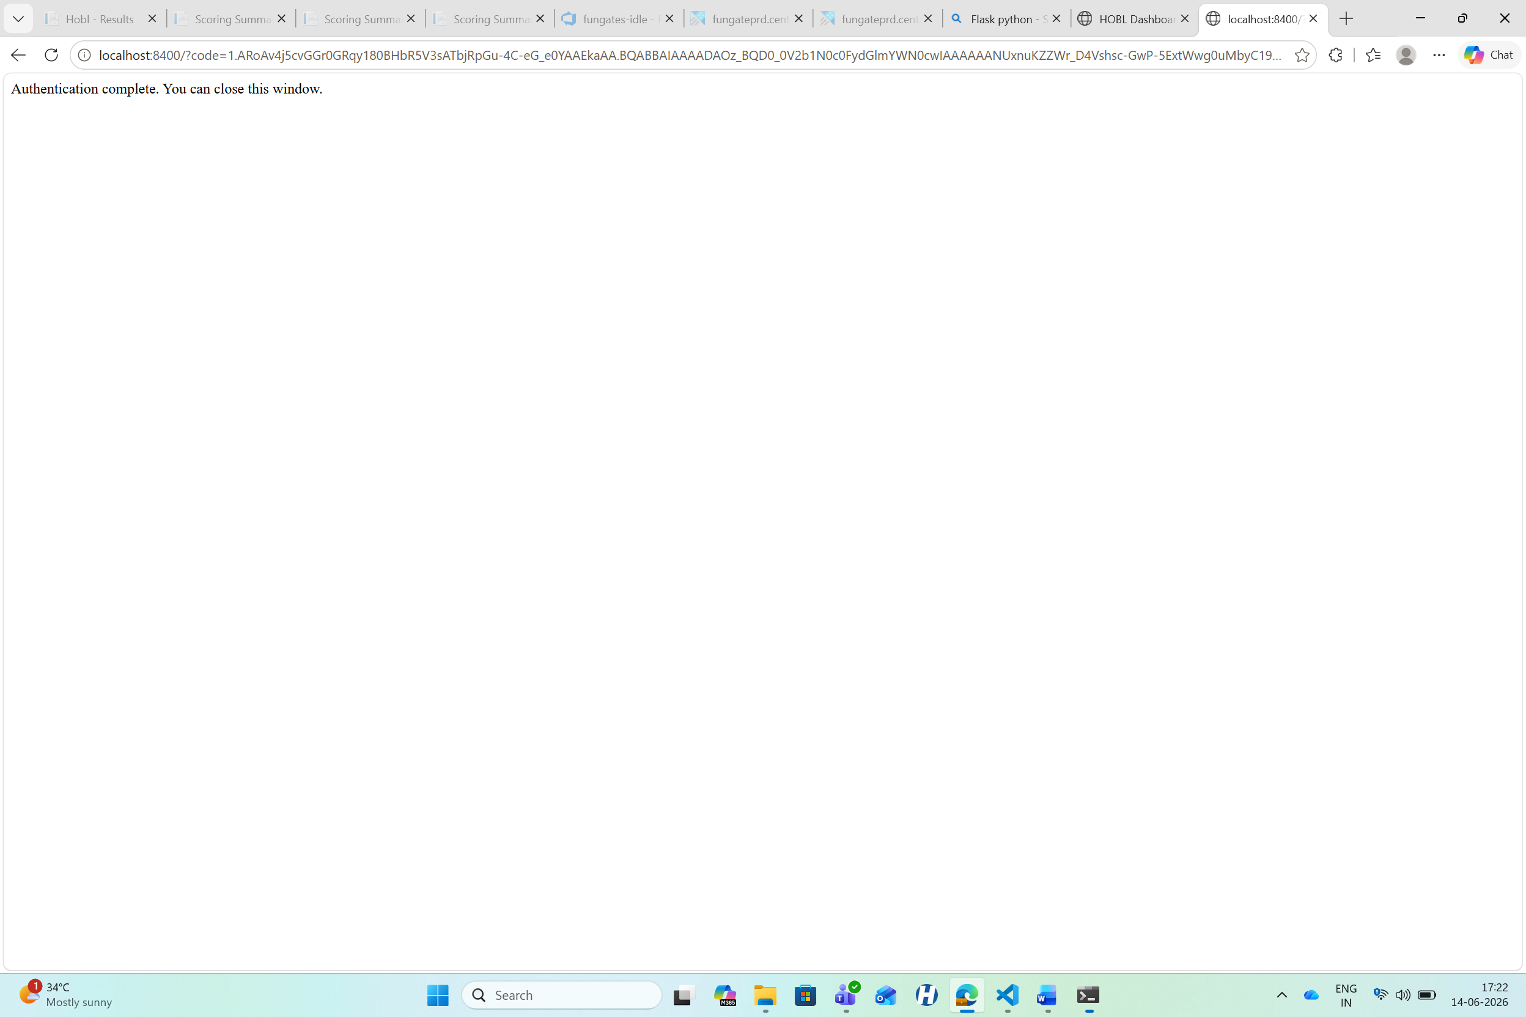
Figure 2: Authentication Complete confirmation
4. The token is cached for the session — subsequent queries do not require re-login.

Access Control:
- Only users with Azure AD accounts that have RBAC access to the Kusto cluster (fungateprd.centralus) can query data.
- The dashboard runs on localhost (127.0.0.1), so only the person running it on their machine can access the web UI.
- No data is exposed externally.

5. Dashboard UI
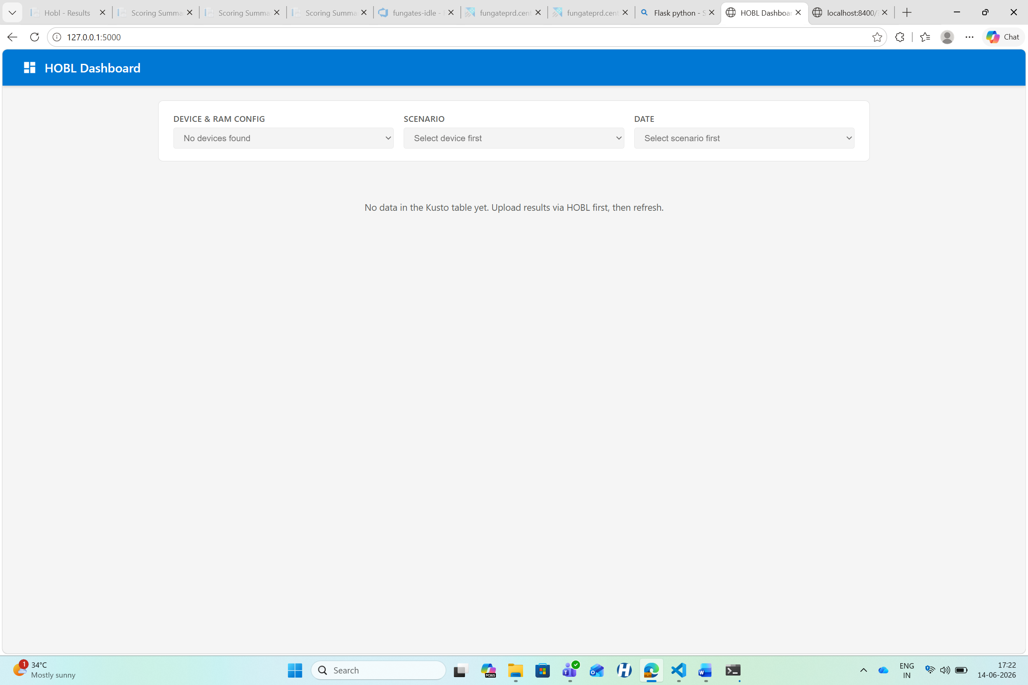
Figure 3: HOBL Dashboard — filters and status area (no data uploaded yet)

5.1 Filters (Cascading Dropdowns)
The dashboard has three cascading filter dropdowns that load data progressively:
Filter | Source Column | Description
Device & RAM Config | TierName | Format: <DeviceName>_<MemorySizeGB>. Displayed as "DeviceName (XX GB)"
Scenario | TestName | Extracted from TestName by removing the _NNN iteration suffix
Date | RunDate | The date when the scenario was run, formatted as YYYY-MM-DD

Cascading behavior:
- Device & RAM Config loads on page open → lists all available devices
- Scenario loads when a device is selected → shows scenarios run on that device
- Date loads when a scenario is selected → shows dates that scenario was run
- Metrics table loads when a date is selected → shows all metrics for that run

5.2 Metrics Table
Once all three filters are selected, the metrics are displayed in a table:
Column | Source Column | Description
Iteration | Iteration | The iteration number (1, 2, 3...) — grouped with a section header
Metric Name | Name | The metric identifier (e.g., pm_emi_cpu_cluster_0, system_power)
Value | Value | The numeric metric value (e.g., 0.177, 4.68)
Unit | Unit | Unit of measurement (e.g., W for Watts, ms for milliseconds)
Type | MetricType | Color-coded: PowerMetrics (green), PowerCalculation (orange), PerfMetrics (blue)

Metrics are grouped by iteration. A blue header row separates each iteration (e.g., "Iteration 1", "Iteration 2"). Within each iteration, metrics are sorted by type and then by name.

6. Kusto Table Schema
The dashboard reads from the Hobl_RawMetrics table in the FungatesDataStore database. Key columns used by the dashboard:
Column | Type | Used For
Name | string | Metric name displayed in the table
MetricType | string | Metric category (PowerMetrics, PowerCalculation, PerfMetrics)
StudyType | string | Run type (e.g., "Power")
Value | real | Metric value displayed in the table
Unit | string | Unit of measurement
TierName | string | <DeviceName>_<RAMSizeGB> — used for device filter
TestName | string | <scenario>_<iteration> — used for scenario filter
RunDate | datetime | Date of the run — used for date filter
Iteration | int | Iteration number — used for table grouping
TestResultId | string | Unique ID for the test result

How TierName maps to Device + RAM:
The TierName is generated during HOBL's upload process (New-MetadataFile.ps1) as:
TierDefinitionKey = "<DeviceName>_<MemorySizeGB>"
For example: ROM-MS-IDCLAB-2_16 → Device: ROM-MS-IDCLAB-2, RAM: 16 GB

How TestName maps to Scenario + Iteration:
The TestName is the ETL filename without extension (e.g., youtube_001). The dashboard extracts:
- Scenario: everything before the last _NNN → youtube
- Iteration: the numeric suffix → 1

7. API Endpoints
The Flask backend exposes four REST endpoints:
Endpoint | Method | Parameters | Returns
/api/tiers | GET | — | List of distinct TierName values
/api/scenarios | GET | tier (TierName) | List of scenario names for that tier
/api/dates | GET | tier, scenario | List of run dates (YYYY-MM-DD)
/api/metrics | GET | tier, scenario, date | List of metric objects with Iteration, MetricName, Value, Unit, MetricType

All endpoints return JSON. Input parameters are sanitized to prevent KQL injection.

8. Project Structure
C:\hobl-dashboard\
├── venv\ # Python virtual environment
├── templates\
│ └── index.html # Dashboard UI (HTML + CSS + JS)
├── app.py # Flask backend with Kusto query logic
├── config.py # Configuration (cluster, DB, table)
├── requirements.txt # Python dependencies
└── DESIGN_DOCUMENT.md # Markdown version of this document

9. How to Run

Prerequisites
- Python 3.10+
- VPN connection (to reach the Kusto cluster fungateprd.centralus)
- Azure AD account with access to the FungatesDataStore Kusto database

Steps
cd C:\hobl-dashboard
.\venv\Scripts\Activate.ps1
python app.py
- 1. The Flask server starts on http://127.0.0.1:5000
- 2. Open that URL in your browser
- 3. A new tab opens for Azure AD login — pick your Microsoft account
- 4. After "Authentication complete", return to the dashboard tab
- 5. Use the cascading filters to explore metrics

First-time Setup (if venv doesn't exist)
cd C:\hobl-dashboard
python -m venv venv
.\venv\Scripts\Activate.ps1
pip install -r requirements.txt
python app.py

10. Dependencies
Package | Version | Purpose
flask | 3.1.1 | Web framework for the dashboard server
azure-kusto-data | 4.6.1 | Kusto / Azure Data Explorer SDK
azure-identity | 1.21.0 | Azure AD authentication (browser login)

11. Future Enhancements
Enhancement | Description
CSV Export | Add a button to download the displayed metrics as a CSV file
Trend Charts | Plot metric values across dates for the same device + scenario
Comparison View | Compare metrics between two different devices or dates side by side
Team Deployment | Host on Azure App Service with Azure AD web app auth for team-wide access
Auto-Refresh | Periodically poll for new data after scenario uploads

