Lab-1
STUDENT DETAILS:
CODE:
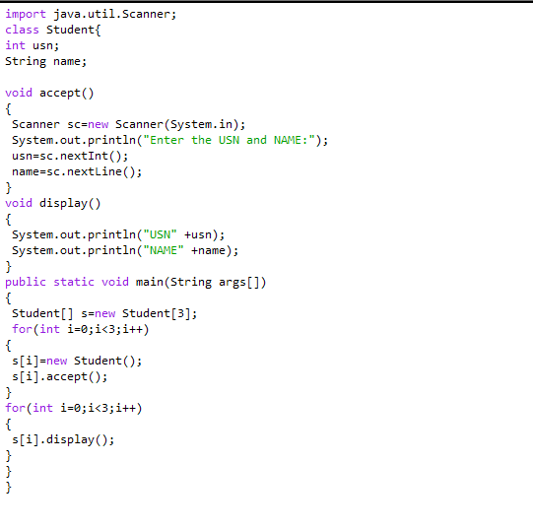
OUTPUT:

