JIRA
What is JIRA
- Project Management tool
- Track project work status
- Track Bugs and Issues
- Team Work & time tracking
- Etc…

Who should learn Jira
- Developer
- QA (Testers)
- Business developers
- Product owners
- Team manager and management

Why need jira
- Help you to get job
- One stop solution for project management
- No need to make excel or other doc
- Project work and bugs can manage easily
- Team can communicate over the project
- Can handle multiple projects
- Charts and graphs will help the project process

History and details
- Developed by Atlassian company
- Git & confluence is also created by Atlassian
- Jira Products
- Jira work management – Business project (HR team, Account, advocates)
- Jira software – used by developers and testers (provides integration with git,ci/cd etc)
- Jira service management – used by customer care, bank etc ()we raise ticket to solve our problems

What we will learn in this Series
- How to make a project in Jira
- Practical use of JIRA
- how to make
- Epic
- Story
- Bug
- Task
- Project setting
- Project dashboard
- Spring
- Agile
- Scrum
- Search items (bug, story etc)
- What is sprint grooming
- Etc

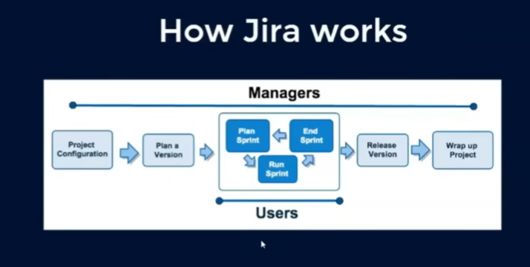

- Project configuration
- Project name
- Assign team/rolls
- Release time = Release total

- Plan a version
- Plan String
- Work done in a sprint
- Can be updated later if required

Project management Release versions Sprint planning (create task by developer and tester will create its own task while working on same story, Assign bug) Release version (1.1,1.2,1.3 etc) UAT Deploy product Wrap (can get chart of complete flow of how project get completed)

Jira Instance (how many ways we can use JIIRA)
- Cloud instance
- Use JIRA on Jira website (small company, student)
- 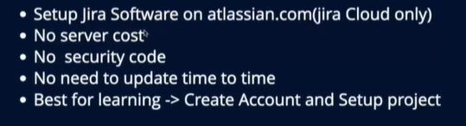

- Server instance
- Purchase Jira on your website and install/set it on website and use it there only
- 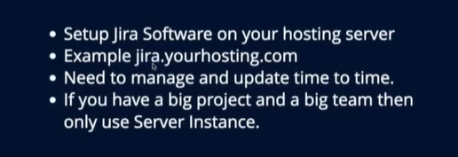

Agile methodology
- Methodology in software development
- What is Agile Method
- The Framework of Agile Method
- Agile Methodology principles
- Alternative of Agile method

Methodology in Software Development
- The software development methodology is a process by which developers design, implement and test new computer software projects
Ex.
- How to develop and test project
- How to release the project
- How to manage roadmap and project milestone
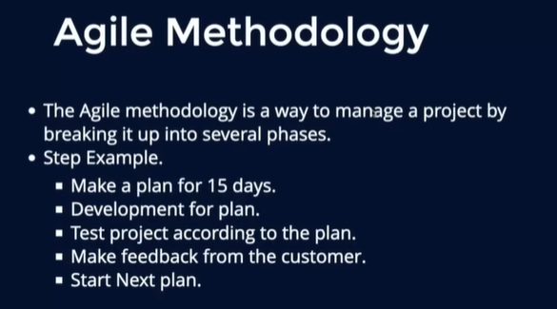
Old project > Maintenance
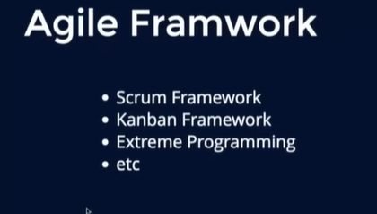
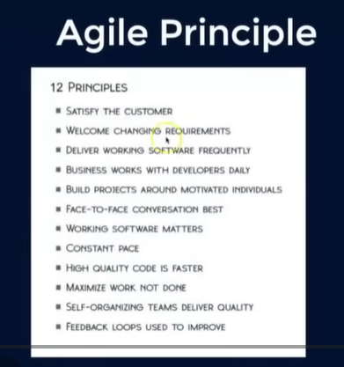
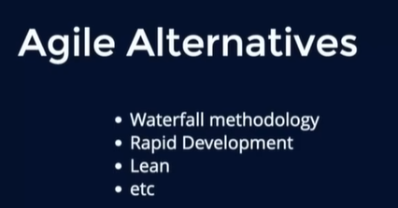
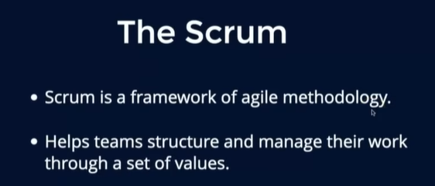
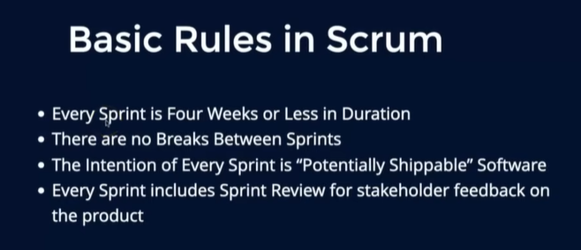
Sprint short term target
