**PART A**

**EXPERIMENT NO. 8**

**A.1 AIM: -** TO detect Breast Cancer Diagnosis via Logistic Regression

**A.2 Prerequisite**

* Different programming language (Python or Java), Understanding of Machine Learning Algorithms, Machine Learning Algorithms

**A.3 Outcome**

After successful completion of this experiment students will be able to Optimize the problem.

**A.4 Theory**

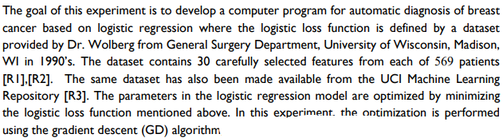

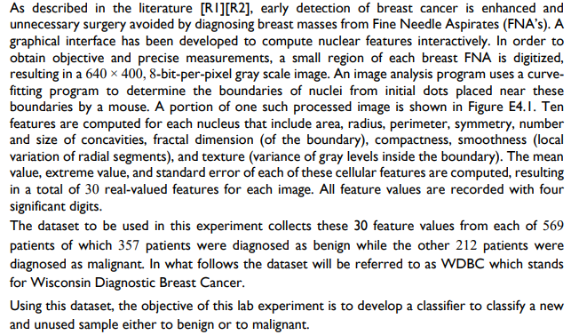

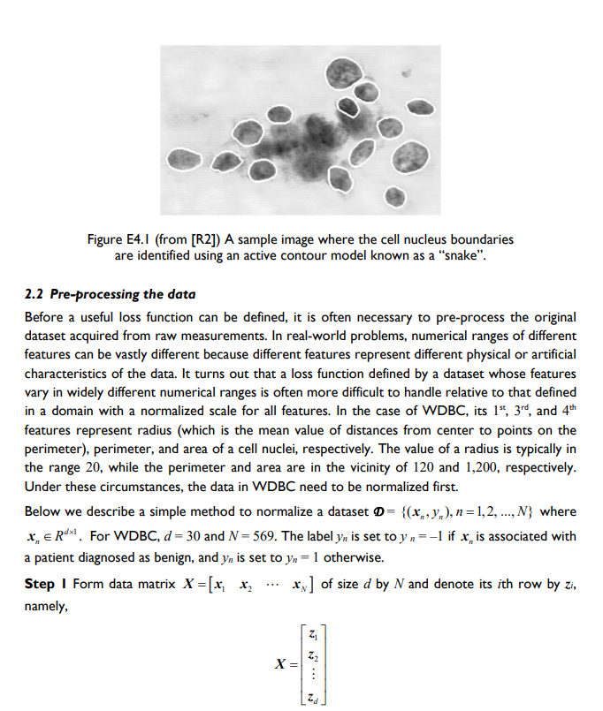

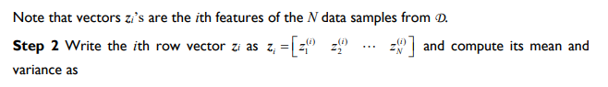

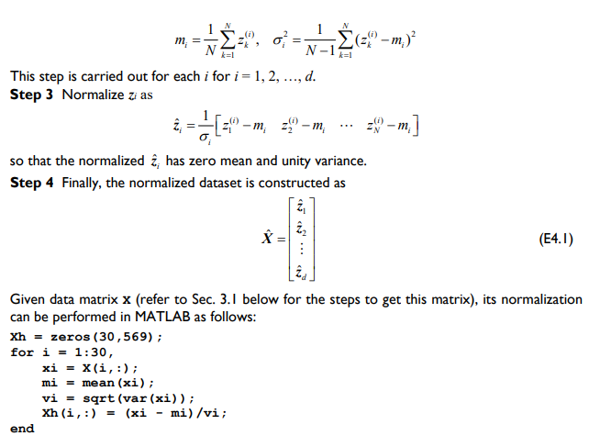

Procedure:

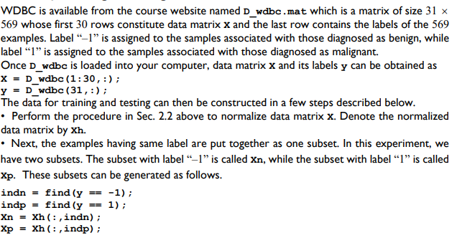

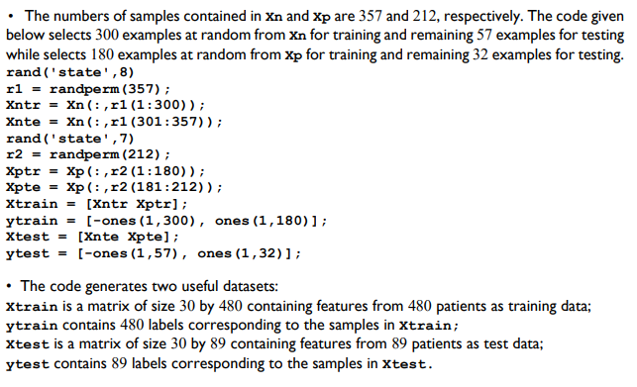

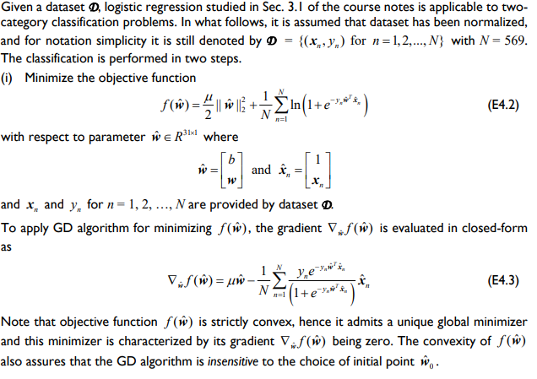

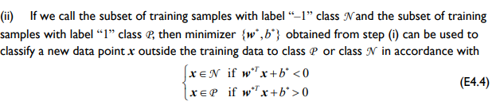

Links: <https://archive.ics.uci.edu/ml/datasets/breast%2Bcancer%2Bwisconsin%2B(Prognostic)>

Or

<https://www.kaggle.com/datasets/yasserhessein/dataset-breast-cancer-wisconsin>

PART B

|  |  |
| --- | --- |
| Roll No. C015 | Name: Prachi Dave |
| Class : BTI SEM 10 | Batch : EB1 |
| Date of Experiment: 22/03/24 | Date of Submission |
| Grade : |  |

**B.1 Documentation written by student:**

import pandas as pd

import numpy as np

from sklearn.model_selection import train_test_split, GridSearchCV

from sklearn.linear_model import LogisticRegression

from sklearn.preprocessing import StandardScaler

from sklearn.metrics import classification_report

df = pd.read_csv('data.csv')

df.drop(*columns*=["id", "Unnamed: 32"], *inplace*=True)

df

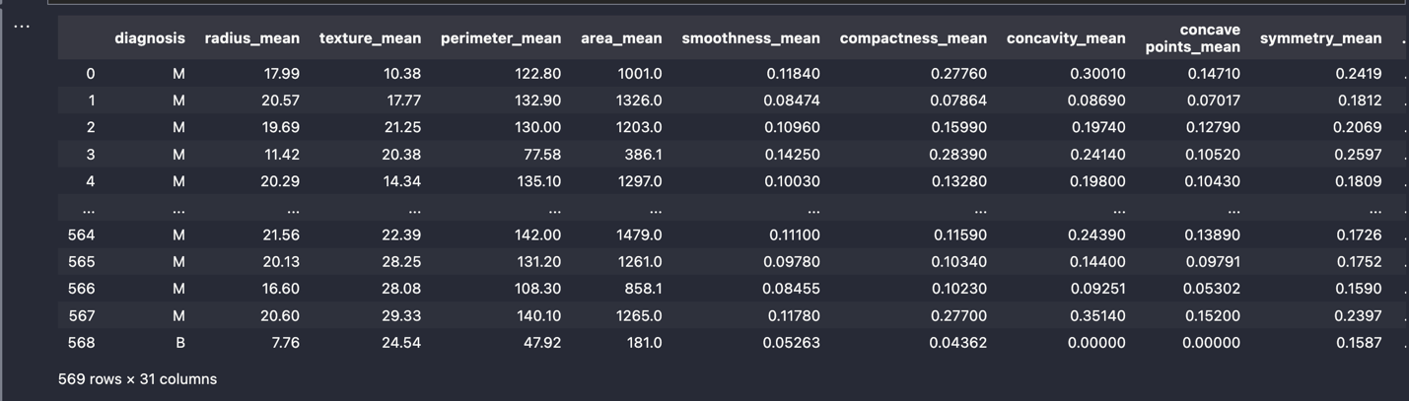

X = df.iloc[:, 1:]

y = df.iloc[:, 0]

y = np.where(y == 'B', 0, 1)

scaler = StandardScaler()

X = scaler.fit_transform(X)

X_train, X_test, y_train, y_test = train_test_split(X, y, *random_state*=42, *test_size*=0.2)

param_grid = {

"penalty": ["l1", "l2"],

"C": [0.1, 1, 10],

"solver": ["newton-cg", "lbfgs", "liblinear", "sag", "saga"]

}

grid_search = GridSearchCV(LogisticRegression(), *param_grid*=param_grid, *cv*=5)

grid_search.fit(X_train, y_train)

best_log_reg = grid_search.best_estimator_

preds_optimized = best_log_reg.predict(X_test)

accuracy_optimized = best_log_reg.score(X_test, y_test)

print("Accuracy of Optimized Logistic Regression:", accuracy_optimized)

print("Classification Report for Optimized Logistic Regression:\n", classification_report(y_test, preds_optimized))

**B.2 Observations and learning:**

The optimized logistic regression model achieves an impressive accuracy of approximately 99.12%. Upon examining the classification report, it's evident that the model performs exceptionally well across both classes (0 and 1), with high precision, recall, and F1-score values. Specifically, for class 0, it achieves near-perfect precision, recall, and F1-score of 0.99, indicating precise and accurate predictions for benign cases. For class 1, although the precision is perfect (1.00), there is a slightly lower recall (0.98), suggesting a small number of malignant cases might have been misclassified as benign.

**B.3 Conclusion:**

In summary, the optimized logistic regression model demonstrates remarkable performance in accurately classifying breast cancer cases. Its high precision, recall, and F1-scores, coupled with an overall accuracy exceeding 99%, underscore its reliability and effectiveness in identifying both benign and malignant tumors. This underscores the importance of fine-tuning model parameters to achieve optimal performance, especially in critical applications like medical diagnosis.