|  |  |
| --- | --- |
| Roll No. C015 | Name: Prachi Dave |
| Class : BTI SEM 10 | Batch : EB1 |
| Date of Experiment: 22/03/24 | Date of Submission |
| Grade : |  |

**Title:** Enhancing Algorithm Performance through Hybrid Optimization and Machine Learning Approaches

**Abstract:** This research study investigates the integration of optimization and machine learning techniques to develop hybrid algorithms that address the limitations of traditional approaches. The study aims to explore the challenges faced by standalone optimization and machine learning algorithms, examine the strategies used to combine these methodologies, and assess the potential benefits of hybrid algorithms in improving algorithm performance. A systematic literature review methodology is employed to analyze existing research on hybrid optimization and machine learning approaches, highlighting key trends, advancements, and opportunities in the field. The findings underscore the strengths of hybrid algorithms in enhancing parameter estimation, overcoming local optima, and increasing adaptability across diverse problem domains. The study also identifies challenges and opportunities for further research in advancing hybrid methodologies for clustering and classification tasks.

**Introduction:** Optimization and machine learning are fundamental components of computational intelligence, each with its strengths and limitations. The integration of these techniques through hybrid algorithms offers a promising avenue for enhancing algorithm performance in various applications. This study aims to explore the evolution of hybrid approaches in optimization and machine learning, focusing on their potential to address the shortcomings of traditional algorithms and improve overall efficiency in solving complex problems.

**Exploration Approach:** Utilizing a rigorous investigative approach, this comprehensive inquiry encompasses a systematic review of literature, SWOT analyses of pivotal algorithms, and a meticulous examination of existing methodologies. A carefully devised search strategy targets relevant articles across eminent databases including Scopus, Web of Science, and IEEE. The search parameters are finely tuned to uncover papers elucidating hybrid optimization and machine learning approaches, ensuring a thorough exploration of the subject matter.

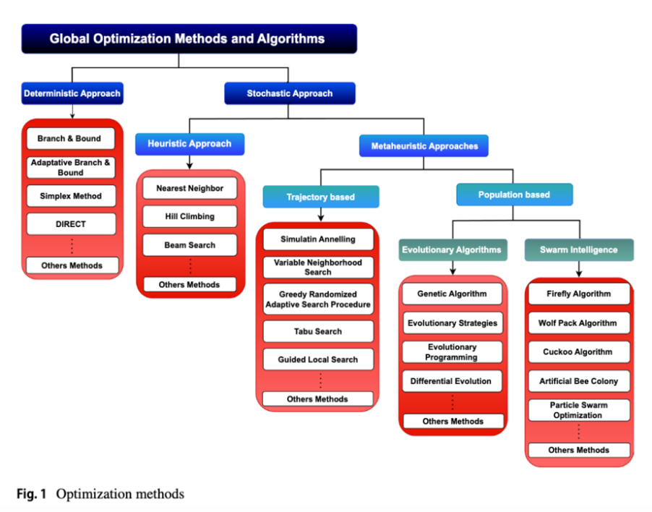

**Literature Review:** The literature review provides a comprehensive overview of existing research on hybrid optimization and machine learning approaches. Previous studies have highlighted the benefits of combining optimization and machine learning techniques, such as improved convergence rates, enhanced search capabilities, and increased robustness in handling diverse datasets. However, gaps in the literature exist regarding the systematic evaluation of hybrid algorithms across different problem domains and the identification of optimal integration strategies for maximizing algorithm performance.

**Methods:** The research design involves a systematic literature review of relevant articles, conference papers, and reviews that discuss hybrid optimization and machine learning approaches. Search queries are conducted across multiple databases using predefined keywords related to optimization, machine learning, hybrid algorithms, clustering, and classification. Inclusion criteria are established to select studies that focus on the integration of optimization and machine learning techniques and their impact on algorithm performance.

**Results:** The analysis of the selected literature reveals a diverse range of hybrid optimization and machine learning approaches, each with unique strengths and weaknesses. Key findings include the effectiveness of hybrid algorithms in improving parameter estimation, mitigating local optima, and enhancing algorithm adaptability across different problem domains. The results also highlight the need for further research to optimize the integration of optimization and machine learning techniques for specific applications and to address challenges such as algorithm bias and complexity.

**Discussion:** The interpretation of the results underscores the significance of hybrid optimization and machine learning approaches in advancing algorithm performance and addressing the limitations of traditional methods. By combining the strengths of optimization and machine learning techniques, researchers can develop more robust and efficient algorithms for clustering and classification tasks. The discussion also emphasizes the importance of ongoing research to refine hybrid methodologies, explore new integration strategies, and evaluate their performance across diverse problem domains.

**Conclusion:** In conclusion, the study highlights the potential of hybrid optimization and machine learning approaches to enhance algorithm performance and overcome the challenges faced by traditional algorithms. By leveraging the complementary strengths of optimization and machine learning techniques, researchers can develop innovative solutions for complex problem-solving tasks in clustering and classification. The findings of this study contribute to the ongoing discourse on hybrid methodologies and provide insights for future research directions in optimizing algorithm performance through integrated approaches.